TEACHER OF MATHEMATICS
STARTING SEPTEMBER 2026

Thank you for showing an interest in this post. We hope that the following information about St Helen’s School, the job description and person specification will help you to decide that this is an application which you wish to pursue.



WELCOME TO ST HELEN’S


St Helen’s is a large, thriving all-through school and many of the girls who leave us at the end of Year 13 have been with us since Nursery or Reception. We are ambitious for every single girl: that she achieves her potential; that she leaves us to embark upon an exciting and fulfilling future, able to deal with whatever life throws at her with resilience and courage; that she possesses inner confidence, strong personal integrity, and a sense of fun; that she is ready to go out into the world and make a difference.

St Helen’s has a long tradition of academic excellence which encourages girls to pursue intellectual curiosity beyond the curriculum. We are proud of our 2025 results where 87% of A Level students obtained A*/A and 81% of GCSE grades were awarded at grades 9-7. Sixth Formers go on to established, high-ranking universities including Oxford and Cambridge, with more than a third studying STEM subjects. However, we give our girls much more than just academic success; our Co-Curricular programme is rich and varied, and our pastoral care ensures that every girl is known, valued, and cared for.

Within easy reach of central London, our school is set in 21 acres of grounds and, just as we are proud of our students’ academic achievements and their personal development, we are also proud of our facilities and buildings. We have invested significantly in developing our facilities over the last ten years and have plans to do more.

St Helen’s has a warm and lively atmosphere that makes it a rewarding and exciting place to work. Our staff and our pupils look out for each other and encourage each other to be the best possible version of themselves. As such, you will play a vital role in supporting the school in the next stage of its journey.

We look forward to receiving your application.

Bridget Ward
Head
THE SCHOOL

St Helen’s is an academically selective independent girls’ day school for over 1100 students aged 3-18, set in beautiful green space in Northwood, Middlesex.

It draws pupils from a wide area of north-west London, Buckinghamshire, and Hertfordshire with easy access by Underground from central London.

We want our students to be ever intellectually curious. They will believe they can do anything. They will want to explore how they can best interact with the world around them and make a difference for the better in their own way. They will be ready for whatever the future brings.

Our aims are:

To provide each and every girl with the opportunity and means to achieve academic excellence.

To provide our students with the personal skills, emotional resilience, and the confidence to achieve their full potential through a varied, rich and challenging Co-Curricular programme.

To know, value and respect all girls as individuals so as to best support them on their journey through the school.

To ensure that the girls are ready to play a full and active part in their communities and in an interconnected digital world.

Our students achieve high academic standards, and we encourage them to develop lifelong skills in a diverse range of areas, both within and outside the curriculum, and to pursue their individual ambitions. The school is proud of its tradition of providing a balanced and forward-looking education through which its pupils can become confident, independent learners and leaders in their fields, their professions, and their communities. Attention to the individual child is at the heart of everything we do and shapes the pastoral care, teaching and learning and the co- curricular opportunities on offer at St Helen’s.

THE POST
St Helen’s is looking to appoint a Full Time Mathematics Teacher to start September 2026. Early Career Teacher (ECT) applicants are welcome. There may be opportunities for an exceptional candidate to undertake additional academic or pastoral responsibilities; please mention in your application if you are interested in being considered for any such responsibilities. The role will report directly to the Head of Maths.

THE MATHS DEPARTMENT
The Department currently comprises the Head of Mathematics, a KS5 Coordinator, and ten other full and part-time Mathematics specialists.

The Maths Department is based in our purpose built, specialist STEM building which contains a dedicated Maths teacher staff room and Head of Department’s office. Teaching takes place in bright, spacious well-equipped classrooms with interactive whiteboards.

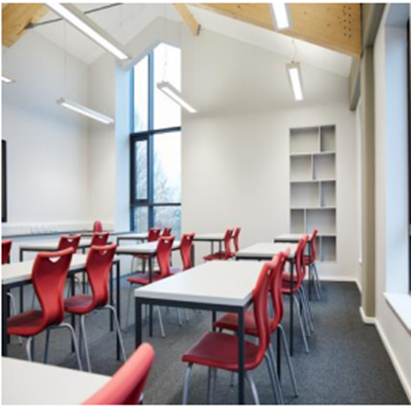

Our pupils are entered for the Edexcel GCSE qualification (higher tier). GCSE results are excellent, with over 87% achieving grades 7 and above in 2025. We also offer AQA Level 2 Certificate in Further Maths. The Key Stage 3 curriculum prepares girls for the rigours of the GCSE course whilst offering many opportunities for enrichment. Pupils enter UKMT challenges and team competitions. Enrichment activities in recent years have included trips to Maths in Action lectures, the Bank of England and Bletchley Park. A Level Mathematics is regularly the most popular subject option in the Sixth Form with 90% of students attaining A*-B in 2025.

We also offer Further Mathematics to both AS and A Level to a small but increasing number of dedicated students. We follow the Edexcel course for both A Level and Further Maths. The Department has an enviable track record of successfully preparing students to apply for Mathematics and related courses at the most prestigious universities, including Oxford and Cambridge.

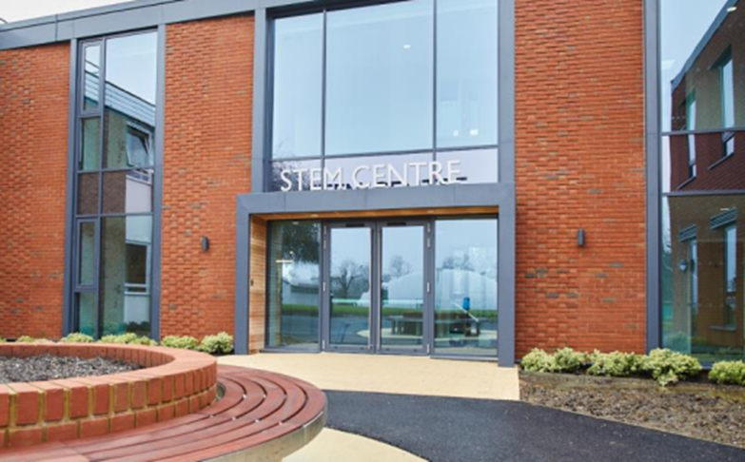

MAIN RESPONSIBILITIES
All teachers are expected to ensure the highest standards of teaching and learning by:
- Preparing and delivering challenging and differentiated lessons.
- Setting homework in accordance with the school’s homework policy.
- Marking work in accordance with the school’s marking policy.
- Using all available data and information to ensure that each student is provided with an appropriate programme of study.
- Having a good understanding of the schemes of work they are following and how these fit into the overall scheme of work for the subject they are teaching.
- Keeping up to date with developments in the teaching of their subject.
- Take a full and active role in the School’s Co-Curricular programme.
Other Duties:
- Carry out such duties as may reasonably be required by the Head of Department
- Support and promote the school’s ethos, aims and objectives.
- Work towards and support the school vision and the current school objectives outlined in the School Strategic Plan
- Promote and safeguard the welfare of pupils and adhere to and ensure compliance with the School’s Safeguarding and Child Protection Policy
- Work within the School’s health and safety policy to ensure a safe working environment for staff, pupils and visitors.
- Promote equality of opportunity for all students and staff
- Help sustain a school culture and curriculum which promotes an ethical education for all including promoting positive strategies for challenging discrimination of any kind.
- Maintain high professional standards of attendance, punctuality, appearance, conduct and positive, courteous relations with pupils, parents, and colleagues.
- Engage actively in the performance review process.
- Undertake other reasonable duties related to the job purpose required from time to time.
THE PERSON
It is essential for the successful candidate to have the following qualifications,
experience, and personal attributes:

- Degree level in relevant or associated subject
- Excellent classroom practice with experience of teaching Maths across the secondary age range including KS5.
- Ability to teach A-Level Further Maths
- A love of teaching and learning and a commitment to further professional development.
- Be able to work well with others and develop the curriculum through collaborative planning.
- Detailed understanding of current developments in the secondary curriculum and assessment.
- Be able to lead learning in their classroom, develop each child and have demonstrable passion for the subject.

- Ability to plan and prioritise workload to meet deadline, including managing multiple tasks/ projects/priorities simultaneously.

- Calm under pressure, ability to remain articulate, and be a confident communicator.

It is desirable for the successful candidate to have the following qualifications,
experience, and personal attributes:

- A teaching qualification such as PGCE or equivalent.
- Evidence of further professional development.
- Knowledge and experience of how technology can be used to support learning.
- Experience of working in an independent school.

BENEFITS
- Competitive Pensions Scheme
- Competitive pay structure with opportunities for progression up the scale
- 50% fee remission for staff children subject to spaces and entry examinations (pro rata for part time staff)
- A strong culture of professional development
- Access to the School’s swimming pool and fitness suite
- High Street Discounts
- Electrical Vehicle Charge Scheme
- Subsidised Staff Coach Travel
- Cycle to work scheme.
- Free lunch and refreshments
- Free on-site parking and excellent public transport links
- Employment Assistance Programme
- Generous occupational sick pay
- A beautiful working environment – the school is set in a conservation site in excess of 21 acres.

APPLICATION PROCESS
Closing date: 9am Monday 16th February 2026

Please apply as soon as possible as shortlisting/interviews will progress up until the closing date. Should a suitable candidate be appointed, we reserve the right to close the advert early.

Due to the high volume of applicants, we receive, if you do not hear from us within 4 weeks of the closing date, please assume we will not be progressing your application further on this occasion.

THE SELECTION PROCESS
Shortlisted candidates will be invited to the school where they will be interviewed by the Head of Maths and members of the Senior Leadership team, be observed teaching a lesson, and have a tour of the school.

St Helen’s school is committed to safeguarding and promoting the welfare of children and young people, as detailed in Part 3 (Safer Recruitment) of the KCSIE 2025 guidance document. Applicants will be asked for proof of right to work in the UK and undergo child protection screening, including checks with past employers and the disclosure and barring service.
If you have any queries about this position, please contact the school at recruitment@sthelens.london
