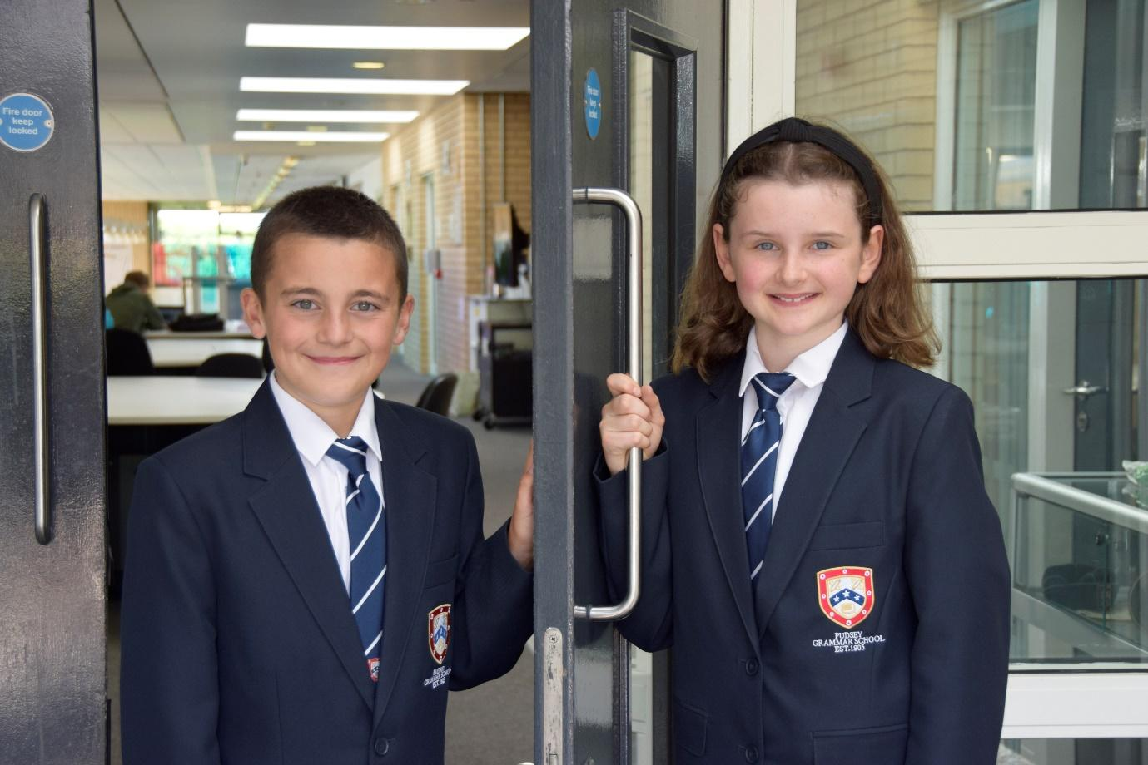

TEACHER OF
ENGLISH

APPLICATION PACK

Teacher of Science
Permanent

MPS/UPS
£32,916 - £51,048

The school operates a flexible early finish on Fridays
To start September 2026

Contents
Introduction from the Headteacher
General school details
Information on the post
Job description
Person specification
Enhanced disclosure

Introduction from the Headteacher

Thank you for the interest you have shown in the post of Teacher of Science. This is an excellent opportunity to join our dynamic Science Team.

Pudsey Grammar School is a heavily oversubscribed mixed comprehensive secondary school located in the heart of the market town of Pudsey. Situated between Leeds and Bradford, the town has always valued its independence from its two larger neighbours. The school has a long and proud history stretching back to 1905. The school has 1350 students with a thriving and expanding Sixth Form of over 250 students, all taught in a state of the art building. The innovative and unique style of the building creates a calm atmosphere very different to many secondary schools.

I was appointed in 2014 and since then we have received a letter from Amanda Spielman (HMCI Ofsted) which stated we ‘have transformed all aspects of the school.’ This assertion was further underlined in 2018 when the increase in our exam results resulted in the school being the most improved school in Leeds and one of the most improved in the country (we were delighted to follow these achievements up with our best ever GCSE exam results in 2019 which were above the national average). The pattern of improvement continued in 2020 with our Year 11 students achieving grades which were outstanding. The school had a highly successful Ofsted inspection in April 2019 and was judged as good in all areas, including our Sixth Form. The school underwent an ungraded inspection in April 2024 which saw, for the first time in the school’s history, a second successive Ofsted judgement of being a good school. This is testament to the consistently high quality of education which the school provides for all of our students and is one of the reasons why we remain one of the most popular schools across the city of Leeds with over 900 applications received for 215 Year 7 places for September 2024.

In 2022, the school was selected to be a national Behaviour Hub school. This is a Department for Education programme led by the Governments’ School Behaviour Advisor, Tom Bennett, which identifies schools who have ‘an exemplary behaviour culture’. We are one of only 20 secondary schools out of 4000 who have achieved this prestigious accolade, and we are working with other schools across the north of England to improve their behaviour cultures.
We have a comprehensive House system which runs across all year groups with over 30 diverse competitions across the year for students and one each half term for staff too. House assemblies take place once every three weeks lead by our four House Leaders. At the end of each academic year, the winning House is awarded our 80-year-old Victor Ludorum Cup.
We are aiming to be a centre of excellence and every indicator we have; we are on track to achieve this goal. Continuing to recruit high calibre staff is a key priority of our strategy.

The following quotes are taken from the latest Ofsted report:

- The school is welcoming and pupils respect the differences in other people.
- Safeguarding is very well led and pupils feel safe
- Pupils get on very well with each other
- Teachers have strong subject knowledge
- Pupils behave well in lessons and the vast majority focus on their work
- The school has developed an ambitious curriculum for pupils
- Staff have high expectations of all pupils. The vast majority of pupils rise to these expectations and work hard
- Pupils benefit from the curriculum and are well prepared for their next steps
- The House system plays a central role in the school and provides a sense of belonging. Pupils who earn House ties for their dedication to House competitions wear them with pride
- If bullying happens, pupils are confident that staff will deal with it quickly
The school has a long tradition in the town, being established as Pudsey Grammar School in 1905. Although the school is taught in a state of the art building, our core values of respect, resilience, integrity, compassion and ambition are highly traditional and are based on the goal of ensuring that every student reaches their true potential.

Our school is not just about the student’s gaining knowledge and qualifications, although these are extremely important. We believe in teaching young people core values of decency, social skills and how to be a good citizen in an ever-changing world. We want their character to develop and grow, and for them to leave us with an inquiring and independent mind. We want our students to gain the best qualifications they are capable of whilst experiencing a range of opportunities which are second to none. As a result, the school is extremely popular with our community and is significantly over-subscribed every year.

Our Sixth Form, which is rated as good by Ofsted, has grown rapidly in recent years following significant investment and we now have over 250 Post-16 students studying at Pudsey Grammar. We have a strong tradition of ensuring students access the best universities, including Oxford and Cambridge.

Our staff show exceptional dedication and commitment to our students. Relationships in the school are extremely strong and this underpins the ethos of the school. We pride ourselves in the care and support that we give our staff and, as a result, there is a real team spirit in the school where people enjoy being part of our school community. Teaching and learning is the key focus of the organisation and everything that we do is designed to ensure that the classroom experience for
the students is excellent. We are currently redesigning our curriculum to ensure that the education we offer is second to none.

We offer fantastic support and professional development to staff, which ensures that they are equipped with all the necessary skills to deliver excellent lessons to the students daily.

The school is a Foundation Trust school, and our partners include global companies Including; HSBC bank, alongside leading local business and training provider, Appris. These high-quality links allow our school to offer excellent careers opportunities to students across the ability range. As a result, the school has 0% NEETs at Year 11.

We are currently part of The Leeds Teaching Hubs, which is providing outstanding opportunities and CPD for all our staff. Subject Leaders attend their Collaborative Learning Groups, which allows them to network and share best practice. This is further disseminated through the school via regular Department meetings and weekly Teaching & Learning briefings.

This clearly is an exciting time to join our school.

If you have a desire to be part of one of the most exciting and rewarding schools to work in, which will also provide you with excellent development opportunities, please complete the application form. Any further details can be obtained directly from the school’s HR Team: recruitment@pudseygrammar.co.uk) or our website www.pudseygrammar.co.uk

Mark McKelvie
Headteacher
Pudsey Grammar School

Department
The Science team is made up of ten teaching staff and two laboratory technicians, hosting a wide range of experience and specialisms. We are a strong team, working collaboratively across the science specialisms to deliver an engaging curriculum with a focus on maximising effective teaching and learning styles. We share all curriculum resources across the team, ensuring both ECTs and more experienced teachers feel supported and well-placed to challenge students to develop their substantive and disciplinary knowledge. Our results at GCSE are consistently above national average. All staff contribute to curriculum planning and development and have opportunities to develop their own teaching practice through departmental CPD.
This is a fantastic opportunity for an ambitious teacher with drive, passion and a strong vision for success. As a department, we actively support the whole-school wider provision offering through exciting extra-curricular activities and projects. Members of the department regularly engage with local primary schools, including inviting KS2 students to school to take part in enrichment sessions. Post 16 students assist in lower school lessons, and we successfully run a well-attended Science club. The department often hosts ITT students through Gorse Scitt training and is skilled in supporting ECTs through their induction. We enhance our science offer through a host of academic visits which have included Drax Power Station, Treetop Nets and Alton Towers to name a few. We actively seek opportunities with local universities and industries to further our students’ understanding of science and to promote studying scientific skills and career opportunities beyond GCSE and A-Level.
Learning at Post 16 is a strong feature of the department, delivering A Level Biology, Chemistry and Physics as well as Btec Applied Science to our sixth form students. Students are actively encouraged to take advantage of enriching projects such as visits to Rodley Nature reserve and completing the A-Level Olympiads. We continue to support bursary students through directed funding to ensure all have the same opportunity to achieve success.
The current management structure in the department is made up Head of Science plus two Seconds in Department. This structure allows effective leadership and support across the full team as we continuously work together to develop teaching and learning, assessment, curriculum and enrichment. We strive for continuous growth and success.
The successful candidate would be joining a very enthusiastic, motivated, inspiring and cohesive team where student progress and engagement is the focal point.

Details of advert

Pudsey Grammar School is a thriving secondary school and sixth form educating students aged 11-18. Established in 1905, our school boasts a long and proud history combined with a modern, state-of-the-art building designed to inspire learning and achievement. We are heavily oversubscribed with 1,350 students in the main school and 250 in the sixth form.
Rated Good by Ofsted in 2024, we were proudly selected as a National Behaviour Hub School in 2022. As part of the Leeds Teaching Hubs, we offer outstanding opportunities for continuing professional development (CPD), enabling our staff to grow and thrive in their careers. At Pudsey Grammar, we are committed to fostering a supportive and dynamic environment where both students and staff succeed.
Teacher of Science - Permanent
Grade: MPS/UPS, £32,916 - £51,048
Start date: September 2026

The school operates a flexible early finish on Fridays
We are looking for an exceptional and highly motivated teacher to join our talented and forward-thinking Science department. We are looking for an inspirational, dedicated and motivated colleague who is passionate about their subject specialism and the development and delivery of an excellent and inspiring curriculum. You will be part of a dynamic subject team which is committed to achieving excellent outcomes for all our students, collaboratively working to improve teaching and learning across key stages 3, 4 and 5.

We are looking for an outstanding candidate who would be keen to:

- Teach across Key Stage 3, 4 and 5
- Work with the department to develop an exciting range of extra-curricular activities and promote our hugely successful school productions
- Contribute to and continue to develop our well-established and successful schemes of work across all key stages
- Work cohesively within a department that is committed to developing new ways of teaching and learning that focus on student needs
- Promote and safeguard the welfare of children and young people in accordance with our Safeguarding and Child Protection policies.
- A commitment to:
  - Working in line with statutory safeguarding guidance (e.g. Keeping Children Safe in Education, prevent and our safeguarding and child protection policies)
  - Working with the designated safeguarding lead (DSL) to promote the best interests of students, including sharing concerns where necessary
  - Promoting the safeguarding of all students in the school
Why work at Pudsey Grammar School?

By working at Pudsey Grammar School, you will:
- Be part of a rapidly improving school with a strong vision for excellence
- Work in an organisation that places staff & student wellbeing at its core
- Join a dynamic and enthusiastic team dedicated to student success
- Access exceptional CPD opportunities through our links with hub schools in Yorkshire and Humber and University College London
- Thrive in a supportive environment with high standards for both staff and students
- Work in an award-winning state-of-the-art building that supports innovative teaching and learning
- Located in Pudsey – a friendly town with a strong community feel
- Close to Leeds city centre and just a short journey to the stunning Yorkshire countryside.

This school is committed to safeguarding and promoting the welfare of children and expects all staff and volunteers to share this commitment. Appointments will be subject to an enhanced DBS disclosure. If shortlisted, you will be required to disclose relevant information regarding criminal history, and an on-line search will be conducted. This includes only information publicly available on-line.

We promote diversity and want a workforce that reflects the population of Leeds.

Employment is conditional on confirmation of the right to work in the UK – either as a UK or Irish citizen, under the EU Settlement scheme or having secured any other relevant work visa. If you do not have the right to work in the UK and the role does not meet eligibility for sponsorship, please consider carefully whether you meet the eligibility to apply for this position.
Application Process
Should you wish to apply for this position, please send the following:
- Please be aware that we do not accept Curriculum Vitaes.
- In support of your application, you may include a covering letter. This should be in addition to the completed application form.
- Application form and full job description can be found on the school website: www.pudseygrammar.co.uk vacancies – My New Term link

Closing date for application Wednesday13th May 2026 by 8.00am
Successful candidates will be contacted directly with details of the interview.
Interview date: Thursday 21st May 2026

Job Description
Post Title: | Teacher of Science
Post Purpose: | - To facilitate and encourage learning which enables students to make progress and achieve high standards; to share and support the corporate responsibility for the well-being, education and positive behaviour of all students.  - To contribute to the positive ethos of the school.  - To be responsible for the health and safety of themselves and those around them.  - To implement the school’s policies and procedures.  - To work as part of curriculum and pastoral teams to effect the school’s mission statement, ensure a strong commitment to Every Child Matters, as well as provide effective high quality teaching and learning.
Reporting to: | Subject Leader of Science
Working time: | Full time– From September 2026. Permanent  School operates an early finish Friday
Salary/Grade: | MPS/UPS, £32,916 - £51,048
Main (Core) Duties:
Teaching & Leading Student Learning | - Ensure effective learning of whole classes, groups and individuals so that teaching and learning objectives are met, momentum and challenge are maintained, and students’ targets are achieved or exceeded.  - Utilise teaching methods which engage students, including stimulating intellectual curiosity, effective questioning and discussion, clear presentation and good use of resources.  - Set high expectations for students' behaviour, establishing and maintaining a good standard of discipline through well-focused teaching and learning experiences and through positive and productive relationships. Lead this process in accordance with school policies and procedures.  - Make use of a variety of techniques to support knowledge retrieval  - Use a variety of Assessment for learning strategies to ensure teaching is responsive to student need.
Planning and Setting Expectations/Student Achievement | - Identify clear learning objectives, content, lesson structures and sequences appropriate to the subject matter and the students being taught.  - Set appropriate and demanding expectations for students’ learning and motivation. Set clear targets for students' learning, building on prior attainment.  - Plan appropriate learning programmes for students who have special educational needs, and know where to get help in order to give positive and targeted support. Implement and keep records on Individual Education Plans (IEPs).
Assessment and Evaluation | - Assess how well learning objectives have been achieved and use this assessment for future teaching.  - Mark and monitor students’ class and homework providing constructive oral and written feedback, in line with the school’s Marking Policy.  - Where applicable, understand the demands expected of students in relation to the National Curriculum, KS4 and post-16 courses.
Relationship with Parents/Carers and the Wider community | - Prepare and present informative reports to parents.  - Provide opportunities to develop students' understanding by relating their learning to real and work-related examples, recognising that learning also takes place outside the school context.  - Liaise with agencies responsible for students' welfare.
Working and Colleague Relationships | - To establish effective working relationships with professional colleagues including, where applicable, support staff.
Manage Own Performance and Development | - Take responsibility for their own professional development and to keep up to date with research and developments in pedagogy and in the subjects they teach.  - Share corporate responsibility the implementation of school policies and practices.  - Provide a role model to all students they encounter, in their presentation and their personal conduct.  - Evaluate their own teaching critically and use this to improve their effectiveness.
Safeguarding | - To work in line with statutory safeguarding guidance (e.g. Keeping Children Safe in Education, prevent and our safeguarding and child protection policies)  - To work with the designated safeguarding lead (DSL) to promote the best interests of students, including sharing concerns where necessary.  - To promote the safeguarding of all students in the school.
Physical conditions | - The post is based at Pudsey Grammar School.  - The school is accessible by stairs and lift and is available by disabled persons to the ground floor by a portable ramp on request.  - This post is subject to an enhanced Disclose and Barring Service check.  - The school operates a non-smoking policy.
Prospects | - Whilst there is no automatic progression to any more senior posts, opportunities do exist for advancement and promotion, dependent upon normal staff movements and on the capabilities of the individual post holder.
Training | - The school encourages training both “in-house” and external to meet the needs of the individual and of the Service..
This job description is to assist staff joining Pudsey Grammar School to understand and appreciate the work content of their post and the role they are to play in the organisation.

Whilst every endeavour has been made to outline the main duties and responsibilities of the post, a document such as this does not permit every item to be specified in detail. This job description is not a definitive list of responsibilities but identifies the key components of the role. The post holder will, therefore, be required to undertake other reasonable duties commensurate with the purpose and salary level of this post.

Employees should not refuse to undertake work, which is not specified on this form, but they should record any additional duties they are required to perform, and these will be taken into account when the post is reviewed.

Statement:
This school is committed to safeguarding and promoting the welfare of children and expects all staff and volunteers to share this commitment. Appointments will be subject to an enhanced DBS disclosure. If shortlisted, you will be required to disclose relevant information regarding criminal history and an on-line search will be conducted. This includes only information publicly available on-line. The employee may be subject to rechecking as required from time to time.

All appointments are subject to satisfactory references.

Pudsey Grammar School is an equal opportunities employer and requires its employees to comply with all current equality policies both in terms of equal opportunity for employment and access to the school’s services.

We promote diversity and want a workforce which reflects the population of Leeds.
Dated: April 2026

The Job Description should be read alongside the range of professional duties of Teachers as set out in Part X11 of the Teachers’ Pay and Conditions Document, sections 48 to 50. The postholder will be expected to undertake duties in line with the new Professional Standards for Teachers (2008) and uphold the professional code of the General Teaching Council for England.

Person Specification
ATTRIBUTES | REQUIREMENTS | ESSENTIAL | DESIREABLE
Qualifications, Training & Knowledge | - Degree in specialist/relevant subject area;  - Qualified Teacher Status;  - Good knowledge of current educational developments, especially in specialist/relevant subject area.  - Good knowledge of the requirements of the Leeds Locally Agreed Syllabus;  - Knowledge of strategies for raising attainment; | *  *  *  *  *
Experience | - Teaching experience of secondary school (in specialist/relevant area). | *
Skills | - A good team member;  - Flexible and able to use own initiative;  - Ability to inspire and motivate students;  - Good ICT skills; including editing software  - Good written and spoken communication skills. | *  *  *  *  *
Personal Qualities | - Evidence of effective organisational and communication skills;  - Evidence of being a successful teacher;  - Capable of inspiring students;  - Able to form good working relationships with colleagues;  - A willingness to become fully involved in the wider life of Pudsey Grammar School. | *  *  *  *  *

Enhanced Disclosure

Thank you for your interest in this post at Pudsey Grammar School. The post you are applying for involves working with young people. It is therefore exempt from the Rehabilitation of Offenders Act and any offer of employment will be subject to an Enhanced Disclosure.

As this post is exempt from the Rehabilitation of Offenders Act, you must declare any convictions, including pending convictions, cautions, reprimands and warnings which would otherwise be regarded as “spent” under this Act. Further details will be sought prior to appointment.

An Enhanced Disclosure is carried out by the Criminal Records Bureau and will check criminal records for information on any convictions, cautions, reprimands and warnings held on the Police National Computer and on local Police records.

All information on criminal records provided both by you and within the Enhanced Disclosure will be used, stored and disposed of in confidence and in line with the Criminal Records Bureau Code of Practice of Disclosure Information.

If your application is successful, you will receive further information on how to complete the Enhanced Disclosure.

We are committed to safeguarding and promoting the welfare of our pupils and expect all staff and volunteers to share this commitment.

School Location and Travel Information

Pudsey Grammar School
Mount Pleasant Road
Pudsey
Leeds
LS28 7ND

Tel: 0113 2558277
Twitter - @PudseyGS
www.pudseygrammar.co.uk

