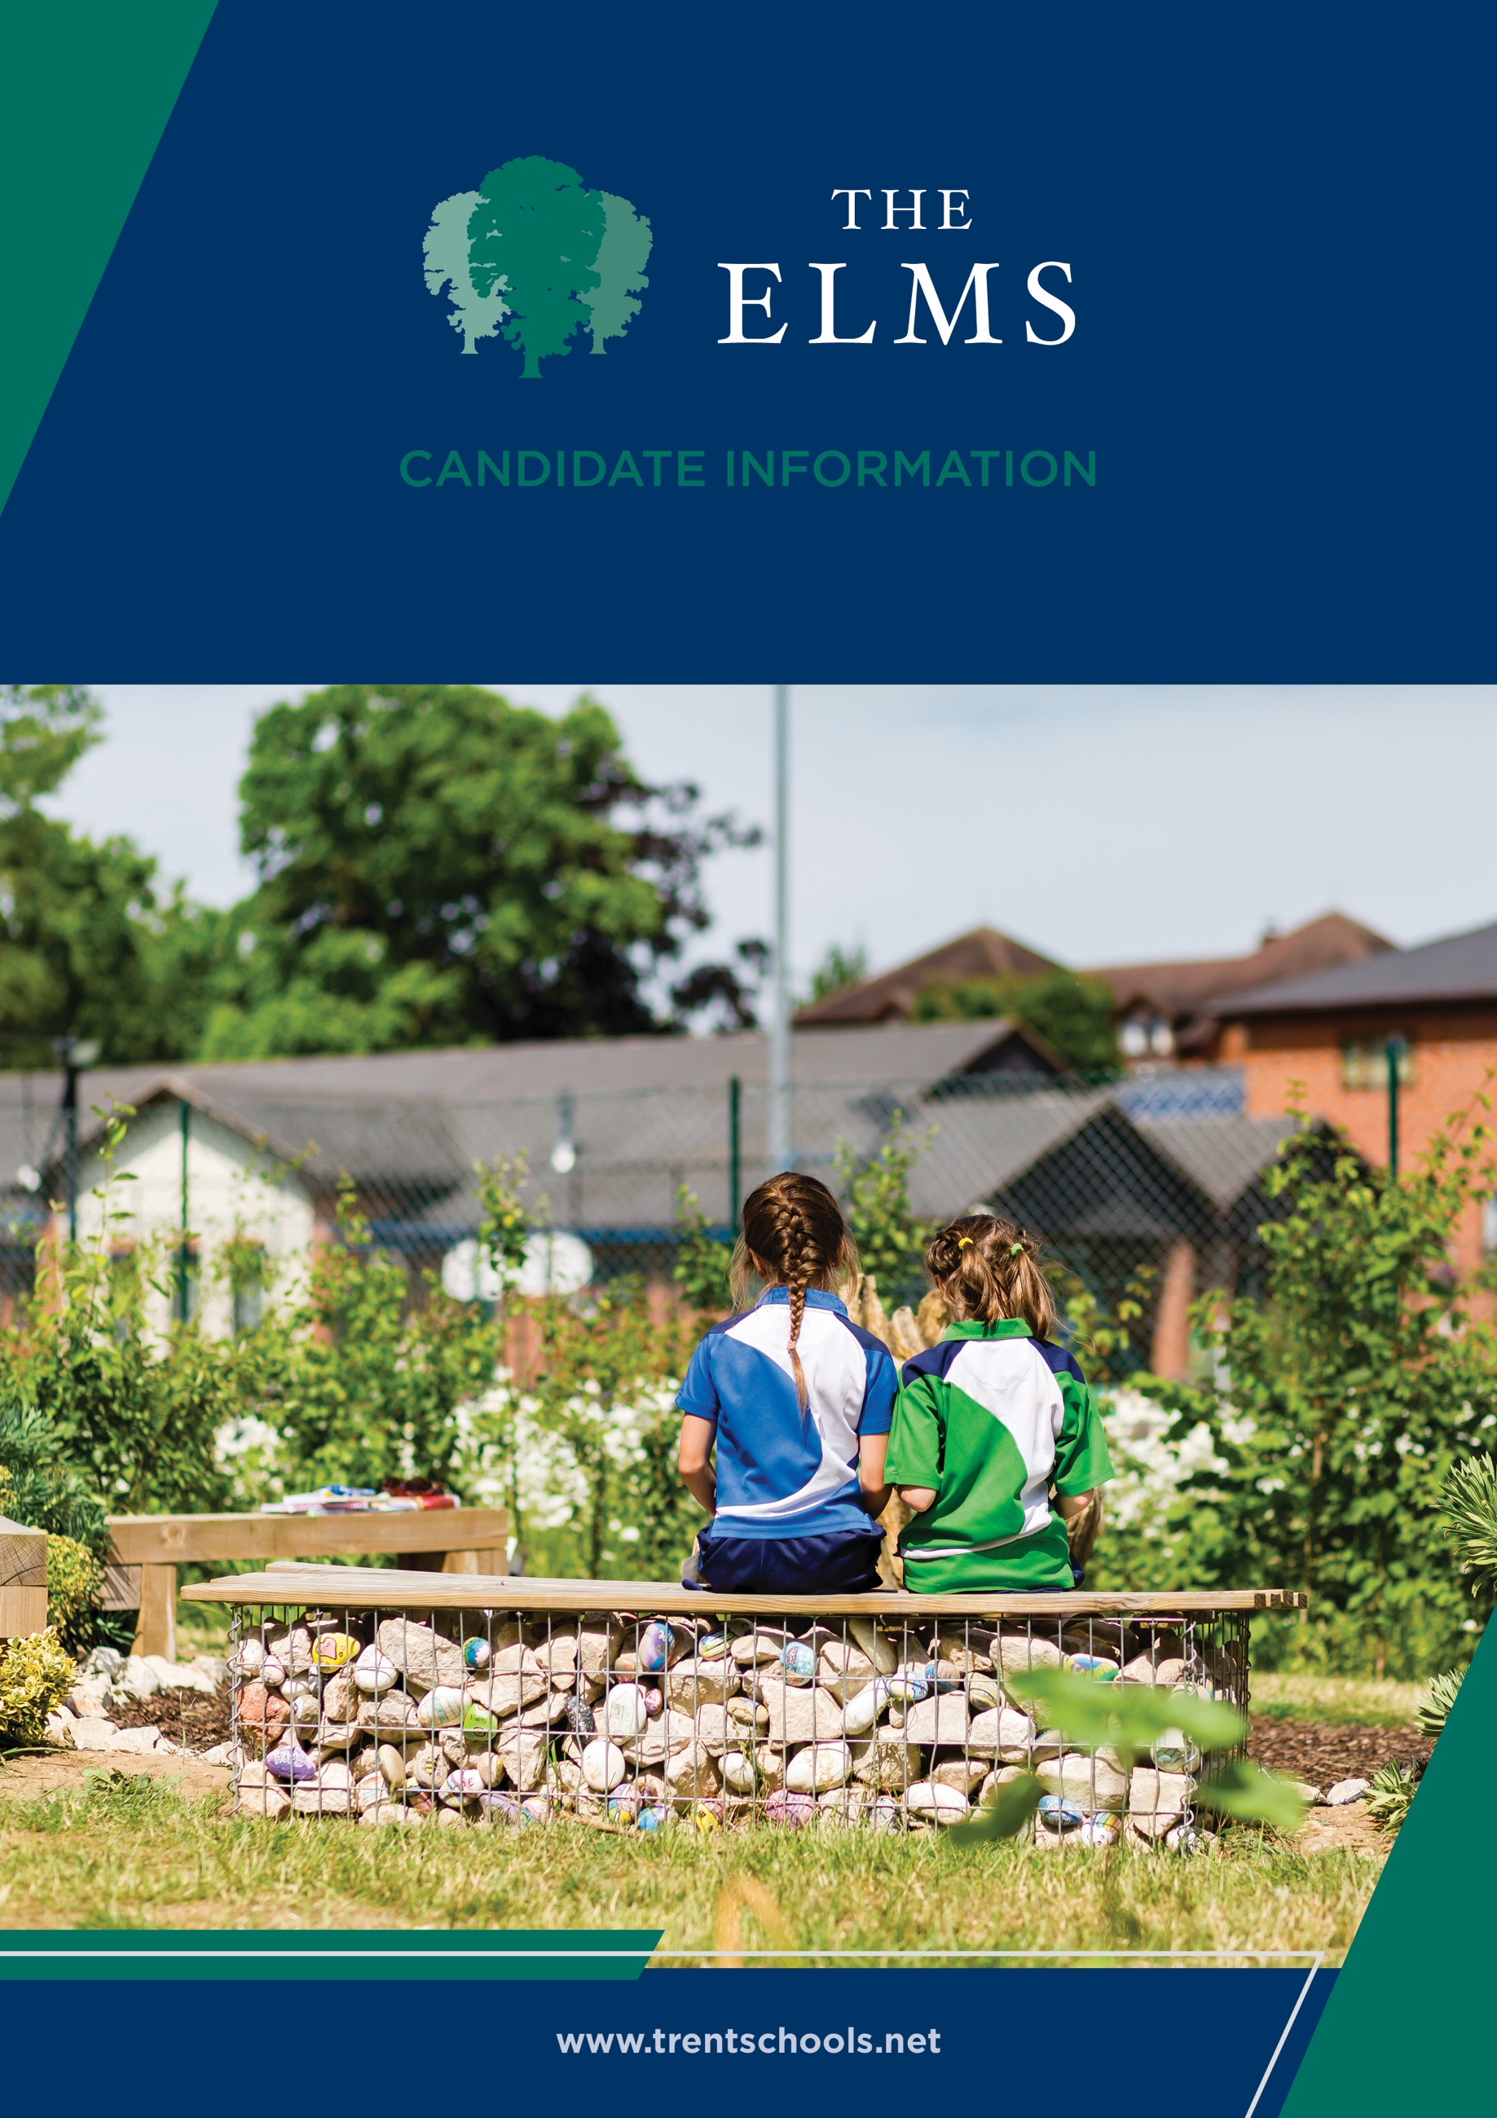


Welcome
The Elms is an independent co-educational school for children aged from 6 weeks to 11 years old. Located in Long Eaton, Nottinghamshire, The Elms is part of Trent College, and enjoys a beautiful, shared 45-acre campus with state-of-the-art facilities, including modern classrooms and sports facilities, as well as dedicated Nursery and Pre-School buildings, and wonderful outdoor learning facilities.
The Elms journey begins in the Nursery, which was recently rated ‘Outstanding’ in all areas. Here learning through play and exploration builds confidence and curiosity about the world around them.
As children progress through the school, the focus on exceptional pastoral care and inspirational teaching, along with a vast array of enrichment opportunities, ensure that our children leave us with the independence and resilience to embark successfully upon their senior school education.
Rated ‘Excellent’ across the whole school by the Independent Schools Inspectorate in 2025, we have highly qualified and experienced teaching staff who are committed to providing an excellent standard of education. We also have a large population of support staff, ensuring that our friendly school and beautiful campus operate to the very highest standards and our pupils are happy and flourish.
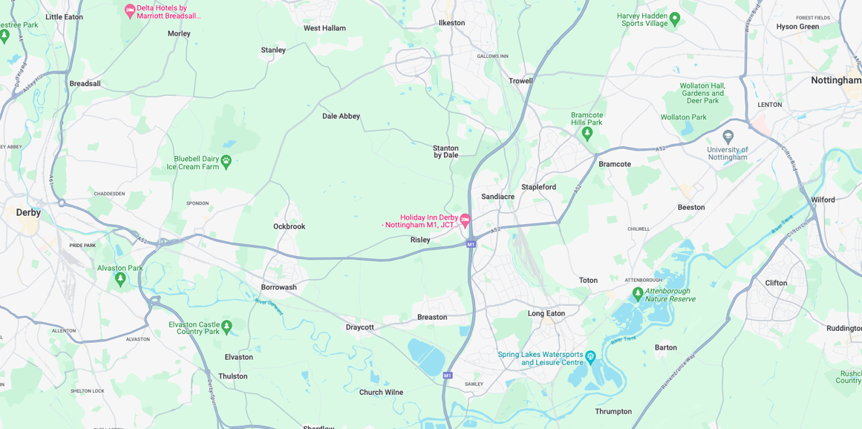


Our Location
Trent College and The Elms are conveniently situated on the border of Nottinghamshire and Derbyshire.
Ideally located at the heart of the UK’s motorway system, we are only 2 miles from junction 25 of the M1, which provides easy access to the M42 and A1.
Reaching Trent College by rail couldn’t be easier. Long Eaton boasts its own train station, located 1.5 miles from the schools. Rail routes through Long Eaton run along the Midlands Main
Line route, with direct routes to London, Loughborough, Leicester, Birmingham, Nottingham, Derby, Chesterfield and Sheffield.

Our Local Community
Working in partnership and serving the community are natural and very important values at Trent College and The Elms. We work with many local schools in Long Eaton and the wider Erewash borough to increase opportunities and aspirations, and to share the school’s excellent grounds, facilities and specialist staff.



Level 3 Teaching Assistant

Job Description
Responsible to: Head, under direction of the Class Teacher, members of ELT & Head of Learning Support
Purpose: To assist in the support, inclusion and development of pupils across The Elms.
The Elms
The Elms Infant and Junior School is a co-educational, independent day school for 4 -11 year olds. The Elms Pre-School and Nursery welcome children from 6 weeks to 4 years old.
The school aims to nurture enquiring minds and increase self-confidence, so pupils will enjoy asking questions and making decisions for themselves. Pupils are provided with a wealth of learning opportunities, enabling each child to grow, learn and flourish in a supportive and stimulating environment.
The wellbeing of pupils is at the core of everything at the school. Getting to know each child as an individual and their needs as a learner, means we can deliver exceptional standards of pastoral care, enabling them to achieve their personal best.


Responsibilities:
Support for pupils
- To work under the instruction of the class teacher, Head of Learning Support and members of the Senior Leadership Team to support the high-quality teaching, learning and pastoral needs of the individual or of small groups of children.
- To support and implement structured evidence-based interventions and Individual Learning Plans for children with SEND.
- To assist and support external agency workers where required.
- To assist and supervise children during online screening and diagnostic work.
- To promote inclusion and acceptance of all pupils within the classroom, encouraging children to interact and work cooperatively with others and engage with all activities.
- To provide positive feedback and effective assessment for individualised learning for pupils, developing an understanding of how to motivate and encourage the individual child to develop independent learning skills.
- To be responsible for promoting and safeguarding the welfare of children and young people within The Elms.
Support for Teachers
- To provide support for learning activities through contribution to planning, preparation and use of online resources as appropriate.
- To assess, feedback and record evidence of achievement, personal response and progress of pupils through agreed monitoring systems and individual targets.
- To establish constructive relationships with parents and / or carers by supporting a dialogue between home and school where appropriate.
- To accompany class teachers and pupils on educational visits when possible / appropriate.
Support for The Elms
- To promote and support the Behaviour Policy of The Elms and to be proactive in managing behaviour, independence and integration of children, both within the classroom and around the school.
- To be aware of and comply with policies and procedures relating to child protection, equal opportunities, health and safety, security, confidentiality, data protection and the reporting of concerns to the appropriate person.
- To attend and participate in regular meetings and in training or other activities as required by the Head.
- To support and comply with the performance management system for staff and the ethos of continuous professional development.
- To undertake broadly similar duties commensurate with the level of the post as required by the Head, which may include Early Morning Care and Lunch/Playground Duties and after school duties
- To support the clubs and activity programme across the school.
- Attend Open Morning events as requested by the Head.
- To keep first aid qualification up to date by attending training as directed by the Head.


Benefits
- Staff can enjoy complimentary lunches in the Obolensky Dining Hall during term time. Free car parking is available on site and staff have access to a cycle to work scheme.
- Staff are able to make free use of the school gym and leisure facilities at designated times.
- A flexible retirement plan run by TPT Solutions (formerly The Pensions Trust), including Death in Service benefit.
- Enhanced sick pay and maternity pay is available to staff.
- Staff are entitled to a fee remission for children attending the school, in line with our policy.
- We provide a range of benefits to support staff, including counselling, an employee assistance programme and 24/7 online GP consultations.

Terms and Conditions
- Full time, permanent
- 08.00 till 17.30 Monday and Tuesday, 08.00 till 17.00 Wednesday, and 08.00 till 16.00 Thursday and Friday.



Making an Application
Candidates who wish to apply for this post should apply via our website.
If you have any questions about the role please email recruitment@trentcollege.net or telephone 0115 949 4942 (during term time).
The closing date for applications is included in the advert.
Interviews are to happen week commencing 7 September 2026 – Please be aware the interviews may be held earlier.
We reserve the right to close this advertisement early if we receive a volume of strong and suitable applications.

The school is committed to safeguarding and promoting the welfare of children and young people and expects all staff and volunteers to share this commitment.
Applicants will be required to undergo child protection screening appropriate to the post, including checks with past employers and the Disclosure and Barring Service (DBS). The school may carry out online searches on shortlisted applicants and all applicants will be required to provide details of their online profile, including social media account names/handles, as part of their application
The post is exempt from the Rehabilitation of Offenders Act 1974. The school is therefore permitted to ask job applicants to declare all convictions and cautions on a self-declaration form in advance of attending an interview (including those which are "spent" unless they are "protected" under the DBS filtering rules) in order to assess their suitability to work with children.



