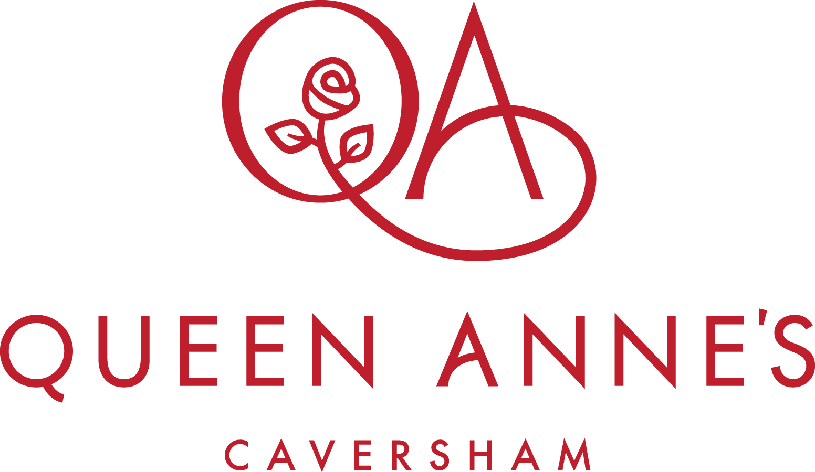

Appointment of

Payroll and HR Assistant

Part time

Job Description

Post Title Payroll and HR Assistant
Reporting to HR Manager
Accountable to Director of Finance and Operations

The Role
Queen Anne’s School is looking to hire a Payroll & HR Assistant to oversee the day-to-day payroll function and assist with the HR service.

The School has recently launched a new HR platform for payroll (Cintra) and the Payroll and HR Assistant’s role will help with the successful roll-out of the Cintra platform. They will be responsible for ensuring that the critical documentation supporting the school’s staffing is kept up to date and efficiently organised and they will be the front-line for initial personnel requests for staff.

A high degree of confidentiality and professional integrity is required due to the sensitive nature of the information. Attention to detail is also critical.

Main Duties
- Establish a full and deep understanding of the school’s new payroll and HR platform, Cintra, so as to become a subject matter expert, supporting all staff as they familiarise themselves with the new platform.
- Manage the regular data input to the Cintra platform, such as new joiners and leavers, contract and pay changes, overtime requests, holiday, sickness absence and employee personal data updates.
- Work closely with Finance team to check monthly payroll reflects any monthly staff changes and pay claims submitted. Process basic payroll and benefits queries from staff
- Monitor the HR inbox together with the HR Manager and respond to any minor personnel requests from staff in a professional manner
- Support the HR Manager with onboarding, including maintaining a tracker for all staff pre-employment checks, timetable for first day onsite, new starter onboarding checklists and calendar reminders for 1 month, 3 month and 6-month probation reviews with line manager
- Organise the logistics of recruitment, interviews and assessments (eg formatting and posting job adverts, acknowledging applications by email, scheduling online first-round interviews, timetabling interviews at school, touring and preparing interview packs for staff panel)
- Maintain the staff training log
Essential Requirements
- Excellent attention to detail
- Strong numerical skills and knowledge of the payroll process
- Able to maintain confidentiality
- A good team member who can work on their own initiative
- Ability to respond swiftly to action payroll changes and staff enquiries

All employees are required to assist the School where necessary in applying UK Border Agency policy with regard to overseas students. These duties include giving information, when requested, to allow records to be kept on pupils' visas and attendance, as well as other matters.

Note: This job description is not a comprehensive definition of the post. It will be reviewed as part of the cycle of appraisal, and it may be subject to modification or amendment at any time after consultation with the holder of the post.

Outline Pay and Conditions
Working pattern: 4 days per week at 30 hours per week, all year round.
Salary £24,551.20.
Alternative working pattern: Term time plus 4 weeks at 37.5 hours per week (38 weeks).
Salary £24,780.14

The school has a free car park, fully subsidised catering for lunch and an on-site café.
Staff benefits include a pension scheme, school fee reduction, where appropriate, and excellent training and Inset opportunities. CPD is actively encouraged for all staff.
Members of staff have the opportunity to use the school sport and leisure facilities which include a fully updated gym, newly refurbished swimming pool and resurfaced floodlit tennis courts. Staff can enjoy a wide range of professional concerts, lectures and symposiums delivered in-house by expert leaders in their fields.
Safeguarding
Queen Anne’s School is an equal opportunities employer and is committed to safeguarding and promoting the welfare of children and young people and expects all staff and volunteers to share this commitment. The appointment is subject to satisfactory pre-employment checks in accordance with the relevant statutory guidance, including an enhanced DBS check, satisfactory references, proof of identity and qualifications. All employees are required to assist the School where necessary in applying UK Border Agency policy with regard to overseas students. These duties include giving information, when requested, to allow records to be kept on pupils' visas and attendance, as well as other matters. Shortlisted candidates will be subject to Social Media Checks.

The Application Process
Please complete the application form available from https://www.qas.org.uk/our-community/work-with-us
Whilst completing the online application form, candidates will be prompted to complete a section outlining their reasons for applying and suitability for the role.
Application deadline: Friday 7th August 2026.
The School reserves the right to close the application process early.

Any queries regarding the role can be directed to hr@qas.org.uk

