Moat Farm Infant School
Learning Support Assistant
SEND Hub
Recruitment Pack





Learning Support Assistant
Temporary position starting asap until July 2026
Grade 3 (SCP3-4)

30 hours 8.40-3.10pm (every day)

We have a great team here at Moat Farm Infant School and we are now in a position to further grow that team. If you are looking for a new challenge in a well-supported school then this could be an excellent move for you. If you have a real passion for Early Childhood education then we are the school for you! We are seeking to appoint a highly motivated and committed learning support assistant to join our team in Moat Farm Infant School.

This is a temporary post and will start as soon as possible. The role is in our SEND Hub and would be well suited to a passionate SEND classroom assistant who has high standards and is keen to work within a successful academy trust dedicated to improving the quality of education for pupils in the Black Country.

We have a good track record of supporting staff with their career develop and providing staff with opportunities to lead and develop areas so if you want to grow in this way we can help you.

We are looking for someone who:-

- Is passionate about teaching and learning in an SEND provision within an infant school
- Puts children first and supports our caring ethos
- Will have high expectations of pupils learning and behaviour
- Is committed to teamwork and working in partnership with parents
- Is passionate about Infant Education.
- Is an energetic and innovative classroom practitioner and be able to model best practice
- Is open to high quality development opportunities the school has to offer and be committed to their own professional development
- Is able to bring new qualities and strengths to our school to improve teaching and learning
- Has excellent interpersonal skills and commitment to work as part of a team, with an optimistic outlook

We can offer the successful applicant the following:

- The chance to be imaginative and innovative in supporting school improvement
- Enthusiastic, friendly and engaging children
- A supportive and friendly team
- A commitment to learning for all

Moat Farm Infant School is committed to safeguarding and promoting the welfare of children and expects all staff and volunteers to share this commitment. We will carry out pre-appointment checks, including DBS check, and will disqualify any applicant where we consider the outcomes to be unsatisfactory. This post is exempt from the Rehabilitation of Offenders Act (ROA) 1974.

We are equally committed to ensuring that no applicant will be disadvantaged or discriminated against because of their protected characteristics under the Equality Act 2010

Thank you for taking the time to consider us.

For informal talks and to arrange a visit to the school please contact:
Jayne Davis
Head of School
0121 552 1885
Jayne.davis@mfi.school

Visits to the school are warmly welcomed and can be arranged by contacting the school office. Please visit our website: moatfarm-inf.sandwell.sch.uk
Please submit your completed application form to Jayne Davis.

Closing date for applications:
Tuesday 5th May 12pm
Shortlisting
Tuesday 5th May
Interview Date:
Wednesday 6th May

About Moat Farm Infant School


Welcome from the Executive Head Teacher

Moat Farm Infant School is a four-form entry school which has 430 pupils on roll, with a School Nursery and Day Nursery housing children between the ages of 0 and 7. We are a member school of Stour Vale Academy Trust. Our school is situated on a pleasant site, surrounded by the playground, grassed areas and trees. The main school building was built in 1938, this part of school comprises of 9 classrooms for Key Stage 1 classes and a SEND hub classroom.

The children are grouped into classes according to their admittance years and all classes are named after British wildlife. There is also a separate EYFS building on site which comprises of four Reception classes and a Nursery class which offers provision to two, three and four-year-old children. We also offer the extended entitlement of 30 hours provision to eligible families.

At Moat Farm Infant School, we believe each child is a unique individual who has the potential to grow and learn. We believe that children are active, curious, intelligent and full members of society and it is our role to provide them with a caring, friendly, secure environment which is also challenging and stimulating where they can learn and grow in body, mind and spirit.

Our school motto is “At Moat Farm Infants everyday;

we learn, achieve, have fund and play!”

Our school has six core values that guides our thinking and behaviour. At Moat Farm Infant School, every child is valued for who they are an what they contribute to school. Our values are intended to support the personal, social and spiritual development of every pupil in school.

Collaboration, Respect, Creativity, Perseverance, Caring and Reflectiveness

Moat Farm Infant School serves an established community; many parents and grandparents of current pupils also attended the school. The pupils at Moat Farm Infant School demonstrate an eagerness to learn. They are very proud of their school and enjoy welcoming visitors. We have created a pleasant, modern learning and working environment for both pupils and staff. The school office is a central point for parents, pupils and staff. Enabling every member of the school community to achieve our school values to become successful learners, responsible citizens and resilient individuals is our mission that we are committed to.

ABOUT STOUR VALE ACADEMY TRUST

Since it was founded in 2017, Stour Vale Academy Trust has held children and young people at the very heart of all that we do.

Our multi-academy trust developed from collaboration between schools, the significant positive impact of which convinced three schools, two secondary and one primary, that together we would have much greater capacity to continuously improve. Over time, Stour Vale has steadily grown. We began as a cross-phase multi-academy trust and as we have grown, both secondary and primary schools have joined us. There are currently 12 member schools – six primary, one junior, one infant and four secondary – and one day nursery, located across Sandwell, Dudley and Worcestershire.

As a successful family of schools, delivering high-quality education for the communities we serve, Stour Vale values its diversity. Each school brings their own distinct character, community, history and identity. We celebrate the uniqueness of member schools, recognising that there is a great deal to learn from education in different contexts. This is also the reason why we remain outward-looking, committed to learning from research and excellent practice across the education system.

OUR VISION AND VALUES

Stour Vale Academy Trust holds children and young people at the heart of all that we do. We recognise that as a multi-academy trust we exist in order to advance education for the public good. Our mission, therefore, is to improve life opportunities for children and young people by both providing the best possible education and care to pupils in Stour Vale member schools and by having a positive impact across the wider education system. Our values are encapsulated in four words:
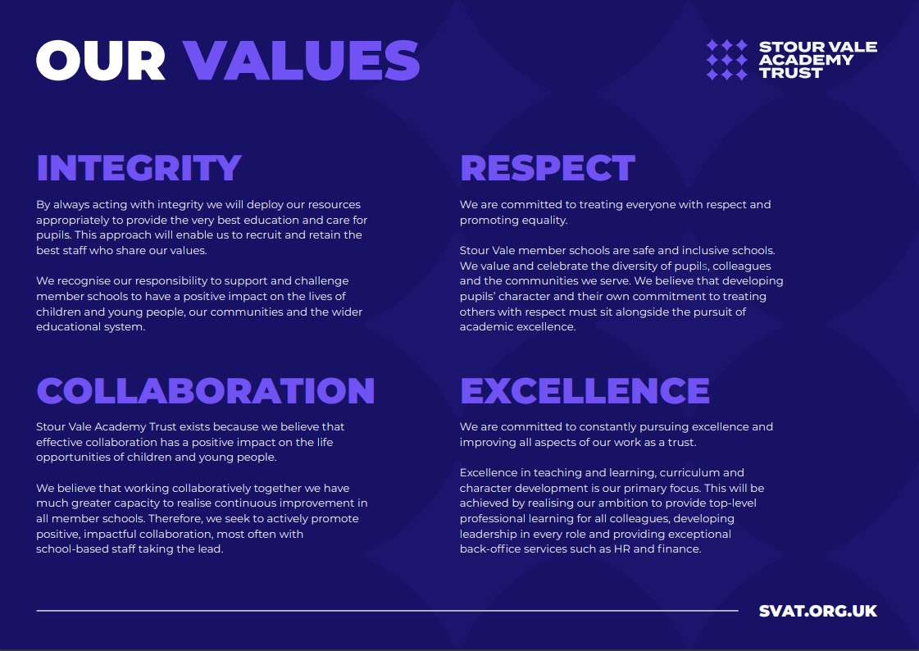

We describe our shared approach to school improvement as ‘secure autonomy’. Headteachers, with school leadership teams and staff, have autonomy to lead school improvement in their own schools, responsively and in collaboration with others within and beyond our trust. We believe that this approach enables us to grow, attract and retain excellent school leaders and to develop the most innovative and impactful school improvement strategies. We recognise that this autonomy must be secured within the structure of the multi-academy trust, and our model of challenge and support for impact, underpinned by our shared values, ensures sustained school improvement and a sharp focus on outcomes for pupils. This in turn realises our ambition that Stour Vale member schools will create the difference together.



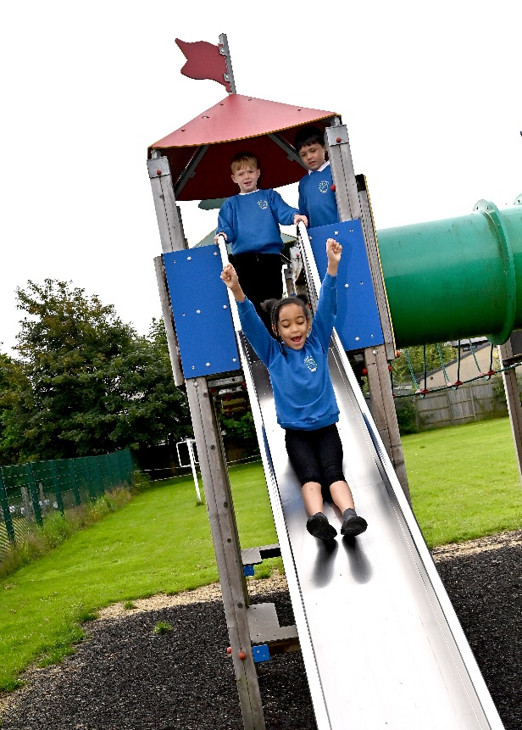


SCHOOL LOGO | Job Description | 
Job Title | Learning Support Assistant (temporary position)
Grade | Grade 3 (SCP3-4)
Responsible to: | SENCO, Phase Leader, or other designated manager
Responsible for: | Not applicable
Working weeks: | Term Time only – Summer Term 2026

Core Purpose:
- Assist in the educational, personal and social development of designated students under the direction and guidance of relevant colleagues (e.g. the Headteacher, SENDCO, phase leaders and class teachers)
- Support students by adopting relevant strategies and techniques to enable them to access the curriculum, engage with their learning and achieve their full potential.
- Implement planned learning activities/ teaching programmes as agreed with the teacher, adjusting activities according to students’ responses as appropriate.
- Deliver measurable impact on pupil attainment as well as social and emotional well-being.
- Work collaboratively with relevant colleagues to fulfil the requirements of the role.
- The duties of the Teaching Assistant will be determined by the Head Teacher, or appropriate senior leader, and will be arranged to meet the needs of the school and pupil(s) being supported. This may involve working in small groups or on a 1:1 basis and may include supporting pupils with an Educational Health Care Plan (EHCP).

Legal and Statutory Requirements
The (job title)’s professional duties must be carried out in accordance with the following:

- The Stour Vale Academy Trust scheme of delegation
- The provisions of all applicable legislation
- Keeping Children Safe in Education (KCSIE)

Main Activities
Supporting Learning
Under the direction of the class teacher, support and supervise pupils undertaking designated activities in a group or on an individual basis and to assist their learning and development by:
- Clarifying and explaining instructions.
- Facilitating the use of appropriate scaffolding for learning
- Mediating language as required
- Implementing specific strategies identified on individual support plans or EHCPs
- Reinforcing relevant aspects of the planned teaching programme, particularly literacy and numeracy.
- Being sensitive to the requirements of all pupils and encouraging their participation and independence.
- Assisting pupils with the appropriate use of materials and resources, including ICT applications.
- Nurturing the development of emotional literacy and social communication skills.
- Encouraging and building pupil resilience and self-esteem
- Undertake structured and agreed learning activities/teaching programmes, adjusting activities according to pupil responses.
- Assist with the development and implementation of individual plans and programmes, including EHCP, IEP and behaviour plans.
- Provide classroom support in the teacher’s absence for short periods of time.
- Support independent learning and inclusion of all pupils and provide feedback to pupils in relation to progress and achievement.
- Support the teacher in behaviour management, effective use of positive behaviour management techniques and strategies with support where required. Encourage pupils to take responsibility for their own behaviour.
- Encourage pupils to interact with others and engage in activities led by the teacher.
- Set challenging and demanding expectations and promote self-esteem and independence.
- Undertake programmes linked to local and national learning strategies e.g. literacy, numeracy,
recording achievement and progress and feeding back to the teacher
- Support the use of ICT in learning activities and develop pupils’ competence and independence in its use.
Resources
- Prepare and clear up the learning environment including displays and the presentation of pupil’s work.
- May handle small amounts of cash e.g. for school visits.
- Photocopying, filing, and preparing resources for lessons as directed by the teacher.
Exams, educational visits and other supervision
- Invigilating exams and tests.
- Escorting pupils on educational visits.
- Assisting with break time supervision including facilitating games and activities.
Personal and welfare support
- Attend to the pupils’ personal needs, and implement related personal programmes, including
social, health, physical, hygiene, first aid and welfare matters, assist pupils with dressing, hygiene and eating whilst encouraging independence.
- Supporting pupils emotional and social well-being, reporting any problems to the teacher.
Systems, policies and procedures
- Contribute to maintaining a safe environment.
- Be familiar with and implement staff codes of conduct and relevant school
policies including those relating to inclusion, behaviour and homework.
- Carrying out the responsibilities of the post with due regard to the Academy’s policies, organisation and arrangements, including (but not exclusively) those relating to Child Protection / Safeguarding, Health and Safety at Work, Data Security & Confidentiality and Equality.
- Responsible for the careful and safe use of equipment.
- Undertake training, networking and professional development as required by the school.
Team involvement
- Demonstrating own duties to new or less experienced staff.
- Performing such other duties as may be required from time to time.
Building relationships
- Establish constructive relationships and communicates with pupils to support learning and development and encourage acceptable behaviour.
- Liaise sensitively and effectively with parents and carers, recognising their roles in pupils’ learning
- Promote the inclusion and acceptance of all pupils, staff and stakeholders.
Record keeping and information management.
- Contribute to basic monitoring, evaluating and assessment of pupil progress.
- Ensure all written and electronic records and reports are accurate, comprehensive and timely.

Other
- Be aware of, and comply with, policies and procedures relating to safeguarding, child protection, health and safety, confidentiality and data protection, recording/ reporting all concerns to the appropriate person and disclosures to the relevant professional.
- Be aware of and support difference and ensure all pupils have equal access to opportunities to learn and develop;
- Contribute to the overall vision and values of Stour Vale Academy Trust;
- Attend and participate in meetings, training and other learning activities and performance development as required;
- Any other duties commensurate with the duties/responsibilities/grade of the post

Duties may vary according to the organisational structure within the school. The structure may include additional posts that are focused on either delivering or supporting the delivery of one or more of the responsibilities outlined above.

The duties above are neither exclusive nor exhaustive and the post holder may be required by the Headteacher/senior leader to carry out appropriate duties within the context of the job, skills and grade. It is the practice of Stour Vale Academy Trust to periodically review job descriptions to ensure that they relate to the job performed and to incorporate any changes. In these circumstances, Stour Vale Academy Trust will seek to reach agreement on reasonable changes but, where agreement is not reached, Stour Vale Academy Trust reserves the right to make changes to the job description, following consultation.

Stour Vale Academy Trust is committed to safeguarding and promoting the welfare of children and young people and expects all staff and volunteers to share in this commitment. As this post meets the requirements in respect of exempted questions under the Rehabilitation of Offenders Act 1974, all applicants who are offered employment will be subject to an Enhanced Disclosure and Barring Service Check (DBS) before the appointment is confirmed. This will include details of ALL cautions, reprimands or final warnings as well as convictions, whether “spent” or “unspent”. Criminal convictions will only be taken into account when they are relevant to the post.

 | Personnel Specification
Job Title | Learning Support Assistant (temporary position)
Grade | Grade 3 (SCP3-4)
Responsible to: | SENCO, Phase Leader, or other designated manager
Responsible for: | Not applicable
Working weeks: | Term Time only – Summer Term 2026

No | Categories | Essential | Desirable
QUALIFICATIONS

1. | NVQ level 2 in Maths and English (or equivalent), and / or qualified or willing to become qualified to Level 2 Teaching Assistant.
2. | training in relevant learning strategies
3. | First Aid training
EXPERIENCE

4. | Experience working with children individually and in groups
5. | Experience of working with children across the range of ages served by the school
6. | Experience with SEND children and challenging behaviour
7. | Experience of running intervention programmes
ABILITIES, SKILLS & KNOWLEDGE

8. | Able to support to pupils’ learning on a one-to-one basis, or in groups, including the provision of specialist support for SEND students, as appropriate.
9. | An understanding of learning and the process of learning
10. | IT and keyboard skills to support learning and allow record keeping.
11. | An understanding of safeguarding
PERSONAL QUALITIES

12. | Ability to relate well to adults and pupils
13. | Ability to organise self and others
14. | A calm, positive nature
15. | Commitment to safeguarding and promoting the welfare of children and young people
16. | Genuine respect for others and desire for equality of opportunity and diversity
17. | Ability to work as part of a team understanding Trust roles and responsibilities and your own position within these
18. | Can-do attitude and solution-focused approach with an ability to manage expectations and not over promise
19. | Have a willingness to demonstrate commitment to the values and ethos of Stour Vale Academy Trust

CONTACT US
For informal talks please contact:
Moat Farm Infant School
Jayne Davis
Telephone: 0121 552 1885

Please visit our website: https://moatfarm-inf.sandwell.sch.uk/

