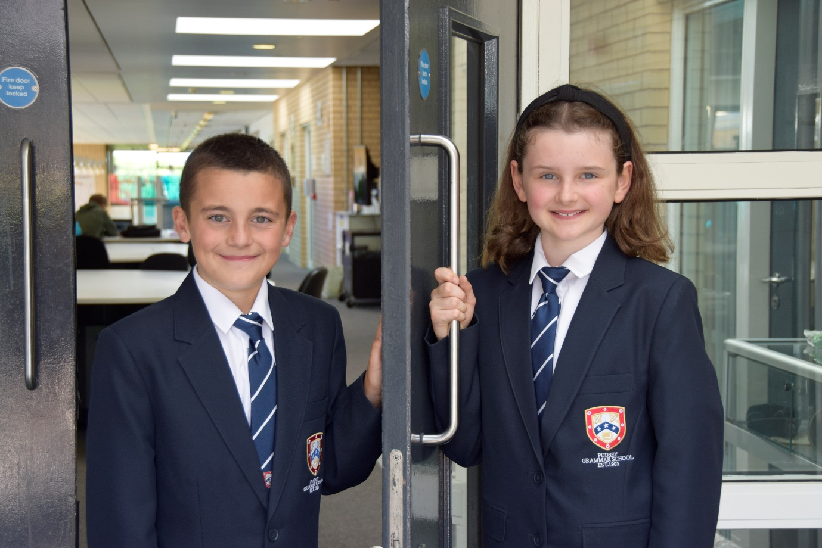

TEACHER OF
ENGLISH

APPLICATION PACK

Finance & Operations Assistant
Pay Scale C3, (19-22)
Salary (£32,061 - £33,699 FTE)
Actual salary £28,989- £30,470

Working pattern:
37 hpw, term time only plus 15 days
8.00am – 4.15pm Monday to Thursday
8.00 – 2.30pm Fridays

Start: As soon as possible

Contents

- Introduction from the Headteacher
- Information on the post
- Job description
- Person specification
- Enhanced disclosure
- School Location and Travel Information

Introduction from the Headteacher
Thank you for the interest you have shown in the post of Finance & Operations Assistant at Pudsey Grammar school.
Pudsey Grammar School is a heavily oversubscribed mixed comprehensive secondary school located in the heart of the market town of Pudsey. Situated between Leeds and Bradford, the town has always valued its independence from its two larger neighbours. The school has a long and proud history stretching back to 1905 and currently has 1350 students with a thriving and expanding Sixth Form of over 250 students, all taught in a state of the art building. The innovative and unique style of the building combined with our excellent standards and expectations has created a calm atmosphere very different to many secondary schools. These high standards allow staff to teach extremely well and students to gain an exceptional education in a safe and welcoming environment.
I was appointed in 2014 and since then we have received a letter from Amanda Spielman (HMCI Ofsted) which stated we ‘have transformed all aspects of the school.’ This assertion was further underlined in 2018 when the increase in our exam results resulted in the school being the most improved school in Leeds and one of the most improved in the country (we were delighted to follow these achievements up with our best ever GCSE exam results in 2019 which were above the national average). The pattern of improvement continued in 2020 with our Year 11 students achieving grades which were outstanding. The school had a highly successful Ofsted inspection in April 2019 and was judged as good in all areas, including our Sixth Form. The school underwent an ungraded inspection in April 2024 which saw, for the first time in the school’s history, a second successive Ofsted judgement of being a good school. This is testament to the consistently high quality of education which the school provides for all of our students and is one of the reasons why we remain one of the most popular schools across the city of Leeds with over 900 applications received for 215 Year 7 places for September 2024.

In 2022 the school was selected to be a national Behaviour Hub school. This was a Department for Education programme led by the Governments’ School Behaviour Advisor Tom Bennett which identifies school who have ‘an exemplary behaviour culture’. We were one of only 20 secondary schools out of 4000 who have achieved this prestigious accolade, and we worked with other schools across the north of England to improve their behaviour cultures.

We have a comprehensive House system which runs across all year groups with over 30 diverse competitions across the year for students and one each half term for staff too. House assemblies take place once every three weeks lead by our four House Leaders. At the end of each academic year, the winning House is awarded our 80-year-old Victor Ludorum Cup

We are aiming to be a Centre of Excellence, and every indicator shows that we will achieve this goal. Continuing to recruit high calibre staff is a key priority of our strategy.

The following quotes are taken from the latest Ofsted report:

- The school is welcoming and pupils respect the differences in other people.
- Safeguarding is very well led and pupils feel safe
- Pupils get on very well with each other
- Teachers have strong subject knowledge
- Pupils behave well in lessons and the vast majority focus on their work
- The school has developed an ambitious curriculum for pupils
- Staff have high expectations of all pupils. The vast majority of pupils rise to these expectations and work hard
- Pupils benefit from the curriculum and are well prepared for their next steps
- The House system plays a central role in the school and provides a sense of belonging. Pupils who earn House ties for their dedication to House competitions wear them with pride
- If bullying happens, pupils are confident that staff will deal with it quickly
The school has a long tradition in the town, being established as Pudsey Grammar School in 1905. Although the school is taught in a state of the art building, our core values of respect, resilience, integrity, compassion and ambition are highly traditional and are based on the goal of ensuring that every student reaches their true potential.
Our school is not just about the students gaining knowledge and qualifications, although these are extremely important. We believe in teaching young people core values of decency, social skills and how to be a good citizen in an ever changing world. We want their character to develop and grow, and for them to leave us with an inquiring and independent mind. We want our students to gain the best qualifications they are capable of whilst experiencing a range of opportunities which are second to none. As a result, the school is extremely popular with our community and is significantly oversubscribed every year.
Our Sixth Form, which is rated as good by Ofsted, has grown rapidly in recent years following significant investment and we now have over 250 Post-16 students studying at Pudsey Grammar. We have ambitious plans to expand this further over the coming years. We also have a strong tradition of ensuring students access the best universities, including Oxford and Cambridge.
Our staff show exceptional dedication and commitment to our students. Relationships in the school are extremely strong and this underpins the ethos of the school. We pride ourselves in the care and support that we give our staff and, as a result, there is a real team spirit in the school where people enjoy being part of our school community. Teaching and learning is the key focus of the organisation and everything that we do is designed to ensure that the classroom experience for the students is excellent. We are currently redesigning our curriculum to ensure that the education we offer is second to none.
We offer fantastic support and professional development to staff, which ensures that they are equipped with all the necessary skills to deliver excellent lessons to the students on a daily basis.

The school is a Foundation Trust school, and our partners include global companies such as M&S; HSBC bank, alongside leading local business and training provider, Appris. These high-quality links allow our school to offer excellent careers opportunities to students across the ability range. As a result, the school has 0% NEETs at Year 11.

We are currently part of The Leeds Teaching HUB, which is providing outstanding opportunities and CPD for all our staff. Subject Leaders attend their Collaborative Learning Groups, which allows them to network and share best practice. This is further disseminated through the school via regular Department meetings and weekly Teaching & Learning briefings.

This clearly is an exciting time to join our school.

If you have a desire to be part of one of the most exciting and rewarding schools to work in, which will also provide you with excellent development opportunities, please complete the application form. Any further details can be obtained directly from the school's HR Team: recruitment@pudseygrammar.co.uk) or our website www.pudseygrammar.co.uk

Mark McKelvie
Headteacher

Pudsey Grammar School

Pudsey Grammar School
Pudsey Grammar School is a thriving secondary school and sixth form educating students aged 11-18. Established in 1905, our school boasts a long and proud history combined with a modern, state-of-the-art building designed to inspire learning and achievement. We are heavily oversubscribed with 1,350 students in the main school and 250 in the sixth form.
Rated Good by Ofsted in 2024, we were proudly selected as a National Behaviour Hub School in 2022. As part of the Leeds Teaching Hubs, we offer outstanding opportunities for continuing professional development (CPD), enabling our staff to grow and thrive in their careers. At Pudsey Grammar, we are committed to fostering a supportive and dynamic environment where both students and staff succeed.
Details of advert

Job Title: Finance & Operations Assistant
Hours and working pattern: 37 hpw, Term-time + 15 days, Monday to Thursday 8.00am – 4.15pm and Friday 8.00am – 2.30pm
Grade: C3 point 19-22
Salary: £32,061 - £33,699 FTE (£28,989 - £30,470 Actual)
Start date: ASAP

We are looking to appoint an exceptional individual to join our Finance team as soon as possible as a Finance & Operations Assistant.

To support the finance and operations functions of the school, including payroll processing, purchasing, premises administration, compliance administration, and operational support.
Applicants will need to demonstrate:
- A commitment to the department’s role in the overall School Improvement Plan
- An inspiring, encouraging and positive outlook
- An enjoyment of working with young people and a determination to make a real difference
- A commitment to:
  - Working in line with statutory safeguarding guidance (e.g. Keeping Children Safe in Education, prevent and our safeguarding and child protection policies)
  - Working with the designated safeguarding lead (DSL) to promote the best interests of students, including sharing concerns where necessary
  - Promoting the safeguarding of all students in the school

Why work at Pudsey Grammar School?

- Be part of a rapidly improving school
- Work for an organisation which has staff wellbeing as its core
- Embrace the opportunity to play a key part in the continuing transformation of the school
- Be part of a dynamic and enthusiastic team of staff who are ensuring our students are successful in every way
- Work alongside hub-schools in the Yorkshire and Humber region and University College London, with access to high quality Teaching and Learning training, networking events, CPD
- Belong to a supportive organisation which prides itself on high standards for staff and students
- Work in an award-winning state of art building

This school is committed to safeguarding and promoting the welfare of children and expects all staff and volunteers to share this commitment. Appointments will be subject to an enhanced DBS disclosure. If shortlisted, you will be required to disclose relevant information regarding criminal history and an on-line search will be conducted. This includes only information publicly available on-line.
The employee may be subject to rechecking as required from time to time.

We promote diversity and want a workforce that reflects the population of Leeds.
All appointments are subject to satisfactory references.
Employment is conditional on confirmation of the right to work in the UK – either as a UK or Irish citizen, under the EU Settlement scheme or having secured any other relevant work visa. If you do not have the right to work in the UK and the role does not meet eligibility for sponsorship, please consider carefully whether you meet the eligibility to apply for this position.

Application Process
Should you wish to apply for this position, please see below:
- Please be aware that we do not accept Curriculum Vitaes.
- Application form and full job description can be found on the school website: www.pudseygrammar.co.uk vacancies – My New Term link
Closing date for applications: Monday 20th April at 8.00am
Successful candidates will be contacted directly with details of the interview.
Interview date: Tuesday 28th April 2026

Job Description:

Job Title | Finance & Operations Assistant
Post Purpose: | To support the finance and operations functions of the school, including payroll processing, purchasing, premises administration, compliance administration, and operational support.
Reporting to: | Director of Operations
Working time/working pattern: | 37 hours per week, term-time plus 15 days  8.00am-4.15pm Monday to Thursday  8.00am to 2.30pm Fridays  There will be a requirement to attend staff training and departmental meetings as required which may fall outside of the set hours.
Salary/Grade: | C3, point 19 - 22  £32,061 - £33,699 FTE  £28,989- £30,470 Actual Salary
Main (Core) Duties:
Finance Administration | - Process purchase orders  - Process invoices  - Deal with supplier queries  - Maintain finance records  - Assist with budget monitoring  - Support audit and finance processes  - Assist with lettings administration and invoicing  - Under direction of the Director of Operations, support with maintaining the asset records  - Assist Finance Lead with maintenance of cashless income system.
Payroll | - Input payroll changes  - Under direction, support with the preparation and reconciliation of monthly payroll reports  - Support with the maintenance of payroll records  - Liaise with HR regarding payroll changes  - Ensure deadlines are met
Premises & Estate Administration | - Administer the premises email inbox and log issues with Mitie when required.  - Liaise with PFI/site team regarding day-to-day issues  - Monitor the school calendar for premises implications and be the point of contact to ensure effective planning of school events  - Maintain estates records  - Provide administrative support for PFI contract and estates projects  - Maintain compliance records  - Track statutory compliance checks
Contracts and Procurement Support | - Support the Finance Lead with maintaining the contracts database  - Support the Finance Lead with tracking and monitoring contract renewal dates  - Support procurement and tender processes  - Provide support to maintain supplier records as required
General Operations Support | - Support operational projects  - Maintain operational records and systems  - Support Director of Operations and Finance Lead  - Support school operational planning
Health & Safety and Compliance | - Maintain compliance trackers  - Support health and safety administration  - Under direction of the Director of Operations, support with updating the school’s risk register  - Support audits and inspections
Manage own conduct, performance and characteristics | - Develop effective professional relationships with others.  - Attend and participate in relevant meetings as required.  - Participate and engage in training and appraisal as required.  - Undertake additional duties as reasonably requested by senior staff.
Relationships | - The post-holder will be required to work flexibly to deliver an efficient Service  - There will be regular contact with pupils, colleagues, other members of staff, line managers and internal and external customers
Safeguarding | - To work in line with statutory safeguarding guidance (e.g. Keeping Children Safe in Education, prevent and our safeguarding and child protection policies)  - To work with the designated safeguarding lead (DSL) to promote the best interests of students, including sharing concerns where necessary  - To promote the safeguarding of all students in the school.
Physical conditions | - The post is based at Pudsey Grammar School  - The school is accessible by stairs and lift and is available by disabled persons to the ground floor by a portable ramp on request  - This post is subject to an enhanced Disclose and Barring Service check  - The school operates a non-smoking policy
Prospects | Whilst there is no automatic progression to any more senior posts, opportunities do exist for advancement and promotion, dependent upon normal staff movements and on the capabilities of the individual post holder.
Training | The school encourages training both “in-house” and external to meet the needs of the individual and of the Service.
Any Special Conditions of Service: No smoking policy
This job description is to assist staff joining Pudsey Grammar School to understand and appreciate the work content of their post and the role they are to play in the organisation.

Whilst every endeavour has been made to outline the main duties and responsibilities of the post, a document such as this does not permit every item to be specified in detail. This job description is not a definitive list of responsibilities but identifies the key components of the role. The post holder will, therefore, be required to undertake other reasonable duties commensurate with the purpose and salary level of this post.

Employees should not refuse to undertake work, which is not specified on this form, but they should record any additional duties they are required to perform, and these will be taken into account when the post is reviewed.

All new appointments of support staff are made subject to the satisfactory completion of a six-month probationary period.
Statement:
Pudsey Grammar School is an equal opportunities employer and requires its employees to comply with all current equality policies both in terms of equal opportunity for employment and access to the school’s services.

We promote diversity and want a workforce which reflects the population of Leeds.

April 2026

Person Specification

SKILLS | Ess | Des
Able to communicate effectively with a wide range of people and build positive relationships with colleagues | *
Exceptionally strong organisational skills | *
Excellent all-round IT skills (Excel, Word) | *
Excellent numeracy skills | *
Excellent attention to detail | *
Ability to manage and prioritise multiple tasks | *
Ability to work independently | *
Excellent problem solving and analytical skills | *
Ability to meet competing deadlines | *
KNOWLEDGE/QUALIFICATIONS | Ess | Des
GCSE or equivalent (Grade C or above) in Maths and English | *
Exceptionally strong organisational skills | *
Knowledge of health and safety administration |  | *
EXPERIENCE | Ess | Des
Experience of working as part of a team | *
Experience in administration or finance role/payroll | *
Experience in school environment |  | *
Experience of working in a secondary school setting |  | *
Experience of procurement or contracts administration |  | *
Experience in premises or compliance administration |  | *
BEHAVIOURAL AND OTHER RELATED CHARACTERISTICS | Ess | Des
Willing to abide by the Council’s Equal Opportunities Policy in the duties of the post, and as an employee of the Council. | *
Willing to carry out all duties having regard to an employee’s responsibility under the Council’s Health and Safety Policies | *
To display a responsible and co-operative attitude to working towards the achievement of the school’s aims and objectives | *
An ability to respect sensitive and confidential work. | *
Commitment to own personal development and learning. | *
Able to respond flexibly to meet daily demands of the role, showing independence and being proactive | *
Able to work collaboratively with the wider Student Support Team | *
A willingness to become involved in the wider aspects of the school |  | *

We are committed to safeguarding and promoting the welfare of our pupils and expect all staff and volunteers to share this commitment.

School Location and Travel Information

Pudsey Grammar School
Mount Pleasant Road
Pudsey
Leeds
LS28 7ND

Tel: 0113 2558277

www.pudseygrammar.co.uk
Instagram/Twitter/Facebook - @PudseyGS

