


Premises Assistant
South Axholme Academy & Epworth Primary Academy

Candidate
Information Pack
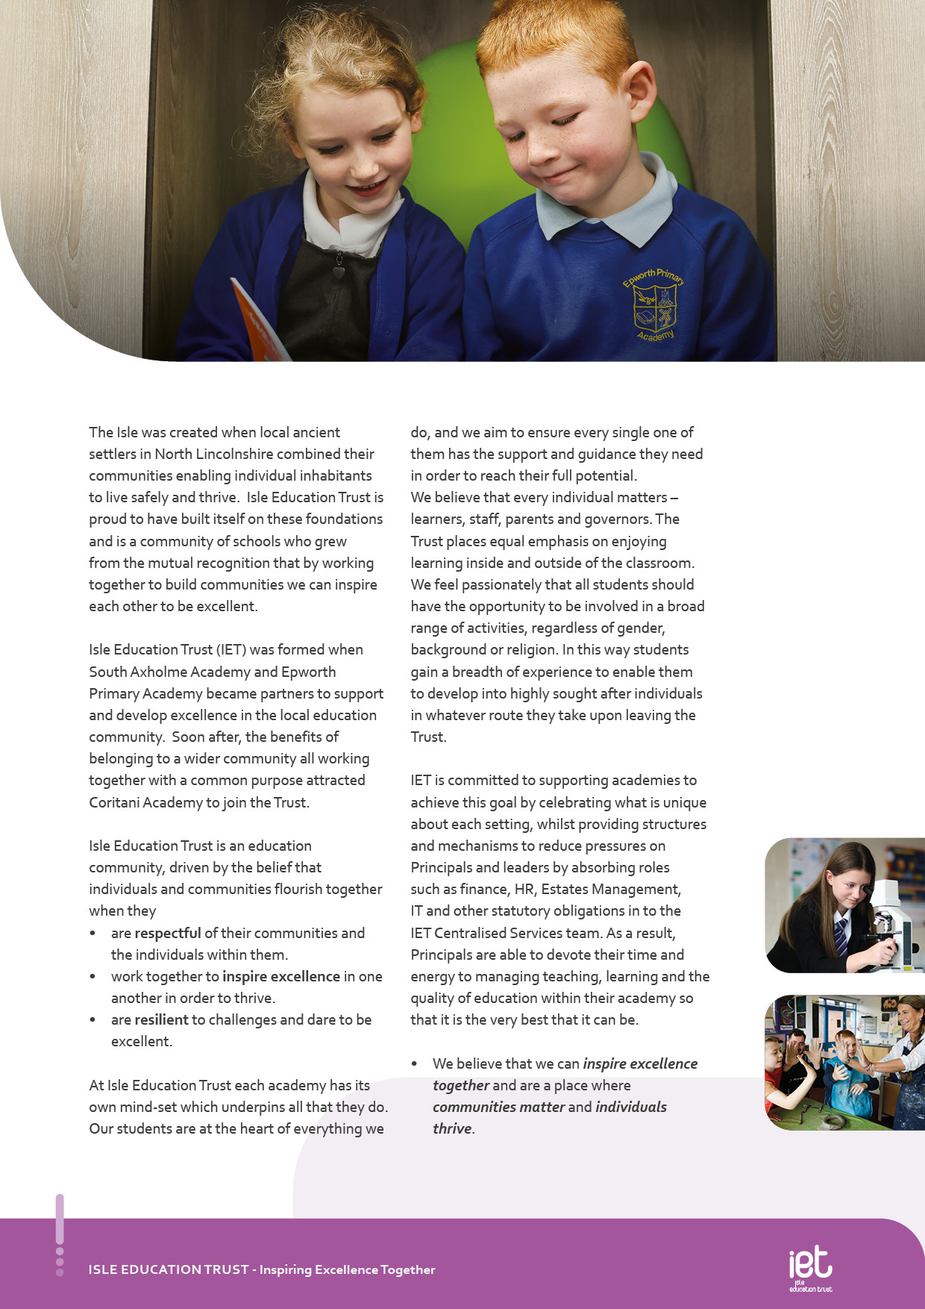
About IET

Welcome from the Chair of Trustees
Dear Applicant

Thank you for your interest in Isle Education Trust (IET) and particularly the role of Governance & Compliance Professional.

IET is a small MAT which formed in 2013. It consists of 6 academies – South Axholme Academy (11-16), Epworth Primary Academy (3-11) and Coritani Academy (an Alternative Provision Academy 7-18), Alkborough Primary Academy, Kirton Lindsey Primary Academy and Burton upon Stather Primary Academy. The Trust was created to protect local education for local communities and to enable like-minded people to work together to provide the very best support and opportunities for all concerned.

We are highly successful in all that we do and work with a variety of partners both locally and further afield. We place a great deal of importance on ensuring individuals are supported and encourage everyone to be the best that they can be, whether that’s students, staff, governors or parents.

We are seeking a Governance & Compliance Professional who shares our vision and values, someone who wants to be part of a passionate and driven team of individuals, both at academy and Trust level.

I hope that the information in this pack gives you a sense of who we are and what we are about and spurs you on to apply for this role.



Paul Barratt
Chair of Trustees
Isle Education Trust


Dear Prospective Colleague,
Thank you for your interest in joining Isle Education Trust. I’m delighted that you are considering becoming part of our team—whether you’re looking to support students directly or contribute to the vital work that happens behind the scenes, your role matters deeply to us.
At Isle Education Trust, our vision is clear: Inspiring Excellence Together. Across our family of academies, we recognise that excellence doesn’t happen by chance—it’s built by a committed, skilled, and diverse team working together with shared purpose.
Our non-teaching colleagues are the backbone of our success. From safeguarding and administration to site management, finance, pastoral support, and everything in between, you help shape the culture and daily experience of our schools. Your expertise keeps our academies running smoothly, our environments safe and welcoming, and our pupils supported every step of the way.
We are proud to uphold values that guide our Trust:
- Respect – shown through honesty, consistency, and care.
- Resilience – demonstrated in our commitment to excellence, even in the face of challenge.
- Inspiration – sparked by individuals who lead by example and empower others to thrive.
When you join our team, you’ll find a community where your contributions are valued, your development is supported, and your wellbeing is prioritised. We offer professional learning opportunities, a culture of collaboration, and a genuine commitment to making our academies great places to work.
If you share our belief that every role within education is a chance to make a difference, I warmly invite you to explore opportunities across the Trust. We’d be thrilled to welcome you into our mission of inspiring excellence—together.
Warm regards,



Sarah Sprack
CEO, Isle Education Trust
Welcome from the CEO

Job Purpose

To proactively support the Premises Manager in the operational management and maintenance of the above sites, ensuring that they meet current Health and Safety and compliance regulations, whilst also providing a positive teaching and learning environment for all.

The Premises Assistant reports to the Premises Supervisor

Job Title Premises Assistant

Salary | £25,683FTE
Job Details | 37 hours per week  06:00 – 14:00  Monday – Friday  Permanent  Full training will be provided.
Location | South Axholme Academy and Epworth Primary Academy
Required | As soon as possible
Application Close | 11th May 2026
Interview Dates | TBC

Job Description


- Carrying out minor repairs to property, fixtures, fittings and equipment, which are not beyond the scope of an unskilled handyman.
- Carrying out repairs, to include plumbing, redecorating and joinery/fixings
- Key holder – responsible for opening and closing of the site when required
- Be a registered key holder and a point of contact in an emergency
- Be available for out of hours’ lettings for such as school events and allow contractors access to site
- Maintaining records of repair, maintenance and compliance as directed
- Operate and respond appropriately to alarm equipment, fire, intruder and operating systems.
- To carry out compliance testing and other weekly/monthly checks and maintain records
- Responsible for heating – day to day management of boilers etc. e.g. maintenance of appropriate temperature, checking of plant/equipment
- Porterage of equipment e.g. delivering parcels, moving furniture and equipment
- To carry out minor ground’s maintenance tasks as necessary
- To carry out ad hoc cleaning duties as needed, such as due to a spillage
- To report any cleaning issues to the cleaning manager and share operational information
- Ensuring that external rubbish is stored appropriately and safely
- Setting up of equipment and resources as requested
- Actively support the Trust in its sustainability aims and recycling initiatives
- Report any defects of the buildings, furniture, fittings and equipment to the Estates Supervisor or the Head of Operations in their absence.
- Monitor contractors to ensure health and safety compliance
- Keep paths, entrances free of rubbish, debris, ice and snow to ensure the safety of children, parents, staff and visitors.
- Read Gas, Electric and Water metres as required.

Key Responsibilities and Accountabilities


INTERVIEWS:
Thursday 13th June 2024
CLOSING DATE:
Tuesday 11th June 2024 at 9:00am
- Work with all students ensuring equality of opportunity for all.
- Take responsibility for Safety and Welfare of all students, raising any concerns following the Academy/Trust protocols and procedures.
- Work proactively and effectively in partnership with all stakeholders.
- Carry out a share of statutory supervisory duties.
- Treat students with dignity and build relationships rooted in mutual respect and at all times observing proper boundaries appropriate to the professional position.
- Participate in CPD relevant to the role.
- Accompany teaching staff and students on visits, trips and out of school activities as required.
- Demonstrate an understanding of and take responsibility for promoting high standards of literacy including the correct use of spoken English and numeracy.
- Participate in arrangements for examinations and assessments.
- Take an active role in promoting good behaviour in and around the Academy/Trust.
- Ensure that students adhere to the uniform code and apply sanctions when this code is breached.
- Develop an academy learner mind-set – the attitudes, skills and learning habits needed to become an inspired, confident and independent learner.
- Be a positive role model and demonstrate consistently and effectively the positive attitudes, values and behaviour which are expected of students.
- Work as a team member and identify opportunities for working with colleagues and sharing the development of effective practice with them.
- Regularly review the impact of their work and its impact on students’ progress, attainment and well-being, refining approaches where necessary and responding to advice and feedback from colleagues.
- Proactively participate with arrangements made in accordance with the Appraisal Policy.
- Have professional regard for the practice, ethos and policies of the Academy/Trust and maintain high standards in your own attendance and punctuality.
- Operate at all times within the stated policies and practices of the Academy/Trust.
- Contribute positively and effectively to the whole Academy/Trust ethos.
- Cooperate with other staff members to ensure a sharing and effective use of resources to the benefit of the Academy, individual departments and students.
- Attend and participate in appropriate calendared meetings.
- Take responsibility for own professional development and duties in relation to Academy policies and practices.
- Liaise effectively with staff, students, parents and governors.
- Ensure compliance with Health and Safety at Work Act 1974 and all other policies related to health and safety, and to ensure compliance with the Data Protection Act 1988.
- Ensure compliance with data protection laws and safeguarding procedures.
- Carry out any other duties as directed by your Line Manager as may from time to time be agreed in accordance with the nature of the job described above.

We expect all Trust staff to:

This is not an exhaustive list of tasks and job descriptions will be continually reviewed and changed according to the needs of the Trust.

Post holders will be expected to be flexible in undertaking duties and responsibilities attached to their post and may be asked to perform duties, which reasonably correspond to the general character of the post and are commensurate with its level of responsibility. This job description is provided for guidance only and does not form part of the contract of employment.


Person Specification:

Professional knowledge, skills and understanding | Essential | Desirable
Ability to work both as a member of a team and on own and to deal with any unexpected problems that may arise | A I
GCSE Maths and English, grade C or above | A
Experience in an estates and facilities management role | A I
Ability to relate well to children and adults | A I
Good computer literacy | A I
Ability to work in an organised and methodical manner | A I
Ability to complete tasks to desired standards and to work to time constraints | A I
Knowledge of Health & Safety regulations relating to Estates function | A I
IOSHH qualification |  | A
Display a conscientious and logical approach to the variety of tasks necessary for the smooth and efficient running of the academy | A I
Knowledge of Estates Management and Health & Safety | A I
Experience | Essential | Desirable
General understanding of academy policies and procedures relating to health and safety, behaviour, attendance, equal opportunities and child protection | A I
First Aid Trained |  | A I
Experience of working with young people |  | A I
Experience and understanding of completing Risk Assessments | A I
Practical Skills | Essential | Desirable
Flexible approach to work as well as good organisational and communication skills | A I
Ability to work collaboratively and effectively within a team | A I
Ability to work independently and to show initiative | A I
Ability to work under pressure, prioritise and meet deadlines | A I
Friendly, approachable and non-confrontational manner combined with the ability to be firm | A I

KEY
A = assessed through the application process
I = assessed through the interview process

Personal Qualities and Essential Attributes |  |  | Essential |  | Desirable
A professional approach in both manner and physical appearance |  |  | I
Ability to demonstrate discretion, confidentiality and commitment |  |  | I
 | Enthusiasm, determination and insistence on high standards |  | I
 | A proven track record of excellent attendance and punctuality |  | I
 | Ability to work with or without supervision |  | A I
 | Commitment to safeguarding and promoting the welfare of children and young people |  | A I
 | High Expectations of Self and Others | Essential |  | Desirable
 | A flexible and adaptable approach | A I
 | Safeguarding Students | Essential |  | Desirable
 | Committed to safeguarding and promoting the welfare of children and young people | I
 | Equal Opportunity | Essential |  | Desirable
 | The ability to ensure that there is equality of access to educational attainment and that all aspects of equal opportunities are adhered to | I



 Pension Scheme
All staff are enrolled in either the Teachers’ Pension Scheme or Local Government Pension Scheme, whichever is relevant.
 Continuous Professional Development
IET offers numerous opportunities for continued CPD for all staff including NPQs and apprenticeships

 Cycle to Work Scheme
Eligible staff may apply to purchase a new bike, e-bike or cycling accessories through this salary sacrifice scheme, making significant savings.

 Staff Wellbeing
This is a priority for the Trust. All staff have access to a free Employee Support Package, including 24/7, 365 days a year online and telephone support covering areas such as mental health, bereavement, financial advice and counselling.

 Healthcare
All staff have free access, 24/7, 365 days a year to an online doctor.

 Flu Vaccinations
All staff are able to request a free voucher for a flu vaccination in the Autumn term.

 Discounts
Through our employee benefits platform, staff can make significant savings through discounts and vouchers in a range of areas including restaurants, supermarkets, retail and holidays.

.
c
Trust Benefits:


Appointment Process
How to apply
To apply for this post, visit the IET website:

Isle Education Trust - Vacancies

Receipt of early applications from candidates with the appropriate experience, qualifications and personal qualities may result in an early interview being offered.

Isle Education Trust promotes equality of opportunity and welcomes applications from all sectors of society.

Isle Education Trust is committed to safeguarding and promoting the welfare of children and expects all staff and volunteers to share this commitment. All posts at Isle Education Trust are subject to an Enhanced Disclosure and Barring check.

