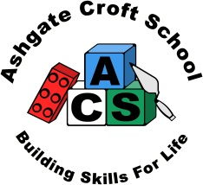
Ashgate Croft School
Person Specification

Job Title | 1:1 Specialist Teaching and Learning Assistant | Job Grade | 8

 | Essential | Desirable | Assessed through
Qualifications  Relevant qualification, level 2 or higher  GCSE or equivalent in English Grade C or above |  |  | A  A
Experience  Appropriate and significant experience of working with children with special educational needs  Contribute to the planning, delivery and assessment of educational work and activities |  |  | A/I/R  A/I/R
Knowledge  Child Protection and appropriate Health and Safety Regulations  Behaviour support  Equal Opportunities |  |  | A/I  A/I  A/I
Skills  Good literacy and numeracy skills  Good communication skills  Good interpersonal skills |  |  | A/R  I/R  I/R
Attributes  Ability to work with children in a learning environment  Ability to work on own initiative  Ability to work as part of a team  Ability to participate actively in physical activities including: swimming and outdoor pursuits  Able to move and handle pupils, attend to their personal care needs and to use physical intervention within the school’s policies |  |  | A/I/R  I/R  I/R  I  I
Factors not already covered
Must be able to perform all duties and tasks with reasonable adjustment, where appropriate, in accordance with the provisions of Disability Discrimination Act 2010.

Key:
A | Application
I | Interview
R | Reference

Ashgate Croft is committed to safeguarding and promoting the welfare of children and young people and expects all staff and volunteers to share this commitment This post will be subject to satisfactory references and enhanced DBS clearance

