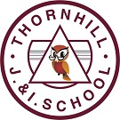

Candidate information pack

Welcome from Jen Rylance, the Headteacher, Thornhill Junior & Infant School.

Dear applicant,

Thank you for taking an interest in the teacher vacancy at Thornhill Junior and Infant School.

Our popular School is situated in the village of Thornhill, Dewsbury, West Yorkshire, serving a large residential area of private and local authority housing. The school's planned admission number is 420 and the school’s admission limit is 60 per year group. The number of children on roll currently stands at 360. Approximately 46% of our children are entitled to free school meals, 15% have Special Educational Needs and 5% come from homes where English is not their first language.
Our school is popular with local families and has a reputation for being friendly and welcoming. There are good links with the local community through various activities and we enjoy positive relationships with neighboring schools as part of the Dewsbury Learning Partnership.
Key messages from our most recent Ofsted report in 2024:
- At Thornhill Junior and Infant School, pupils are happy and grow in confidence. They show curiosity in their learning. Pupils build their self-esteem in a safe and positive atmosphere.
- The school maintains a calm and orderly environment. Pupils behave respectfully both in and outside the classroom. They follow instructions, engage well in group discussions and listen to each other.
- The school prepares pupils well for life in modern Britain. It adapts the curriculum expertly to broaden pupils’ horizons. They are taught and remember essential life skills. Pupils learn how to stay safe and make empowered choices.
- The school offers a broad and ambitious curriculum. Pupils’ respectful and engaged behaviour contributes to their progress across the curriculum. They are well prepared for the next stage of their education.
- The school identifies, assesses and meets the needs of pupils with special educational needs and/or disabilities well. They are fully immersed in this inclusive curriculum, supported by trained staff who provide both academic and emotional assistance.
- Pupils’ personal development and cultural awareness are expertly enriched by tailored curriculum decisions. For example, the extensive music offer allows pupils to learn about a range of musicians from different cultures.
- Pupils understand equality and advocate for fairness. These experiences help pupils become independent, compassionate and well-rounded individuals. They articulate their thoughts clearly and express themselves with maturity. Pupils are ambitious for their future.
- Leaders support staff well-being and workload. The trust and school ensure that staff, including early-career staff, receive the professional development that they need. Leaders at all levels provide effective wraparound support and challenge.

I am extremely proud to be the Headteacher at Thornhill Junior and Infant School and believe it is a rich and vibrant place to learn and work. I would be very happy to answer any questions that you may have.
We hope that you will find this information pack helpful in finding out more about this post. You are very welcome to make an appointment to visit the school and meet with me. Please contact the school office on 01924 453259, to make an appointment.
If you would like a further conversation about any aspect of this post or about working as part of Focus-Trust, please do not hesitate to email thornhill@focus-trust.co.uk or contact the school office who will arrange a telephone call.
Please contact us if you require any further information.
Jen Rylance
Headteacher



Welcome from Paul Spencer, Chair of Governors

Dear applicant,

Thank you for taking the time to consider applying for the post of teacher at Thornhill Junior and Infant School. As Chair of the Governing Body, I would like to take this opportunity to tell you a little bit about the context of our school.

Thornhill Junior and Infant School is a two-form entry school, situated in Thornhill on the outskirts of Dewsbury, West Yorkshire. We have PAN of 420 primary aged pupils with an admission limit of 60 pupils per year group. A small percentage of pupils come from homes where English may not be the first language.

We are proud to be part of the Focus Academy Trust and recognise the value of support, ethos, challenge, and collective efficacy embodied within the trust.

This is a very friendly school where children are happy, and staff work exceptionally well as part of a team. The large staff of teachers and teaching assistants are led by a dedicated, highly respected Senior Leadership Team.

There are 15 spacious and well-equipped classrooms. The school has a large hall which is used as a gymnasium, dining room and assembly hall. Our school is surrounded by secure playgrounds and a large, grassed area which includes an orchard. The building is a mixture of old and new and there has been much renovation and interior development over the last five years.

We offer a wide range of extra-curricular activities and clubs, and the school is renowned as a lead in music provision.

Parents are made very welcome in the school and provide much valuable support; they run the ‘Friends of Thornhill’ group which organises social and fund-raising activities.
Our school is popular with local families and has a reputation for being friendly and welcoming. There are good links with the local community through various activities and positive relationships with neighboring schools, including the local High School.

I hope I have given you a flavor of Thornhill Junior and Infant School and that it makes you feel that you would like to become a part of our school community.

Yours sincerely,

Paul Spencer
Chair of the Governing Body

3

Academy details
Address Thornhill Junior & Infant School
Edge Lane
Thornhill
Dewsbury
West Yorkshire
WF12 0QT

Telephone 01924 453259
Website www.thornhilljischool.co.uk

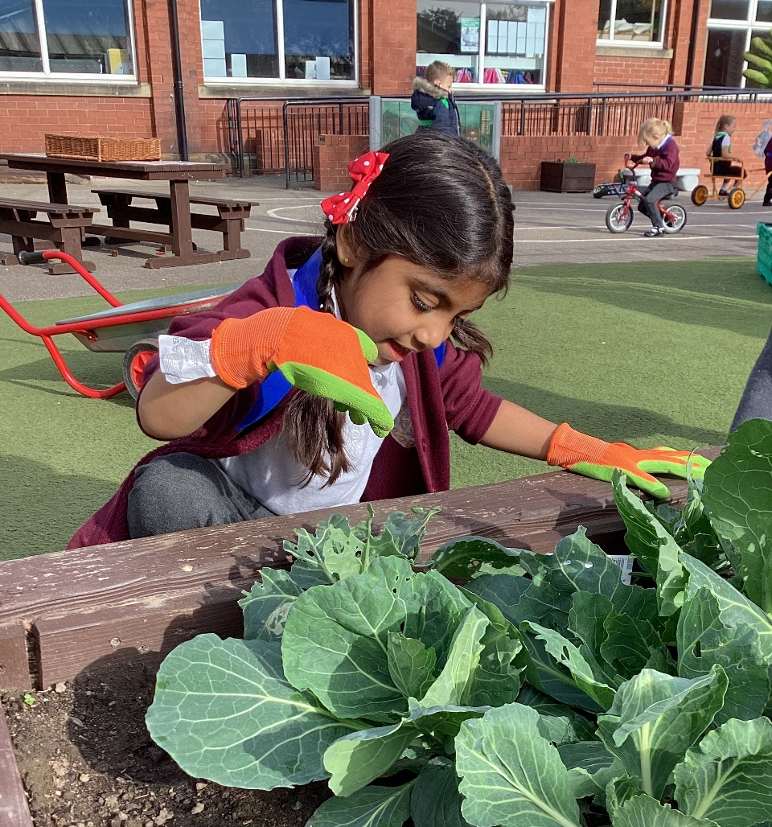

Job Description

School/Academy | Thornhill Junior and Infant School
Job title | Teacher
Accountable to | Headteacher
Line manager | Key Stage Leader/Assistant Headteacher

Introductory statement
The responsibilities and professional duties of the post are to be performed in accordance with the provisions of the most recent version of the Teachers’ Standards.

Teachers make the education of their pupils their first concern, and are accountable for achieving the highest possible standards in work and conduct. Teachers act with honesty and integrity; have strong subject knowledge, keep their knowledge and skills as teachers up-to-date and are self-critical; forge positive professional relationships; and work with parents, colleagues and external agencies in the best interests of their pupils.

Purpose of the role
To ensure all pupils achieve high standards of learning and well-being.

Main duties

Set high expectations which inspire, motivate and challenge pupils
- Establish a safe and stimulating environment for pupils, rooted in mutual respect
- Set goals that stretch and challenge pupils of all backgrounds, abilities and dispositions
- Lead by example and demonstrate consistently the positive attitudes, values and behaviour which are expected of pupils

Promote good progress and outcomes by pupils
- Be accountable for pupils’ attainment, progress and outcomes.
- Plan teaching to build on pupils' capabilities and prior knowledge.
- Guide pupils to reflect on the progress they have made and their emerging needs.
- Demonstrate knowledge and understanding of how pupils learn and how this impacts on teaching.
- Encourage pupils to take a responsible and conscientious attitude to their own work and study.

Demonstrate good subject and curriculum knowledge
- Have a secure knowledge of all curriculum areas, foster and maintain pupils’ interest in the subject, and address misunderstandings.
- Demonstrate a critical understanding of developments in curriculum areas, and promote the value of learning and scholarship.
- Demonstrate an understanding of and take responsibility for promoting high standards of literacy, articulacy and the correct use of Standard English, whatever the teacher’s specialist subject.
- Demonstrate a clear understanding of the teaching of systematic synthetic phonics, reading and the teaching and application of basic skills.
- Demonstrate a clear understanding of the teaching of mathematics and the application of basic skills.

Plan and teach well-structured lessons
- Impart knowledge and develop skills and understanding through effective use of lesson time.
- Promote a love of learning and children’s intellectual curiosity.
- Set and assess homework and plan other out-of-class and enrichment activities to consolidate and extend the knowledge and understanding pupils have acquired.
- Reflect systematically on the effectiveness of lessons and approaches to teaching.
- Contribute to the review, design and provision of an engaging curriculum.

Adapt teaching to respond to the strengths and needs of all pupils
- Know when and how to differentiate appropriately, using approaches which enable pupils to be taught effectively.
- Have a secure understanding of how a range of factors can inhibit pupils’ ability to learn, and how best to overcome these.
- Demonstrate an awareness of the physical, social and intellectual development of children, and know how to adapt teaching to support pupils’ education at different stages of development.
- Make effective use of resources (including other adults) to impact on pupil learning and progress.
- Have a clear understanding of the needs of all pupils, including those with special educational needs; those of high ability; those with English as an additional language; those with disabilities; and be able to use and evaluate distinctive teaching approaches to engage and support them.

Make accurate and productive use of assessment
- Undertake formative, summative and statutory assessments in line with the Academy’s policy and assessment calendar.
- Make use of formative and summative assessment to plan for and secure pupils’ progress.
- Use data to monitor progress, set targets, and plan subsequent lessons.
- Give pupils regular and timely feedback, both orally and through accurate marking, and encourage pupils to respond to the feedback.
- Prepare and present written and verbal reports for parents and carers.

Manage behaviour and resources effectively to ensure a good and safe learning environment
- Have clear rules and routines for behaviour in classrooms, and take responsibility for promoting good and courteous behaviour both in classrooms, around the academy and when learning off-site, in accordance with the Academy’s behaviour policy.
- Have high expectations of behaviour, and establish a framework for discipline with a range of strategies, using praise, sanctions and rewards consistently and fairly.
- Manage classes effectively, using approaches which are appropriate to pupils’ needs in order to involve and motivate them.
- Maintain good relationships with pupils, exercise appropriate authority, and act decisively when necessary.
- Ensure the learning environment is kept well ordered, tidy and free from hazards.

Fulfill wider professional responsibilities
- Make a positive contribution to the wider life and ethos of the Academy and the Trust.
- Develop effective professional relationships with colleagues, knowing how and when to draw on advice and specialist support.
- Deploy support staff and other adults in a support role effectively.
- Liaise with external agencies with regard to pupil progress, safety and welfare.
- Take responsibility for improving teaching through appropriate professional development, responding to advice and feedback from colleagues and external advisers.
- Work with other staff across the Trust and in other maintained schools.
- Communicate effectively with parents with regard to pupils’ achievements and well-being.
- Lead an area or strand of school improvement (excl NQT).

Personal and professional conduct
A teacher is expected to demonstrate consistently high standards of personal and professional conduct. The following statements define the behaviour and attitudes which set the required standard for conduct throughout a teacher’s career.

- Teachers uphold public trust in the profession and maintain high standards of ethics and behaviour, within and outside the Academy, by:
- treating pupils with dignity, building relationships rooted in mutual respect, and at all times observing proper boundaries appropriate to a teacher’s professional position;
- having regard for the need to safeguard pupils’ well-being, in accordance with statutory provisions;
- showing tolerance of and respect for the rights of others;
- not undermining fundamental British values, including democracy, the rule of law, individual liberty and mutual respect, and tolerance of those with different faiths and beliefs; and
- ensuring that personal beliefs are not expressed in ways which exploit pupils’ vulnerability or might lead them to break the law.
- Teachers must have proper and professional regard for the ethos, policies and practices of the Academy and the Trust, and maintain high standards in their own attendance and punctuality.

- Teachers must have an understanding of and always act within, the statutory frameworks which set out their professional duties and responsibilities; and within the policies, handbooks and guidelines of the Academy and of the Focus-Trust.

General
The post holder will:
- Be expected to actively support work and values of the Focus-Trust;
- Be expected to undertake such additional duties as may reasonably be requested by the Principal or their representative.
- Respect confidentiality of staff, pupils, families and visitors and not breach this trust. Any breaches of confidentiality must be reported to the Principal immediately.
- Comply with the requirements of all policies, procedures & handbooks of the Focus-Trust and individual academy.
- Participate in arrangements for appraisal and in the identification of areas in which s/he would benefit from training and undergo such training.
- Proactively keep abreast of developments in relation to the post, and whenever possible and appropriate, attend professional development opportunities.
- Comply with and support all requirements related to equal opportunities and safeguarding children.

This job description is neither exhaustive nor exclusive, and it may, after consultation with the post holder be subject to modification and amendment in accordance with the needs of the academy.

About Our School

Thornhill Junior and Infant School vision:

‘Together we will make the difference’.

Thornhill Junior and Infant school aims to nurture: happy, confident, inquisitive, responsible citizens with high aspirations for themselves and others.

We seek to achieve this through:

- Working together to create a happy school full of learning, laughter and friendship where individual contributions and opinions are valued.
- Promoting each pupil’s self-esteem by building and developing individual strengths and talents so that children feel able to take risks within a safe, positive environment.
- Providing opportunities to explore, investigate and question the world around them through a broad and balanced curriculum enabling children to develop their natural inquisitiveness.
- Creating a stimulating environment, with high quality teaching, where children are encouraged to think for themselves, express their opinions and take responsibility for their learning.
- Supporting children to make the right choices for themselves and others, enabling them to make a valuable contribution to society and become responsible citizens.

Our pupils
The very large majority of pupils are of White British heritage and some have a first language other than English. The proportion of pupils known to be eligible for free school meals is above average. The proportion of disabled pupils or who are supported on the SEND register are above average. Attainment on entry is broadly in line with age-related expectations.

Our staff
Our leadership team comprises the Headteacher, Deputy Headteacher, two Assistant Headteachers and two senior leaders. In addition to teachers and teaching assistants, we have behaviour and pastoral leads who work with children and families, staff and outside agencies to offer support for wellbeing and develop parental engagement. The running of the school is also supported by admin, site, kitchen and lunchtime teams.

Our facilities
Thornhill is a two-form entry school. The classrooms are light and spacious and well equipped to ensure the children have a learning environment conducive to the 21st century. We are extremely fortunate to have large grounds which have been designed and developed to support children’s learning.

Our school organisation
Our pupil admission number is 420 and there are two classes for each year group, from Reception to Year 6. In addition to class teachers, learning is supported in classes by teaching assistants – the number of these depends on needs within classes and year groups.

Our curriculum
We offer a broad and balanced curriculum which gives the children a wide range of experiences to develop the whole child. Our curriculum is geared to giving children a firm grounding and the necessary skills to succeed in an ever-changing world as well as providing them with the solid foundations of Reading, writing and Maths. We are very proud to be an Arts Mark School as well as having achieved the Platinum Sing Up Award.

Our extra-curricular activities
As well as our extensive range of music clubs we have lots of other extra-curricular activities that run throughout the year including; football, cooking, Scalextric, board games, homework, Lego and arts and crafts. We have an After School and Holiday Club to provide affordable childcare and to meet the needs of our working parents.

School Quick Facts

Type of school | Primary
Age range | 4-11
Location/LA | Kirklees
Number of children | 360
Number of teaching staff | 21
Number of support staff | 40
% FSM | 45.56%
% SEN | 18.33 %
% EAL | 3.89 %

Our geographical area

Our popular school is situated in the village of Thornhill, Dewsbury, West Yorkshire, serving a large residential area of private and local authority housing.

Thornhill Junior & Infant School is one of two in the village.

In addition to our partner academies within Focus-Trust, we work collaboratively with schools in our local partnership and with a range of secondary schools in the nearby areas to which our pupils transfer at the end of Year 6.

Facts about Thornhill

- Thornhill is a village and former township in Dewsbury, Kirklees, West Yorkshire, England.
- It is situated on a hill on the south side of the River Calder, and has extensive views of Dewsbury, Ossett and Wakefield.
- Historically, Thornhill was part of the West Riding of Yorkshire.
- The village is known for its collection of Anglo-Saxon crosses.
- Thornhill was a centre for coal mining and stone quarrying during the Industrial Revolution.
- Thornhill Parish Church, dedicated to St. Michael and All Angels, is a Grade I listed building.
- The village is also home to the Grade II* listed Thornhill Rectory, which was built in the 18th century.
- The village has a community academy, Thornhill Community Academy, which was featured in the Channel 4 documentary series ‘Educating Yorkshire’.
- Thornhill is also home to a rugby league club, Thornhill Trojans, which plays in the National Conference League.

What you might want to know about Focus Trust
Who are we?
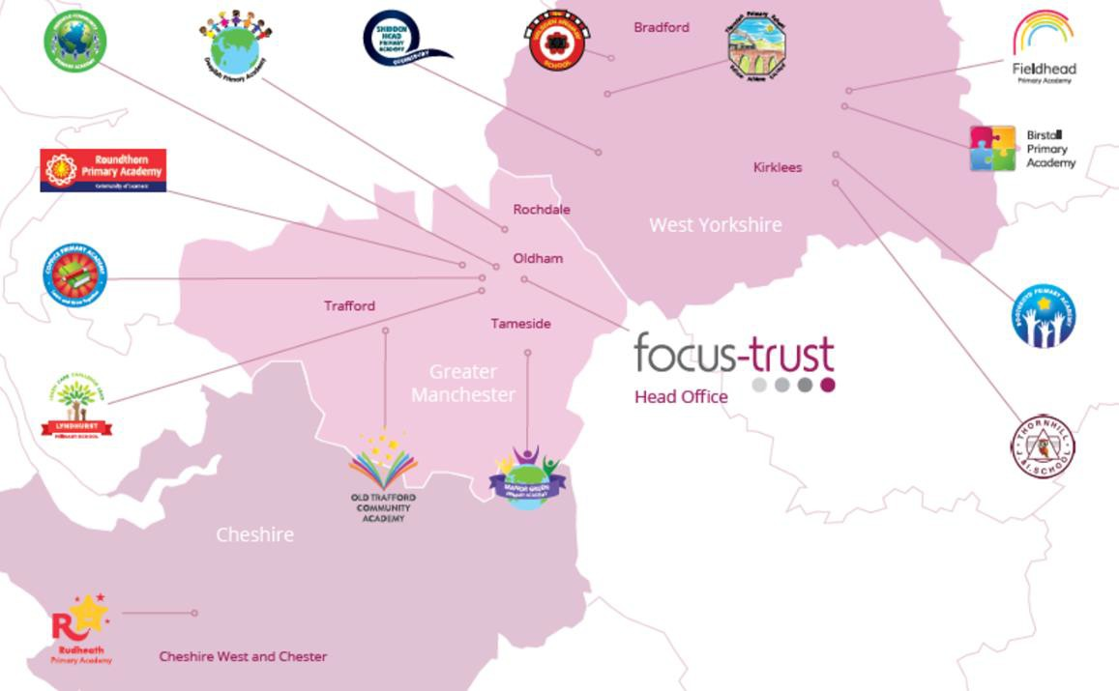
Focus-Trust was incorporated in May 2012 as a primary trust. The Trust has links with the sponsor, Focus Education, but is an entirely separate legal entity. As with all academy trusts, the Trust is a company limited by guarantee and an exempt charity. The Trust’s offices are situated in a newly converted historic mill conversion in Chadderton, Oldham with excellent motorway networks to access our schools.

The defining feature of Focus-Trust is that it is a specialist primary phase trust. This means that the work of the Trust is driven by the distinctive needs of primary schools. Whilst the Trust has robust systems for accountability, each school has their own distinctive identity, ethos and culture, and this is a commitment to every school when they convert and join the Trust.

Focus-Trust currently has a small centrally employed team. The members of the team are highly skilled and committed to the vision, culture and values of the Trust.

All the schools within the Trust are willing partners who have actively chosen to join Focus-Trust and there is a very high degree of consensus, cooperation and commitment from within the group.

The Trust has robust policies and systems in place to govern and guide its work. These have been gradually implemented as the Trust has grown. The Trust has well-established productive relationships with trade unions and meets half termly with a group of national trade union representatives to discuss policy development. This has enabled us to introduce and change a range of policies in a streamlined and cooperative way.

Equality of opportunity

Focus-Trust is an equal opportunity employer, dedicated to a policy of non-discrimination in employment on any basis including age, gender, race, colour, nationality, ethnic origin, disability, gender, religion, age, marital status, sexual orientation and/or medical condition.

Safeguarding

Focus-Trust is committed to safeguarding and promoting the welfare of all children and young people. There is an explicit expectation that all employees share this commitment and adhere to all safeguarding policies and procedures. Applicants should be aware that the recruitment process will include an assessment of your suitability to work with children.

Right to work in the UK

Under the Asylum and Immigration Act 1996, it is a criminal offence to employ anyone who is not entitled to live or work in the United Kingdom. Applicants can expect us to ask for proof of this at interview stage, where you will be asked to provide some original documentation to confirm that you are eligible to work within the UK. Photographic proof of identity will also be required.

Validation of qualifications and identity

All shortlisted candidates will be asked to bring original certificates or relevant qualifications and identity documents to interview. These will be photocopied and kept on file and, if appropriate, may be confirmed as genuine with the relevant awarding bodies. The copies of the successful candidate will be retained on their personnel file. The copies of unsuccessful candidates will be treated as confidential waste and disposed of appropriately.

References and Social Media Checks

If you are shortlisted, we will take up references before the interview date, unless you state otherwise on your application form. However, two satisfactory references must be received before we can confirm any offer of an appointment. One of your referees must be your current or most recent employer. The information we request will relate to salary, length of service, skills and abilities, suitability for the job, disciplinary record, and suitability to work with children. Copies of references or open references will not be accepted. On receipt of references, your referees may be contacted to verify any discrepancies, anomalies, or relevant issues as part of the recruitment verification process.

In line with our safer recruitment policy, on-line presence checks will be undertaken if you are shortlisted. This check is designed to complement the range of standard recruitment checks and allows us to identify a candidate’s online presence, which potentially could damage the organisation’s reputation.

Disability

To comply with the Equality Act 2010, we are legally required to consider making reasonable adjustments to ensure that disabled people are not disadvantaged in the recruitment and selection process. We are therefore committed to meeting, wherever possible, any needs you specify on the application form. Please contact the named person on the advert, if you need to discuss this in any detail. We will consider any reasonable adjustment under the terms of the Act to enable an applicant with a disability (as defined under the Act) to meet the requirements of the post.

Disclosure of a criminal record

Employment in this role is subject to an enhanced check with the Disclosure and Barring Service (DBS). Checks will also be made against the lists showing people barred from working with children. All checks must be satisfactory before any offer of employment can be confirmed and before commencement of work can take place.

Dress code

We expect all staff to dress professionally and appropriately for the roles undertaken. We pride ourselves on the high standards of dress of both our pupils and staff; these standards are led by our staff who we expect to set an example.

Knowledge and skills profile

This is an important part of your application and is your opportunity to explain how you meet the person specification for the post. You should demonstrate, using no more than 2000 characters, your skills, knowledge and experience and give short examples. Describe how you match the requirements of the role; include experience gained from previous jobs, community, or voluntary work. Ensure that the information you give is well organised, relevant, and brief. You may find it helpful to use sub-headings to keep your statement well focused. If you do not submit this profile, you will not be considered for short listing.

Policies

Focus-Trust and the schools have a range of policies and handbooks that help to make clear our expectations and ways of working. These are always shared openly with staff and are accessible to everyone. There are several policies that prospective employees should be aware of when making an application. These can be found on the Trust website www.focus-trust.co.uk and school websites. All members of staff will be asked to sign a declaration as part of the induction process to acknowledge that they have read and understand the Code of Conduct and some of the key policies, e.g. Safeguarding and Child Protection, Health and Safety, Acceptable use of IT.

Pensions

Focus-Trust contributes to Teachers’ Pensions and Local Government pensions in the same way and with the same level of contribution as local authorities.

Employer Relations

Focus-Trust has a Trade Union agreement which recognises the teacher and support staff unions. This is further supported by an ongoing and productive relationship with key trade union officials.
Thank you for taking the time to read this information pack. We wish you every
success in any application you may make.

Thornhill Junior & Infant School
Edge Lane
Thornhill
Dewsbury
WF12 0QT

E: thornhill@focus-trust.co.uk

