



Wraparound Care Assistant
Tornedale Infant Academy

RECRUITMENT INFORMATION PACK

Contents
- Headteacher’s Letter
- Trust Vision, Value and Strategy
- Application Process
- Vacancy Advertisement
- Job Description
- Person Specification

14 April 2025

Dear Applicant
Thank you for your interest in this exciting position of Wraparound Care Assistant at Tornedale Infant Academy. The successful candidate will have the opportunity to have a positive impact on many young people’s lives.
Within this application pack you will find a job description and person specification, as well as information on the Academy and how to apply. I would strongly encourage you to visit our Academy website on www.tornedaleacademy.com to see up to date information on life at our Academy.
The successful applicant will be assured of a well-considered induction to the academy and support for your own professional development. We are looking for a person who is fully committed to making a difference, who has energy and determination, and wants to be part of a school where all staff work relentlessly to ensure that all students achieve their full potential.
Tornedale has a shared vision of community, where everyone works together for the children. We wish to provide a safe and inclusive school where everyone is challenged and supported to reach their own individual potential. We aim to be creative and innovative in our approach and welcome new ideas to enhance learning experiences for everyone. We want our children, staff and parents to feel safe and happy and enjoy the experiences that learning provides.
We hope that you feel Tornedale will be the right school for you, and you intend to apply for the role.
We believe that it is a great place to work and that you will find this role rewarding and enjoyable.
Yours faithfully
Lisa Almunshi
Headteacher



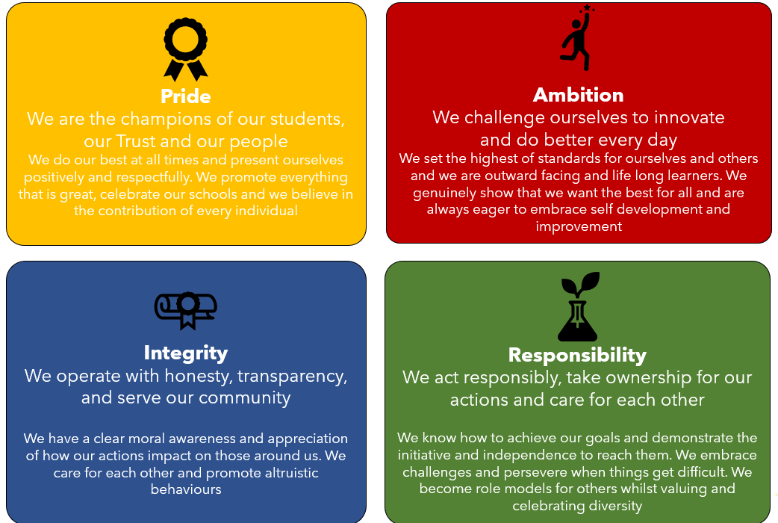
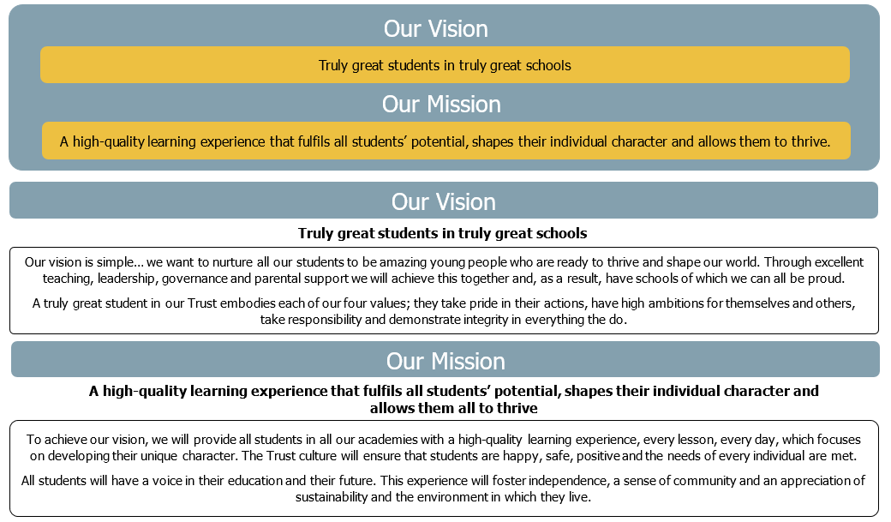

The Application Process
Further details about Leger Education Trust and Tornedale Infant Academy can be found on our website: www.tornedaleacademy.com.
To complete an application please click on the link below (this will open up an online form via the ‘My New Term’ website):

ADD MYNEWTERM LINK

Shortlisted candidates will receive an email detailing the interview process.
If you have not heard from us within 2 weeks of the closing date, please assume your application has been unsuccessful.
Written references will be sought on all short-listed candidates before interview.
If you have any queries on any aspect of the application process or need additional information, please contact Tornedale Infant Academy.

Key dates:

Closing date for receipt of applications: Monday 13 July 2026 at 9.00 am

Shortlisting will take place: Friday 18 July 2026

Interviews will take place: Monday 27 July 2026

The Governors at Tornedale Infant Academy are committed to safeguarding and promoting the welfare of children. All applicants will undergo child protection screening appropriate to the post, including checks with past employers. The role is exempt from the Rehabilitation of Offenders Act 1974 and therefore candidates will be subject to an enhanced DBS certificate, the role is engaged in regulated activity and will therefore require a children’s barred list check. Shortlisted applicants will be required to complete a self-disclosure.

WRAPAROUND CARE ASSISTANT

Leger Education Trust is a Multi-Academy Trust with sponsor status. Since its establishment in November 2018 the Trust has grown rapidly and now includes seven schools and an alternative provision in Doncaster.

The Trust is committed to safeguarding and promoting the welfare of children and young people and expects all staff and volunteers to share this commitment. This post is subject to an enhanced DBS check.

Job Description

Job Title: Wraparound Care Assistant
Grade and Salary: Grade 5 SCP 4-6 £25,185-£25,989 (pro rata) for 7 hours 30 minutes per week, term time only
Hours of Work: 7.5 hours per week, temporary until 20 July 2027 but may be extended; term time only
Responsible to: Headteacher
Job Purpose: To provide a wraparound care facility to parents of pupils attending Tornedale infant Academy
Location: Tornedale Infant Academy
Term: Temporary until July 2027

The Role of the Wraparound Care Assistant is to:
- To supervise and control pupils during regulated activity in wraparound care, ensuring their safety, welfare and general well-being.
- To play an appropriate part in child protection procedures, such as relating relevant factual information and recording/reporting disclosures to the Designated Safeguarding Lead and recording in CPOMS.
- To deal with any immediate problems or emergencies according to the school’s policies and procedures
- To set suitable behaviour standards in line with school policy.
- To set an exemplary example to children at all times.
- To liaise effectively and professionally with staff, teachers, teaching assistants and parents, as required.
- To report any issues, causes for concern or acts that constitute infringement on school rules to the Headteacher, School Business Manager or a Class Teacher.

Responsibilities
- To ensure all pupils attending breakfast club are escorted from Jenny’s Space to their classroom ready for school starting at 8.30 am.
- To ensure all children attending the after school provision have been brought from their classroom to Jenny’s Space as per the attendance register.
- To accurately complete and maintain registers at both breakfast and afterschool provisions and return them to the school office after each session.
- To effectively manage behaviour in line with the school policy.
- To deal with any unacceptable and challenging behaviour under the guidance set by school.
- To attend to pupils should they become ill and seek appropriate assistance if necessary.
- To attend to any accidents sustained, and seek appropriate assistance if necessary.
- To set up tables in Jenny’s Space for eating and activities.
- To ensure all items used for eating are washed, dried and put away before the end of the session.
- To prepare food and serve to pupils at an appropriate standard (Food Hygiene Level 2 certificate to be completed and adhered to by all staff working in the Wraparound Care provision) taking into account the dietary information for each child.
- To ensure that daily checks are undertaken on the fridge and freezer as per the checklist provided.
- To encourage social skills and good table manners.
- To clean up spillages when food/drinks are dropped/spilled in accordance with infection control procedures; ensuring there are no hazards to others.
- To read the wraparound care folder and be aware of all medical information and dietary requirements of the pupils attending the session.
- To pack away all items used during the session, so that the room is left in the same tidy condition.
- To undertake resource preparation and tidy up exercises during quiet periods in the after school provision

Supervisory Responsibility
All school staff must uphold the standards of personal and professional conduct at all times ensuring honesty and integrity prevails in every situation. Staff who work with children must maintain appropriate professional boundaries and respect the unique position of trust they have at all times.

These duties and responsibilities should be regarded as neither exclusive nor exhaustive as the post holder may be required to undertake other reasonably determined duties and responsibilities that are commensurate with the level of the post.

Person Specification

 | Essential | Desirable | How Assessed
Qualifications:
- Willingness and ability to obtain and/or enhance qualifications and training for development in the post | ✓ |  | Application form  Interview
- Minimum grade C GCSE in Maths and English or equivalent |  | ✓ | Application form  Certificate Evidence
- NVQ Level 2 minimum |  | ✓ | Application form  Certificate Evidence
- First Aid Certificate |  | ✓ | Application form  Certificate Evidence
- Food Hygiene Level 2 |  | ✓ | Application form  Certificate Evidence
- Other specific courses and qualifications recently completed |  | ✓ | Application form  Certificate Evidence
Experience:
Previous experience of working with children | ✓ |  | Application form Interview  References
Competent at basic IT skills | ✓ |  | Application form Interview  References
Positive Handling Training |  | ✓ | Application form  Certificate Evidence
- Previous experience of wraparound care |  | ✓ | Application form Interview
Knowledge, Skills and Abilities
- Competent oracy skills | ✓ |  | Application form Interview
- Some understanding of school policies and procedures | ✓ |  | Application form Interview
- Good understanding of safeguarding procedures | ✓ |  | Application form Interview
- Knowledge of children with additional needs |  | ✓ | Application form Interview

Other:
Ability to relate well to children and adults, and work as part of a team. | ✓ |  | Application form Interview  References
A calm, flexible pleasant and sympathetic manner | ✓ |  | Application form Interview
Personal interests and skills which can be used to enhance this role |  | ✓ | Application form Interview
Physically fit enough to undertake the duties associated with this role | ✓ |  | Medical Questionnaire
Ability to attend to children’s personal care needs, eg, toileting | ✓ |  | Application form Interview

Leger Education Trust will require the appointed candidate to gain satisfactory relevant background checks in accordance with safer recruitment guidelines; this will include an Enhanced (with Barred) Disclosure check.

