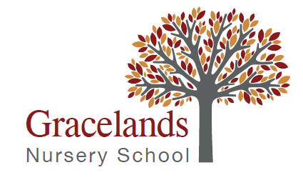

THE BIRMINGHAM FEDERATION OF MAINTAINED NURSERY SCHOOLS

GRACELANDS NURSERY SCHOOL
Grace Road, Sparkbrook
Birmingham, B11 1ED
Tel: 0121 7723124
Email:enquiry@grclands.bham.sch.uk
Executive Head Teacher: Samantha Richards

Teacher
Start date 1st September 2025

Person specification

Gracelands Nursery School is committed to safeguarding and promoting the welfare of children and young people and expects all staff to share this commitment. An Enhanced CRB check is required for the successful applicant.

Methods of assessment:
AF Application Form | C Certificate | I Interview | T Teaching/Task

 | ESSENTIAL CRITERIA | METHOD OF ASSESSMENT
 | Right to work in the UK
QUALIFICATIONS | Qualified Teacher Status | A/C
KNOWLEDGE AND UNDERSTANDING | Knowledge of the EYFS Framework  Understanding of Early Years pedagogy  Knowledge of safeguarding in a school setting | A/I  A/I  A/I
EXPERIENCE | Teaching experience within an EYFS environment  Experience of deploying additional adults  Teaching experience of pupils with a range of special educational needs and/or disabilities | A  A/I  A/I
SKILLS AND ABILITIES | Ability to plan and evaluate own teaching  Ability to use assessments of pupils’ learning to inform future targets and planning  Ability to work as part of a team  Ability to manage other adults in the classroom  Ability to work under pressure  Ability to manage own time to meet deadlines  High standards of written communication skills  Effective interpersonal skills  Ability to build positive and supportive working relationships  Ability to work sensitively in partnership with parents/carers and other professionals  Promotion of positive behaviour strategies and constructive handling of problems | A/I/T  A/I  A/I  A/I  A/I  A/I  A/T  A/I/T  A/I  A/I  A/I/T
PERSONAL QUALITIES | Self-motivated and able to work independently  A good team player | A/I  A/I
SAFEGUARDING | Awareness of promoting and safeguarding the welfare of children | A/I
OTHER | Maintain a personal commitment to professional development linked to the competencies necessary to deliver the requirements of this post  A passion for early years education | A/I  A/I/T

NB: If shortlisted, any relevant issues arising from references will also be taken up at interview. References will be used to support the selection panel’s assessment.
Conditions of Service
Commitment to the safeguarding and welfare of all children.
This post is subject to an enhanced Disclosure and Barring Services (DBS) check.

