


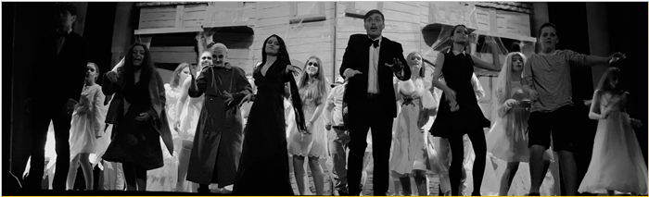

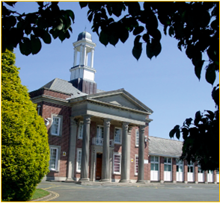

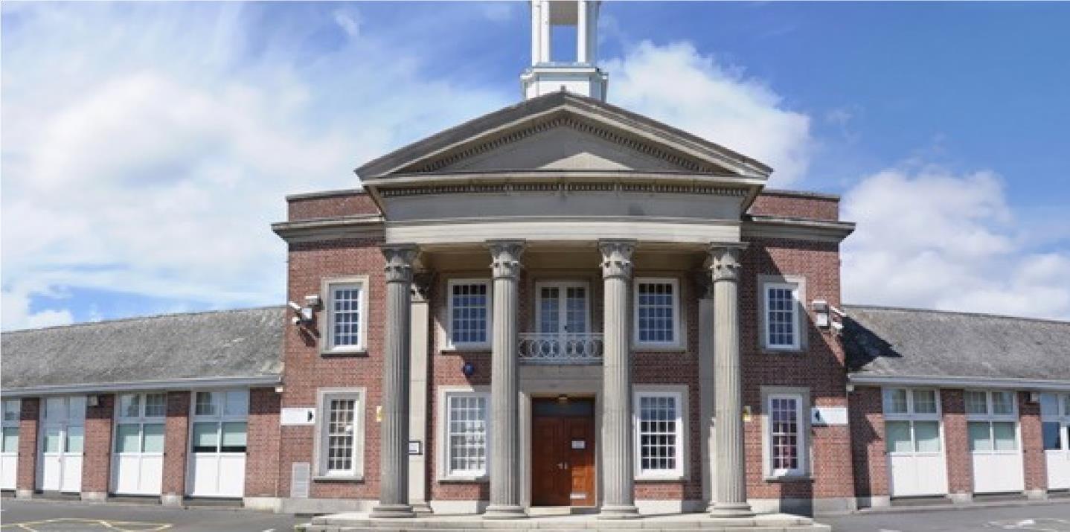

PART TIME CLEANER
Candidate Pack

Seymour Road, Plympton, Plymouth, Devon PL7 4LT
Phone: 01752 337193
Email: heles.school@plymouth.gov.uk
Web: www.heles.plymouth.sch.ukd us on

Principal: Emma Clapham

Application Procedure
Part Time Cleaner

Salary: NJC Grade A (scp2 ). Starting salary £24413 FTE, actual salary £8911.48 per annum
Hours: 15 hours per week x 41 weeks per annum (15.15 – 18.15)
Required to start as soon as possible

This is an exciting opportunity to join Hele’s School and Westcountry Schools Trust. Hele’s is a supportive, friendly and oversubscribed learning community with a very good reputation. We wish to appoint an exceptional candidate, who possesses energy and creativity and can provide effective and efficient cover to support colleagues. If you are motivated by the prospect of being part of ‘Team Hele’s’ and by working alongside others who share a passion and determination to provide the very best opportunities of our young people, then we would very much welcome your application.

If you would like to join us and feel you could thrive in a collegiate and positive atmosphere, then we’d love to hear from you!
Please click the link to submit your application form. Please note – we do not accept CVs. Completed applications should be submitted prior to the closing date.

The closing date for this application is 9.00am Wednesday February 4, 2026
Shortlisting will take place on Wednesday February 4, 2026
Interviews will be held on Friday February 6, 2026, If you have not heard from us by this date, you should assume that your application has been unsuccessful. Prospective candidates are welcome to telephone the school for additional clarification if they wish.

With 31- strong cross-phase MAT we are regularly looking for passionate people to join our teams. If there are no vacancies currently, but you would like to register your interest for future vacancies, please join our talent pool and we will be in touch as soon as we have a suitable position.

Equality Statement
Hele’s School affirms its opposition to unfair discrimination and commits itself to a comprehensive policy of equal opportunity. At Hele’s we regard all members of our school as being of equal value and that each person has the right to equality of opportunity. We aim to create an atmosphere, which actively explores and counters myths, fears and prejudices that can work against equality of opportunity. No individual or group should be discriminated against on the grounds of their racial group, religion, sexual orientation, disability, ethnicity, nationality, age, gender, gender identity or political affiliation. Bullying and harassment will not be tolerated. Sexual and racial harassment, including persecution on the grounds of sexual orientation (i.e. homophobic bullying), are disciplinary offences and relevant policies will be followed in such circumstances.

Hele’s School is committed to safeguarding and promoting welfare of children and young people and expect all staff and volunteers to share this commitment; therefore, all posts will be subject to a satisfactory DBS Enhanced Disclosure.




Welcome to Westcountry Schools Trust (WeST), and thank you for your interest in this exciting position at Hele’s School.

This post presents a fantastic opportunity to work in a dynamic, ambitious school and a tight-knit team of dedicated staff, governors and trustees committed to providing the very best experiences and support for the young people in our care. The Pupil Admission Number at Hele’s increased from 210 to 240 students in September 2019, and each intake since has been over-subscribed at that number with a waiting list, such is the popularity of the school.

Beyond the boundaries of Hele’s School, you will have the opportunity to work and contribute to the development of a cross-phase family of twenty-seven schools. We are passionate about our children benefiting from the blend of education in which we believe and know that we can only achieve this by creating the right climate for our staff to excel and feel professionally rewarded. As such, you will work amongst a wide team of colleagues who are mutually supportive and value high quality professional development.

If you share our passion for children succeeding, regardless of their starting points, and believe you have the skills and energy to make a difference to the lives of our young people, we very much look forward to you joining our team. We actively appoint people with a strong sense of moral purpose and a desire to help all students – we firmly believe that education can make a difference to the life chances of all young people.

Our promise to you as a colleague working in a Westcountry Schools Trust establishment is that you will be valued, empowered, invested in and grown in this role, supported to move on to the next stage in your career, whatever and wherever that may be.

Rob Haring
Chief Executive Officer, WeST




A message from
Emma Clapham, Principal

I take great pleasure in welcoming you to Hele’s School! We are a school with a tradition of academic excellence, high aspirations and a big heart. A school that students and staff are proud to attend. A school where we never compromise our insistence that everyone is valued, learns, enjoys and achieves. Expectations for staff and students are unapologetically high, and very simple; be kind and work hard, both to do things right and to do the right thing…even when no one is looking!

Our mission is to support and challenge everyone, adult or child, to continually get better. We have a ‘no excuses’ philosophy which reinforces our belief that all of us can improve and nothing is impossible. Quite simply, it isn’t about being ‘the best’ at something, as being ‘the best’ is temporary. Instead, we seek to ensure we get better each day – that’s permanent growth and ensures we never stop aspiring. It is for this reason that recognising and celebrating endeavour, as well as achievement, is something we hold dear, for staff and students alike.

We work hard at providing an inclusive, calm, and purposeful learning environment, with students committed to excellence, and aim to ensure all students have opportunities to enrich their learning and discover new skills and interests through a breadth of curricular and extra-curricular opportunities to excite and engage young people. In short, we are what we believe school should be.

Having been a Senior Leader at Hele’s for the past decade, I am extremely proud to now lead the dedicated and enthusiastic team of staff who are passionate about working with young people and are committed to ensuring that those entrusted in our care get the best life chances possible. Everything we do is shaped by our determination to ensure that each and every child has a positive and memorable experience of school and leaves with every opportunity open to them to ensure they can choose their path through life. We look to shape young people who thrive, flourish and, crucially, are happy.

In terms of curriculum, we offer a traditional and broad offer across Key Stages 3, 4 and 5. We focus on opportunities to develop teaching and learning at every turn and, importantly, teachers at Hele’s have a resolve to be the best they can be in the classroom. Our extended pastoral team ensure our core purpose to keep children safe and remove barriers to learning is fulfilled so that young people can be inspired, can aspire and can achieve. In return we expect a buy in to our belief that we all have an active role to play in making our school a great place to be, which manifests itself in every child displaying the highest standards of commitment to learning, pride and care.

Hele’s is a community committed to personal and professional growth of all, with dedicated staff, supportive families and committed students. I have no doubt that the right candidate will be happy, supported and fulfilled being part of Team Hele’s and will take great pride in what we can achieve together for our community and for each other. I do hope you are inspired to apply for this post and I look forward to reading your application.

Thank you in advance for the time and emotional investment that I know you will commit to this process.

With very best wishes,
Emma Clapham
Principal

About Hele’s School

Hele’s School is a larger than average 11-18 comprehensive school in Plympton, Plymouth. Plympton sits at the northeastern edge of the city, bordering the South Hams area of outstanding natural beauty.

The school makes use of the closeness of Devon’s countryside and moors and Plymouth’s waterfront with a thriving Cadet Corps and Duke of Edinburgh Scheme. Our Combined Cadet Force (CCF), incorporating Army, Royal Navy and Royal Air Force corps, is one of our unique selling points, providing a visible presence both in the school and the wider community and opening countless opportunities for our students around leadership, teamwork and personal presentation, outdoor pursuits, to name just a few.

In recent years, the Pupil Admission Number has increased to 240 in each year group and a period of capital investment to meet this growth is being planned. There are 1350 students in the school, which includes a thriving Sixth Form of 210, based in specialist accommodation.

Hele’s has a proud and long history as a caring school with a strong reputation for excellence and providing opportunity. It enjoys the support of an active parent body, who share our determination to provide the highest quality of education and pastoral care for their children. Students’ attitudes to learning are good; they are well behaved, and attendance and punctuality are excellent. In short, the young people entrusted to our care want to learn and are delightful to teach.

Our pastoral system is organised around year groups with an 8-form entry and leadership from a teaching Head of Year and a non-teaching Pastoral Support Manager for each year group. There is a 30-minute tutor period each morning with a Guided Reading Programme and a strong programme of Personal Development in this time, supported by weekly assemblies. The pastoral leadership team and tutors remain with the tutor group and take them through from Year 8 to Year 11 so that the relationship between tutor and students is deep and sustained, and family connections with school become trusted and embedded. Year 7 remains as a separate year team of specialist tutors and Head of Year so that we can ensure an exceptional start to secondary school for every child.

Post-16 has a mix of Year 12 and Year 13 students in each Tutor group. We use every opportunity to harness the expertise and interest of our Post-16 learners to act as leaders and mentors to younger students in all manner of ways, including having a visible Junior Leadership Team (JLT) to act as an important conduit for student voice and school improvement.

An excellent professional body of teachers and a hardworking and effective team of associate staff is a hallmark of the school and Hele’s is fully staffed in all areas with specialist teachers. Middle Leaders form an active and effective Joint Leadership Group (JLG) with Senior Leaders, and the JLG is the driving force behind school improvement.

The curriculum structure is currently based around a 2-year KS4, with GCSE options ordinarily taken in the spring term of Year 9. We operate a 2-week timetable with 50 lessons a fortnight, each of 1-hour duration. The school day runs from 8.40am to 3.10pm, allowing plenty of time for the well-developed and rich extra-curricular provision, which includes a mix of academic, sporting, performance and personal development opportunities, as well as a newly-implemented Guided Reading Programme that runs for all year groups (except for Year 11 and Year, which have an intervention programme) in Tutor time.

Hele’s plays its part fully in the Westcountry Schools Trust, in Plymouth and beyond; the Principal has a passion and commitment for Hele’s to be outward-facing, and the school and trust regularly contribute to national, regional and city-wide initiatives on a range of fronts, maintaining a strong relationship with the Local Authority, the Regional Directors, and other organisations across the country.

History of Hele’s School

Elize Hele was born in Brixton in about 1560 and although he lived most of his life at Fardell, Cornwood, on the outskirts of Plympton, his final resting place is in St Andrew’s Chapel in Exeter Cathedral. Having no heirs, Elize left his wealth to be used for “pious uses”. A number of schools in the South West were founded out of his estate by his trustees, including the grammar school at Plympton, which was, until its temporary closure at the end of last century, known as Hele’s School, Plympton.

The old grammar school building, which still stands in Plympton St. Maurice, was completed in 1671. Next to it stood the Schoolmaster’s house in which Sir Joshua Reynolds was born. It is a surprising fact that the old grammar school produced four distinguished artists: Sir Joshua Reynolds, the first President of the Royal Academy; James Northcote; Benjamin Haydon and Sir Charles Eastlake, President of the Royal Academy and the first Director of the National Gallery.

The school faced many difficulties in the latter part of the nineteenth century and was eventually forced to close in 1903, before it was reconstituted by Devon County Council as a co-educational grammar school in 1921 called Plympton Grammar. The school grew and prospered and moved to its present site on Seymour Road in 1937.

New extensions were opened from 1970, and in 1983 refurbishment took place in preparation for reorganisation into an 11 – 18 mixed comprehensive school and it reverted to its old name of Hele’s School.

In the decade from 2000, Hele’s benefited from three specialisms - Languages, Maths & Computing and Applied Learning - and enjoyed national acclaim as a Language College. This strength continues, despite the change to national policy and the subsequent removal of funding, and international links and internationalism remain important.

The school became a Converter Academy in April 2011 and operated as a Stand-Alone Academy Trust for the following 7 years. In September 2018, Hele’s joined a Multi Academy Trust, the Westcountry Schools Trust (WeST), which it played a key part in co-constructing.

Stronger Together

A now 31- strong cross-phase MAT of 23 Primaries, 8 Secondaries, plus an Adult Training Provider, the Westcountry Schools Trust is geographically tight but spans Devon, Plymouth and Cornwall. With the strength of collaboration and ambition, the capacity for shared school improvement, leadership development and collaboration is limitless. The WeST aspiration of ‘Every child in a great school’ sits well with the Hele’s vision (and vice-versa) and the strap line ‘Stronger together’ articulates our shared ambition to ensure that this aspiration becomes a reality.

There remains a strong commitment, professionalism and moral imperative amongst the Hele’s staff and Local Governing Body to ensure we provide the young people in our care with an educational and pastoral support experience that is first class in every aspect. This is very much supported by the WeST Trust Board and strategic direction of the MAT. We have a burning ambition and determination to put Hele’s firmly on the map locally, regionally and nationally and to be recognised as an outward-facing, aspirational and collegiate centre of excellence, which remains committed to continuous improvement.

Hele’s School Ambition


Our school’s purpose:
To warm hearts and to light fires in minds. Our ambition is to inspire confident learners who will thrive in a changing world, never fearful of taking risks and learning from mistakes made as part of their growth. We hold dear the belief that ‘people matter’, and the quality of personal relationships at all levels is central to ensuring a safe, happy, caring, inclusive environment.

Vision:
We pride ourselves on being an outward-facing school community that delivers outstanding academic and personal outcomes for all.

Mission:
We instil a passion for learning - for child and adult alike.
We allow everyone a chance to shine.
We provide a safe, happy community, where we are all supported and challenged to be the best we can be.
We believe there is no ceiling to aspiration.
We ensure a growth mindset culture pervades all we do.
We celebrate endeavour at every opportunity.
We grow ‘future fit’ young people.
We are a school in the heart of the community and with the community in our heart.
We develop and maintain a reputation for excellence - locally, regionally and nationally.
We remain restless for continuous improvement, always striving to be better.

Values:
We dream big, aim high and work hard.
We have pride in all we do and all we are.
We respect each other, our environment, and ourselves.
We ensure outstanding learning is at the core of our provision.
We do things right, and we do the right things.
We have high expectations of and for every person.
We strive to be better each day – as adults and as young people.
There are no excuses – all can achieve no matter their starting point.
We ’walk the talk’ and all play our part in ensuring Hele’s is a great school to be part of.



WESTCOUNTRY SCHOOLS TRUST

JOB DESCRIPTION

Job Title: Cleaner
Location: Across the Trust (based at Hele’s School currently)
Grade/Salary: NJC Grade A (Scp 2)

Hours: 15 hours per week for 38 weeks term time, plus 3 weeks of Deep cleaning in the school holidays (1 at Easter 2 in summer holidays)

Reports to: Premises Manager/ Operations Team

Job Purpose
To clean and provide a high standard of cleanliness in the area of the school that you are assigned to, the area you clean may change based on School need. To be flexible and work within time allocations and ensure that all cleaning is carried out. Discretion/ confidentiality/ following instructions. Work alone within a team

Key Areas of Responsibility

- To undertake, the cleaning of the area you are assigned to within the school site and to ensure that you follow the Schedule and keep the school premises in a clean and hygienic condition.
- Duties will include cleaning, mopping floors, sweeping, vacuum cleaning, emptying of litter bins, polishing, dusting cleaning glass and touch points in your area. This will include toilets, sinks and shower areas, fixtures, and fittings. Extra Deep clean during specified 3 weeks outlined above.
- To follow health and safety guidelines, report faulty machinery and equipment to your line manager. To adhere to the CosSh guidelines
- To attend training sessions when requested.
- To be aware of and adhere to the security needs of the premises.
- To complete all forms as requested by management.
- Report shortfall in stock requirements to line managers.

General
- To act in accordance with, and actively promote, all Trust policies, including Safeguarding, Health and Safety and Equality & Diversity.
- To participate in Continuing Professional Development (CPD relevant to the role and to engage in Performance Development Reviews (PDRs).
- Preparing and contributing to Trust wide development by sharing best practice and delivering/receiving professional feedback.
- To retain confidentiality and maintain data and/or files in accordance with Trust policies for data governance, as appropriate for the role.

This job description outlines the duties of the post as required for the time being to indicate the level of commitment and responsibility expected. It is not a comprehensive or exclusive list and duties may be varied from time to time which do not change the general character of the job or the level of responsibility.



PERSON SPECIFICATION – CLEANER

Method of Assessment  The table indicates the possible method/s by which the skills/knowledge/level of competence in each area will be assessed. | Essential or Desirable | Application Form | Interview
Knowledge, Skills and Experience
Cleaning Experience in a similar role | Essential | ü | ü
Understand the schools cleaning standards | Essential | ü | ü
Able to communicate & work effectively with other team members and take direction from Line manager | Essential | ü | ü
Ability to ensure that all cleaning tasks are carried out with due regard to health and safety. | Essential | ü | ü
Carry out the various periodic cleaning processes e.g., vacuum cleaning, carpet cleaning, toilet cleaning, sweeping, and polishing, removal of graffiti, cleaning off all marks on wall and doors. | Essential | ü | ü
Understand the appropriate use of different cleaning materials, preferably Coshh Trained, but training is given. | Essential | ü | ü
Attention to detail and observation of high standards regarding infection control, cleaning all touch points daily | Essential | ü | ü
Ability to carry out instructions and work with the minimum of supervision and equally to work under pressure should flexibility be needed if an after-school event is on after School and routine needs to be changed. | Essential | ü | ü
Ability to work as part of a team, form good relationships with other colleagues | Essential | ü | ü
Ability to adhere to and implement the Trust’s Equal Opportunities Policy. | Essential |  | ü
Honest and trustworthy and an ambassador for the school | Essential | ü | ü
Able to demonstrate a commitment to professional development through further training. | Essential |  | ü
Have a DBS check and clearance | Essential | ü | ü
Knowledge / or Training in Manual handling and Health and Safety at Work Act | Desirable | ü | ü

