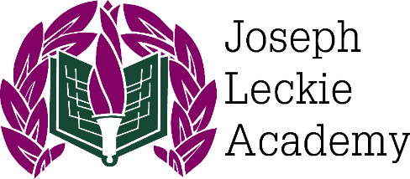
Joseph Leckie Academy

Walstead Road West, Walsall, WS5 4PG
Tel: 01922 721071 Fax: 01922 641497
Email: a.morgan@josephleckieacademy.co.uk
Principal: Mr A McNaughton

Dear Candidate,

Thank you for expressing an interest in the post of Teacher of Science (Physics) at Joseph Leckie Academy.

Joseph Leckie Academy is a vibrant and thriving mixed 11-18 Academy and part of the newly formed Forge Brook Trust. We were graded as “Good” across all areas by Ofsted (October 2021). Our ongoing desire to continually move forwards means that this is an exciting time to join our successful and welcoming team. The Academy has remained as one of the top non-selective secondary schools for progress in Walsall based on validated results (+0.11 for Progress in 2024, the fifth consecutive year of positive Progress). We are an expanding Academy with student numbers growing over 1500 and continue to be oversubscribed at Key Stage 3.

We pride ourselves on high expectations of all learners. We prioritise high quality teaching and learning to ensure successful student achievement. This creates a calm learning environment where teachers can teach and students can learn, as is clearly supported by feedback from Ofsted. We offer a highly supportive environment and are committed to ensuring outstanding teaching, behaviour, progress and achievement. Staff can develop their teaching practice through a number of opportunities, including ongoing CPD and access to a range of courses.

The Science Faculty is comprised of 18 staff including experienced teachers, leaders, teaching assistants and technicians, all who offer a wealth of support and professional advice to staff at all levels. There are 13 specialist laboratories for practical lessons, as well as access to computer rooms for vocational coursework. We are passionate about promoting STEM subjects and, as such, offer AQA Trilogy Combined Science GCSE and AQA Separate Science GCSEs (a popular option choice with around 60-70 students each year and achieving 75.4% 4+ in Biology, 81.3% 4+ in Chemistry and 71.9% in Physics in 2025), Pearson BTEC Level 3 Applied Science and all three AQA A-Level disciplines. We have a growing Sixth Form, supporting large cohorts of A-Levels in Biology, Chemistry and Physics as well as BTEC Applied Science (100% A*-C and 47.8% A*-A in Biology A-Level, 95.5% A*-E and 40.9% A*-A in Chemistry A-Level and 100% D*-P in Applied Science L3 BTEC ). We are aiming to further develop Post-16 provision with new AAQ courses, and the additional potential of T-levels from September 2026, meaning there will be excellent opportunities to contribute to Post-16 expansion across the faculty.

We are looking to appoint an inspirational, enthusiastic, dynamic and forward-thinking teacher of science to contribute to a growing Faculty. This is a fantastic opportunity for an ambitious candidate to join our dynamic team at the forefront of change and to make a real difference to our drive to continue to raise standards of education in the Academy and the Forge Brook Trust. We are looking for staff who are committed to developing confident and capable learners. We expect hard work, skill and dedication and in return will provide a supportive working environment that values staff development and well-being.

If you believe that you can make a positive contribution to Joseph Leckie Academy, we would love to hear from you. Please apply via our website, https://www.josephleckieacademy.co.uk/

I look forward to reading your application.

Yours faithfully,
Andrew McNaughton
Principal



