
School Business Manager

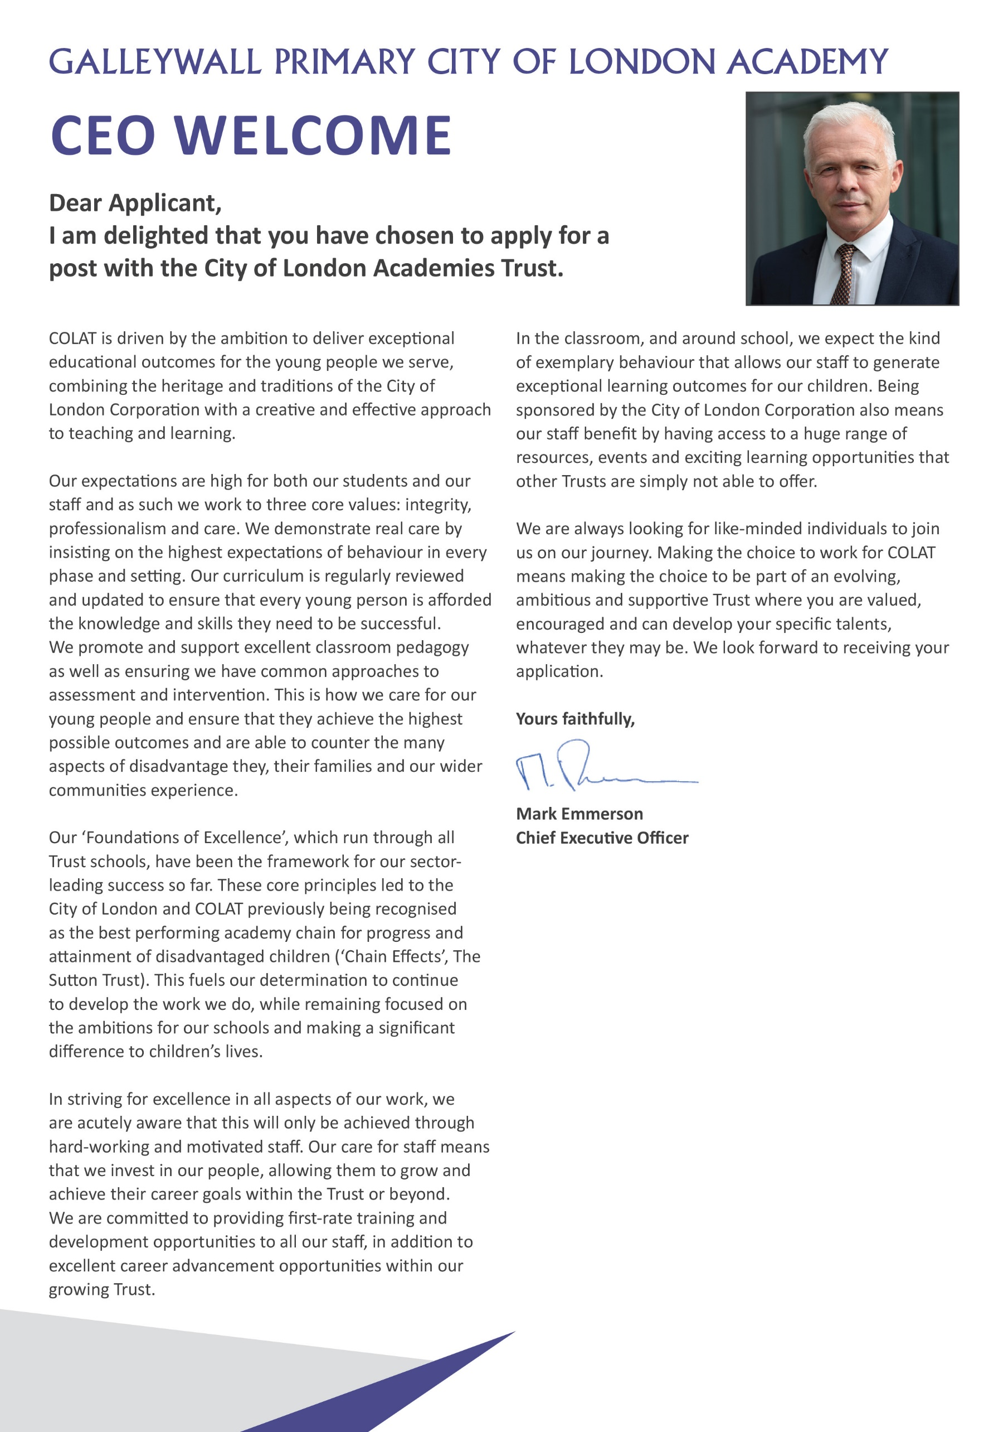

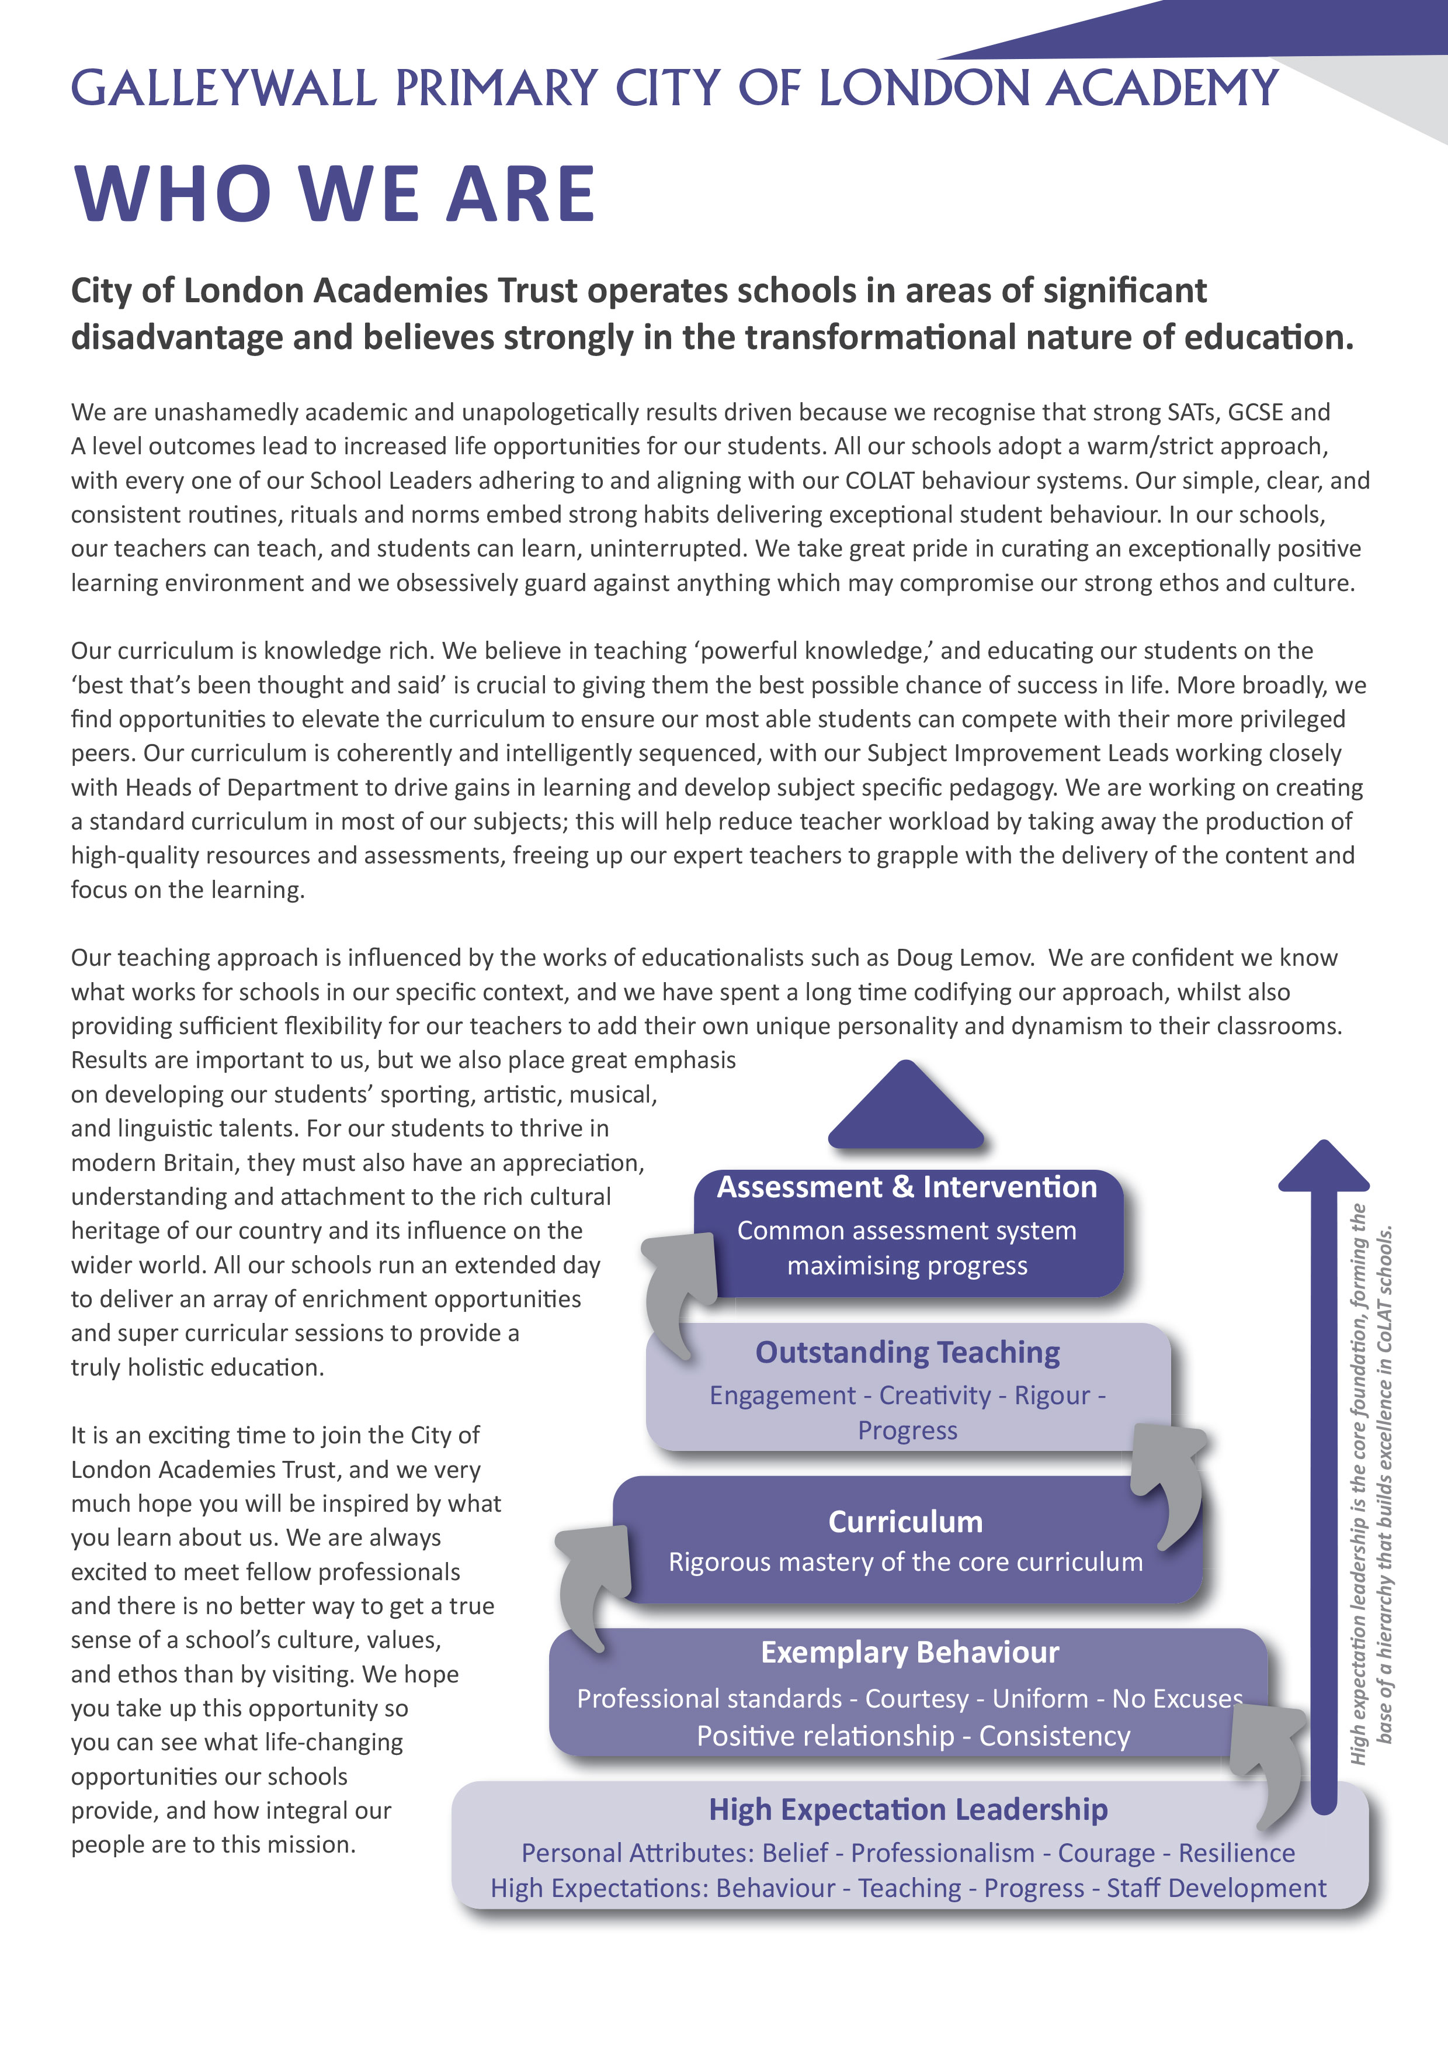

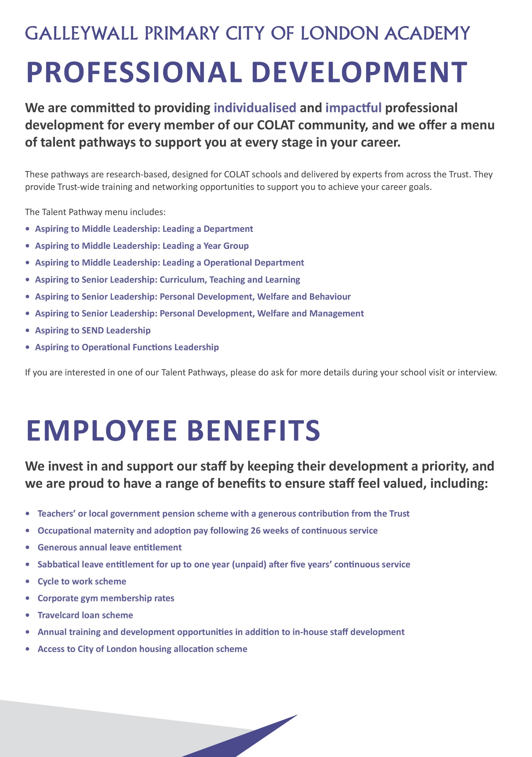
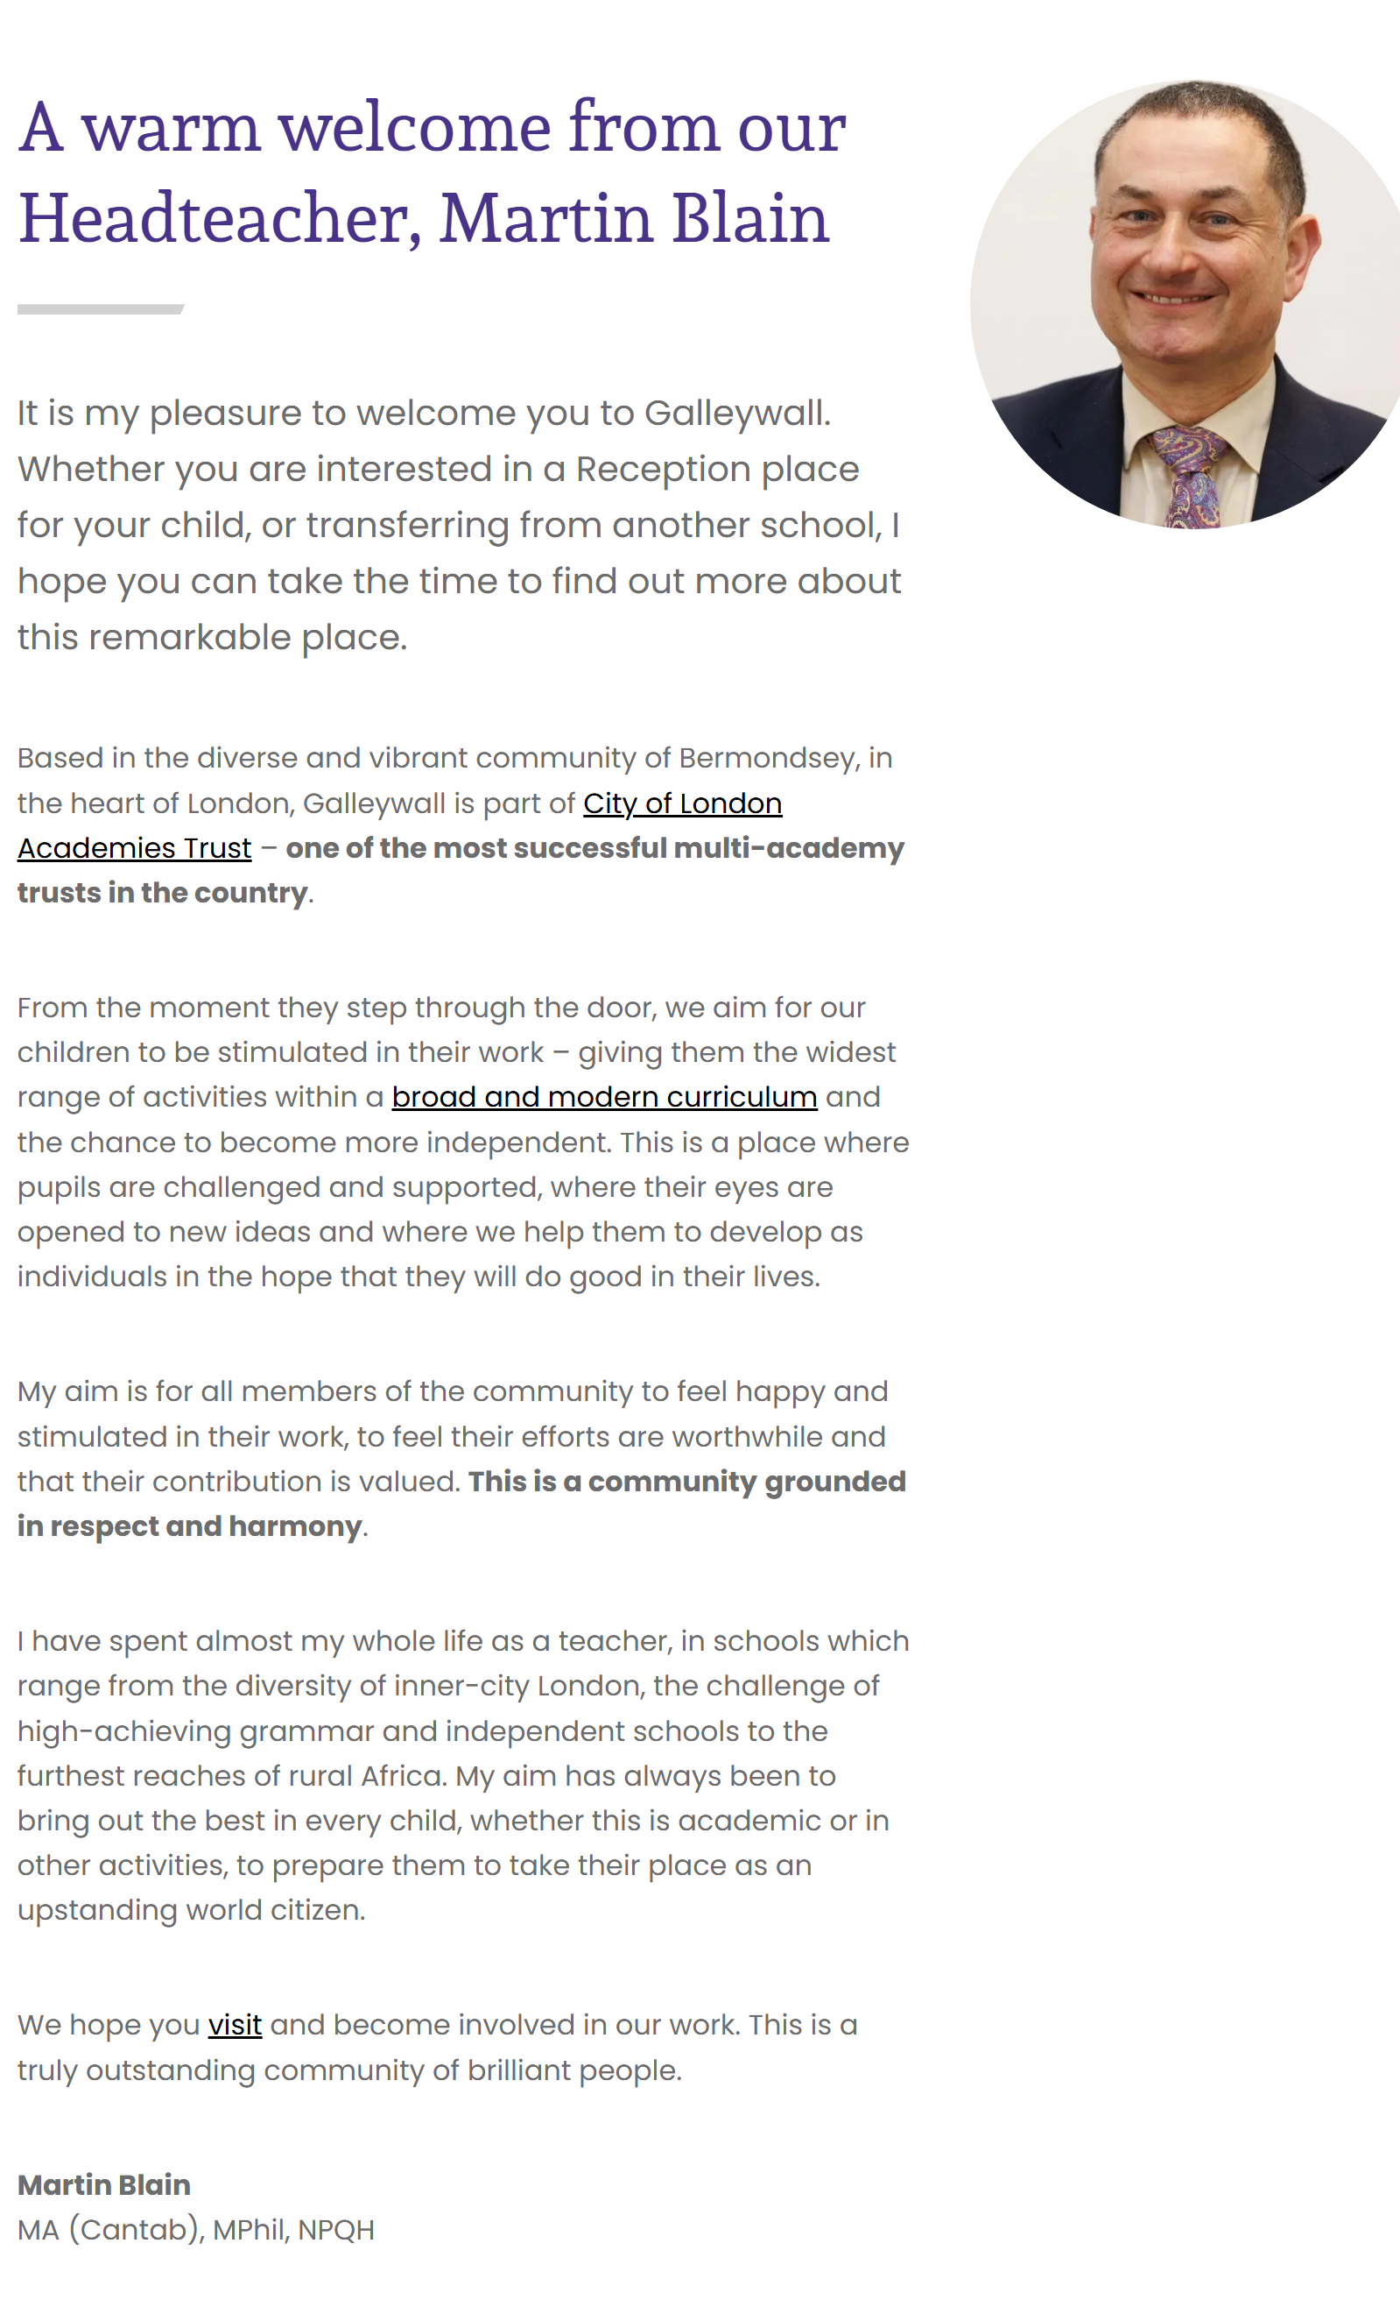
School Business Manager - Job Description

Post: School Business Manager

Accountable to: Headteacher, with dotted line to Trust CFOO

Grade Scale Point Range: JE9 SCP 36 - 40

Salary Range: £51,228 - £55,353

Working Pattern: The role is full-time, 35 hours per week, all year round, with 29 days annual leave plus bank holidays. We would welcome discussions about the possibility of reduced hours or ‘term-time plus’ but we expect the role to require a minimum of 0.8FTE across the year.

Location: Galleywall City of London Academy. Travel to other Trust Academies and the central offices (all within London) will be required.

Disclosure level: Enhanced

Responsible for: Operational leadership and management of the financial, operational and business support functions at the Academy.

Main Purpose:

- Leads the efficient and secure administration, management and monitoring of the academy’s financial and administrative functions on a day-to-day basis, reporting to the Headteacher and in liaison with the central Trust team.
- Line management of a range of staff, mostly on the administrative side of the school.
- Promotes the highest standards of business ethos within the business support function of the academy and supports the academy’s leadership team in ensuring the most effective use of resources in support of learning objectives.
- Be a team player with a desire to embed yourself in the day-to-day running of a vibrant primary school community.
- Be responsible for the School Office, Finance, Estates, HR, Catering, Medical and Health and Safety functions at the Academy. Liaise and work collaboratively with colleagues across the Trust to ensure Trust policies and procedures are embedded and operating as intended and that best practice is shared across the Trust.
- Play a full part as a senior leader within the school.
- CoLAT strives to ensure all colleagues throughout the Trust feel part of a single team, unified in our vision for all of our pupils. This role is a key part of ensuring this happens through positive two-way communication from your Academy to and from the Central Trust Directorates (Finance, HR, IT, Estates and Governance).

Key Accountabilities
Liaison with the Central Trust Team and other Academies
The central team will provide support, guidance and direction to ensure you are able to discharge your duties effectively at the Academy. You will be able to ensure that the specific strengths, challenges and context of your Academy are appropriately understood and taken account of in wider Trust planning.
- You should ensure that you are up to date with all Trust policies, procedures and ways-of-working.
- You should ensure that you keep Trust colleagues fully up to date with all key occurrences at your Academy.
- Regularly meet and liaise with colleagues at other Academies within the Trust to share best practice.

Leadership, Management & Strategy
- Working closely with the Headteacher and SLT colleagues on the strategic development, ensuring the best possible use of resources through effective planning and risk management.
- Provide clear information, advice and recommendations to the Headteacher, Local Board (LB), School Leaders and the Trust central team regarding the strategic development of support services and best use of assets in order to deliver high expectation outcomes for students.
- Attend the Academy’s Local Board and appropriate sub-committee meetings and Senior Leadership Team meetings, proactively preparing papers/reports as required.
- Support the Local Board and sub-committees in ensuring effective clerking services are in place.
- Represent the Academy at relevant Trust meetings where appropriate.
- Lead and line manage relevant operational teams ensuring an effective and efficient service to each academy by delivering training, managing performance and modelling effective behaviours.
- Be the primary contact for the out-sourced premises and catering contracts.

Human Resource Management
To be the lead on Human Resource matters, supported by the central Trust HR Team.
- Liaise with the Headteacher to manage staffing budgets and forecasts
- Ensure that all Trust HR policies and processes are being implemented and provide support where necessary.
- Liaise with the Trust HR Team on Trust policies, procedures and projects, and when specific HR advice or guidance is needed.
- Liaise with the central Trust HR team to advise the Headteacher on HR matters.
- Ensure all employee relations cases within the Academy are managed effectively and efficiently.
- Oversee performance management process and appraisal process for all staff (teaching and support) in conjunction with the Senior Leadership Teams.
- Ensure all staffing and contract changes are correctly processed onto payroll.
- Review and approve, with the Headteacher payroll each month in line with Trust procedures.
- With the support of the Trust HR Team, ensure all HR related reporting and compliance is adhered to, including HMRC and pension funds.
- Ensure HR processes are completed including contracts, letters, DBS checks and safer recruitment compliance.
- Support recruitment, onboarding/offboarding, and maintain accurate staff records.

Catering
Oversee the catering operation at the Academy to ensure:
- Out-sourced catering contracts are being monitored, to include quality of service delivery, fulfilment of contractual obligations and KPIs.
- The academy is receiving a catering service to meet its needs, and the service is monitored to continually improve the quality, to include external audits as appropriate.
- Catering income and expenditure are properly managed and reported.
- All aspects of hygiene, health and safety comply with current legislation and regular updated records are kept.

Financial Planning, Budget Management and Financial Reporting
- Ensure an effective system of internal control is maintained at (in accordance with the Trust Finance Policies and the Academy Trust Handbook), including monitoring and evaluating the effectiveness and efficiency of all financial systems, policies and procedures.
- In liaison with the Trust Finance Team and the Headteacher, prepare a realistic and balanced budget each year, submit the proposed budget to the Local Board for approval, and lead on the overall 3-5-year strategic financial planning process for your academy (again with support from the Trust Finance Team).
- Review and input into the monthly management accounts in accordance with the Trust Finance Policies and the requirements of the Local Board meetings.
  - Monitor income and expenditure in relation to the agreed budget to actively monitor and control performance and to achieve value for money.
  - Identify and inform the Headteacher, Governors and the Central Finance Team of any causes of significant variance and suggest prompt corrective action.
  - Prepare regular re-forecasting (using the forecast tool provided by the Trust) to give an up-to-date view on likely outturn for the next 12 months.
  - Provide ongoing budgetary information and reports to relevant colleagues in the academy and Trust.
- In liaison with the Headteacher and Trust Finance Team, prepare documents and present at the Trust annual Finance Scrutiny meeting.
- Monitor local authority, DfE income and other grant income to ensure all available funding is being claimed.
- Support and advise academy leaders on strategic financial planning and budget management to best support teaching and learning requirements.
- Seek and administer new sources of revenue for each academy, including working with the Corporation of London and other City institutions.
- Assist the Trust Accounting Officer and Chief Financial & Operating Officer in discharging their responsibilities in accordance with statutory and regulatory requirements.
- Liaise with and ensure the completion of all financial returns to the Trust, DfE, ESFA and any other external agencies.
- Oversee and manage procurement and tendering processes and have overall oversight of all contracts in line with the Trust Finance and Procurement policies, the Trust Scheme of Delegation and the Academy Trust Handbook.
- Input into internal and external financial audits for the Academy, as required, in liaison with the Trust CFOO and the Trust Finance Team.
- Ensure any recommendations from the external and internal auditors are implemented.
- Advise academy leaders, LB members and the Trust CFOO if fraudulent activities are suspected or uncovered.

Estates & Facilities Management
Manage the Facilities Management on-site team, and liaising with the central Trust Estates Team to ensure:
- The delivery of a professional, efficient and cost-effective Facilities Management service to the Academy, ensuring the site is safe, accessible, compliant and fully functional, in accordance with Trust Premises Management Policies and Procedures and all relevant legislation.
- Line management of the Site Manager and liaison with other schools within the Trust regarding services sub-contracted by them to the school.
- The safe maintenance and secure operation of the premises to ensure the safety and comfort of staff, students and visitors and to provide a secure and optimal learning environment.
- The continuing availability of utilities, site services and equipment.
- Out-sourced facilities management contracts are being monitored effectively, to include quality of service delivery, fulfilment of contractual obligations and KPIs.
- Building works and refurbishments and planned and executed, and asset management and forward maintenance plans are developed and updated.
- Premises costs are properly managed and reported.
- A proactive Health and Safety environment and routines are embedded and maintained across all sites and systems are in place for effective monitoring, measurement and reporting of health and safety issues to the Senior Leadership Team, Governors, the central Trust team and (where appropriate) the Health & Safety Executive.
- Manage the letting of academy premises to external organisations, for the development of the extended services and local community requirements.

Risk Management and GDPR
- Manage and ensure documentation of appropriate risk management procedures as necessary and oversee disaster recovery policies and procedures in accordance with Trust policies.
- Monitor risk management policies and procedures to ensure that organisational risks are minimised.
- Ensure an operational risk register is in place and regularly updated (in accordance with the Trust Risk Management Policy)
- Oversee all insurance arrangements, ensuring that the academies have appropriate levels of cover in all areas, and handle any claims that arise.
- Oversee implementation of the Trust’s Data Protection Policy at the Academy
- Liaise with the Trust’s Data Protection Officer on local policy, procedures, training, data breaches, freedom of information and subject access requests.

IT Service Delivery
In collaboration with the central IT Team matrix manage the IT site team. Ensuring:
- The smooth IT service delivery and operational requirements on the site.
- Work with the Trusts IT support team to manage the Academies IT budget and procure new technology in alignment with the Trusts IT strategy and hardware refresh plan.
- Ensure site based cyber security training is being undertaken as planned.

Front Office
- Manage and supervise the front office team, ensuring a welcoming environment and efficient daily operations.
- Oversee reception services, including visitor management, parent enquiries, and school communications.
- Line manage administrative staff, including performance, training, and development.
- Ensure front office processes are effective, compliant, and support safeguarding requirements.
- Act as the point of escalation for complex or sensitive parent enquiries.
- Manage and oversee the school’s MIS, ensuring accurate pupil data, attendance, and safeguarding records are maintained and effectively used.

Medical
- Oversight of the school’s medical practice.
- Management of the Inclusion Assistant and other staff in terms of the management of medicines and allergies
- Management of the first aid team, ensuring processes are adhered to in line with policies.

Events
- Coordination of the practicalities of school events including the physical management, financial control, access to site.

Other
- To be part of the schools rota for playground, lunchtime and other pupil supervision duties.
- Cover reception desk as part of a rota.
- Undertake such other duties as reasonably correspond to the general character of the post and commensurate with roles of this level.
- Promote the safety and wellbeing of students, ensuring that Trust and academy Child Protection and Safeguarding policies and procedures are promoted
- Be responsible for your own health and safety and that of students and your colleagues, in accordance with the Health and Safety at Work Act 1974 and other relevant legislation

Review and scope of Job Description
This job description sets out the main duties of the post at the time when it was prepared. Such duties may vary from time to time without changing the general character of the post or the level of responsibility entailed.

The above responsibilities are subject to the general duties and responsibilities contained in the Statement of Conditions of Employment. The duties of this post may vary from time to time without changing the general character of the post or level of responsibility entailed.

The person undertaking this role is expected to work within the policies, ethos and aims of the Trust and to carry out such other duties as may reasonably be assigned. The post holder will be expected to have an agreed flexible working pattern to ensure that all relevant functions are fulfilled through direct dialogue with employees, contractors and community members.

Safeguarding Children, DBS & H&S
COLAT is committed to safeguarding and promoting the welfare of children and young people. We expect all staff to share this commitment and to undergo appropriate checks, including enhanced DBS checks.

English Duty
This role is covered under part 7 of the Immigration Act 2016 and therefore the ability to speak fluent spoken English is an essential requirement for this role.

Equal Opportunities
The postholder will be expected to carry out all duties in the context of and in compliance with the academy Equalities policies.

School Business Manager – Person Specification

Our Values and Vision
The City of London Academies Trust, sponsored by the City of London Corporation, aims to provide high-quality education for students and pioneer educational innovation. We are driven by the ambition to provide world-class experiences and deliver exceptional educational outcomes for the young people we serve.

All City of London academies draw upon the traditions, institutions, heritage and historical successes of London to furnish each of their diverse communities with life-transforming learning experiences. In doing so, we believe that the young people we serve develop into successful, compassionate young adults, who make a positive contribution to their local, national and global communities.

Our schools are characterised by a common understanding of what makes outstanding schools, based on five key principles which are known as our 'Foundations of Excellence'​.

Our Staff
Our staff have high expectations, are consistent and driven to provide the best teaching and opportunities for our students. Teachers work in a well-disciplined environment where they are able to teach creative and engaging lessons, and all staff are given exciting opportunities to develop and learn from exceptional practitioners.

Equal Opportunities
The postholder will be expected to carry out all duties in the context of and in compliance with the COLAT Equalities policies.

 | Essential | Desirable
Qualifications
School Business Manager specific qualification e.g. ISBL, DSBM, CSBM. ADSBM or MSc School Business Management, or a willingness to undertake | X
Degree or equivalent related professional qualification. |  | X
Experience, Skills and Knowledge
Able to deliver services and systems applicable for effective academy/school management. | √
Able to deliver value for money initiatives. | √
Manage and lead a range of teams and individuals | √
Able to strategically influence decision making within the academies | √
Managing budgets, financial reporting, procurement and fixed assets | √
Highly computer literate | √
Experience in a similar role in an educational setting |  | √
Experience managing change projects, including build project and lettings |  | √
Experience managing Health & Safety |  | √
Personal Qualities
Highly developed interpersonal skills including influencing skills. | √
Willingness to constructively challenge the work of self and others to continually improve own and team performance. | √
Strong teamworking and a willingness to collaborate | √
Ability to work under pressure and meet deadlines. | √
Other
Commitment to safeguarding and promoting the welfare of children and young people | √
Willingness to undergo appropriate checks, including enhanced DBS Checks | √
Motivation to work with children and young people | √
Ability to form and maintain appropriate relationships and personal boundaries with children and young people | √

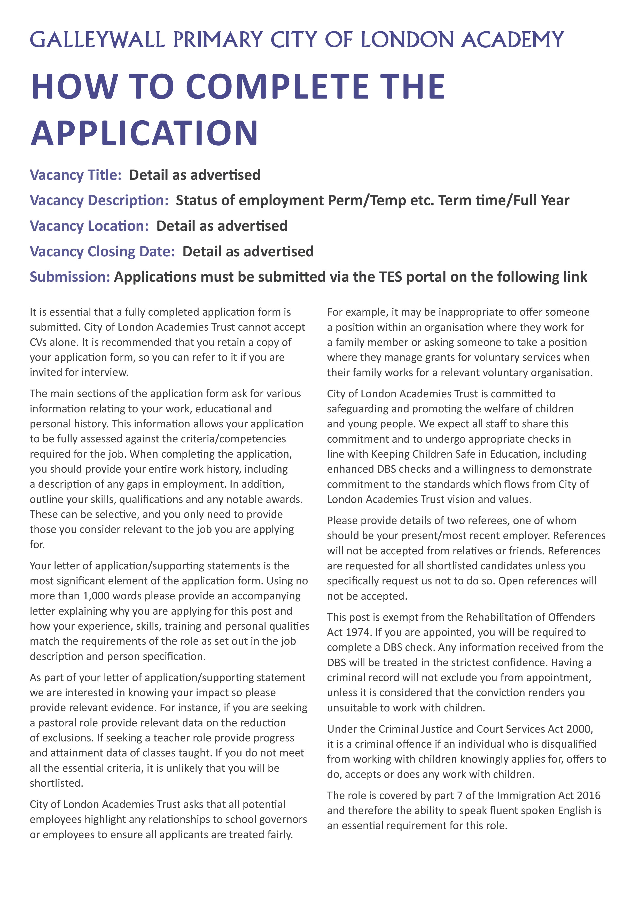
School Business Manager
Wednesday 03 June at 09.00
Applications must be submitted via the link to the My New Term portal
Galleywall Primary School
Permanent, Full Time, Term Time Only plus 3 weeks



