
Job Title: Building & Facilities Manager

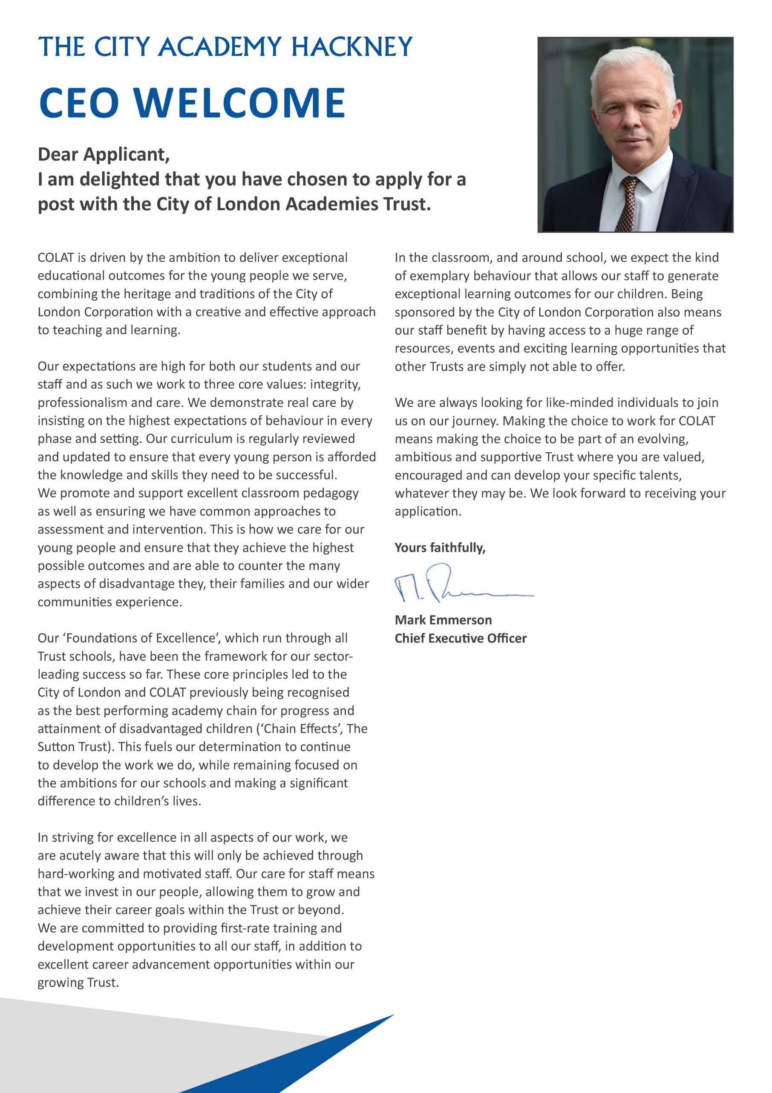

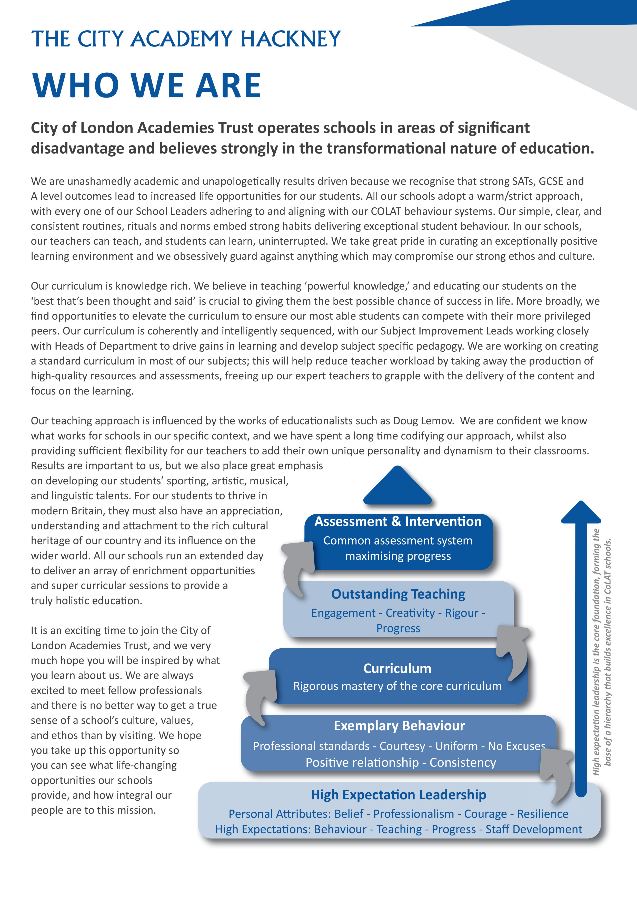

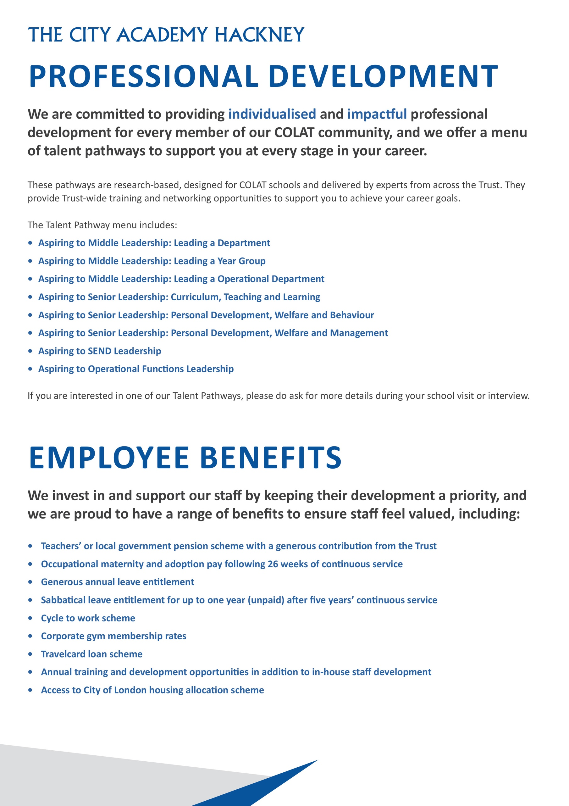
Headteachers Welcome

Dear Candidate,

Thank you for expressing an interest in the post of Building & Facilities Manager at The City Academy, Hackney.

At The City Academy, Hackney, we are dedicated to providing all the students in our community with the best possible educational opportunities. We believe excellence is achieved through three key ingredients: clear structures, high expectations and strong relationships. Our outstanding curriculum is built around 'The City Experience' which places equal value on academic, creative, sporting, linguistic and personal development.
We pride ourselves on being a school which offers young people a warm and supportive environment, enabling them to meet our very high expectations. Our inspirational staff are skilled and committed and we are generously supported by The City of London Academies Trust. As a result of this, our students make exceptional progress.
We are looking for staff who are committed to working with students of all abilities, who constantly seek to learn and improve and who are ambitious for themselves as well as for their students. We expect hard work, skill and dedication, and in return will provide a supportive, flexible working environment, first class training opportunities and a comprehensive benefits package.

If you have the experience and passion to join our team and inspire the next generation, we look forward to hearing from you. Please apply via our website: https://www.thecityacademyhackney.org/

If you have any questions or would like to arrange a visit to the academy please contact our HR team at hr@thecityacademy.org. I look forward to reading your application.

Yours sincerely,



Anna Sarchet
Principal

Building & Facilities Manager - Job Description

Post: Building & Facilities Manager

Accountable to: Head of Operations & Finance

Grade Scale Point Range: Grade PO2 SCP 32-33

Salary Range: £46,854 - £47,925 per annum (2025/6)

Working Pattern: Full time, 35 hours per week, 52 weeks per year. The role will require the post holder to work flexibly to meet the business needs of the academy, being prepared to work outside normal working hours and days when required, including out-of-hours and call-outs.

Location: City of London Academy Hackney

Disclosure level: Enhanced

Responsible for: Management of Premises Officers x 2

Main Purpose:
- To manage the site premises to ensure compliance with all health and safety legislation, including compliance with the Health & Safety at Work Act, undertaking all risk assessment, maintenance of fire and other safety equipment, hazards and defects
- To manager and oversee the quality and performance of all external facilities management contracts including: cleaning, site maintenance, grounds maintenance, security, mechanical and electrical, service engineers and all sub-contracts
- To plan and execute building works and refurbishments, updating and developing the asset management and forward-maintenance plans, liaising with the Head of Operations and Finance and the Principal to ensure the COLAT site is fit for purpose and operates efficiently.

Key Accountabilities

Site Management
- Support the Facilities Team, ensuring an effective and efficient service
- Lead the daily staff management and rota for the whole site, ensuring the safeguarding and security of students
- Manage efficiently and effectively all accommodation, buildings and grounds to ensure the safety of staff, students and visitors
- Ensure the security of the premises and equipment in accordance with the established procedures and practices, making recommendations for improvements where required
- Establish and maintain a proactive Health and Safety provision in conjunction with the Head of Operations and Finance

- Support the development of policies, systems and procedures for First Aid and premises management, ensuring records are maintained in accordance with HSE and education best practice
- Prepare and maintain all maintenance records
- Control the selection, supervision and quality of work undertaken, and ensure a safe system of work for all staff and external contractors working on site
- Manage staff requests for repairs and minor improvements through in-house work programmes
- Manage the Permit to Work schemes for all contractors coming to site
- Maintain, in conjunction with the Head of Operations and Finance, the asset register
- Identify and project manage building and refurbishment works
- Develop and oversee facilities budgets
- Maintain and develop spend plans and forecasts for all facilities function.
Managing Service Providers and Contractors
- Supervise and manage contractors when undertaking work on buildings and grounds, ensuring all labour levels associated with the maintenance and upkeep of the facilities are maintained, including any specialist sub-contractors used to deliver contracts
- Ensure safe working practices and appropriate quality standards are maintained across both sites including Risk Assessments and Method Statements
- Undertake contractor management responsibility for reporting and monitoring against key performance indicators, with regular reviews with contractors to review and resolve problems, anticipating changes to mitigate problems in advance
- Manage the safety and security of the sites throughout the term and during closure period on a daily basis
- Proactively manage the premises and key building management and control systems including access system, CCTV, BMS, fire safety systems, plant and equipment, electrical systems
- Oversee and monitor energy consumption and energy usage
- Ensure building systems and assets are maintained in such a way as to maintain warranties (where appropriate), to reduce running costs and maximise asset life
- Lead and manage all contractors, ensuring they follow all relevant protocols.
Health and Safety
- Manage safety and security of the site through the external FM Contractor
- Provide health and safety and facilities induction for all staff and visitors as required
- Ensure staff, students and visitors are aware of reporting procedures, time frame of work and immediate action as required
- Provide health and safety training and updates to all staff as required to ensure safe practice across the site
- Ensure that all Health and Safety policies are implemented and adhered to, and that appropriate legislation is compiled in terms of both staff, contractors and suppliers
- Provide training for staff on preparation of Risk Assessments, review Risk Assessments prepared by staff, and prepare all common Risk Assessments
- Manage schedule of health and safety audits including Risk Assessments
- Recruiting First Aiders internally and sourcing training, ensure adequate equipment and supplies.

Fire Safety
- Act as Fire warden lead in conjunction with the Head of Operations and Finance.
- Recruit and train Fire wardens and source training
- Liaise with external FM to ensure Fire Safety assessments are undertaken and compliance with legislation
- Manage and implement the Fire evacuation procedures, including arranging termly fire drills, updating procedures to reflect changes and ensuring compliance with legislation and the recommendations of external consultants
- Liaise with the Police and Fire Brigade in all aspects of security, fire and safety and take appropriate action in the case of a break in, theft or fire.
Statutory Responsibilities
- To work within a framework of best practice governed by the relevant occupational standards
- To promote the safety and wellbeing of students, ensuring that the Child Protection and Safeguarding policies and procedures
- To be responsible for your own health and safety and that of students and your colleagues, in accordance with the Health and Safety at Work Act 1974 and all applicable regulations and ACOPs
- To adhere to the Trust’s Equality policy in all activities, and actively promote equality of opportunity.
Other Duties
- To undertake such other duties as reasonable and commensurate with the general character of the post.
- All staff at The City Academy have a responsibility to be aware and supportive of First Aid requirements for pupils and staff, on-site and on trips and visits. It is an expectation in many support staff roles that participation in a managed First Aid rota will be required. In these instances a small allowance and full training will be given.
Safeguarding Children
COLAT is committed to safeguarding and promoting the welfare of children and young people. We expect all staff to share this commitment and to undergo appropriate checks, including enhanced DBS checks.

The above responsibilities are subject to the general duties and responsibilities contained in the Statement of Conditions of Employment. The duties of this post may vary from time to time without changing the general character of the post or level of responsibility entailed.

The person undertaking this role is expected to work within the policies, ethos and aims of the Trust and to carry out such other duties as may reasonably be assigned. The post holder will be expected to have an agreed flexible working pattern to ensure that all relevant functions are fulfilled through direct dialogue with employees, contractors and community members.

English Duty
This role is covered under part 7 of the Immigration Act 2016 and therefore the ability to speak fluent spoken English is an essential requirement for this role.

Building & Facilities Manager – Person Specification

Our Values and Vision
The City of London Academies Trust, sponsored by the City of London Corporation, aims to provide high-quality education for students and pioneer educational innovation. We are driven by the ambition to provide world-class experiences and deliver exceptional educational outcomes for the young people we serve.

All City of London academies draw upon the traditions, institutions, heritage and historical successes of London to furnish each of their diverse communities with life-transforming learning experiences. In doing so, we believe that the young people we serve develop into successful, compassionate young adults, who make a positive contribution to their local, national and global communities.

Our schools are characterised by a common understanding of what makes outstanding schools, based on five key principles which are known as our 'Foundations of Excellence'​.

Our Staff
Our staff have high expectations, are consistent and driven to provide the best teaching and opportunities for our students. Teachers work in a well-disciplined environment where they are able to teach creative and engaging lessons, and all staff are given exciting opportunities to develop and learn from exceptional practitioners.

Equal Opportunities
The postholder will be expected to carry out all duties in the context of and in compliance with the COLAT Equalities policies.

 | Essential | Desirable
Qualifications
City & Guilds/OND in Engineering and/or Plumbing |  | Y
Formal Health & Safety qualification – NEBOSH |  | Y
Membership of relevant professional organisation e.g. BIFM , CIOB, RICS |  | Y
Evidence of on-going training and development relevant to the role | Y
Experience, Skills and Knowledge
Facilities management skills and experience | Y
Experience working within the education sector |  | Y
Project management skills and experience |  | Y
High level of health and safety knowledge | Y
Experience of overseeing building maintenance | Y
Customer focused approach | Y
Strong administrative and organisational skills | Y
‘Can do’, positive approach to problem solving | Y
Ability to prioritise workload and meet deadlines | Y
Excellent communication skills | Y

 | Essential | Desirable
Ability to consider immediate and potential factors and their possible impact on successful implementation of any solution | Y
Ability to work using own initiative and as part of a team | Y
Personal Qualities
Flexible attitude to work including:  - Working hours and attendance out of hours, as required  - Demands and changes within the role | Y
Able to act with integrity and honesty | Y
Able to maintain confidentiality | Y
Collaborative working | Y
Excellent timekeeping | Y
Set high standards and expectations for self and others | Y
Smart, professional appearance | Y
Other
Willing to undertake any training required for the effective implementation of the role | Y
Commitment to safeguarding and promoting the welfare of children and young people | Y
Willingness to undergo appropriate checks, including enhanced DBS Checks | Y
Motivation to work with children and young people | Y
Ability to form and maintain appropriate relationships and personal boundaries with children and young people | Y
An understanding of, and commitment to, Equal Opportunities, and the ability to apply this to strategic work and day-to-day situations | Y

Building & Facilities Manager ManaManaManager
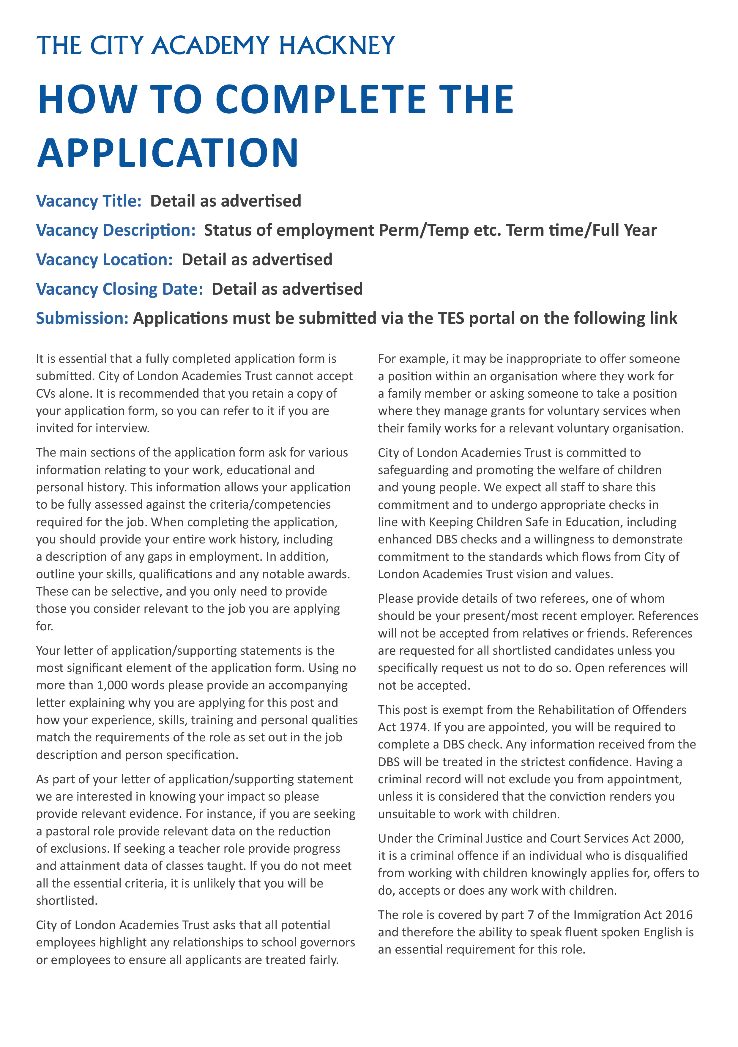
Permanent, Full time 35 hrs per week, All year round 52 weeks per year
Friday 24 July 2026, 9am
The City Academy Hackney
Applications must be submitted via MyNewTerm



