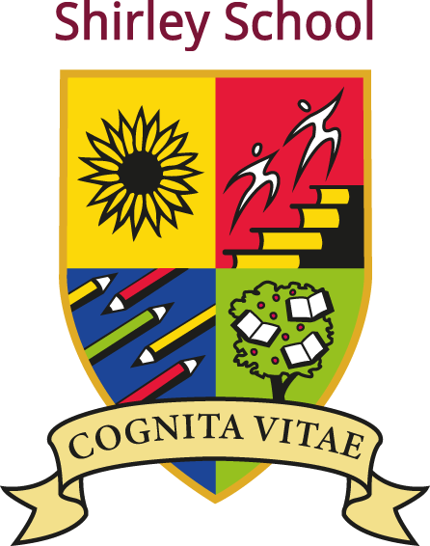

Shirley Community Primary School

Shirley Pre-School

Nuffield Road, Cambridge CB4 1TF

www.shirley.cambs.sch.uk

e-mail: office@shirley.cambs.sch.uk

Tel: 01223 712252

Headteacher Mr J A Cattermole B.A. (Hons), PGCE, NPQH

Required from April 13th 2026: 1x Full-time Class Teacher (Main scale M1-M6)

This post is Fixed Term (13/04/2026 to 31/08/2026)

We are looking for someone who:
- Is an excellent practitioner and team player
- Is inspirational, adaptable, resilient and consistent in their approach to working with children
- Has high expectations and a commitment to raising standards
The post is open to experienced teachers and ECTs
Shirley Community Primary is situated in north Cambridge, 10 minutes’ walk away from Cambridge North Station, which is on the main trainline between Kings Lynn and London. We are also within easy access of the A10, A14 and M11 roads.

Closing date: 27/02/2026 09:00
Interviews: Week Beginning 3/3/2026.

Application via ‘My New Term 'only.

Applicants should include a letter of application to the Headteacher, outlining their experience, teaching ethos, what they hope to bring to Shirley and how they meet the person specification.

Visits to the school are welcome. If you would like to visit us for a tour, please contact the school office and ask to speak to Claire Smalley, the Interim Headteacher, to book a time – alternatively email us at head@shirley.cambs.sch.uk

Shirley Community Primary School is committed to safeguarding and promoting the welfare of children and young people and expects all staff and volunteers to share this commitment. All appointments are conditional and subject to an enhanced DBS check.

