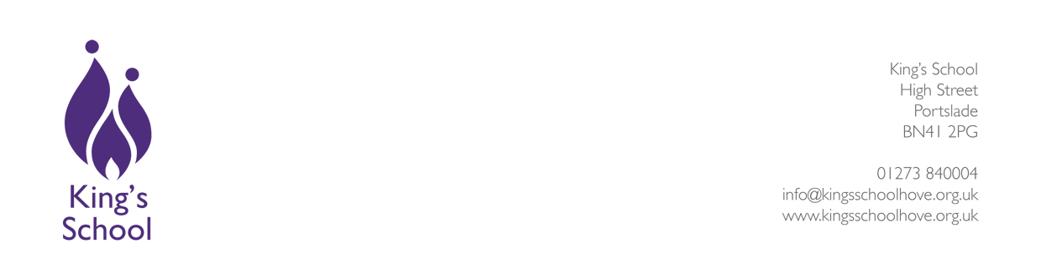
Job Profile & Person Specification

Teacher
Core purpose
To secure rapid progress for students throughout the school through the provision of high quality teaching and learning. All teachers at the school are expected to meet the requirements of the National Teachers’ Standards.

General Responsibilities
- To deliver the curriculum through the scheduled teaching programme.
- To perform duties and attend meetings as required.
- To assess and record students' progress, to prepare reports and take part in parental consultations.
- To undergo in-service training where required to keep abreast of developments in school initiatives curriculum and subject areas.
- To contribute to the school's pastoral system.
- To observe and implement current school policies and good practice.
- To participate in the School’s performance management scheme.
- To provide emergency cover (rarely and in unforeseen circumstances) for absent teachers.
- To carry out such particular duties as the Headteacher may reasonably direct from time to time, in accordance with the Teachers' Pay and Conditions Document.

Person Specification
Experience – the successful candidate will have:
- Successful secondary phase teaching experience resulting in good and outstanding learning.
- Experience of teaching their primary subject to Key Stage 3 and 4.
- Experience working with students of a range of abilities and prior attainment.
- Experience in raising standards through intervention and other strategies.
- Experience in using data and benchmarking to ensure the rapid progress of every student.
- A clear understanding of health and safety requirements as relate to the subject and wider school life.

Professional knowledge – the successful candidate will know:
- The relationship of their subject to the curriculum as a whole, and will have outstanding subject knowledge.
- The statutory curriculum requirements for the subject, the requirements for assessment recording and reporting and the use of assessment for learning in developing student understanding.
- How to develop students’ literacy, communication, numeracy, and ICT skills.
- The most effective methods of using ICT to improve learning in their subject area.
- The implications of the Special Educational Needs Code of Practice.
- The Health and Safety requirements for teaching and learning in the subject.
- How effectively to support students’ pastoral and emotional needs and ensure the care of the “whole child”.
- The importance of current educational issues and developments in improving standards.

Skills – the successful candidate will be:
- An outstanding classroom practitioner who leads by example.
- An effective and supportive team member.
- A (potential) leader of whole school performance
- Skilled at monitoring and evaluating student progress.

Attributes – the successful candidate will:
- Support the Christian ethos and values of the school.
- Be flexible and resourceful.
- Be an effective member of a team.
- Display moral, intellectual and personal integrity and authority.
- Show determination, optimism and resilience in the face of challenges and set-backs.
- Be committed to equality of opportunity, community cohesion and student social mobility.

Qualifications – the successful candidate will:
- Be qualified to degree level.
- Have or be working towards qualified teacher status.
- Have undertaken recent and relevant professional development.

