
Reflection Room Manager

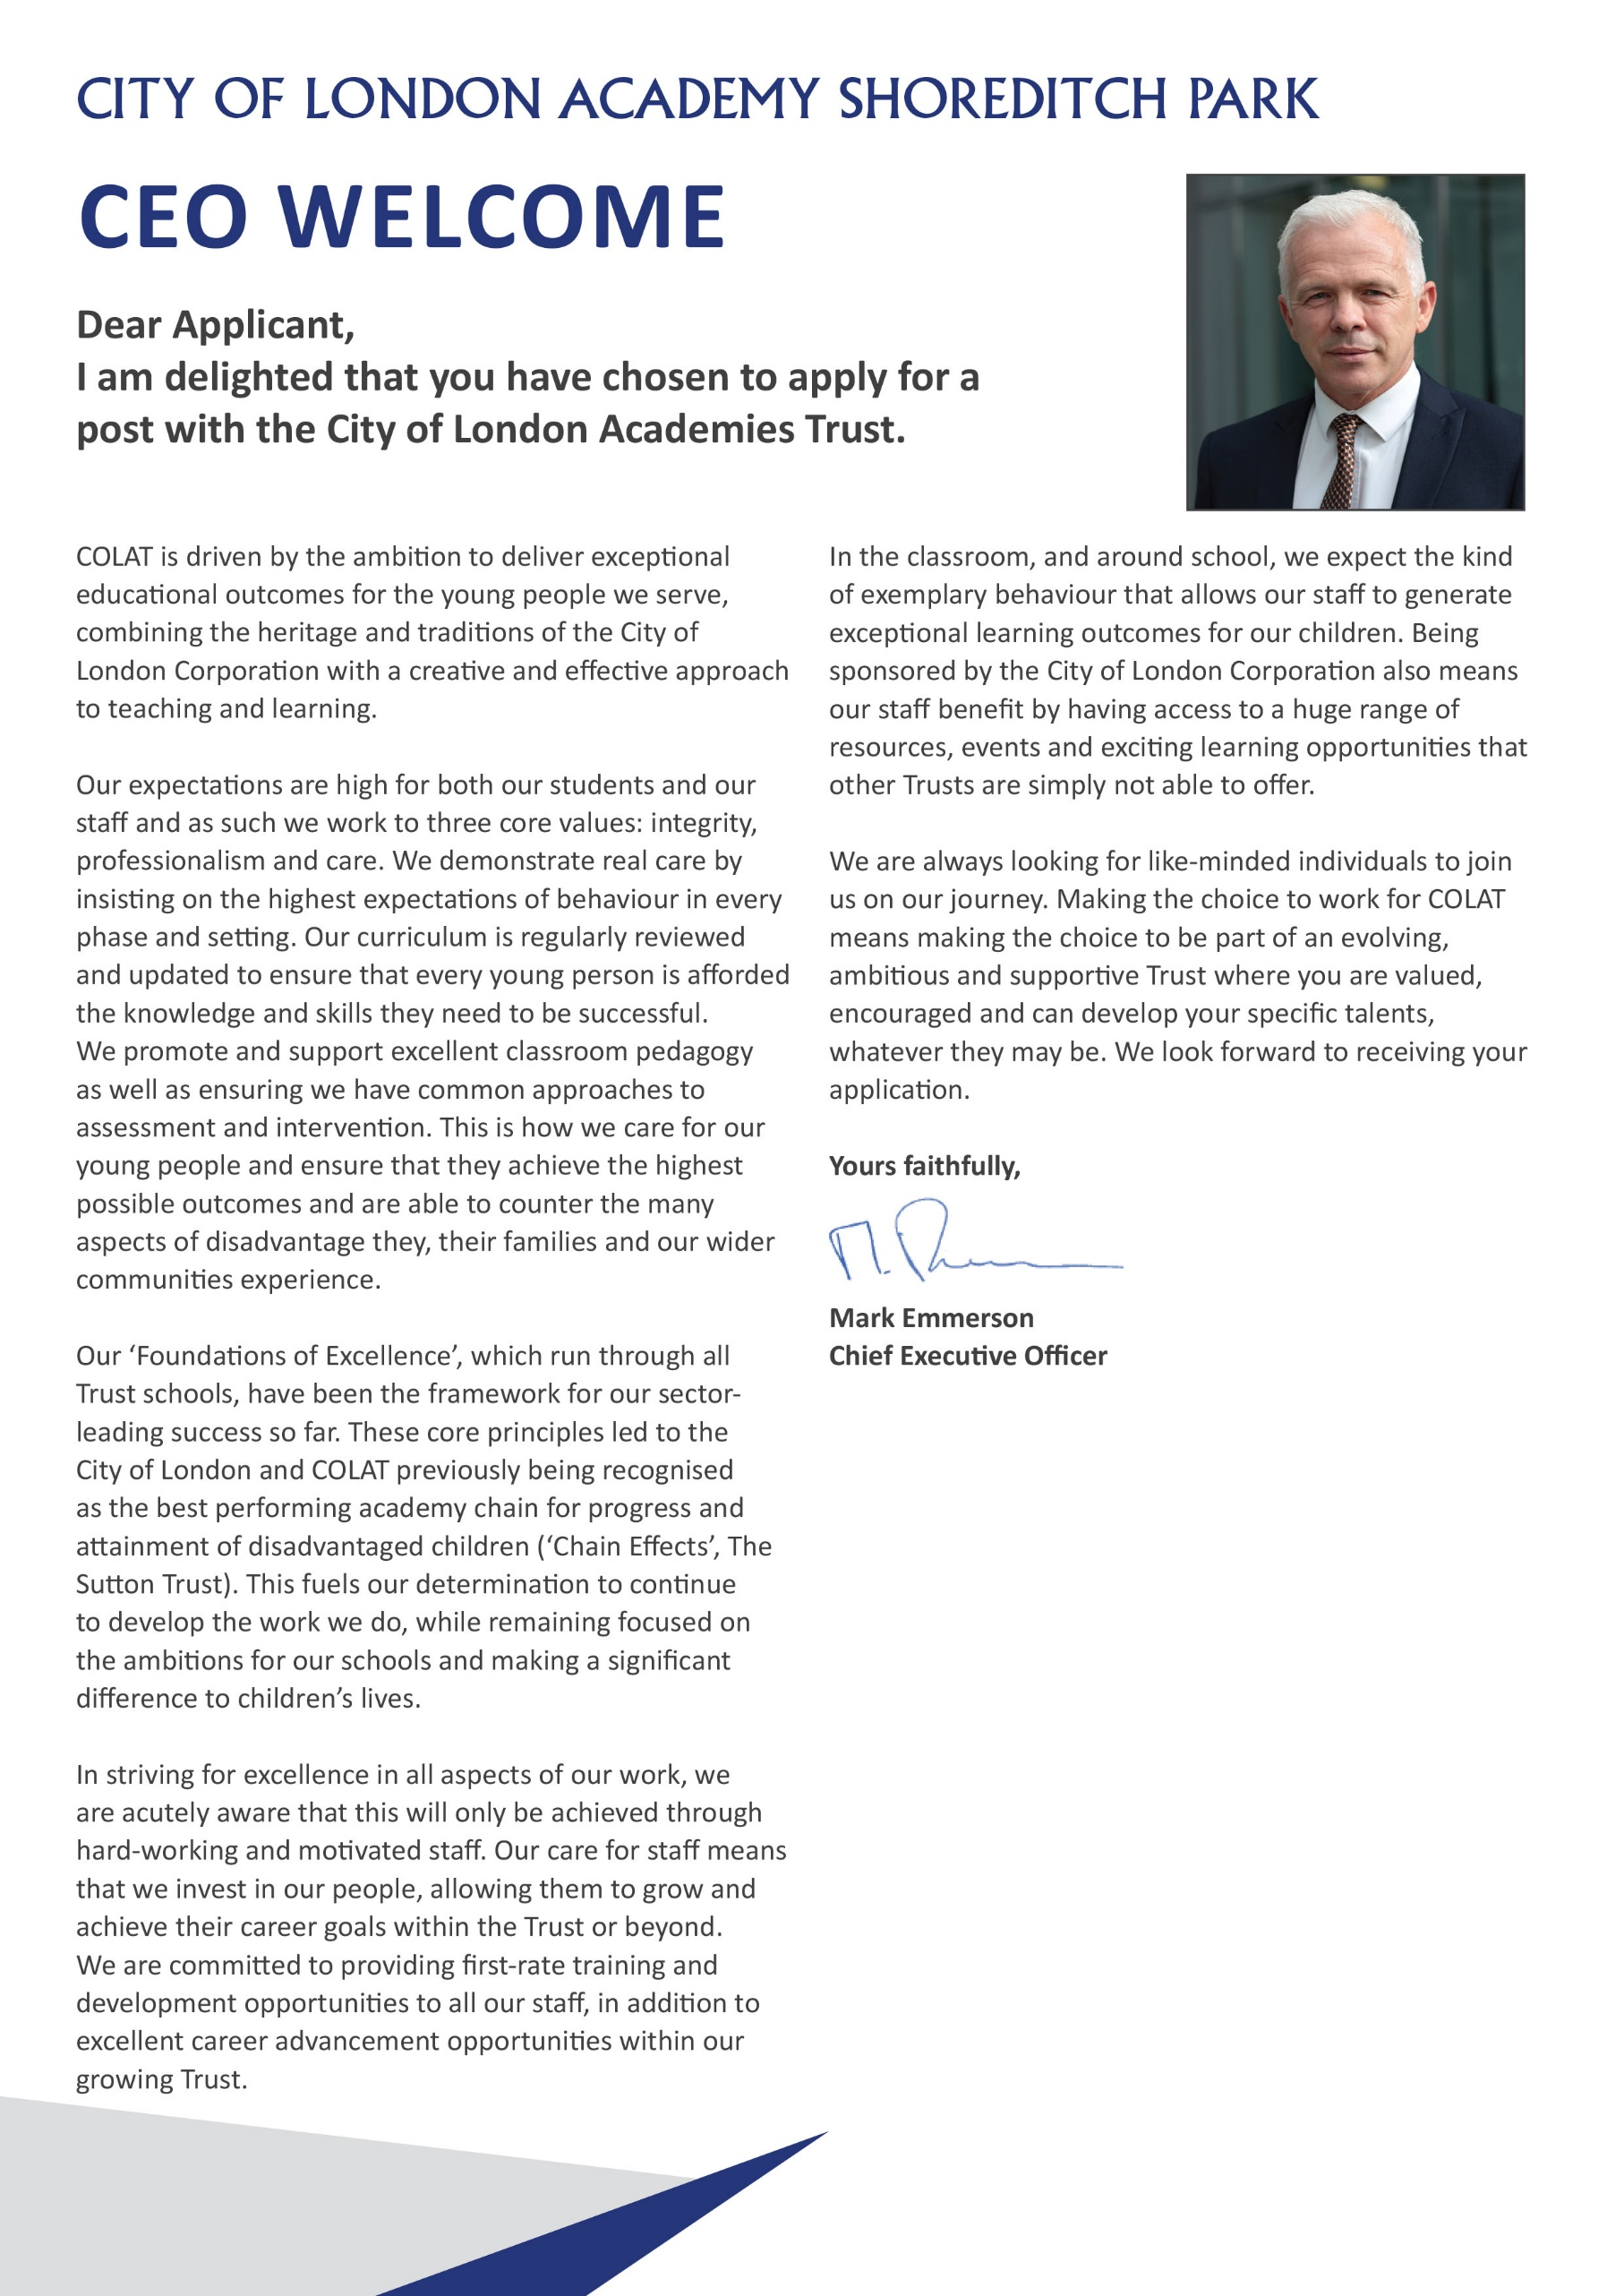

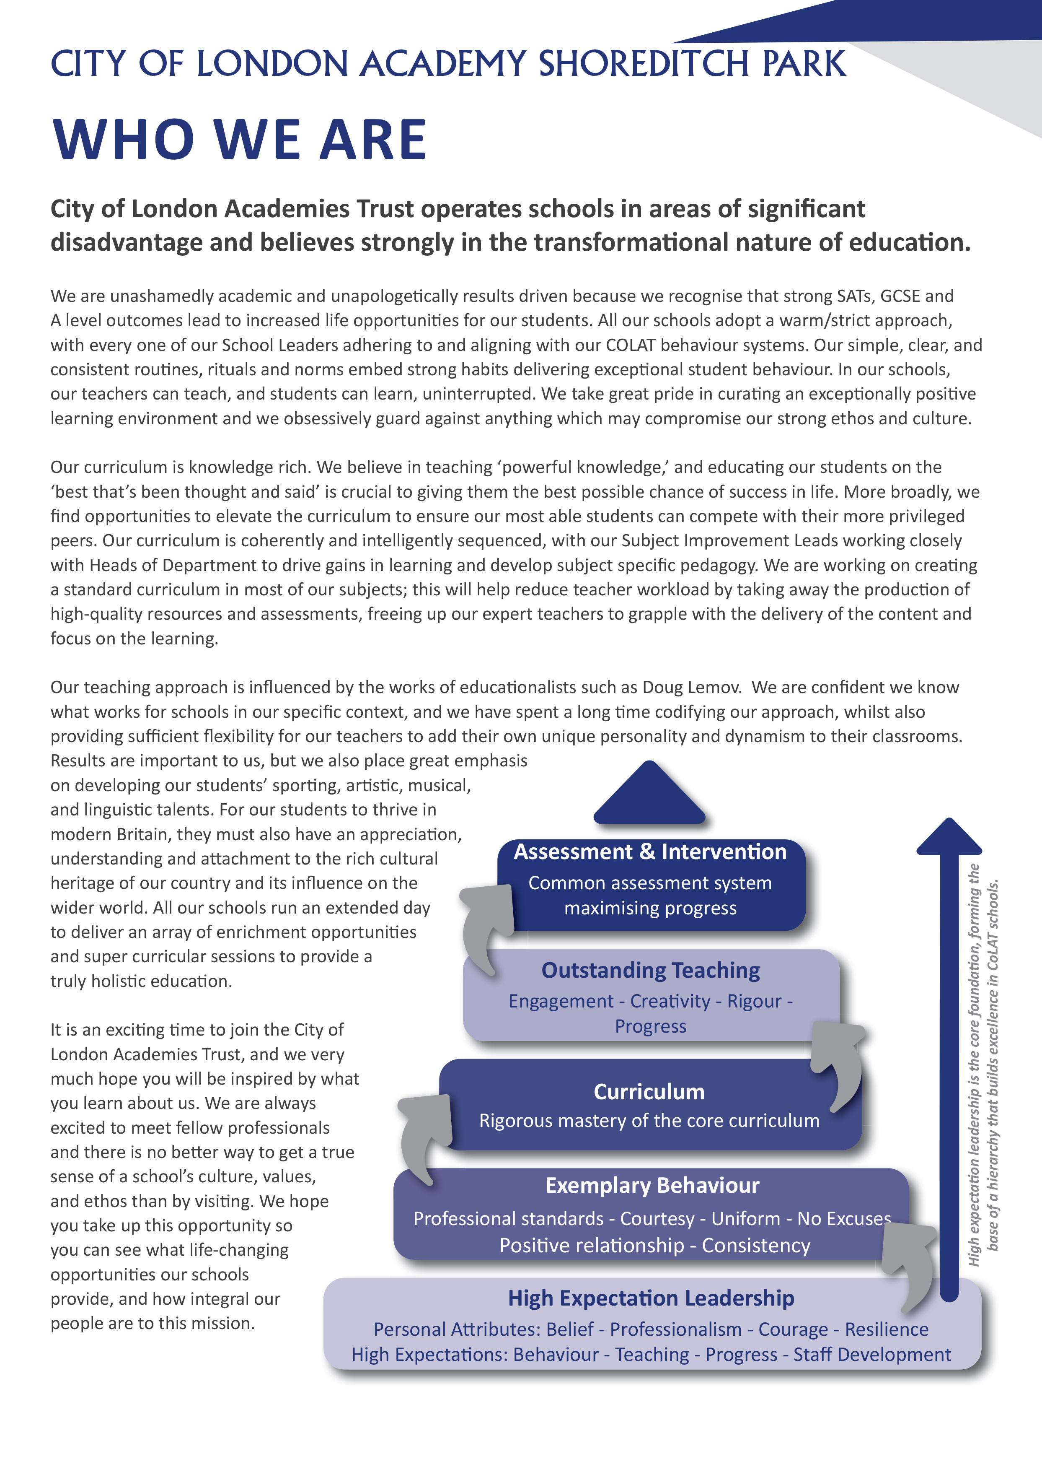

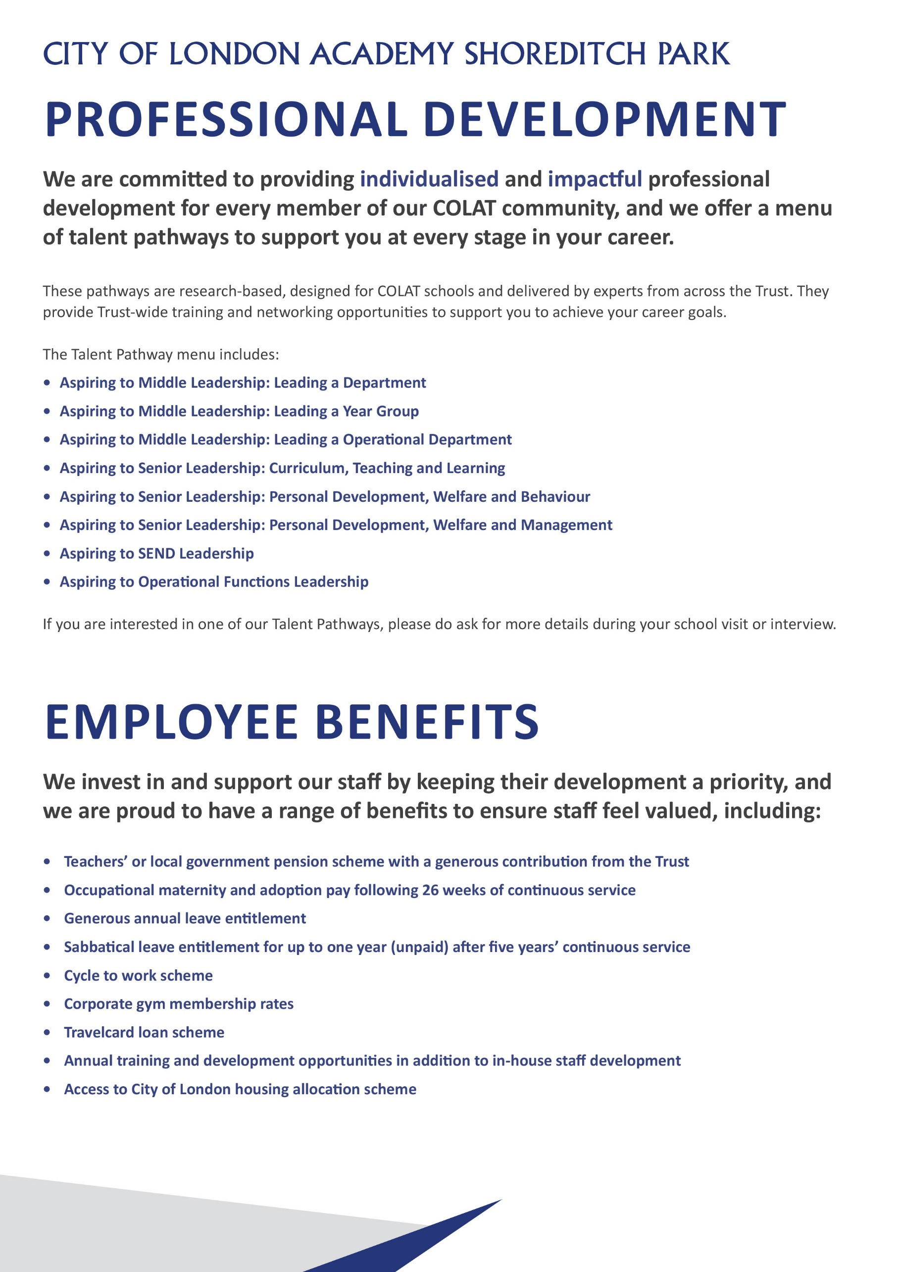
Principal’s Welcome

City of London Academy Shoreditch Park

We are currently looking to appoint driven and highly skilled staff members to our talented and experienced staff body who will help us to continually improve on our outstanding outcomes and who are willing to stay the course to achieve the vision of raising our Progress 8 figure from +0.68 to +1.

If you are aligned with our vision, values and mission to improve students’ life chances, we want to hear from you.

We are looking for candidates who will contribute to improving every aspect of the school’s provision, even the outstanding elements. The successful candidate will have an eye for detail, recognise excellence when they see it and not be afraid to challenge underperformance when standards are not as high as they should be. You will have the necessary skills and qualities to support the school to achieve its objectives. You will be someone who wants to contribute to all aspects of academy life and who has a constant eye on outcomes for students.

Our staff body is characterised by a relentless focus on student outcomes and supporting students from disadvantaged backgrounds, as well as the attention to detail and high expectations that are required to do so. We have extremely strong behaviour routines with line ups, single file silent corridors and family dining: all the key components of a warm/strict school.

Our Senior Leadership Team is committed to providing the highest quality training and support for staff to enable them to flourish and develop, whatever their role in the school.

City of London Academy Shoreditch Park opened in September 2017 and is now a full, thriving school with the highest academic outcomes in the City of London Academies Trust for four years running. We are the third highest performing secondary school in Hackney and we have ranked 12th, 4th and 7th in the country for similar schools over the past 3 years.

We are looking for members of staff who will join our mission to continually drive up our Progress 8 score of +0.68. Our vision is to become the best school in the country, and to achieve this we need the best teachers and support staff in the country.

Whatever their background or starting point, we aim to teach our students the skills, knowledge and values that will enable them to become happy, successful and employable young adults. Our culture balances expectations of self-discipline with the positive support from teachers that enable students to feel happy and safe in school.

If you share this moral imperative, then we welcome your application for this role.

I look forward to hearing from you.



Holly Arles
Principal

Reflection Room Manager - Job Description

Post: Reflection Room Manager

Accountable to: Lead Behaviour Mentor

Grade Scale Point Range: Grade 5 Scale Point 13 – 15 £34,863 -£35,892 FTE
£33,273.25 - £34,255.32 Pro Rata

Working Pattern: 37 hours, term time only.

Location: City of London Academy Shoreditch Park, 40 Hyde Road, N1 5JU

Disclosure level: Enhanced

Key Accountabilities

Supervision and Monitoring:
- Oversee the daily operation of the Reflection Room, maintaining a secure and controlled environment.
- Supervise all students in the Reflection Room and ensure students are working silently and independently at all times.
- Monitor the behaviour and work of students assigned to the Reflection Room.
- Ensure that the system of Reminder, Warning, Fail is implemented effectively.
Communication:
- Collaborate with teaching and support staff to gather relevant information about the students placed in the Reflection Room.
- Communicate daily to staff regarding which students are in the Reflection Room that day and why.
- Communicate effectively with parents and guardians regarding the reasons for exclusion and the expected duration.
Record Keeping:
- Maintain accurate and up-to-date records and registers of students placed in the Reflection Room, including the reasons for exclusion and any notable incidents.
- Provide regular reports to the Lead Behaviour Mentor, Achievement Team Leaders and Senior Leadership Team on internal exclusion trends and patterns.
Support and Guidance:
- Offer guidance and support to students during their time in the Reflection Room, fostering a positive and constructive atmosphere.
- Work closely with the school's pastoral care team to address underlying issues contributing to challenging behaviour.
- Support students to reflect on their behaviour and ensure restorative meetings and apologies take place with the relevant staff members.
- Work to ensure that students are not repeatedly placed in the Reflection Room.
Reintegration Planning:
- Collaborate with relevant school staff to plan for the successful reintegration of students into mainstream classes following the exclusion period.
- Implement strategies to help students address and learn from their behaviour.
Training and Development:
- Participate in relevant training sessions to stay informed about best practices in behaviour management and Reflection Room operation.
- Provide guidance to staff on effective approaches to supporting students in the Reflection Room.

Administrative Support for the Behaviour Department
- Communication with parents via email, phone and letter.
- Work flexibly with all other members of the Behaviour Team to ensure a coherent approach across the school.
- Use data to identify trends in student and parent engagement.
- Assist with the administration of the Behaviour Team.
- Develop relationships with teachers to support students effectively.
- Support information-sharing and the appearance of the Reflection Room by designing, mounting and refreshing relevant displays.

Leadership of self and others by:
- Providing an approachable and supportive presence for staff, students, parents and the local community.
- Setting high standards and expectations for personal, student, and staff behaviours and actions in support of the achievement of the academy’s intended outcomes.
- Helping to develop and maintain respect across all stakeholders, inspiring individuals to contribute positively to shared ideas and plans for the academy.
- Playing a part in creating a positive, inclusive climate that carries the academy’s vision forward.
- Regularly reviewing own practice, setting personal targets and taking responsibility for own development.
- Maintaining open professional dialogue with the Lead Behaviour Mentor about the identification of academy strengths and weaknesses, ensuring a proactive approach to sharing and solving potential or existing difficulties.
- Being committed to a collaborative vision of excellence and equality that sets high standards for every student and member of staff.

Assist in management of the organisation by:
- Liaising with all academy staff, parents and students where required.
- Liaising with external agencies as appropriate.
- The effective use of ICT.
- Where applicable undertaking additional administrative tasks including stock recording, ordering etc.
- Working within a defined organisation structure which enables effective and efficient ways of working and support the achievement of the academy’s objectives.
- Acting in accordance with policies and legislation affecting the conduct of the academy, particularly those that govern health and safety matters and employment rights.
- Undertaking any other duties commensurate with the post as reasonably delegated by the Principal and Governing Body.

Standards/Quality Assurance and Additional Responsibilities
- Participate in staff training and development.
- Develop relationships with governors, LEAs and neighbouring schools/academies.
- Adhere at all times to professional business standards of dress, courtesy and efficiency in line with the ethos and specialism of the academy.
- Attend team and staff meetings.
- Compile statistical returns as required.
- Attend and participate in Open Evenings and other events where required.
- Uphold the academy’s behaviour code and uniform regulations.

Key Organisational Objectives
The postholder will contribute to the academy’s objectives in service delivery by:
- Following Health and Safety requirements and initiatives as directed.
- Sharing the Academy’s commitment to safeguarding and promoting the welfare of children and young people.
- Ensuring compliance with Data Protection legislation.
- At all times operating within the school’s Equalities policies, demonstrating commitment and contribution to improving standards of attainment.
- Ensuring customer care and quality assurance initiatives.
- Fulfilling the role of Student Personal Adviser and/or mentor if required.
- Contributing to the maintenance of a caring and stimulating environment for young people.

Special Conditions of Service to Note
Governed by the National Agreement on Pay and Conditions of service, supplemented by local conditions as agreed by the Trust. The postholder may be required to work outside of normal school hours on occasion (e.g. to attend Full Governing Body and/or Committee Meetings, etc.), with due notice.

Because of the nature of the post, candidates are not entitled to withhold information regarding convictions by virtue of the Rehabilitation of Offenders Act 1974 (Exemptions) Order 1975 as amended. Candidates are required to give details of any convictions on their application form and are expected to disclose such information at the appointed interview.

Because this post allows substantial access to children, candidates are required to comply with departmental procedures in relation to Police checks. If candidates are successful in their application, prior to taking up post, they will be required to give written permission to the Department to ascertain details from the Metropolitan Police regarding any convictions against them and, as appropriate the nature of such convictions. The academy is committed to safeguarding and promoting the welfare of children and young people and we expect all staff to share this commitment.

Associated Duties
The current School Teachers’ Pay and Conditions document describes the duties which are required to be undertaken in the course of employment. In addition, certain particular duties are reasonably required and exercised and completed in a satisfactory manner. It is the contractual duty of the postholder to ensure that professional duties are discharged effectively.

Safeguarding Children
COLAT is committed to safeguarding and promoting the welfare of children and young people. We expect all staff to share this commitment and to undergo appropriate checks, including enhanced DBS checks.

The above responsibilities are subject to the general duties and responsibilities contained in the Statement of Conditions of Employment. The duties of this post may vary from time to time without changing the general character of the post or level of responsibility entailed.

The person undertaking this role is expected to work within the policies, ethos and aims of the Trust and to carry out such other duties as may reasonably be assigned. The post holder will be expected to have an agreed flexible working pattern to ensure that all relevant functions are fulfilled through direct dialogue with employees, contractors and community members.

English Duty
This role is covered under part 7 of the Immigration Act 2016 and therefore the ability to speak fluent spoken English is an essential requirement for this role.

Reflection Room Manager – Person Specification

Our Values and Vision
The City of London Academies Trust, sponsored by the City of London Corporation, aims to provide high-quality education for students and pioneer educational innovation. We are driven by the ambition to provide world-class experiences and deliver exceptional educational outcomes for the young people we serve.

All City of London academies draw upon the traditions, institutions, heritage and historical successes of London to furnish each of their diverse communities with life-transforming learning experiences. In doing so, we believe that the young people we serve develop into successful, compassionate young adults, who make a positive contribution to their local, national and global communities.

Our schools are characterised by a common understanding of what makes outstanding schools, based on five key principles which are known as our 'Foundations of Excellence'​.

Our Staff
Our staff have high expectations, are consistent and driven to provide the best teaching and opportunities for our students. Teachers work in a well-disciplined environment where they are able to teach creative and engaging lessons, and all staff are given exciting opportunities to develop and learn from exceptional practitioners.

Equal Opportunities
The postholder will be expected to carry out all duties in the context of and in compliance with the COLAT Equalities policies.

 | Essential | Desirable
Qualifications
Educated to degree level or equivalent
Evidence of continuing professional development
Experience and skills
Fully conversant with all aspects of MS Office, email and internet
Ability to provide high-quality administrative support to staff
Ability to provide high-quality behavioural/emotional support to students
Knowledge of whole school behaviour systems
Knowledge of multi-agency working
Experience of setting up, using, maintaining and developing behaviour systems
Demonstrable experience of improving student outcomes
Personal Qualities
Ability to organise and prioritise workload and work on own initiative
Excellent written and oral communication at all levels
Ability to work under pressure while maintaining a positive, professional attitude
Ability to ensure that deadlines are met
Ability to work as part of a team
Ability to work independently
Attention to detail in communication and planning
Ability to problem-solve
Ability to develop good relations with staff and pupils and the wider school community
Well-organised
Well-presented
Fast and accurate keyboard skills
Good understanding of database systems to produce reports and statistics
Ability to communicate with and support parents, maintaining a calm professional and friendly attitude even in difficult situations or conversations
Vision and values aligned with the academy’s high aspirations and high expectations for children, staff and families
Commitment to working with others to secure the best outcomes for children
Skilful management and understanding of how to secure strong relationships with other academy staff, families, trustees and other external relationships
Commitment to safeguarding and promoting the welfare of children and young people
Willingness to undergo appropriate checks, including enhanced DBS Checks
Motivation to work with children and young people
Ability to form and maintain appropriate relationships and personal boundaries with children and young people
Other
Vision and values aligned with the academy’s high aspirations and high expectations for children, staff and families
Commitment to working with others to secure the best outcomes for children
Skilful management and understanding of how to secure strong relationships with other academy staff, families, trustees and other external relationships
Commitment to safeguarding and promoting the welfare of children and young people
Willingness to undergo appropriate checks, including enhanced DBS Checks
Motivation to work with children and young people
Ability to form and maintain appropriate relationships and personal boundaries with children and young people

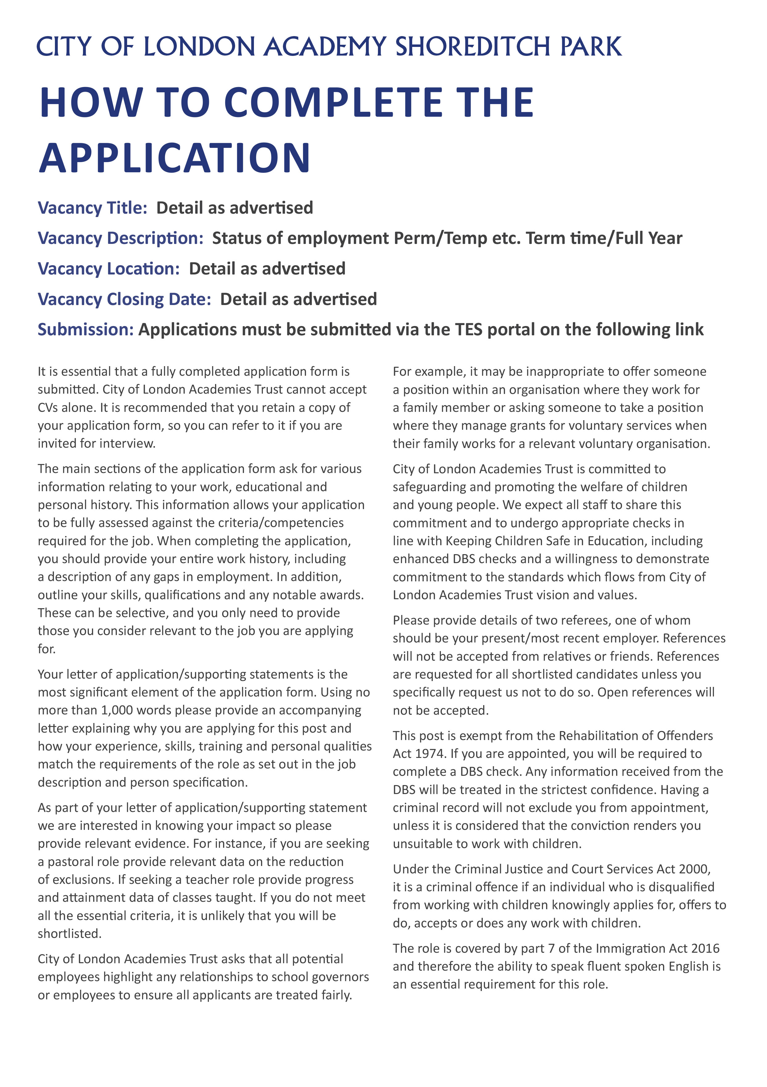
Applications to be submitted by the TES portal
Wednesday 9th September 2026
City of London Academy Shoreditch Park
Permanent
Reflection Room Manager



