
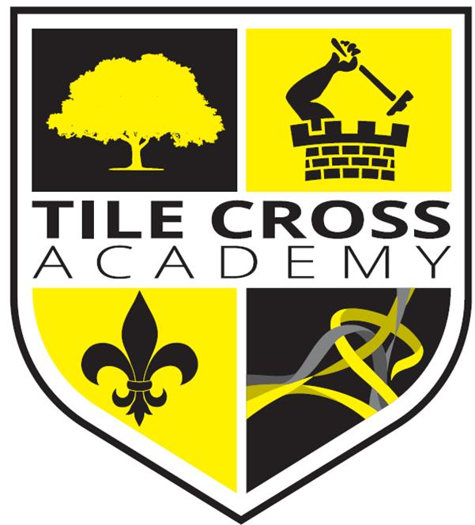
Tile Cross Academy

English – Deputy Head of Faculty
Candidate Pack

Headteachers Welcome

Welcome to Tile Cross Academy. Thank you for your interest in the role of Deputy Head of Faculty - English within our School.

At Tile Cross Academy we care deeply for our students; their safety and wellbeing is our primary concern. Tile Cross Academy is the ideal environment in which to stimulate the minds of the next generation. It is a special place where both students and staff feel a real sense of belonging, with relationships at the heart of everything we do. With the wide range of backgrounds and cultures represented in our school population we celebrate diversity and difference, whilst recognising that we are all equal through a Rights Respecting ethos where students’ rights are ‘learned, celebrated and lived’. We value everyone’s opinions and beliefs, whilst also encouraging every single child to achieve their very best.



We were honoured to be named ‘School of the Year 2020’ at the UK Social Mobility Awards and have been recognised as a finalist every year since. This reflects our unwavering commitment to providing opportunities for all students, regardless of background.
Most recently, in June 2024, we were rated 'Good' by Ofsted, a testament to the dedication and hard work of our staff, students, and wider school community.
Tile Cross Academy opened in May 2017 as part of the Washwood Heath Multi Academy Trust. It sits on a site once occupied by Central Grammar School for boys, Byng Kenrick Grammar School for Girls, Sir Wilfred Martineau School and The International School. Our new school sits at the very heart of its community with a proud and distinguished heritage and an exciting and successful future ahead of it.
Thank you for your interest in our school and I would like to take this opportunity to wish you well in your application.
Gurt Sanghera
Headteacher

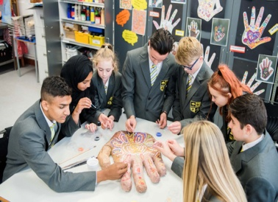



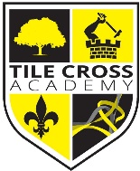

About Our School

School Vision & Ethos

Tile Cross Academy is a small and caring 11-16 mixed comprehensive school. We have high expectations for our students in which they develop through high quality Teaching and Learning and our focus to develop the Character of every child, so they become outstanding learners and citizens.

We aim to provide a high-quality education in an atmosphere of mutual respect where everyone is valued as an important member of our school community. We strive to develop and nurture the values, skills and attributes which create good citizens and lifelong learners, so that every student can discover, develop, and achieve their full potential and be successful in whatever path they choose. Our broad and balanced curriculum prepares our students to meet the challenges of a rapidly changing society, ready and willing to grasp the opportunities available to them and positive about their futures.

Curriculum Overview

Our curriculum is at the heart of our school and reflects our values ‘Strive, Achieve, Believe’.

At Tile Cross Academy we aim to offer a curriculum that is ambitious and designed to give all learners the knowledge and cultural capital they need to succeed in life. We offer this through a curriculum which is sequenced towards knowledge retention and developing skills for future learning and employment. We offer a full programme of enrichment activities to engage our learners that allows them to develop experiences outside the classroom.

We offer a full, broad and balanced curriculum with a diverse range of subjects including GCSE and Vocational subjects. Within our curriculum, we strive to improve literacy across all age groups so that our learners are articulate, speak to a high standard, listen to their peers and respond with fluency and expression, read widely and write with enjoyment and confidence.

We want all our students, no matter what their background or previous social and academic experience, to leave school as well qualified, resilient, independent and confident young adults, ready to make a highly positive contribution to their community and wider society.

In a rapidly changing world we feel strongly that our students should show adaptability and resilience as well as demonstrating respect, kindness and tolerance of people from all faiths, cultures and backgrounds.

Our ambitious curriculum will engage and stimulate our learners and develop their knowledge and skills to achieve high quality outcomes.

Our learners will:
- Experience a diverse, challenging, and engaging curriculum
- Thrive by exemplary practice modelled through our Teaching & Learning cycle
- Develop their independence, collaboration, and ability to evaluate
- Be supported and challenged as they aim to reach their true potential
- Be literate and articulate enabling them to access the wider world

Pastoral Care & Wellbeing

Tile Cross Academy Provides a caring atmosphere where students feel secure and comfortable as they settle down to focus on their learning.

Form Tutors and Pastoral Managers look after the day to day needs of students and they remain with their tutor groups throughout the five years wherever possible, getting to know both students and parents very well. We value our close partnership with parents and encourage them to be actively involved in their child’s education at every opportunity.

Students build up a trusting and friendly relationship with their Tutor, Pastoral Manager, Head of Year and peers through activities in registration and assemblies. Each Year group has a weekly assembly in the Central Hall, with Form Tutors, the Head of Year and a member of the Senior Leadership Team present. Others, including outside speakers are invited during the year. Heads of Year ensure the social and academic well-being of students in their year group as well as helping to maintain good attendance and standards of behaviour. A wide range of pastoral, wellbeing and academic interventions take place with students supported to overcome challenges and develop lifelong character traits.

Our culture and environment will empower each child to develop the attitudes and their characters to thrive, enabling them to be the best version of themselves.

Our learners will:
- Understand how their behaviours and attitudes impact on theirs and other children’s progress within a supportive, caring, and inclusive environment.
- Anticipate and experience being praised and rewarded as well as experience support and fair and effective sanctions when they fail.
- Grow through our Personal Development curriculum, modelling British Values, our ‘Character Days’ and our ethos of visible kindness.
- Understand their rights and responsibilities to themselves and others.
- Understand their roles within a cohesive, diverse community, celebrating our equalities and diversity.
- Prosper through understanding the needs and requirements of a healthy lifestyle.
- Be shaped for their future, their studies, their careers, and their lives as adults.
At Tile Cross Academy, we expect our students to be:

- On time, think smart and dress smart and be Ready to learn.
- Respectful of everyone in school; every child, every adult.
- Responsible for their learning and responsible for their actions.
- Resilient to the challenges that face them; in lessons and around school and as they grow through life.
- Reflective; understand what they do well, what they could do better and how they can all help each other grow and develop.

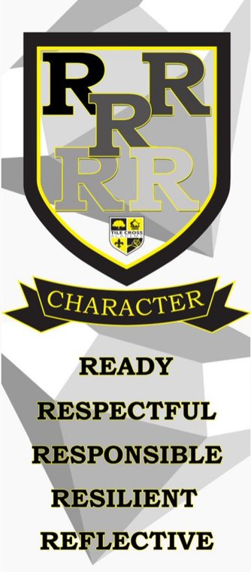

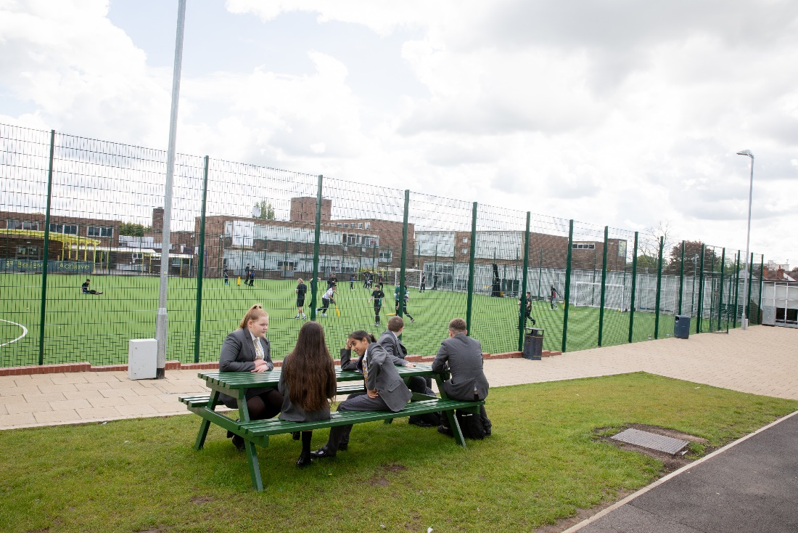
Our English Faculty

We want all our students to leave Tile Cross being able to read, write and communicate in all forms with fluency and confidence. All students are encouraged to stretch themselves in English lessons throughout their school life at Tile Cross. We promote challenging texts and exceptional writing to enable students to develop and deepen both their subject knowledge and expertise. As a supportive department in a diverse school, we explicitly incorporate children’s rights through discussions and activities that bear relevance to our wide-ranging texts, ensuring students’ rights are learned, understood and lived.

The department currently has 7 full time members of staff representing a range in experience and covering all specialisms for English Language and English Literature. We are located in Central building on the first floor and have a suite of fully resourced classrooms that are equipped for our delivery of multi-media lessons as and when required.

At Key Stage 3, we deliver a diverse and ambitious English curriculum designed to foster engagement, excitement, and fluency in reading, writing, and communication. Our curriculum is text-rich, featuring a wide range of material from contemporary works, such as Refugee Boy by Benjamin Zephaniah, through to canonical texts like Shakespeare’s Romeo and Juliet and classic Victorian literature. Every year, students are given the opportunity to study a Shakespearean text, progressively building their confidence and expertise to support their future academic success. Writing is woven throughout each year, with opportunities to develop both fiction and non-fiction skills, firmly rooted in their reading experiences. Competitions and enrichment activities further enhance pupils’ creativity and engagement, ensuring they see reading and writing as essential and exciting parts of their learning journey.

Our Key Stage 3 curriculum evolves year on year. In Year 7, pupils explore themes of identity, conflict, and emotional growth through poetry, prose, and drama. In Year 8, students deepen their understanding of internal and external struggles, tackling issues of injustice, inequality, and personal resilience through texts such as Of Mice and Men and The Merchant of Venice. In Year 9, pupils develop critical perspectives on societal structures and moral responsibility, studying The Crucible by Arthur Miller alongside Gothic literature and thematic poetry. Across Key Stage 3, pupils build their analytical reading skills, develop sophistication in their writing, and gain confidence in public speaking and debate, ensuring they are well-prepared for the demands of Key Stage 4.

At Key Stage 4, all students study both English Literature and English Language. We structure the pathway to success carefully. Pupils complete their studies of core Literature texts, including Macbeth A Christmas Carol, An Inspector Calls, and the AQA Power and Conflict poetry anthology. In addition to this, pupils consolidate their reading, writing, and evaluation skills across a variety of fiction and non-fiction texts for their study in GCSE English Language, with structured revision programmes, targeted feedback, and mock examinations designed to secure their best outcomes.
Throughout Key Stages 3 and 4, we strive to ensure English lessons are dynamic, challenging, and relevant. Alongside the study of set texts, pupils engage with topical issues such as youth crime, mental health, and societal wellbeing, helping them connect literature to the world around them. These thematic links not only drive engagement but also help to build resilience, empathy, and critical thinking skills – essential tools for life beyond school. Our curriculum aims to inspire all students to view English as a subject of exploration, empowerment, and opportunity.

We aim to ‘Create Confident Communicators’.
“Raise your words not your voice” Rumi

Job Description – English Deputy Head of Faculty; responsibilities in supporting KS3 and KS4 learning.

In addition to the responsibilities of class teacher as set out the Classroom Teachers Job Description (taken from the schoolteachers’ pay and conditions document) you will also undertake the following duties and responsibilities.

To provide outstanding Deputy Head of Faculty leadership for the subject of English and ensure that it is appropriately and effectively monitored and delivered.

Responsible to: Head of English Responsible for: KS3 and KS4
Salary: MPS/UPS + TLR 2b

Accountabilities:

Curriculum
- Be responsible for the day-to-day curriculum including developing Schemes of Work, Resources and Special activities.
- Ensure that the curriculum meets the needs of all students, is engaging and provides effective challenge.
- Keep up to date with national changes to the curriculum and make changes as appropriate.
- Identify and highlight aspects of SMSC (Spiritual, Moral, Social and Cultural) and the Rights of the Child delivered with the curriculum area.
- Ensure that there is consistency of assessment across the designated area and ensure that the assessments are appropriate to enable all pupils to achieve expected and more than expected progress.
- Monitor and review the delivery of the curriculum from other team members.
- Identify excellent practice and those in need of development.
- Ensure all teachers (including those from outside the department area) are provided with the resources to enable them to teach content effectively.
- Ensure cover work is suitable and supplied as required.
- Ensure team members have the knowledge to deliver and teach the controlled assessments effectively and seek training where appropriate – including health and safety and the use of innovative technologies.

Leadership and Management
- Produce a regular (after each data collection) review of progress relating to examination performance and suggest areas for development with respect to their specific area of responsibility.
- Contribute to the school improvement plan by setting and reviewing targets for the development of their specific area of responsibility.
- Encourage team members to develop their professional development and recommend training that might be appropriate.
- To support Head of Faculty in designing and developing departmental trackers for all year groups.
- Lead department team meetings and briefings, as necessary.
- Stand in for the Head of Faculty in their absence.

Behaviour and Safety
- Track the quality and quantity of homework tasks identifying trends and areas for development.
- Promote and celebrate the faculty raising the profile of the department through competition entries and promotional events.
- Promote and implement the vision of the faculty leader and school improvement plan.
- Promote the production and application of positive rewards within the designated area of responsibility.
- Support the HOF with behaviour monitoring and management within the faculty.
- Work with specific staff in a mentoring / coaching role as defined by HOF. This includes ECT and/or ITT mentoring.
- Recognise ‘hot spots’ for behaviour during lessons.

Monitoring and Review (in relation to the designated Key Stage or Curriculum area as defined by their job role)
- Review the progress of students after every whole school data entry point.
- Identify students and/or groups of students underperforming and those meeting and exceeding their assigned target grades.
- Track the progress of students using student voice, learning walks, lesson observations, whole school data, faculty data, work scrutiny and learning conversations.
- Develop and implement intervention strategies to improve progress of individuals and groups.
- Support teaching staff and support staff in the implementation of strategies.
- Review effectiveness of interventions through further use of monitoring.

Whilst every effort has been made to explain the main duties and responsibilities of the post, each individual task undertaken may not be identified. Employees will be expected to comply with any reasonable request from a line manager to undertake work of a similar level that is not specified in this job description.

Employees are expected to be courteous to colleagues and provide a welcoming environment to visitors and telephone callers. This job description is current at the date shown, but, in consultation with you, may be changed by the Head Teacher to reflect or anticipate changes in the job commensurate with the grade and job title.

Person Specification – Teacher
Key: A.F. = Application Form; I = Interview; T = Test or Exercise; P = Presentation

CRITERIA | ESSENTIAL | M.O.A | Criteria Met
EXPERIENCE  (Relevant work and other experience) | Experience of working in a school  Ability to teach KS3 and examination courses at KS4 | AF/I  AF/I
SKILLS AND ABILITIES  (e.g. Written communication skills, dealing with the public) | Excellent teacher performance in the classroom and ability to utilise an effective range of teaching and learning styles  Ability to create a learning environment that values all students equally and enables all to achieve  To provide opportunities for students to develop awareness of cross-curricular themes and key skills  Ability to work under pressure and meet competing deadlines  Knowledge of the curriculum and current issues in education  Ability to work in a pastoral team as a form tutor  Good understanding and competence in ICT  Good organisational skills  Excellent communication skills – written and verbal  Set high expectations for student behaviour and establish a clear framework for classroom discipline which promotes self-control and independence whilst managing students’ behaviour constructively  Work effectively as part of a team; developing positive relationships with colleagues, students, parents and other agencies as appropriate  Willingness to be involved in the extra-curricular programme within the faculty  Committed to raising standards in the school  High level of self-motivation and energy and enthusiasm for the education of young people | AF/I  AF/I  AF/I  AF/I  AF/I  AF/I  AF/I  AF/I  AF/I  AF/I  AF/I  AF/I  AF/I  AF/I
TRAINING | Willingness to undertake appropriate training  Willingness to deliver appropriate training within the school training plan | AF/I  AF/I
EDUCATION/  QUALIFICATIONS  NB Full regard must be paid to overseas qualifications | Qualified teacher status  Degree or equivalent  Subject specialism that has been applied for | AF/I  AF/I  A/F/I
OTHER | Ability to respond flexibly and adapt to changing and challenging circumstances  Ability to persuade, negotiate and influence others  Ability to maintain strict confidentiality of information received and processed as part of the job role  Ability to set and maintain high standards within the maths team  Ability to project a professional image for the school  Ability to have a flexible approach to work to meet the needs of the school | AF/I  AF/I  AF/I  AF/I  AF/I  AF/I
CONTRA INDICATION | Criminal convictions involving offences against children | AF/I

We are part of Washwood Heath Multi Academy Trust, welcoming students from 11 years old to 16 years old, providing a standard of academic excellence for secondary and education. We are very proud of the positive learning experience offered to our students and the support available to ensure they achieve their full potential.
We:
- offer an excellent induction programme within a friendly and supportive environment
- offer a whole range of opportunities to further develop colleagues’ teaching skills and leadership
potential, including a Supportive NQT Induction Process & Policy, Career Pledge for Teachers to support at each stage of career, paid opportunities to upskill via apprenticeship levy (right up to masters level).
- are creative and innovative in our approach to all aspects of school life
- have motivated, vibrant, multi-ethnic students and staff
- have a strong family ethos where individuals are respected and valued
- are part of the WHA Trust that provides numerous professional development opportunities

We know you would love working at Tile Cross Academy. We have wonderful, enthusiastic students and amazing staff who always go the extra mile for their classes.

Informal conversations are warmly welcomed. Please contact Rohan Khan – Head of English rkhan@tilecross.academy or
Amy Milner – PA to the Headteacher amilner@tilecross.academy

Application Packs are also available to download from our website on www.tilecross.academy

Tile Cross Academy is committed to safeguarding and promoting the welfare of children and young people and expects all staff to share this commitment. An enhanced DBS check is required for all successful applicants.

