The Dunstan Catholic Educational Trust
The Dunstan Catholic Educational Trust is a charitable company limited by guarantee. Registered in England and Wales
under company no. 13306248. Registered office: St Joseph’s Catholic Primary School, Park Avenue, Bridgwater, Somerset TA6 7EE. More information can be found via: www.thedcet


Corpus Christi Catholic Primary School
Headteacher
Start Date: April 2026




Head Teacher
Start date: As soon as possible
Hours: Full time, Permanent
Individual School Salary Range: 12-18
Closing date: 30th January 2026
Interview dates: 12/13th February 2026

We have a wonderful opportunity for a dynamic and inspiring Head Teacher to join our dedicated and supportive team working at Corpus Christi Catholic Primary School in Weston-super-Mare, part of the Dunstan Catholic Educational Trust (DCET). Our friendly school welcomes applications from candidates who are enthusiastic about working in a school where children are at the heart of all we do, and our vision is rooted in the Catholic values of respect, resilience, stewardship, curiosity, forgiveness, and love.

We want a Headteacher who will:
- Be smiley and happy so our school feels welcoming.
- Help everyone feel happy and safe at school.
- Listen to ideas from children and grown-ups.
- Make learning exciting so we all love coming to school.
- Encourage us to do our best and never give up.
- Be kind and fair to everyone.
- Work with teachers and families to make our school even better.

What Our School and Trust Can Offer
- Friendly teachers and staff who care about you and each other.
- Children who love learning and want to do well.
- Lots of chances to learn new things and try out great ideas.
- Support from other schools in our Trust so you’re never on your own.
- A school that feels like a family, where everyone looks after each other.
- Fun activities and projects that make school a brilliant place to be.

To submit an application, candidates are required to visit our Website and complete the online application form on My New Term. For any inquiries, or to book a visit please call the central office on 01278 226 006 or contact our us via email recruitment@thedcet.com

The DCET is committed to safeguarding and protecting the welfare of children. All staff are expected to share this commitment. The post is subject to an enhanced disclosure application and satisfactory references.




Headteacher Job Description

Post: Headteacher
Contract: Permanent
Salary: Leadership 12-18
Base: To be based at Corpus Christi Catholic Primary School,
Weston-super-Mare
Accountable to: Chief Executive Officer (CEO) and the Chair of the Local Governing Committee
Reports to: CEO, Directors, and the Chair of the Local Governing Committee
Start Date: As soon as possible.

Job Summary:

The role of the Headteacher covers three main domains

- Culture and ethos, school culture, behaviour and professional development.
- Curriculum and learning, teaching, curriculum and assessment and additional needs and inclusion
- Organisational effectiveness, management school improvement and working in partnership

Main Duties and Responsibilities the Headteacher will be accountable for:

Ethics and Professional Conduct
The Headteacher is expected to demonstrate consistently high standards of principled and professional conduct. They are expected to meet the teachers’ standards and be responsible for providing the conditions in which teachers can fulfil them.
Headteachers always uphold and demonstrate the Seven Principles of Public Life. Known as the Nolan principles, these form the basis of the ethical standards expected of public office holders and reflect the principles influenced by the Gospel message and Church teaching:

- selflessness
- integrity
- objectivity
- accountability
- openness
- honesty
- leadership

The Headteacher upholds public trust in school leadership and maintain high standards of ethics and behaviour. Both within and outside school, the Headteacher:

- builds relationships rooted in mutual respect, and always observe proper boundaries appropriate to their professional position
- shows tolerance of and respect for the rights of others, recognising differences and respecting cultural diversity within contemporary Britain, recognising everyone’s individual worth as made in the image and likeness of God

- upholds fundamental British values including democracy, the rule of law, individual liberty and mutual respect, and tolerance of those with different faiths and beliefs
- ensures that personal beliefs are not expressed in ways which exploit their position, pupils’ vulnerability or might lead pupils to break the law

As leaders of their school community and profession, the Headteacher:

- serves in the best interests of the school’s pupils
- conducts themselves in a manner compatible with their influential position in society by behaving ethically, fulfilling their professional responsibilities, and modelling the behaviour of a good citizen and of a leader inspired by Christ
- upholds their obligation to give account and accept responsibility

- knows, understands, and acts within the statutory frameworks which set out their professional duties and responsibilities
- takes responsibility for their own continued professional development, engaging critically with educational research
- makes a positive contribution to the wider education system

Headteachers’ Standards

- School Culture

The Headteacher:
- strengthens and sustains the school’s Catholic ethos and strategic direction in partnership with those responsible for governance and through consultation with the school Parish and community
- ensures a culture where pupils experience a positive and enriching school life
- upholds ambitious educational standards which prepare pupils from all backgrounds for their next phase of education and life, reflecting the distinctive characteristics of Catholic Education.
- promotes positive and respectful relationships across the school community and a safe, orderly, and inclusive environment to promote Gospel values which unite society in a commitment to social justice and the common good.
- ensures a culture of high staff professionalism

- Teaching

The Headteacher:

- ensures and sustains high-quality, expert teaching across all subjects and phases, built on evidence informed understanding of effective teaching and how pupils learn
- ensures teaching is underpinned by high levels of subject expertise and approaches which respect the distinct nature of subject disciplines or specialist domains
- ensures effective use is made of formative assessment

- Curriculum and Assessment

The Headteacher:
- ensures a broad, structured, and coherent curriculum entitlement which sets out the knowledge, skills and virtues that will be taught
- ensures effective curricular leadership, developing subject leaders with high levels of relevant expertise with access to professional networks and communities
- ensures that all pupils are taught to read through the provision of evidence-informed approaches to reading, particularly the use of systematic synthetic phonics in schools that teach early reading ensures valid, reliable, and proportionate approaches are used when assessing pupils’ knowledge and understanding of the curriculum

- Behaviour

The Headteacher:
- Ensures and sustain high expectations of behaviour for all pupils, built upon relationships, rules and routines, based on the Gospel values, which are understood clearly by all staff and pupils
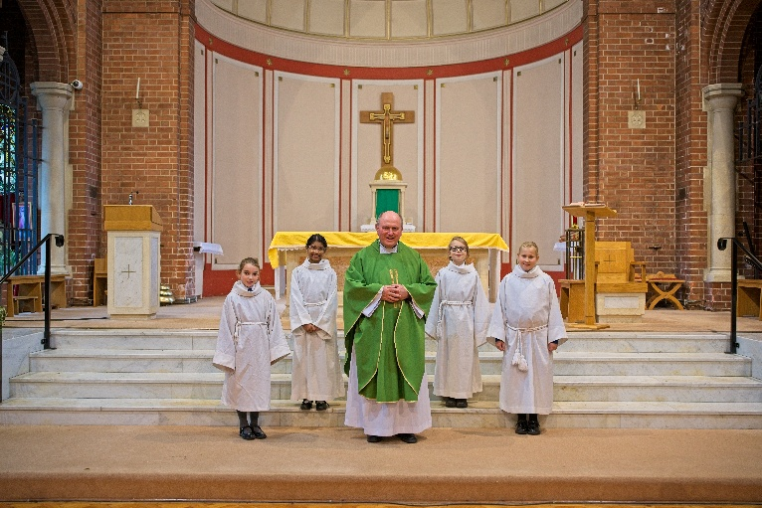
- ensures high standards of pupil behaviour and courteous conduct in accordance with the school’s behaviour policy
- implements consistent, fair, and respectful approaches to managing behaviour
- ensures that adults within the school model and teach the behaviour of a good citizen and inspired by the life of Christ.

- Additional and Special Educational Needs and Disabilities

The Headteacher:
- ensures the school holds ambitious expectations for all pupils with additional and special educational needs and disabilities
- Ensures and sustains cultures and practices that enable pupils to access the curriculum and learn effectively
- ensures the school works effectively in partnership with parents, carers, and professionals, to identify the additional needs and special educational needs and disabilities of pupils, providing support and adaptation where appropriate
- ensures the school fulfils its statutory duties regarding the SEND code of practice

- Professional Development

The Headteacher:
- ensures staff have access to high-quality, sustained professional development opportunities, aligned to balance the priorities of whole-school improvement, team, and individual needs
- prioritises the professional development of staff, ensuring effective planning, delivery and
evaluation which is consistent with the approaches laid out in the standard for teachers’ professional development

- ensures that professional development opportunities draw on expert provision from beyond the school, as well as within it, including the DCET Trust, the Diocese and nationally recognised career and professional frameworks and programmes to build capacity and support succession planning

- Organisational Management

The Headteacher:
- ensures the protection and safety of pupils and staff through effective approaches to safeguarding, as part of the duty of care
- prioritises and allocates financial resources appropriately, ensuring efficiency, effectiveness, and probity in the use of public funds
- ensures staff are deployed and managed well with due attention paid to workload and well being
- establishes and oversee systems, processes and policies that enable the school to operate effectively and efficiently
- ensures rigorous approaches to identifying, managing, and mitigating risk

- Continuous School Improvement

The Headteacher:
- makes use of effective and proportional processes of evaluation to identify and analyse complex or persistent problems and barriers which limit school effectiveness, and identify priority areas for improvement
- develops appropriate evidence-informed strategies for improvement as part of well-targeted plans which are realistic, timely, appropriately sequenced and suited to the school’s context ensures careful and effective implementation of improvement strategies, which lead to sustained school improvement over time
- inspires and influence others—within and beyond the school—to believe in the fundamental importance of Catholic education in young people’s lives and to promote the value of education

- Working in Partnership

The Headteacher:
- forges constructive relationships beyond the school, working in partnership with parents, carers, the Parish, the Trust, and the local community
- commits their school to work successfully with the other Trust schools and organisations in a climate of mutual challenge and support
- establishes and maintain working relationships with fellow professionals and colleagues across other public services to improve educational outcomes for all pupils

- Governance and Accountability

The Headteacher:
- understands and welcomes the role of effective governance, rooted in faithful stewardship of Gospel values, upholding their obligation to give account and accept responsibility
- establishes and sustain professional working relationship with those responsible for governance
- ensures that staff know and understand their professional responsibilities and are held to account
- ensures the school effectively and efficiently operates within the required regulatory frameworks and meets all statutory duties

Headteacher Person Specification

Professional Qualities, Knowledge, and Experience  Key: E = Essential and D = Desirable | E | D
Practising Catholic | E
Qualified Teaching Status | E
Degree | E
NPQH or similar |  | D
CCRS (Catholic Certificate in Religious Studies) |  | D
Teaching and leadership experience in more than one Catholic primary school |  | D
Lead by example and be a positive role model with excellent communication skills | E
Ability to articulate a clear vision and purpose for Catholic education | E
Personal impact and presence | E
Participation in a Parish Community |  | D
Ability to lead the spiritual development of staff and pupils | E
Understanding of current educational provision and the wider school systems |  | D
Pupils and Staff | E | D
Have ambitious standards and high expectations for all pupil’s | E
Excellent understanding of high-quality teaching and learning | E
Promote the development of the whole child | E
Use data analysis to effectively drive whole school improvement | E
Encourage all staff to develop their unique potential | E
Identify emerging talent, develop excellence, and clear succession planning | E
Self-Improving School | E | D
Knowledge and experience of working with other schools and organisations | E
Effective partnerships with a range of professionals | E
Use well evidenced research to achieve excellence |  | D
Provide high quality opportunities for staff development | E
Confident and innovative approach to school improvement | E
Source of inspiration and encouragement for all in the school community. | E
Child Protection | E | D
Ensure that the child protection policies and procedures adopted by the Local Governing Committee and Trust Board are fully implemented and followed by all staff | E
Ensure that sufficient resources and time are allocated to enable staff to discharge their child protection related responsibilities effectively | E
Securing Accountability | E | D
Fulfil commitments arising from contractual accountability to the Local Governing Committee and Trust Board | E
Ensure a Catholic school ethos | E
Ensure individual staff accountabilities are clear, understood, agreed, reviewed, and evaluated | E
Work with the Local Governing Committee and Trust Board to enable it to meet its responsibilities | E
Develop an accurate and understandable account of the school’s performance for a range of audiences | E
Personally contribute to school achievements taking account of feedback from others | E
Strengthening Community | E | D
Ensure a school culture and curriculum which takes account of the richness and diversity of the community’s Catholic Christian faith | E
Create and promote strategies for challenging racial and other prejudices | E
Ensure learning experiences for pupils are linked into and integrated with the wider community | E
Collaborate with agencies in providing for the academic, spiritual, moral, social emotional and cultural well-being of pupils and their families | E
Create and maintain an effective partnership with parents and carers | E
Invite local community into school to enhance and enrich the school | E
Share effective practice working in partnership with other schools | E

