

ROLE PROFILE

Red Kite Learning Trust is committed to supporting work–life balance and recognise the benefits of flexible working. We welcome requests for flexible working arrangements as part of the recruitment process. While flexibility may be possible for many roles, each request will be considered on an individual basis.
Job Title: | Teaching and Learning Assistant | School: | Oatlands Junior School
Salary Grade: | Band 4 SCP 2-4 | Working Hours: | 30 hours 25 minutes per week Monday - Friday
Contract Type: | Permanent, Term Time only + Training Days | Location: | Harrogate
Responsible to: Headteacher
Role summary: To support teaching and other staff in assisting the delivery of the national curriculum and other learning processes, in direct contact with pupils. The role will involve working with both groups and individual pupils under the direction of the class teacher and other appropriate staff.
Special conditions of service:
No smoking policy, including e-cigarettes/vaping.
Role specific responsibilities:
- To work with the teacher to establish an appropriate learning environment
- Support the learning process under the direction of the teaching or other appropriate staff
- Providing feedback, as requested, to the class teacher or other appropriate person to support the
planning and evaluation of the learning process in respect of groups and individual pupils
- Providing, with appropriate guidance and supervision limits, educational, emotional and physical support
to pupils
- To supervise and provide support for pupils, including those with special needs, ensuring their
safety and access to learning activities
- To promote the inclusion and acceptance of all pupils within the classroom, assisting in the
implementation of appropriate behaviour management strategies
- Communicate effectively and establish constructive relationships with all children, parents, families,
carers, external agencies, and other professionals
- Assisting with playground and lunch time supervision
- Preparation of materials, resources, displays including undertaking clerical duties
- To contribute to the overall ethos/work/aims of the school, in accordance with your role and the direction
of the Headteacher
- To encourage children of all ages to interact and work co-operatively with others and engage all children
in activities
- To establish good relationships with pupils, acting as a role model and being aware of and responding appropriately to individual needs

For colleagues appointed to our school at Upper Pay Spine level, then responsibilities and expectations will complement this career and pay stage.
All colleagues, regardless of career stage, will make a positive contribution to the wider life and community of our school, for example through sport, music, hobbies etc.

RK People responsibilities:
- Contribute to the overall aims and values of our Trust, appreciate and support the roles of other members of the wider team and attend and participate in relevant meetings as required
- Comply with all Trust policies and procedures including child protection, health, safety, welfare, security, confidentiality and data protection etc., reporting any concerns to the appropriate person
- Contribute to ensuring safeguarding procedures are in place and used effectively at all times.
The role holder must demonstrate a flexible approach to the delivery of the role. Consequently, the role holder may be required to perform work not specifically identified in the role profile but which is in line with the general scope, grade and responsibilities of the role.

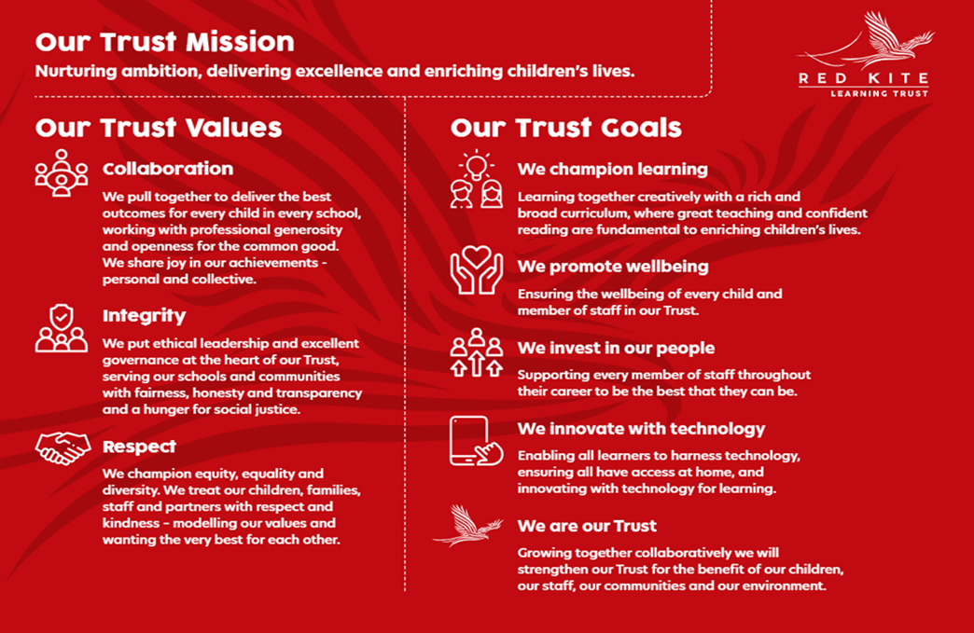
PEOPLE PROFILE
Aptitudes and Characteristics |  |  | Essential | Desirable
Ability to work flexibly and collaboratively as part of a team as well as on own |  |  | *
Ability to communicate and influence effectively with colleagues at all levels |  |  | *
Strong communication skills and experience of communicating with young children |  |  | *
Ability to relate well and form effective and appropriate working relationships and boundaries with young people |  |  | *
A commitment to our mission and values demonstrated by current practice |  |  | *
Ability to adopt confidentiality, discretion and judgement, communicating effectively with staff, students and parents |  |  | *
An understanding of the strategies that can be used to reduce the barriers to learning |  |  | *
Willingness to undertake training |  |  | *
Ability to manage pupil behaviour in a supportive and effective manner |  |  | *
Understanding of individual children and young peoples’ needs |  |  | *
Have an enthusiasm for and an active interest in children’s play |  |  | *
Qualifications, Knowledge and Experience |  |  | Essential | Desirable
GCSE English and Maths grade A - C |  |  | *
Relevant NVQ Level 3 or equivalent |  |  |  | *
Experience of delivering evidenced based interventions and accelerated learning |  |  | *
Experience / knowledge in general subject matters such as English, Maths, Art, Music, Science, Sport |  |  |  | *
Working in a classroom or nursery environment or appropriate experience working with children in an education setting |  |  | *
Demonstrable IT skills and ability to use them as part of supporting the school and children’s learning process |  |  | *
Experience of utilising MIS Systems e.g. Arbor |  |  |  | *
Proven track record of successfully working with children/young people in a work/voluntary setting |  |  | *
Working knowledge of national curriculum and other relevant learning programmes/strategies |  |  |  | *
Good knowledge of a child’s development and learning processes, understanding that all children have differing needs and knowledge of how to apply inclusive practice |  |  | *
Safeguarding and Promoting the Welfare of Students |  |  | Essential | Desirable
An appropriate motivation to work with children and young people |  |  | *
Ability to maintain appropriate relationships and personal boundaries with children and young people |  |  | *
Emotional resilience in working with challenging behaviours and appropriate attitudes to the use of authority and maintaining discipline |  |  | *

