
Recruitment Pack

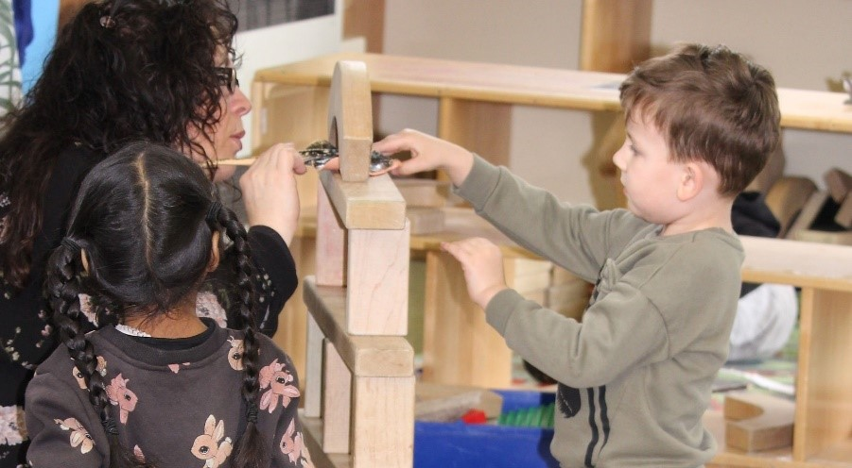 | 

Contents

Welcome from our Executive Principal Lindsay Lambert 2

A Brief History 4

Why work for us 5

Welcome from our Executive Principal Lindsay Lambert


Thank you for your interest in joining the Foundation for Schools Nursery Federation.
Foundations for Children Nursery Schools Federation comprises of four maintained nursery schools: Camrose Early Years Centre for Children & Families and Parklands Nursery School in Northampton; and Croyland Nursery School & Day Nursery and Highfield Nursery School in Wellingborough. We have over 80 years' experience providing high quality early education for children aged 0-5.
Working collaboratively across our nursery schools we provide responsive, high quality early education, for all children in our communities. Our ambition for children's lifelong learning and success drives our commitment to strengthen our sustainable model of Nursery Schools, as we support the growing and diverse learning community.
Our mission underpins our values aiming to inspire and nurture foundations for lifelong learning, to foster strong family partnerships, and to optimise the life chances of all children.

In addition to our core values,
Every child is known, equally valued and supported to achieve their potential in all our nurseries. Every community we serve benefits from the facilities and services we provide.

We ensure that well-run nurseries retain and develop their distinct contextual identity, while sharing and contributing to our common values, practices, curriculum approaches and operational systems

Our staff benefit from strong networks, excellent career opportunities and a human approach where they are equally valued and supported.

Being part of a family community who are compassionate and dedicated, who believe can really improve young people’s life chances and opportunities by working together. If this appeals to you, we very much look forward to receiving your application.

A Brief History
The Federation was formed in December 2021 comprising of Croyland Nursery School, Highfield Nursery School, Parklands Nursery School and Camrose Early Years Centre.

Our schools have a long history of providing early years education to the families of Wellingborough and Northampton - embedded into our local communities. We are proud to be working together so closely to continue the provision of high quality, extended services in our areas, in addition to training and support for our colleagues in the Early Years sector across Northamptonshire.
Federation Vision, Mission and Values

Our values and who we are:
Every child is known, equally valued and supported to achieve their potential in all our nurseries. Every community we serve benefits from the facilities and services we provide.

We ensure that well-run nurseries retain and develop their distinct contextual identity, while sharing and contributing to our values, practices, curriculum approaches and operational systems.
Our Values;
Nurture and Compassion
Harnessing a nurturing environment where compassion and kindness are at the heart of everything we do.

 Challenging
Testing boundaries and not accepting the status quo

Accountability
Colleagues strive for excellence, taking responsibility for their actions and results.

Equitable and inclusive
Always fostering respect and a culture of inclusion, diversity, tolerance, and fairness
Sense of belonging
Child centred, encouraging curiosity, independence, participation, and encouragement towards skills for the future.
Integrity
Doing the right thing, always. This means being honest and open even when it is difficult.
High-quality educational provision for all at the heart of local communities.

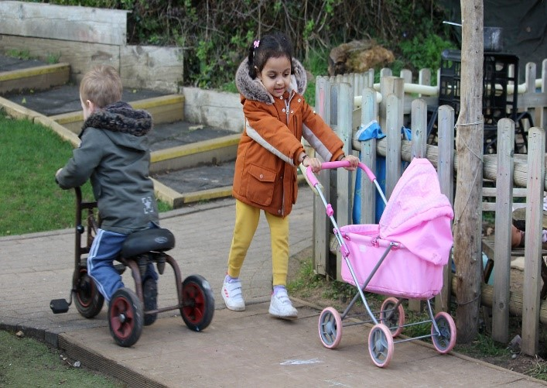
Our Vision:
Our vision is to provide warm, stimulating, welcoming environments which give us a secure foundation for all children and their families to become happy, confident, caring individuals who achieve personal success and develop a lifelong love of learning. We are proud of our school nurseries and welcome all visitors.

Why work for us

Benefits:
As a collaborated Federation of 4 nursery schools, we can provide a wide network of opportunities for collaboration and career development for both teaching and support staff.
In addition, we also offer:

- Access to CPD via virtual college and development programme.
- Access to a free Employee Assistance Programme, offering mental health and wellbeing support
- Opportunity for progression and CPD within the Federation and wider maintained nursery school network.
- Access to the Local Government pension scheme
- Access to discounted fees for your children that attend one of our schools.


How to apply
To apply please complete the online form on MyNewTerm. Your supporting statement should address and evidence the selection criteria detailed in the Person Specification.



Applying:
For any questions about the application process please contact: Claire Eustace, School Business Manager
Email: ceustace@ffcnschools.com

We are committed to diversity & inclusion and equality of opportunity for all staff and applications from individuals are encouraged regardless of age, disability, sex, gender reassignment, sexual orientation, race, religion or belief and marriage and civil partnerships.

Foundations for Children Nursery School Federation is committed to safer recruitment practice and pre-employment checks will be undertaken before any appointment is confirmed. This post is subject to an enhanced disclosure and barring service check. We expect all adults who work for FFCN to share our commitment to safeguarding and the health and wellbeing of our children.

JOB DESCRIPTION AND PERSON SPECIFICATION
Job Title: | Administration Assistant / Receptionist (Mat cover) FTC
JD Reference: | MATAA
Nursery/School: | Parklands Nursery School
Weeks: | 39.00 weeks
Hours of work: | 9.75 hours weekly (Monday, Tuesday & Wednesday) 12:30pm – 3:45pm Term time only.
Salary: | NJC Grade D, SCP 3 (£24,796 FTE) Actual £5,620.19
Responsible to: | School Business Manager/ Bursar

Role: | Provide efficient administrative support across the nursery school
Purpose of job: | To carry out administrative and general office duties, as required, providing an efficient and effective service for the Nursery School, in support of the school’s Bursar. To provide reliable support to the federation’s Strategic School Business Manager across many competing priorities needing accurate and timely administrative support.

Responsibilities and Accountabilities:

- Provide clerical and administrative support, including scanning, photocopying, filing and emailing to ensure the provision of an efficient and effective administration service for the nursery.
- Assisting with various administrative tasks and duties, utilising word, excel, outlook email and the use of local Management Information Systems (where training will be given)
- Answer telephone calls, directing through to the relevant people and helping with queries where possible
- Maintain electronic and manual systems efficiently and effectively in line with the GDPR Retention Policy, as well as file and retrieve documents and reference materials
- Ensure that the reception area is kept smart and tidy
- To assist with the ordering of stationery, materials and resources including first aid supplies and ensuring that stock levels are maintained and passed to the relevant management for approval.
- Maintaining and updating school information, records, and databases. This includes pupil database, assisting with the preparation and raising of invoices, monitoring contributions recording attendance and quotes.
- Receive, sort, and distribute all packages, deliveries, and mail including Distribute incoming mail, frank, and send outgoing mail
- Arrange, co-ordinate and communicate details for meetings, training, and events, including booking meeting rooms and providing refreshments

Support for School/Federation/Place of work:
- Participation in staff events by arrangement.
- Attend Staff Meetings.
- Contribute and participate in events and activities where possible.
- Develop and maintain effective working relationships with other staff and parents/carers.
- Adhere to the Federation values.
- Follow nursery school policies, practices and procedures.

Data security:
- Act in accordance with legal provisions regulating confidentiality and security of data and information in accordance with GDPR regulations.

Health and Safety:
- Be aware of the responsibility for personal Health, Safety and Welfare and that of others who may be affected by your actions or inactions.
- Co-operate with the Federation on all issues to do with Health, Safety & Welfare.
- To work/operate all equipment within Health and Safety and other legal regulations, including risk assessments.
- Physically able to perform tasks set out in this job description.
- Contribute to the maintenance of a safe and healthy environment.

Continuing Professional Development:
- In conjunction with the line manager, take responsibility for personal professional development, keeping up to date with research and developments related to school/ Federation/place of work efficiency, which may lead to improvements in the day-to-day running of the nursery school.
- Undertake any necessary and identified professional development taking full advantage of any relevant training and development available, particularly when related to the use of ICT, for data management and record keeping.
- Maintain a professional portfolio of evidence to support the Performance Management process – evaluating and improving own practice.

Child Protection and Safeguarding
- The post holder will have a shared responsibility for the safeguarding of all children and young people. The post holder also has an implicit duty to promote the welfare of all children and young people.
- To inform the Safeguarding Leads of any issues relating to the safety and well-being of students.

The post holder will undertake any other duties commensurate with the grade of the post, in consultation with line manager.
This job description is subject to review and may be changed following consultation with the post holder. It is not a comprehensive statement of procedures and tasks but sets out the main expectations of the Federation in relation to the post holder’s professional responsibilities and duties.

The Foundation is committed to safeguarding and promoting the welfare of children and young people and expects all staff and volunteers to share in this commitment.
All staff will be subject to an enhanced check with the Disclosure & Barring Service.

Person Specification – ADMINISTRATION/RECEPTIONIST |  | Assessment Key:  A = Application Form  I = Interview
Education and Qualification |  | Essential | Desirable | Assessment
1 | Good educational background including GCSE or equivalent in English and Maths. | ✓ |  | A
Experience |  | Essential | Desirable | Assessment
2 | Experience in working in an administrative/ reception environment | ✓ |  | A/I
3 | Experience of working in an educational setting |  | ✓ | A/I
4 | Experience in working with external agencies |  | ✓ | A/I
Knowledge and understanding |  | Essential | Desirable | Assessment
5 | Understanding of the education system |  | ✓ | A/I
6 | A sound grasp of the concept of inclusive practice | ✓ |  | I
7 | Knowledge of the concept of confidentiality | ✓ |  | I
8 | Awareness of child protection issues. | ✓ |  | I
9 | First Aid certificate |  | ✓ | A
Skills and abilities |  | Essential | Desirable | Assessment
10 | High level of personal organisation skills. | ✓ |  | I
11 | Ability to use IT systems including email, word and excel | ✓ |  | I
12 | Excellent written and oral communication skills.
13 | Ability to contribute to team meetings and contribute ideas | ✓ |  | I
Personal Qualities |  | Essential | Desirable | Assessment
14 | High personal standards in terms of attendance, punctuality and organising workload. | ✓ |  | !
15 | Willingness to undergo further training and development. | ✓ |  | I
16 | Positive and enthusiastic approach towards work. | ✓ |  | I
17 | Ability to act on own initiative. | ✓ |  | I
18 | Kindness and empathy towards students and colleagues. | ✓ |  | I
19 | Ability to work as part of a team effectively. | ✓ |  | I
Child Protection |  | Essential | Desirable | Assessment
20 | Support the Federation policies on safeguarding and child protection. | ✓ |  | A/I
Other |  | Essential | Desirable | Assessment
21 | Flexibility of working hours | ✓ |  | A/I

