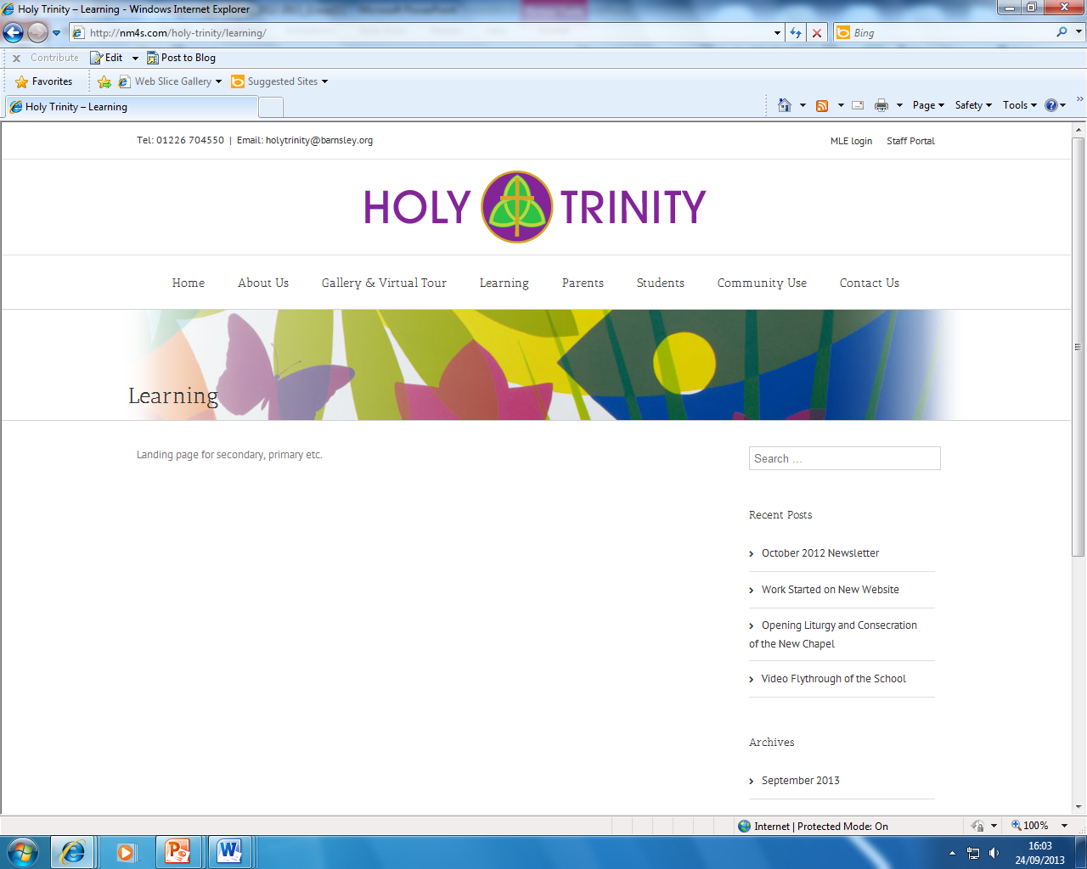

PERSON SPECIFICATION
POST TITLE: MPS/UPS/ECT

ATTRIBUTES |  | ESSENTIAL | DESIRABLE | HOW IDENTIFIED
RELEVANT EXPERIENCE | Successful teaching experience either through work or training |  |  | A/I/R
EDUCATION AND TRAINING | Degree Level Qualification in specialist subject area  Qualified Teacher Status  Knowledge of technology for use in teaching the curriculum |  |  | A  A  A/I
GENERAL AND SPECIAL KNOWLEDGE | Evidence of skilled and successful classroom practice  Good classroom management  Knowledge and experience of curriculum planning and delivery  Awareness of the National Curriculum  A commitment to develop evidence-informed practice and the willingness to commit to undertake professional development which is both school and self-directed  Knowledge of current educational issues  Ability to set meaningful and realistic learning goals for students  Ability to establish good working relationships with students and colleagues  A willingness to support the Christian ethos of the school |  |  | A/I/R  I/R  A/I  A/I/R  A/I  A/I  A/I  A/I/R  A/I
SKILLS AND ATTRIBUTES | Good personal organisation and efficient administration  Interest in involvement with extra-curricular activities  Ability to work within a team |  |  | A/I/R  A/I  A/I/R
ADDITIONAL FACTORS | Demonstrate a commitment to equal opportunities  To comply with all school policies adopted by the governing body for example Health and Safety, Equal Opportunities and Data Protection |  |  | A/I  A/I/R

