

Candidate information pack



Welcome from Ewan McPherson, Principal, Deeplish Primary Academy

Dear applicant,
‘Growing great learners’

Thank you for your interest in the post of cleaner at Deeplish Primary Academy. I am extremely proud to be the Principal of such a warm and friendly school as Deeplish.

Whatever the needs of our children we aim to ensure they thrive at Deeplish, feeling safe, having fun and enjoying success. We want our pupils’ time in our school to be memorable, build on what they know and can do and help them become lifelong learners.

We value highly the partnership between home and school and encourage all parents to take an active part in the education of their children. The partnership between school staff, parents, governors and other stakeholders is an essential one. Children are at the heart of all we do and their social and emotional well-being, as well as their academic achievements are very important.

We are looking for a cleaner to start as soon as possible. The successful candidate must be a good communicator, team player, child centred, able to meet deadlines and reliable.

It is desirable that candidates would have experience of working in an education setting as a cleaner.

Prospective candidates are welcome to visit the Academy, please contact Mrs Minton to arrange a suitable date and time.

Closing date for applications: Tuesday 21st April 2026 at midday
Interview day: Wednesday 29th April am

Post to commence – ASAP

Academy details

Address | Derby St, Rochdale, Lancs. OL11 1LT
Telephone | 01706 392480
Email | deeplish@focus-trust.co.uk
Website | www.deeplishprimaryacademy.co.uk

Welcome from David Roberts, Chair of Governors

Dear applicant,

Thank you for taking the time to consider applying for the role of cleaner at Deeplish Primary Academy. As Chair of the Governing Board, I would like to take this opportunity to tell you a little bit about the context of our school.

Deeplish is an academy right at the heart of the Deeplish community and we work really hard to do everything that we can to support our children and families. We joined Focus Trust in December 2014 and have not stopped improving.

When you visit us, you will find a very inclusive culture where everyone is valued and listened to. Our children and staff are fantastic and have a real love for learning. We have a reputation for being a friendly, caring and successful school, something that I know you will see if you come to visit us.

I hope I have given you a flavour of Deeplish and I have every confidence that we will successfully recruit a teaching assistant who can work with us in order to develop school further. We will offer you a very supportive governing body with high expectations for our children and staff. I hope that you feel encouraged to apply for the post.

Job Description

Academy | Deeplish Primary Academy
Job Family | Site – Cleaning
Job Title | Cleaner
Grade | FT Grade 1 – SCP 2-4
Accountable to | Principal
Line manager | Site Manager

Purpose of the role

To provide a high standard of hygiene and cleanliness throughout the school, ensuring a safe and clean environment for staff pupils and visitors to the school in accordance with Health and Safety and Focus-Trust policies.
General Duties
- Undertake day to day cleaning of allocated areas/whole school in line with specified standards to ensure the premises are presented in the best possible manner.
- Operate domestic and industrial cleaning equipment and materials, following appropriate training
- Store allocated equipment and materials safely and securely and report any faults or maintenance issues to your line manager
- Perform duties in line with health and safety regulations (COSHH) and act where hazards are identified, report serious hazards to line manager immediately
- Clean floors, including sweeping to control dust and debris and mopping to sanitize using hot water, with suitable cleaning products at the end of each school day.
- Steam clean carpet as part of a deep clean or when necessary
- Safely use electronically powered scrubbing, polishing and vacuuming machines to scrub, polish, spray and clean floors
- Safely use chemical agents as directed by the site manager in the discharge of cleaning operation or maintenance procedures
- Empty waste bins routinely, and transport waste material to designated collection points and support with internal and external litter picking as required.
- Clean glass vision panels
- Clean furniture, doors and other woodwork areas
- Undertake wall washing and inside window pane cleaning to a height no greater than body height plus an arm’s extension from floor level, during weekly cleaning maintenance programs.
- Follow cleaning routines
- Dust, damp wipe, wash or polish the furniture, ledges, window sills and external surfaces of cupboards, radiators, shelves and fitments
- Move equipment/furniture to enable proper cleaning
- Clean toilets and cloakroom areas including toilets and sink areas on a daily basis
- Replenish consumable items including, soap, toilet rolls and paper towels, where required.
- Undertake specialist deep clean as directed by the line manager particularly during holiday periods and when supporting with staff absence.
- Report any Health & Safety concerns to the Site Manager immediately and record in line with school systems and procedures.
- Assist in maintaining a tidy and safe cleaning storeroom
- Adhere to the School’s Health & Safety Policy

May from time to time be required to undertake other duties commensurate with the grade and level of responsibility defined in this job description.

The post holder is required to carry out any such particular duties which the Principal/Headteacher may reasonably direct from time to time.

Administration

- Keep a check on cleaning stock levels and inform the site manager of low stock levels, e.g., of cleaning products.
- Carry out a stock check with the site manager on a monthly basis.
- Record all completed cleaning tasks on a daily basis.

Resources

- Maintain clean, tidy and organised work spaces and storage areas.
- Check equipment and machinery used and ensure health and safety guidelines are adhered to and report issues to line manager as appropriate.

Fulfill wider professional responsibilities
- Make a positive contribution to the wider life and ethos of the School and the Trust.
- Develop effective professional relationships with governors, colleagues, families knowing how and when to draw on advice and specialist support.
- To be willing and able to be part of a team of first aiders/fire wardens as may be required.
- Communicate effectively with pupils, school staff and visitors.
- To participate in training and other learning activities and performance development as required.
- To be aware of and comply with policies and procedures relating to child protection, health, safety and security, confidentiality and data protection, reporting all concerns to an appropriate person.

Personal and professional conduct
All Focus Trust staff are expected to demonstrate consistently high standards of personal and professional conduct. The following statements define the behaviour and attitudes which set the required standard for conduct throughout a career with the Trust.

All Staff must uphold public trust in the profession and maintain high standards of ethics and behaviour, within and outside the School, by:
- treating governors, pupils, staff, parents and visitors with dignity, building relationships rooted in mutual respect, and at all times observing proper boundaries appropriate to an adult working in a School environment;
- having regard for the need to safeguard pupils’ well-being, in accordance with statutory provisions;
- showing tolerance of and respect for the rights of others;
- not undermining fundamental British values, including democracy, the rule of law, individual liberty and mutual respect, and tolerance of those with different faiths and beliefs; and
- ensuring that personal beliefs are not expressed in ways which exploit pupils’ vulnerability or might lead them to break the law.

All staff working in the Focus-Trust must have proper and professional regard for the ethos, policies and practices of the School and the Trust, and maintain high standards in their own attendance and punctuality.

All staff must have an understanding of, and always act within, the statutory frameworks which set out their professional duties and responsibilities; and within the policies, handbooks and guidelines of the School and of the Focus-Trust.

General
The post holder will:
- Be expected to actively support the work and ethos of the Focus-Trust.
- Be expected to undertake such additional duties as may reasonably be requested by the Principal/Headteacher or their representative.
- Respect confidentiality of staff, pupils, families and visitors and not breach this trust. Any breaches of confidentiality must be reported to the Principal/Headteacher immediately.
- Participate in arrangements for appraisal and in the identification of areas in which s/he would benefit from training and undergo such training.
- Comply with and support all policies related to equal opportunities, child protection and safeguarding of children and colleagues.

This job description is neither exhaustive nor exclusive, and it may, after consultation with the post holder be subject to modification and amendment in accordance with Trust’s procedures.

Cleaner
Person specification

Key:
App – Application Form
Ref – Reference
SP – Selection process. This could include a range of exercises, including an interview.

Knowledge, Experience and Skills

 | Essential/  Desirable | How identified
Experience
Experience of cleaning and general upkeep of the site. | E | App/SP
Using general cleaning equipment, e.g. buffing machinery, vacuums and carpet cleaners. | E
Experience of team working to work effectively with others and meet deadlines and goals | E
Basic administrative experience including record keeping | D
Skills and abilities
Have an in-depth knowledge of cleaning equipment and techniques. | D | App/SP
Able to communicate clearly, understand and follow instructions | E
Understand health and safety issues and good practice in relation to cleaning. | E
Initiative to respond to unexpected problems using recognized procedures and policies as a guide | E
Some knowledge of Health & Safety Regulations as they relate to the operation of cleaning equipment and the dilution of cleaning materials. | D
Basic Literacy and Numeracy Skills | D
Ability to relate well to children and adults | E
Able to undertake some tasks which need some physical effort and fitness appropriate to the duty. | E
Knowledge
Understanding of cleaning machinery and cleaning routines | E
Good working knowledge of polices/codes of practice/legislation relevant to premises management and Health and Safety | D
Child protection
Understands why safeguarding is important when working with children. | E | App/SP
Able to maintain a high level of confidentiality and discretion at all times. | E
Qualifications and training
Willingness to gain a basic first aid certificate (as required) | E
Personal qualities and attributes
Moral purpose (Equality, children and adults treated with respect) | E | SP
Child Centered | E | SP
Integrity - Responsible adult role model and being a positive influence | E | SP
Self motivated and work to deadlines | E | SP
Reliable and understand the importance of good attendance | E | SP
Enthusiastic and optimistic | E | SP
Self-awareness, knowledge of strengths and limitations | E | SP
Integrity – Responsible adult role model and being a positive influence | E | SP
To be flexible and adaptable to the ever-changing needs of the school | E | SP
Able to remain calm and focused in a busy and demanding environment | E | SP

About our Academy

Academy vision, ethos and values
Our vision is ‘Growing Great Learners’.

At Deeplish we aim to create a quality environment where everyone involved with the school has respect for themselves, for others and for their community.

By constantly encouraging and emphasising positive aspects of work and behaviour we seek to promote the high standards we strive to achieve.

We believe that the goals and targets we set should be high but realistic so every child has equal opportunity to achieve their maximum potential.

We actively promote healthy life-styles and give children the knowledge and understanding they need to make informed decisions about their health, safety and well-being as they grow.

Everyone at Deeplish, be they child or adult, has a role to play and a contribution to make to the life of the school and its place in the community.

We believe that the teaching/learning environment we provide should reflect the fact that everyone’s contribution will be recognised and their views will be listened to.

We aim to have a school which provides stimulating, enriching and fulfilling experiences - a place which people enjoy coming to.

Our children are our future. At Deeplish we work together to give children the academic and life skills they will need for a happy and successful future.

Our pupils

The children at Deeplish are a real strength of the school. Pupils’ behaviour, their relationships with all people and their eagerness to learn makes the school a great place to be. Pupils get on well together and their relationships with each other and their teachers are characterised by warmth and mutual respect. We have a very active School Council who play a key role in how school runs and how we will take the school forward in the future.

Our staff

The staff at Deeplish are committed to providing the best possible education for all children. They work extremely hard to nurture and develop children so they achieve their full potential in a supportive environment.

Our facilities

Deeplish is a modern school (completed in December 2011) and is a two-form entry. The classrooms are light and spacious and well equipped to ensure the children have a learning environment conducive to the 21st century. We are extremely fortunate to have large grounds which have been designed and developed to support childrens’ learning.

Our school organisation

Our pupil admission number is 60 and there are two classes for each year group, from Reception to Year 6. In addition to class teachers, learning is supported in classes by teaching assistants – the number of these depends on needs within classes and year groups.

Our curriculum

We offer a broad and balanced curriculum which gives the children a wide range of experiences to develop the whole child. Our curriculum is geared to giving children a firm grounding in the necessary knowledge and skills to succeed in an ever-changing world as well as providing them with the solid foundations of reading, writing and maths.

Our extra-curricular activities

A range of extra-curricular activities usually operates in the autumn and summer terms, during which staff generally run an after-school club once a week. Examples of clubs offered include basketball, choir and debating.

School Quick Facts

Type of school | Primary
Age range | 3 - 11
Location/LA | Rochdale
Number of children | 457
Number of teaching staff | 20
Number of support staff | 27
% FSM | 37%
% SEN | 8%
% EAL | 86%

Our geographical area

Deeplish Primary Academy is right at the heart of the community it serves. The school is situated in the middle of Deeplish, very close to Rochdale train station.

In addition to our partner academies within Focus-Trust, we work collaboratively with schools in our local partnership and with a range of secondary schools in the Rochdale area to which our pupils transfer at the end of Year 6.
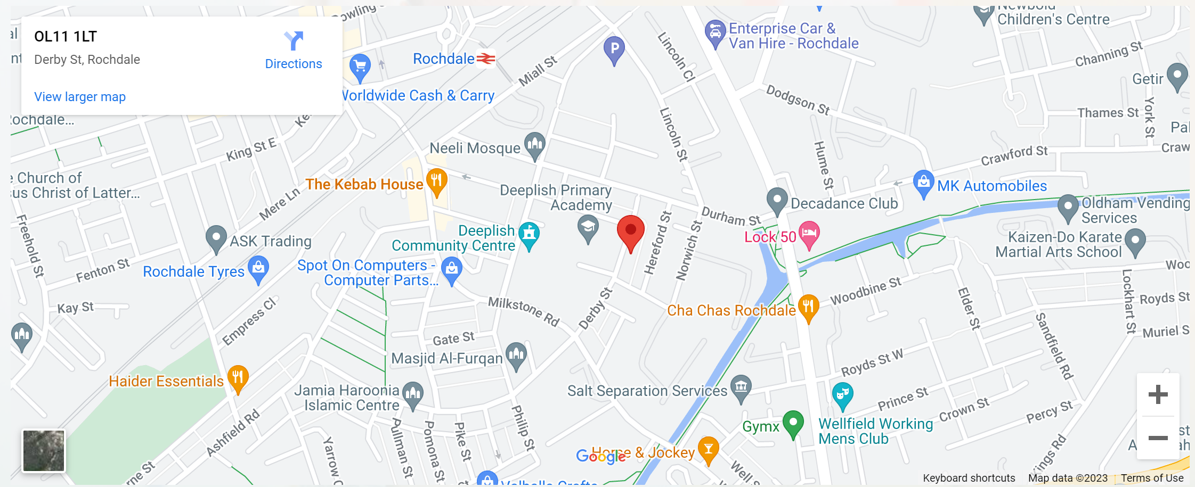

What you might want to know about Focus Trust

Who are we?
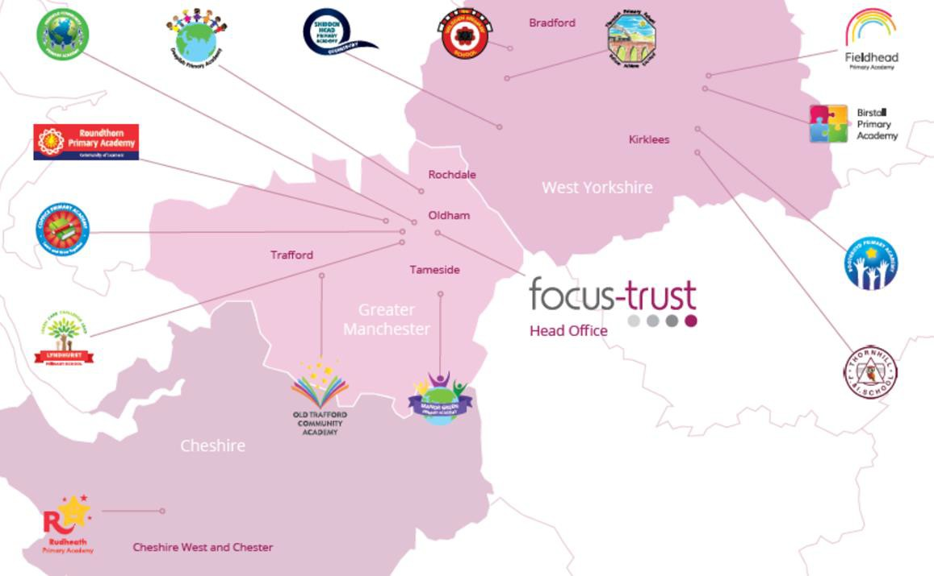
Focus-Trust was incorporated in May 2012 as a primary trust. The Trust has links with the sponsor, Focus Education, but is an entirely separate legal entity. As with all academy trusts, the Trust is a company limited by guarantee and an exempt charity. The Trust’s offices are situated in a newly converted historic mill conversion in Chadderton, Oldham with excellent motorway networks to access our schools.

The defining feature of Focus-Trust is that it is a specialist primary phase trust. This means that the work of the Trust is driven by the distinctive needs of primary schools. Whilst the Trust has robust systems for accountability, each school has their own distinctive identity, ethos and culture, and this is a commitment to every school when they convert and join the Trust.
Focus-Trust currently has a small centrally employed team. The members of the team are highly skilled and committed to the vision, culture and values of the Trust.
All the schools within the Trust are willing partners who have actively chosen to join Focus-Trust and there is a very high degree of consensus, cooperation and commitment from within the group.
The Trust has robust policies and systems in place to govern and guide its work. These have been gradually implemented as the Trust has grown. The Trust has well-established productive relationships with trade unions and meets half termly with a group of national trade union representatives to discuss policy development. This has enabled us to introduce and change a range of policies in a streamlined and cooperative way.

Additional information.
Equality of opportunity
Focus-Trust is an equal opportunity employer, dedicated to a policy of non-discrimination in employment on any basis including age, gender, race, colour, nationality, ethnic origin, disability, gender, religion, age, marital status, sexual orientation and/or medical condition.

Safeguarding
Focus-Trust is committed to safeguarding and promoting the welfare of all children and young people. There is an explicit expectation that all employees share this commitment and adhere to all safeguarding policies and procedures. Applicants should be aware that the recruitment process will include an assessment of your suitability to work with children.

Right to work in the UK
Under the Asylum and Immigration Act 1996, it is a criminal offence to employ anyone who is not entitled to live or work in the United Kingdom. Applicants can expect us to ask for proof of this at interview stage, where you will be asked to provide some original documentation to confirm that you are eligible to work within the UK. Photographic proof of identity will also be required.

Validation of qualifications and identity
All shortlisted candidates will be asked to bring original certificates or relevant qualifications and identity documents to interview. These will be photocopied and kept on file and, if appropriate, may be confirmed as genuine with the relevant awarding bodies. The copies of the successful candidate will be retained on their personnel file. The copies of unsuccessful candidates will be treated as confidential waste and disposed of appropriately.

References and Social Media Checks
If you are shortlisted, we will take up references before the interview date, unless you state otherwise on your application form. However, two satisfactory references must be received before we can confirm any offer of an appointment One of your referees must be your current or most recent employer. The information we request will relate to salary, length of service, skills and abilities, suitability for the job, disciplinary record and suitability to work with children. Copies of references or open references will not be accepted. On receipt of references, your referees may be contacted to verify any discrepancies, anomalies or relevant issues as part of the recruitment verification process.
In line with our safer recruitment policy, on-line presence checks will be undertaken if you are shortlisted. This check is designed to complement the range of standard recruitment checks and allows us to identify a candidate’s online presence which potentially could damage the organisation’s reputation.

Disability
To comply with the Equality Act 2010, we are legally required to consider making reasonable adjustments to ensure that disabled people are not disadvantaged in the recruitment and selection process. We are therefore committed to meeting, wherever possible, any needs you specify on the application form. Please contact the named person on the advert, if you need to discuss this in any detail. We will consider any reasonable adjustment under the terms of the Act to enable an applicant with a disability (as defined under the Act) to meet the requirements of the post.

Disclosure of a criminal record
Employment in this role is subject to an enhanced check with the Disclosure and Barring Service (DBS). Checks will also be made against the lists showing people barred from working with children. All checks must be satisfactory before any offer of employment can be confirmed and before commencement of work can take place.

Dress code
We expect all staff to dress professionally and appropriately for the roles undertaken. We pride ourselves on the high standards of dress of both our pupils and staff; these standards are led by our staff who we expect to set an example.

Knowledge and skills profile
This is an important part of your application and is your opportunity to explain how you meet the person specification for the post. You should demonstrate, using no more than 2000 characters, your skills, knowledge and experience and give short examples. Describe how you match the requirement of the job; include experience gained from previous jobs, community or voluntary work. Ensure that the information you give is well organised, relevant and brief. You may find it helpful to use sub-headings in order to keep your statement well focused. If you do not submit this profile, you will not be considered for short listing.

Policies
Focus-Trust and the schools have a range of policies and handbooks that help to make clear our expectations and ways of working. These are always shared openly with staff and are accessible to everyone. There are several policies that prospective employees should be aware of when making an application. These can be found on the Trust website www.focus-trust.co.uk and school websites. All members of staff will be asked to sign a declaration as part of the induction process to acknowledge that they have read and understand the Code of Conduct and some of the key policies, e.g. Safeguarding and Child Protection, Health and Safety, Acceptable use of IT.

Pensions
Focus-Trust contributes to Teachers’ Pensions and Local Government pensions in the same way and with the same level of contribution as local authorities.

Employer Relations
Focus-Trust has a Trade Union agreement which recognises the teacher and support staff unions. This is further supported by an ongoing and productive relationship with key trade union officials.

Thank you for taking the time to read this information pack. We wish you every
success in any application you may make.

xxxxxxxxxxxxxxxxxxxxxxxxxxxxxxxxxxxxxxxxxxxxxxxxxx

