Primary SEMH Outreach Services
TITLE: Specialist Outreach SEMH Assistant
HOST SCHOOL: Hillborough Junior School
NEIGHBOURHOOD: South Area Partnership Schools- Luton
RESPONSIBLE TO: Lead Practitioner
GRADE: L6
PURPOSE OF POST:

To work, under the overall direction of the Lead Practitioner, to provide outreach in supporting individual pupils and their teachers/support assistants to meet both learning needs and ensure that individuals are supported appropriately within their mainstream schools. Work will be undertaken alongside an agreed support plan and with targets for improved provision, behaviour support and outcomes. The Specialist Outreach SEMH Assistant will work alongside staff in schools in supporting and modelling good practice techniques in improving staff confidence in meeting and supporting the pupil’s needs within mainstream provision, advising on routines and environments that support the child’s SEMH needs, foster their sense of belonging in the school and thereby reducing the risk of exclusion. The Postholder may be required to work intensively with colleagues and individual pupils in ‘turn around’ activities and planned alternative curriculum and provision over an agreed timeframe to enable reintegration into mainstream classes or, to support into specialist provision. The Postholder will be involved in transition support where a child is in a planned move to an alternative setting.
The postholder will:
- Work under direction of the Lead Practitioner and be deployed in schools alongside school staff working with individual pupils identified and being supported through the Service;
- Work with the teacher and support assistants with whom he/she is based to help adapt approaches and both curriculum activities and planning in response to the needs of the pupil being supported;
- Model and support effective practice in managing pupil learning needs through a therapeutic approach to supporting needs and behaviour, guiding and providing advice on the use of appropriate tools and techniques to strengthen local capacity;
- Engage in direct work with the pupil being supported;
- Work with school-based support staff in planning and using appropriate resources to create a learning experience that secures appropriate educational outcomes whilst also promoting positive engagement and work towards achieving the targets set in the agreed individual pupil support plans;
- Work collaboratively with school staff on reporting and evaluating progress and agreeing next steps;
- Promote Therapeutic Thinking practices in all interactions with staff working with the individual and model the principles of Therapeutic Thinking to those working with the pupil;
- Work with local staff in managing any short-term ‘turn-around’ or temporary in-reach provision with a pupil who may need a period of alternative provision but maintaining a clear focus on the exit strategy in line with the child’s reintegration plan
- Provide information and data to the Lead Practitioner on progress being made against any plans to help inform the next steps as part of an assess, plan, do review cycle.
ORGANISATION CHART:

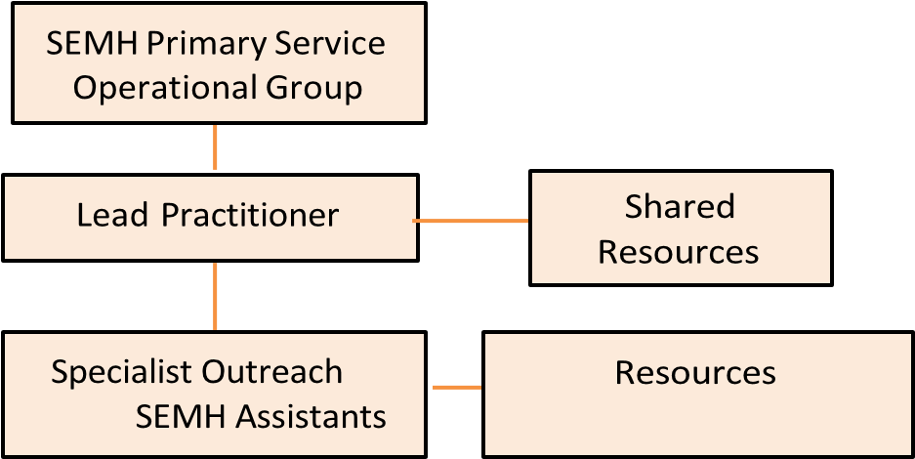

PRINCIPAL RESPONSIBILITIES:
- Under the direction of the Lead Practitioner, work with school-based support staff to prepare and collate materials and resources to support the curriculum for the pupil being supported, with a strong focus on providing differentiated tasks, in order to enhance motivation and meet the individual needs of pupils. This will involve using information technology to produce printed materials and accessing planning and resources from class teachers to support this.
- On the basis of knowledge of individual pupil’s behaviour and learning needs, contribute to discussions with the class teacher, support staff and the Lead Practitioner on strategies and tools that are working and those that need further development, and on reporting and evaluating progress.
- Model effective practice in assessing progress and in establishing and maintaining positive working relationships with the pupil and responding to need.
- Contribute towards identifying gaps in knowledge and learning, in order to develop appropriate and flexible lesson plans for pupils, which both bridge those gaps and offer opportunities for progression. Also model the evaluation and adaptation of learning activities as appropriate to others during tasks to ensure relevance and appropriate challenge.
- Work with school-based support staff and engage with class teachers with regard to strategies and tools that successfully improve the pupil’s learning. This may involve working with groups of children alongside the substantive staffing.
- Respond appropriately to pupils to encourage and motivate as necessary in order to keep pupils on task and consistent with behaviour and achievement expectations. Refer to class teacher or team leader as necessary.
- Promote a calm and ordered learning environment, maintaining an awareness of the whole class situation, and using initiative to ensure pupil behaviour does not interfere with other pupil learning.
- Contribute to the on-going assessment and recording of pupil development and achievement by making observations and recording notes about progress in writing to be able to feed back on progress and to support next steps.
- Contribute to the discussions on progress with other staff members, pupils and parents/carers.
- Complete daily logs, incident and monitoring forms and use safeguarding and behaviour logging systems to record concerns, events and incidents to the school through the school’s agreed processes.
- Support the school’s staff in providing pastoral support and one to one mentoring to pupils in line with a therapeutic approach. Plan and deliver appropriate specialist interventions, making observations and keeping notes on progress as appropriate, to feed into ongoing assessment of pupils’ strengths and needs.
- Develop and maintain constructive relationships with referring schools and external agencies, e.g. social services, Educational Psychology CAMHS, Learning Support Services etc. which aim to serve the needs of pupils.
- Support pupils through transfer and transition between schools and provisions through liaison with the receiving school, providing advice and guidance for professionals, along with behavioural support to pupils.
- Accompany pupils (and other adults) on external visits to ensure the safety and acceptable conduct of pupils and assist in meeting the desired learning outcomes of such visits.
- Prepare and manage supportive resources for visits, such as Visual Timetables, Social Stories and Communication Aids, e.g. PECS (Picture Exchange Communication System).
- Maintain awareness and comply with policies and procedures relating to child protection, health, safety and security, confidentiality and data protection, reporting all concerns to an appropriate person.
- Use safeguarding recording systems to record concerns, events and incidents in all settings.

DIMENSIONS:
Supervisory Management: N/A
Financial Resources: N/A
Physical Resources: Classroom materials, equipment, including IT (computers, laptops and ipads), specific skillset equipment and resources such as games, resources to capture child’s views and specific resources e.g. visuals
Other: N/A
CONTEXT:
All Specialist Outreach SEMH Assistants are part of a whole Service Team and will be required to be based in the school they are supporting and comply with the school’s policies and procedures which may differ by school. The postholder will need to take personal responsibility for ensuring that they understand the policies and context within which they are working. The postholder will be required to support the values and ethos of the school within which they are working. They will be required to work as part of the Service Team and support the goals and ambitions of the Service in meeting the needs of children with SEMH and following the Service’s plans and approaches.
Due to the nature of this job, it will be necessary for the appropriate level of criminal record disclosure to be undertaken. Therefore, it is essential in making your application you disclose whether you have any pending charges, convictions, bind-overs or cautions and, if so, for which offences. This post will be exempt from the provisions of Section 4 (2) of the Rehabilitation of Offenders 1974 (Exemptions) (Amendments) Order 1986. Therefore, applicants are not entitled to withhold information about convictions which for other purposes are ‘spent’ under the provision of the Act, and, in the event of the employment being taken up, any failure to disclose such convictions will result in dismissal or disciplinary action by the Authority. The fact that a pending charge, conviction, bind-over or caution has been recorded against you will not necessarily debar you from consideration for this appointment.
Disclosures are handled in accordance with the DBS Code of Practice which can be accessed via www.disclosure.gov.uk
Specialist Outreach SEMH Assistants may find themselves working in schools within a Learning Support Unit where the postholder will be working entirely with pupils withdrawn from class teaching and at severe risk of exclusion. They may be working with specialists on behaviour support and SEND within the school. The children being supported may include those with specific conditions (e.g. Autism, Attention Deficit and Hyperactivity Disorder), pupils with an EHCNA in process and pupils with particular behavioural difficulties. As a Specialist Outreach SEMH Assistant at this level, the postholder is responsible for working within the culture and operational structure of the school but is primarily focused on increasing the capacity of staff within the school to manage learning successfully for the pupil who has been referred. This may require working through influence, modelling and supporting in introducing techniques and approaches to engage and reduce the risk of disruption. Guidance should always be sought from the Service Lead Practitioner if ask to undertake work by the school which may be outside or potentially outside the brief of the role.
Physical Effort: The job is likely to involve moving children or equipment safely on a regular basis in line with policy on positively supporting children with SEMH need. Training will be provided.
Working Environment: There could be a frequent requirement to deal with vomit and bodily fluids when children are unwell.

Person Specification
This acts as selection criteria and gives an outline of the types of person and the characteristics required to do the job.
Essential (E) :- without which candidate would be rejected
Desirable (D):- useful for choosing between two good candidates.
Please make sure, when completing your application form, you give clear examples of how you meet the essential and desirable criteria.
Attributes | Essential | How Measured | Desirable | How Measured
Experience | Demonstrable experience of working with pupils with social emotional and mental health needs  Some experience in working with parents to support their child’s development. | 1,2  1,2 | Some experience of supporting learning of disaffected pupils in an educational environment. Some experience of providing counselling/pastoral care.  Experience of working in a school environment is desirable for this post. | 1,2  1,2  1,2
Skills/Abilities | Able to motivate disaffected pupils and able to respond positively in emotionally demanding situations. | 1,2
 | Able to contribute constructively to the work of a team. | 1,2
 | Able to build and maintain constructive relationships with pupils and parents/carers. | 1,2
 | Literacy skills – able to read, understand and differentiate written material within relevant curriculum. | 1,2,3
 | Numeracy skills – able to add, subtract, multiply and divide to support pupils in accessing relevant curriculum | 1,2,3
 | Able to converse with ease with members of the public and provide effective help or advice in accurate and fluent spoken English | 1,2,5
Competencies | Able to demonstrate appropriate motivation to work with young people. | 1,2 | Appropriate attitudes to use of authority and maintaining discipline. | 1,2
 | Able to form appropriate relationships with young people. | 1,2
 | Emotional resilience in working with detrimental behaviours. | 1,2
Equality Issues | Able to recognise and act upon discrimination | 1,2
Specialist Knowledge | Knowledge of some of the causes of social, emotional and mental health issues in children  Some knowledge of relevant policies and codes of practice and awareness of relevant legislation  Some knowledge of national curriculum at Key Stage 1 and 2 with awareness of EYFS | 1,2  1,2  1,2
Education and Training | Minimum NVQ 3 for Teaching Assistants or equivalent qualification or equivalent experience. | 1,2,4 | Specialist training in drawing and talking, anger management, social skills, learning mentoring or similar | 1,2,4
Other  Requirements | Capable of using restrictive physical intervention strategies to keep children safe | 1,2 | Able to drive with access to a car in order to support outreach work | 1,2

( 1 = Application Form 2 = Interview 3 = Test 4 = Proof of Qualification 5 = Practical Exercise )

We will consider any reasonable adjustments under the terms of the Equality Act 2010 to enable an applicant with a disability (as defined under the Act) to meet the requirements of the post.

The Job-holder will ensure that Luton Borough Council’s policies are reflected in all aspects of his/her work, in particular those relating to;
- Equal Opportunities
- Health and Safety
- Data Protection Act (1984 & 1998)

The Service is committed to safeguarding and promoting the welfare of children and expects all staff to share this commitment. Applicants must be willing to undergo child protection screening appropriate to the post, including checks with past employers and the Disclosure and Barring Service.
CVs will not be accepted for any posts based in schools

