

Child Protection and Safeguarding Policy
2024-2025

Prepared by: | Simon Sackwild DSL/ Head of Student Pastoral Support
Approved by: | Governing Body
Signature of Chair of Governors: | A Pajpani
Status & review cycle | Statutory - Annual
Date approved: | SLT: December 2nd 2024  GB: January 2025
Review date: | SLT: December 2025

Safeguarding Team Contacts at Shaftesbury High school

Role: | Name and contact details:
Designated Safeguarding Lead (DSL) | Simon Sackwild
Deputies DSL(s) | Jackie O Hanlon
Named safeguarding governor | Jean Lammiman
Chair of Governors | Anand Pajpani
School online safety Lead | Matt Evans
Designated teacher for Children in Care and children previously in care (CiC) | Simon Sackwild
Headteacher | Sage Ball
The SHS wishes to acknowledge Suffolk County Council on whose policy this document is based

Table of Contents

- Ethos statement

- Introduction

- Statutory framework

- Key roles and responsibilities

- Induction & Training

- Recognising concerns – signs and indicators of abuse

- Specific safeguarding issues

- Children potentially at greater risk of harm

- Curriculum

- Online safety and filtering & monitoring

- Procedures

- Information sharing, record keeping and confidentiality

- Managing allegations made against teachers, including supply teachers, other staff, volunteers and contractors.

- Use of school premises for non-school activities

- Whistleblowing

- Useful contacts and links

- Appendix A – recording form for safeguarding concerns or guidance for raising concerns on My Concern

- Appendix B – body map

School Child Protection and Safeguarding Policy Framework
Safeguarding and promoting the welfare of children is everyone’s responsibility. ‘Children’ includes everyone under the age of 18. Everyone who comes into contact with children and their families has a role to play. In order to fulfil this responsibility effectively, all practitioners should make sure their approach is child centred. This means that they should consider, at all times, what is in the best interests of the child.
(Keeping Children Safe in Education 2024)

Ethos statement
Shaftesbury High School is fully committed to meeting its responsibility to protect and safeguard the welfare of children and young people in its care.

We recognise the moral and statutory responsibility placed on all staff to safeguard and promote the welfare of all children. We aim to provide a safe and welcoming environment in which children can learn, underpinned by a culture of openness where both children and adults feel secure, are able to raise concerns and believe they are being listened to, and that appropriate action will be taken to keep them safe.

Shaftesbury High School’s Safeguarding Mission Statement
All staff at Shaftesbury High School understand that safeguarding children is everyone’s responsibility.

We will:

- Provide a caring, positive, safe and stimulating environment that promotes the social, physical and moral development of the individual child.
- Always act in the best interests of the child, taking their wishes and feelings into account.
- Ensure that all staff and volunteers are recruited using robust ‘Safer Recruitment’ processes (See Shaftesbury High School Safer Recruitment Procedures).
- Aim to identify concerns early and prevent concerns from escalating. This includes identifying emerging problems, liaising with the DSL, sharing information with other professionals to support early identification and assessment and, in some cases, providing the lead professional in undertaking an early help assessment. See Appendix 1 and Harrow's Early Help Offer.
- Establish and maintain an environment where children feel respected, safe, and are encouraged to talk and be listened to when they have a worry or concern.
- Require any member of staff who has a concern about a child’s welfare to follow the referral process set out in this document.
- Ensure where there is a safeguarding concern, take the child’s wishes and feelings into account at all stages of the process of intervention.
- Ensure that children who have been abused or neglected will be supported in line with a child protection plan.
- Work with parents/carers to build a supportive relationship and be clear about our Safeguarding and Child Protection Procedures and in particular, when we may need to refer concerns to other agencies.
- Include opportunities across the curriculum, including PSHE and IT for children to be taught about safeguarding and to develop the skills they need to recognise danger and know where to seek help.
- Maintain an attitude of “it could happen here” where safeguarding is concerned.

Why is safeguarding important to Shaftesbury High School

It is important for children to receive the right help at the right time to address risks and prevent issues escalating. Research and serious case reviews have repeatedly shown the dangers of failing to take effective action.
Examples of poor practice include:
- failing to act on and refer the early signs of abuse and neglect;
- poor record keeping:
- failing to listen to the views of the child;
- failing to re-assess concerns when situations do not improve;
- not sharing information or sharing information too slowly; and
- a lack of challenge to those who appear not to be taking action

Introduction
The governing body recognises the need to ensure that it complies with its duties under legislation and this policy has regard to statutory guidance, Keeping Children Safe in Education (KCSiE), Working Together to Safeguard Children and locally agreed inter-agency procedures put in place by Harrow Safeguarding Children’s Board.

This policy will be reviewed annually, as a minimum, and will be made available publicly via the school website or on request.

Safeguarding and promoting the welfare of children is defined as: providing help and support to meet the needs of children as soon as problems emerge:

- protecting children from maltreatment, whether that is within or outside the
home, including online
- preventing the impairment of children’s mental and physical health or development
- ensuring that children grow up in circumstances consistent with the provision of safe and effective care
- taking action to enable all children to have the best outcomes

This policy is for all staff, parents, governors, volunteers, supply staff and contractors and the wider school community. It forms part of the child protection and safeguarding arrangements for our school and is one of a suite of policies and procedures which encompass the safeguarding responsibilities of the school (school to include appendix detailing school specific linked policies and procedures). In particular, this policy should be read in conjunction with the school’s Code of Conduct/Staff Behaviour Policy (including Acceptable Use of ICT), Safer Recruitment Policy, Online Safety Policy, Behaviour and Anti-Bullying Policy, school’s guidance on low-level concerns, and KCSiE, copies of which will be provided to all staff on induction.

The aims of this policy are to:

- Provide staff with a framework to promote and safeguard the wellbeing of children and young people, and ensure that all staff understand and meet their statutory responsibilities;
- Ensure consistent good practice across the school.

The governing body expects that all staff will have read and understand this child protection and safeguarding policy and their responsibility to implement it. Staff working directly with children must, as a minimum, have read and understand Part One of KCSiE and Annex B. Governors will ensure that they and senior leaders have read and understand Parts One and Two of KCSiE. The governing body will ensure that those staff who do not work directly with children have read either Part One or Annex A of KCSiE together with Annex B. There may some staff whom the governing body require they read additional sections.

The governing body will ensure that arrangements are in place for all staff members to receive appropriate safeguarding and child protection training which is regularly updated. The governing body will ensure that all governors receive appropriate safeguarding and child protection training (including online) at induction which is regularly updated.

Compliance with the policy will be monitored by the Headteacher, designated safeguarding lead (DSL) and named safeguarding governor.

Statutory framework
Section 175 of the Education Act 2002 (as amended) in the case of maintained schools and pupil referral units, Section 157 of the Education Act 2002 (as amended) and the Education (Independent School Standards) Regulations 2014 for independent schools (including academies and free schools), the Non-Maintained Special Schools (England) Regulations 2015, and the Apprenticeships, Skills, Children and Learning Act 2009 (as amended) for post 16 education providers, place a statutory duty on governing bodies and proprietors to have policies and procedures in place that safeguard and promote the welfare of children and young people who are pupils of the school which must have regard to any guidance given by the Secretary of State.
In accordance with statutory guidance, Working Together to Safeguard Children 2023, local safeguarding arrangements must be established for every local authority area by the three safeguarding partners (Local Authority, Police and Integrated Care Boards). All three partners have equal and joint duty for a range of roles and statutory functions including developing local safeguarding policy and procedures and scrutinising local arrangements. In Harrow, all schools have been named by the Harrow Safeguarding Children’s Board (HSCB) as relevant agencies, this means staff in schools must work in accordance with the multi-agency procedures developed by the HSCB which can be found on their website at: HSCB

Key roles and responsibilities
Governing Body
The governing body has a strategic leadership responsibility for the school’s safeguarding arrangements and must ensure that they comply with their duties under legislation. The governing body has a legal responsibility to make sure that there are appropriate policies and procedures in place, which have regard to statutory guidance, in order for appropriate action to be taken in a timely manner to safeguard and promote children and young people’s welfare. The governing body will also ensure that the policy is made available to parents and carers by publishing this on the school website or in writing if requested.
The governing body will ensure they facilitate a whole school approach to safeguarding. This means involving everyone in the school and ensuring safeguarding and child protection are at the forefront and underpin all relevant aspects of process and policy development, and that all systems, processes and policies are transparent, clear and easy to understand and operate with the best interests of the child at their heart.
The governing body will ensure that where there is a safeguarding concern school leaders will make sure the child’s wishes and feelings are taken into account when determining what action to take and what services to provide. Systems will be in place that are well promoted, easily understood and easily accessible for children to confidently report any form of abuse, knowing their concerns will be treated seriously, and knowing they can safely express their views and give feedback.
The governing body will ensure that the school contributes to multi-agency working in line with statutory guidance Working Together to Safeguard Children and that the school’s safeguarding arrangements take into account the procedures and practice of the locally agreed multi-agency safeguarding arrangements in place.
The governing body will ensure that, as a minimum, the following policies are in place to enable appropriate action to be taken to safeguard and promote the welfare of children and young people as appropriate:

- online safety,
- behaviour, including measures to prevent bullying (including cyberbullying, prejudice-based and discriminatory bullying)
- special educational needs and disability
- supporting pupils in school with medical conditions
- staff code of conduct/behaviour policy (which should also include the procedures that will be followed to address low-level concerns and allegations made against staff, and acceptable use of IT, including the use of mobile devices and communications, including the use of social media.)
- procedure for responding to children who go missing from education, particularly on repeat occasions.
- safer recruitment
It is the responsibility of the governing body to ensure that staff and volunteers are properly vetted to make sure they are safe to work with the pupils who attend our school and that the school has procedures for appropriately managing safeguarding allegations made against, or low level concerns involving, members of staff (including the headteacher, supply teachers, contractors, and volunteer helpers).
The governing body will ensure that there is a named governor for safeguarding, a Designated Safeguarding Lead (DSL) who is a senior member of the leadership team and has lead responsibility for safeguarding and child protection, and a designated teacher to promote the educational achievement of children who are looked after, or previously looked after, and will ensure that these people have the appropriate training.
The governing body will have regard to their obligations under the Human Rights Act 1998 and the Equality Act 2010 (including the Public Sector Equality Duty).
The governing body will inform London Borough of Harrow Council and the HSCB annually about the discharge of their safeguarding duties by completing the safeguarding self-assessment audit.
Designated Safeguarding Lead (DSL)

The DSL will take lead responsibility for safeguarding and child protection (including online safety including and understanding the filtering and monitoring systems in place). This will be made explicit in the role-holder’s job description. (The broad areas of responsibility and activities related to the role of the DSL are set out in Annex C of KCSiE).
The DSL will have the appropriate status, authority, time, funding, training, resources and support they need to carry out the duties of the post effectively.
The DSL and any alternate DSLs will provide advice and support to staff in school and will liaise with the local authority and work with other agencies in line with Working Together to Safeguard Children.
During term time, the DSL and/or an alternate should always be available during school hours for staff to discuss any safeguarding concerns. The DSL will make arrangements for adequate and appropriate cover arrangements for any out of hours/out of term time activities.
The DSL will undergo training to provide them with the knowledge and skills to carry out the role and is expected to update their knowledge and skills at regular intervals to allow them to keep up with developments relevant to their role.
The DSL will liaise with the headteacher to inform them of issues and in particular ongoing enquiries under section 47 of the Children Act 1989 and police investigations.

Headteacher

The headteacher will ensure that the policies and procedures adopted by the governing body are fully implemented and that sufficient resources, time and training are provided to enable staff members to discharge their safeguarding responsibilities and contribute effectively to a whole school approach to safeguarding.
The headteacher will be responsible for ensuring a culture of safety and ongoing vigilance that fosters the belief that ‘it could happen here’.
All staff

All staff have a responsibility to provide a safe environment in which children can learn.
All staff working directly with children must read and ensure they understand at least Part One of KCSiE. Those staff that do not work directly with children must read and ensure they understand either, at least Part One or Annex A of KCSiE.
All staff must ensure they are familiar with the systems within school which support safeguarding, including the child protection and safeguarding policy, the code of conduct/staff behaviour policy, the behaviour policy, the safeguarding response to children who go missing from education, and the role of the DSL (including the identity of the DSL and any deputies). These will be explained to all staff on induction.
All staff should be aware of indicators of abuse, neglect and exploitation and so that they are able to identify cases of children who may be in need of help or protection. All staff should maintain a belief that ‘it could happen here’ where safeguarding is concerned and if staff have any concerns about a child’s welfare they must act on them immediately.
All staff should be able to reassure victims that they are being taken seriously and that they will be supported and kept safe. A victim should never be given the impression that they are creating a problem by reporting abuse, sexual violence or sexual harassment. Nor should a victim ever be made to feel ashamed for making a report.
All staff should know what to do if a child tells them he/she is being abused, neglected or exploited, and/or is otherwise at risk of involvement in criminal activity, such as knife crime, or involved in county lines drug dealing.
All staff should be aware of the process for making referrals to children’s social care and for statutory assessments under the Children Act 1989 that may follow a referral, especially section 17 (children in need) and section 47 (a child suffering, or likely to suffer, significant harm) along with the role they might be expected to play in such assessments.
All staff should be aware of, and understand their role within the early help process for all services, at both a Local Authority and school or college level. This includes providing support as soon as a problem emerges, liaising with the DSL, and sharing information with other professionals in order to support early identification and assessment, focussing on providing interventions to avoid escalation of worries and needs (see Section 12: Information Sharing). In some cases, staff may be asked to act as the lead professional in undertaking an early help assessment.
Any child may benefit from early help, but all school and sixth form staff should be particularly alert to the potential need for early help for a child who:
- is disabled or has certain health conditions and has specific additional needs
- has special educational needs (SEN) (whether or not they have a statutory Education, Health and Care Plan)
- has a mental health need
- is a young carer
- is showing signs of being drawn in to anti-social or criminal behaviour, including gang involvement and association with organised crime groups or county lines
- is frequently missing/goes missing from education, home or care
- is at risk of modern slavery, trafficking, sexual and/or criminal exploitation
- is at risk of being radicalised or exploited
- has a parent or carer in custody, or is affected by parental offending
- is in a family circumstance presenting challenges for the child, such as drug and alcohol misuse, adult mental health issues and domestic abuse
- is misusing alcohol and other drugs themselves
- is at risk of ‘honour’-based abuse such as Female Genital Mutilation (FGM) or forced marriage.
- is a privately fostered child

Knowing what to look out for is vital to the early identification of abuse, neglect and exploitation and specific safeguarding issues such as child criminal exploitation and child sexual exploitation. If staff are unsure, they should always speak to the DSL (or deputy). If in exceptional circumstances the DSL (or deputy) is not available, this should not delay appropriate action being taken. Staff should consider speaking to a member of the senior leadership team and/or take advice from children’s social care. In these circumstances, any action taken should be shared with the DSL as soon as is practically possible. Details of the school’s safeguarding team are at the front of this policy.

Induction & Training
The governing body will ensure that all staff receive appropriate safeguarding and child protection training (including online safety, which amongst other things includes an understanding of the expectations, applicable role and responsibilities in relation to filtering and monitoring) which is regularly updated and in line with advice from the HSCB. In addition, all staff members will receive regular safeguarding and child protection (including online safety) updates (for example, via email, e-bulletins, staff meetings) as required, but at least annually, to provide them with relevant skills and up to date knowledge of emerging and evolving safeguarding issues to safeguard children effectively.

All new staff members will undergo safeguarding and child protection training at induction. This will include training on the school’s safeguarding and child protection policy, online safety, the code of conduct/staff behaviour policy, low-levels concerns guidance, the behaviour policy, the safeguarding response to children who are absent from education, and the role of the designated safeguarding lead. Copies of the school’s policies, procedures and Part One of KCSiE (or Annex A for those staff who do not work directly with children) will be provided to new staff at induction.

The governing body will ensure that safeguarding training for staff, including online safety training, is integrated, aligned and considered as part of the whole school safeguarding approach and wider staff training and curriculum planning.

The Headteacher will ensure that an accurate record of safeguarding training undertaken by all staff is maintained and updated regularly.

In considering safeguarding training arrangements the governing body will also have regard to the Teachers’ Standards which set out the expectation that all teachers manage behaviour effectively to ensure a good and safe educational environment, and require teachers to have a clear understanding of the specific needs of all pupils.

Recognising concerns - signs and indicators of abuse.
All staff should be aware of indicators of abuse, neglect and exploitation so that staff are able to identify cases of children who may be in need of help or protection. Staff should be aware that children can be at risk of harm inside and outside of school, inside and outside of home and online. Staff should exercise professional curiosity and know what to look for as this is vital for the early identification of abuse or neglect.
All staff should be aware that abuse, neglect and safeguarding issues are rarely standalone events that can be covered by one definition or label. In most cases, multiple issues will overlap with one another.
All staff should consider whether children might be at risk of abuse of exploitation in situations outside their families – harms take a variety of different forms and children can be vulnerable to multiple harms including sexual abuse (including harassment and exploitation), domestic abuse in their own intimate relationships (teenage relationship abuse), criminal exploitation, serious youth violence, county lines and radicalisation.
All staff should be aware that technology is a significant component in many safeguarding and wellbeing issues and recognise that children are at risk of abuse and other risks online as well as face to face. In many cases abuse will take place concurrently both online and offline. Children can also abuse other children online, this can take the form of abusive, harassing, and misogynistic/misandrist messages, the non-consensual sharing of indecent images, especially around chat groups, and the sharing of abusive images and pornography, to those who do not want to receive such content.
In all cases, if staff are unsure, they should always speak to the DSL.

Indicators of abuse and neglect

Abuse is defined as a form of maltreatment of a child. Somebody may abuse or neglect a child by inflicting harm or by failing to act to prevent harm. Harm can include ill treatment that is not physical as well as the impact of witnessing ill treatment of others. This can be particularly relevant, for example, in relation to the impact on children of all forms of domestic abuse, including where they see, hear or experience its effects. Children may be abused in a family or in an institutional or community setting by those known to them or, more rarely, by others. Abuse can take place wholly online, or technology may be used to facilitate offline abuse. They may be abused by an adult or adults or another child or children.

The following indicators listed under the categories of abuse are not an exhaustive list:

Physical abuse: a form of abuse which may involve hitting, shaking, throwing, poisoning, burning or scalding, drowning, suffocating or otherwise causing physical harm to a child. Physical harm may also be caused when a parent or carer fabricates the symptoms of, or deliberately induces, illness in a child.
Emotional abuse: the persistent emotional maltreatment of a child such as to cause severe and adverse effects on the child’s emotional development. It may involve conveying to a child that they are worthless or unloved, inadequate, or valued only insofar as they meet the needs of another person. It may include not giving the child opportunities to express their views, deliberately silencing them or ‘making fun’ of what they say or how they communicate. It may feature age or developmentally inappropriate expectations being imposed on children. These may include interactions that are beyond a child’s developmental capability as well as overprotection and limitation of exploration and learning, or preventing the child participating in normal social interaction. It may involve seeing or hearing the ill-treatment of another. It may involve serious bullying (including cyberbullying), causing children frequently to feel frightened or in danger, or the exploitation or corruption of children. Some level of emotional abuse is involved in all types of maltreatment of a child, although it may occur alone.
Sexual abuse: involves forcing or enticing a child or young person to take part in sexual activities, not necessarily involving violence, whether or not the child is aware of what is happening. The activities may involve physical contact, including assault by penetration (for example rape or oral sex) or non-penetrative acts such as masturbation, kissing, rubbing and touching outside of clothing. They may also include non-contact activities, such as involving children in looking at, or in the production of, sexual images, watching sexual activities, encouraging children to behave in sexually inappropriate ways, or grooming a child in preparation for abuse (including via the internet). Sexual abuse is not solely perpetrated by adult males. Women can also commit acts of sexual abuse, as can other children. The sexual abuse of children by other children is a specific safeguarding issue (also known as child-on-child abuse) in education and all staff should be aware of it and of the school’s policy and procedures for dealing with it. (See section 7: Specific safeguarding issues)
Neglect: the persistent failure to meet a child’s basic physical and/or psychological needs, likely to result in the serious impairment of the child’s health or development. Neglect may occur during pregnancy as a result of maternal substance abuse. Once a child is born, neglect may involve a parent or carer failing to: provide adequate food, clothing and shelter (including exclusion from home or abandonment); protect a child from physical and emotional harm or danger; ensure adequate supervision (including the use of inadequate care-givers); or ensure access to appropriate medical care or treatment. It may also include neglect of, or unresponsiveness to, a child’s basic emotional needs.
(Source Keeping Children Safe in Education)

Specific safeguarding issues
All staff should have an awareness of safeguarding issues that can put children at risk of harm. Behaviours linked to issues such as of drug taking and/or alcohol abuse, unexplainable and or/persistent absences from education, serious violence (including that linked to county lines) and consensual and non-consensual sharing of nude and semi-nude images and/or videos can be signs that children are at risk. Other safeguarding issues all staff should be aware of include:

Child-on-child abuse
All staff should be aware that children can abuse other children (often referred to as child-on-child abuse). That it can happen both inside and outside of school and online. It is important that all staff recognise the indicators and signs of child-on-child abuse and know how to identify it and respond to reports.

All staff should understand that even if there are no reports in school it does not mean it’s not happening, it may be the case that it is just not being reported. As such, it is important if staff have any concerns regarding child-on-child abuse they should speak to the DSL (or deputy) and record these using the school/college’s safeguarding system. At Shaftesbury there is a system called “My Concern”, All staff are trained to use this reporting system.
It is essential that all staff understand the importance of challenging inappropriate behaviours between children, many of which are listed below, that are abusive in nature. Downplaying certain behaviours, for example dismissing sexual harassment as “just banter”, “just having a laugh”, “part of growing up” or “boys being boys” can lead to a culture of unacceptable behaviours, an unsafe environment for children and in worst case scenarios, a culture that normalises abuse leading to children accepting it as normal and not coming forward to report it.

Child-on-child abuse is most likely to include, but may not be limited to:

- bullying (including cyberbullying, prejudice-based and discriminatory bullying)
- Abuse in intimate personal relationships between children (sometimes known as ‘teenage relationship abuse’)
- physical abuse such as hitting, kicking, shaking, biting, hair pulling, or otherwise causing physical harm (this may include an online element which facilitates, threatens and/or encourages physical abuse)
- sexual violence, such as rape, assault by penetration and sexual assault (this may include an online element which facilitates, threatens and/or encourages sexual violence)
- sexual harassment, such as sexual comments, remarks, jokes and online sexual harassment, which may be stand-alone or part of a broader pattern of abuse.
- Causing someone to engage in sexual activity without consent, such as forcing someone to strip (remove their clothes), touch themselves sexually, or to engage in sexual activity with a third party.
- Consensual and non-consensual sharing of nudes and semi nudes images and or videos (also known as sexting or youth produced sexual imagery)
- upskirting, which typically involves taking a picture under a person’s clothing without their permission, with the intention of viewing their genitals or buttocks to obtain sexual gratification, or cause the victim humiliation, distress or alarm; and
- initiation/hazing type violence and rituals (this could include activities involving harassment, abuse or humiliation used as a way of initiating a person into a group and may also include an online element)

All staff should be clear about the school’s policy and procedures with regards to child-on-child abuse and the important role they have to play in preventing it and responding where they believe a child may be at risk from it.

Bullying –
Our school’s policy on the prevention and management of bullying (including on-line bullying) is reviewed annually by the governing body. This policy includes reference to all prejudice related bullying. We acknowledge that to allow or condone bullying may lead to considerations under child protection procedures.
We recognise that children can also be vulnerable to physical, sexual and emotional bullying and abuse by their peers or they may be the perpetrator of such behaviour. We will always address such abuse seriously, involving partner agencies where required. We will remain alert to the possibility that a child or young person who has harmed another may well also be a victim. Staff should not dismiss some abusive sexual behaviour as 'normal' between young people and should not develop high thresholds before taking action
At Shaftesbury High School, we recognise that sexual violence and sexual harassment can occur between children of any age and sex. It may occur online and offline and can be complex.
Consent is about having the freedom and capacity to choose. Consent to sexual activity may be given to one sort of activity but not another. Consent can be withdrawn at any time and each time an activity occurs. A child under the age of 13 can never give consent to any sexual activity, the age of consent is 16, sexual intercourse without consent is rape.
Sexual harassment means ‘unwanted conduct of a sexual nature’ that can occur online and offline. In referencing sexual harassment, it is in the context of child on child sexual harassment. Sexual harassment is likely to: violate a child’s dignity, and/or make them feel intimidated, degraded or humiliated and/or create a hostile, offensive or sexualised environment.
Sexual harassment can include: sexual comments, sexual jokes or taunting, physical behaviour, displaying pictures or drawings of a sexual nature, upskirting and online sexual harassment.
Children’s sexual behaviour exists on a wide continuum, ranging from normal and developmentally expected to inappropriate, problematic, abusive and violent. The umbrella term is ‘harmful sexual behaviour’ (HSB) and it can occur online and/or face-to-face. The school will always consider HSB in a child protection context.
Children with special education needs and disabilities (SEND) are also three times more likely to be abused than their peers.

Early help
In line with managing internally, the school may decide that the children involved do not require referral to statutory services but may benefit from early help. Early help is support for children of all ages that improves a family’s resilience and outcomes or reduces the chance of a problem getting worse.
Providing early help is more effective in promoting the welfare of children than reacting later. Early help can be particularly useful to address non-violent Harmful Sexualised Behaviour and may prevent escalation of sexual violence.
It is particularly important that the designated safeguarding lead (and their deputies) know what the local early help process is and how and where to access support.

Child sexual exploitation (CSE) and Child Criminal Exploitation (CCE)
Both CSE and CCE are forms of abuse and both occur where an individual or group takes advantage of an imbalance of power to coerce, manipulate or deceive a child into taking part in sexual or criminal activity, in exchange for something the victim needs or wants, and/or for the financial advantage or increased status of the perpetrator or facilitator and/or through violence or the threat of violence. CSE and CCE can affect children, both male and female and can include children who have been moved (commonly referred to as trafficking) for the purpose of exploitation.

Child Criminal Exploitation (CCE)
Some specific forms of CCE can include children being forced or manipulated into transporting drugs or money through county lines, working in cannabis factories, shoplifting or pickpocketing. They can also be forced or manipulated into committing vehicle crime or threatening/committing serious violence to others.
Children can become trapped by this type of exploitation as perpetrators can threaten victims (and their families) with violence, or entrap and coerce them into debt. They may be coerced into carrying weapons such as knives or begin to carry a knife for a sense of protection from harm from others. As children involved in criminal exploitation often commit crimes themselves, their vulnerability as victims is not always recognised by adults and professionals (particularly older children), and they are not treated as victims despite the harm they have experienced. They may still have been criminally exploited even if the activity appears to be something they have agreed or consented to.

It is important to note that the experience of girls who are criminally exploited can be very different to that of boys. The indicators may not be the same, however staff should be aware that girls are at risk of criminal exploitation too. It is also important to note that both boys and girls being criminally exploited may be at higher risk of sexual exploitation.

Child Sexual Exploitation (CSE)
CSE is a form of child sexual abuse. Sexual abuse may involve physical contact, including assault by penetration (for example, rape or oral sex) or nonpenetrative acts such as masturbation, kissing, rubbing, and touching outside clothing. It may include non-contact activities, such as involving children in the production of sexual images, forcing children to look at sexual images or watch sexual activities, encouraging children to behave in sexually inappropriate ways of grooming a child in preparation for abuse including via the internet.
CSE can occur over time or be a one-off occurrence, and may happen without the child’s immediate knowledge e.g. through others sharing videos or images of them on social media.
CSE can affect any child, who has been coerced into engaging in sexual activities. This includes 16 and 17 year olds who can legally consent to have sex. Some children may not realise they are being exploited e.g. they believe they are in a genuine romantic relationship.
It can involve violent, humiliating and degrading sexual assaults. In some cases, young people are persuaded or forced into exchanging sexual activity for money, drugs, gifts, affection or status. Consent cannot be given, even where a child may believe they are voluntarily engaging in sexual activity with the person who is exploiting them. Exploitation can also happen on-line
Where there has been a report of sexual violence, or harassment the DSL will complete a risk assessment. a case-by-case basis
Our DSL will engage with children’s social care, the police and specialist services as required. Any risk assessments undertaken by the other agencies/services will be used to inform our school/college’s own risk assessment.
Important considerations:
- the wishes of the victim in terms of how they want to proceed. Victims should be given as much control and support as is reasonably possible;
- the nature of the alleged incident(s), including whether a crime may have been committed and consideration of harmful sexual behaviour;
- the ages and developmental stages of the children involved;
- any power imbalance between the children e.g. age differential, disability or learning difficulty
- if the alleged incident is a one-off or a sustained pattern of abuse;
- that sexual violence and sexual harassment can take place within intimate personal relationships between children
- importance of understanding intra familial harms and any necessary support for siblings following incidents
- any ongoing risks to the victim, other children, adult students or staff; and other related, contextual issues e.g. in the community/local environment
- If both the alleged perpetrator and victim are still attending the same school/college, how best to keep them at a reasonable distance apart (including on transport).

- all the other children and, if appropriate, students and staff, at the school, especially any actions that are appropriate to protect them.
- The alleged Perpetrator and their family.

Unsubstantiated, unfounded, false or malicious reports – if a report is determined to be
unsubstantiated, unfounded, false or malicious, the designated safeguarding lead should
consider whether the child and/or person who has made the allegation is in need of help or
may have been abused by someone else and this is a cry for help. In such circumstances, a
referral to local authority children’s social care may be appropriate. The school should also
consider whether any disciplinary action is appropriate against the individual who made it as
per our behaviour policy.

Safeguarding and supporting the victim – victims may not disclose the whole picture immediately. They should be asked if they would find it helpful to have a designated trusted adult to talk to about their needs and have a choice about who this is. In response to any stress they may experience, flexible or alternative arrangements for their education may need to be considered. We will do everything we reasonably can to protect the victim from bullying and harassment to ensure that they continue to receive a suitable education.

Safeguarding and supporting the alleged perpetrator – Any child will likely experience stress as a result of being subject of allegations and any associated negative reactions by their peers. We will respond proportionately, recognising that the alleged perpetrator may have unmet needs as well as potentially posing a risk of harm to other children. These behaviours may be a symptom of either their own abuse or exposure to abusive practices and or materials. We will seek advice as appropriate from children’s social care, specialist sexual violence services and the police.

If the victim or alleged perpetrator moves to another educational provision, our DSL will ensure that relevant staff at the new provision are made aware of any ongoing support needs and any potential risks to other children and the staff.

Domestic Abuse
Domestic abuse can encompass a wide range of behaviours and may be a single incident or pattern of incidents. Domestic Abuse can be, but is not limited to, psychological, physical, sexual, financial or emotional. Children can be victims of domestic abuse. They may see, hear, or experience the effects of abuse at home and/or suffer domestic abuse in their own intimate relationships (teenage relationship abuse). All of which can have a detrimental and long term impact on their health, well-being, development, and ability to learn.

Female Genital Mutilation (FGM)
At Shaftesbury we recognise that whilst there is not necessarily an intention to harm a girl through FGM, the practice has serious short and long term medical and psychological implications. We are committed to work with families and partner agencies to promote understanding and safeguard students who may be at risk of this practice.
We aim to work sensitively with community groups where this may be a cultural belief and practice.
Whilst all staff should speak to the DSL (or deputy) with regard to any concerns about FGM, there is a specific legal duty on teachers. If a teacher, in the course of their work in the profession, discovers that an act of FGM appears to have been carried out on a girl under the age of 18, the teacher must report this to the police.
Multi-agency statutory guidance on female genital mutilation

Mental Health
Our school seeks to promote positive mental health in our students and to identify and address those with less severe problems at an early stage and build their resilience. We are also committed to identifying and supporting students with more severe needs and to help make appropriate referrals to specialist agencies such as Child and Adolescent Mental Health Services (CAMHS) where necessary.
Only appropriately trained professionals should attempt to make a diagnosis of a mental health problem. Education staff, however, are well placed to observe children day-to-day and identify those whose behaviour suggests that they may be experiencing a mental health problem or be at risk of developing one.

Staff can access a range of advice to help them identify children in need of extra mental health support, this includes working with external agencies.

Where children have suffered abuse and neglect, or other potentially traumatic adverse childhood experiences, this can have a lasting impact throughout childhood, adolescence and into adulthood. It is key that staff are aware of how these children’s experiences can impact on their mental health, behaviour and education.
If staff have a mental health concern about a child that is also a safeguarding concern, immediate action should be taken, following the school’s policy, and speaking to the DSL or a deputy.

In addition, Public Health England has produced a range of resources to support secondary school teachers to promote positive health, wellbeing and resilience among young people including its guidance ‘Promoting children and young people’s emotional health and wellbeing’. Its resources include social media, forming positive relationships, smoking and alcohol.

Children requiring mental health support
Mental health problems can, in some cases, be an indicator that a child has suffered or is at risk of suffering abuse, neglect or exploitation.

The governing body will ensure there is a clear system and process in place for identifying possible mental health problems, including routes to escalate, and a clear referral and accountability system.

Staff can access further advice in a DfE guidance documents Preventing and tackling bullying and mental health and behaviour in schools which set out how staff can help prevent mental health problems by promoting resilience as part of an integrated, whole school approach to social and emotional wellbeing, which is tailored to the needs of pupils.

Parental and family Mental Health: We recognise that some parents with mental health issues may experience difficulties at times with their parenting responsibilities. We are committed to supporting such families and will endeavour to identify those who would benefit from an early help assessment from local services and work with them to avoid any adverse impact on their children.

Serious violence
All staff should be aware of the indicators which may signal that children are at risk from, or involved with, serious violent crime. These may include increased absence from school, a change in friendships or relationships with older individuals or groups, a significant decline in performance, signs of self-harm or a significant change in wellbeing, or signs of assault or unexplained injuries. Unexplained gifts or new possessions could also indicate that children have been approached by, or are involved with, individuals associated with criminal networks or gangs and may be at risk of criminal exploitation.

Children potentially at greater risk of harm
The governing body recognises that whilst all children should be protected there are some groups of children who are potentially at greater risk of harm and, in some cases, these children may find it difficult to communicate what is happening to them.

Children with Disabilities or Special Educational Needs
Our school is committed to ensure that children with disabilities or special educational needs have exactly the same human rights to be safe from abuse and neglect, to be protected from harm and achieve the same outcomes as non-disabled children. We recognise that disabled children do however require additional action because they can experience greater vulnerability as a result of negative attitudes and because they may have additional needs relating to physical, sensory, cognitive and/or communication impairments.
This understanding is incorporated into our staff training, so that we all remain vigilant to identifying the additional vulnerabilities for these children in our care and provide the appropriate level and type of pastoral support.
Staff should bear in mind that additional barriers can exist when recognising abuse and
neglect in children with special educational needs and/or disabilities. These can include: assumptions that indicators of possible abuse such as behaviour, mood and injury relate to
the child’s condition without further exploration; these children being more prone to peer
group isolation or bullying (including prejudice-based bullying) than other children; the potential for children with SEND or certain medical conditions being disproportionately impacted by behaviours such as bullying, without outwardly showing any signs and communication barriers and difficulties in managing or reporting these challenges.

Children with SEN and disabilities, or health issues can face additional safeguarding challenges, both online and offline.

Staff should avoid making assumptions that indicators of possible abuse such as behaviour, mood and injury may relate to the child’s disability or medical condition without further exploration.

Staff should also be aware that these children may be more prone to peer group isolation or bullying (including prejudice-based bullying) than other children. Similarly, staff should be aware of the potential for children with SEND or certain medical conditions being disproportionately impacted by behaviours such as bullying without outwardly showing signs or being able to communicate how they are feeling.

Staff also need to be mindful of children’s cognitive understanding, for example, whether they are able to understand the difference between fact and fiction in online content and the consequences of repeating the content/behaviours in school.

As such, any reports of abuse involving children with SEND will require close liaison with the DSL and the Senior Leadership Team.

Further information can be found in the DfE’s:
• SEND Code of Practice 0 to 25 years, and
• And from specialist organisations such as:

• The Special Educational Needs and Disabilities Information and Support
Services (SENDIASS). SENDIASS offer information, advice and support for
parents and carers of children and young people with SEND.
All local authorities have such a service: Find your local IAS service
(councilfordisabledchildren.org.uk)

• Mencap - Represents people with learning disabilities, with specific advice and
information for people who work with children and young people

• NSPCC - Safeguarding children with special educational needs and
disabilities (SEND) and NSPCC - Safeguarding child protection/deaf and
disabled children and young people

Alternative Provision

Where a school places a pupil with an alternative provision provider, it continues to be responsible for the safeguarding of that pupil and should be satisfied that the placement meets the pupil’s needs.

The SLT recognises that the cohort of pupils in alternative provision often have complex needs and are/is aware of the additional risk of harm pupils may be vulnerable to.
The SLT will have regard to the following statutory guidance:
Alternative provision – DfE Statutory Guidance, and Education for children with health needs who cannot attend school – DfE Statutory Guidance

Children who need a social worker (Child in Need and Child Protection Plans)
Children may need a social worker due to complex safeguarding or welfare needs. Children may need this support due to abuse, neglect and/or complex family circumstances. A child’s experiences of adversity and trauma can leave them vulnerable to further harm, as well as educationally disadvantaged by impacting attendance, learning, behaviour and mental health.

The governing body expects that the Local Authority will share the fact a child has a social worker, and the DSL will hold and use this information so that decisions can be made in the best interests of the child’s safety, welfare and educational outcomes. This should be considered as a matter of routine. There are clear powers to share this information under existing duties on both LAs and school to safeguard and promote the welfare of children.

Where children need a social worker, this should inform decisions about safeguarding (for example, responding to unauthorised absence or to a child missing education where there are known safeguarding risks) and about promoting welfare (for example, considering the provision of pastoral and/or academic support, alongside action by statutory services.

Children absent from education
A child being absent from education, particularly repeatedly, can be a warning sign of a range of safeguarding issues. This might include abuse or neglect, such as sexual abuse or exploitation or child criminal exploitation, or issues such as mental health problems, substance abuse, radicalisation, FGM or forced marriage.
There are many circumstances where a child may be absent or become missing from education, but some children are particularly at risk. These include children who:
- Are at risk of harm or neglect
- Are at risk of forced marriage or FGM
- Come from Gypsy, Roma, or Traveller families
- Come from the families of service personnel
- Go missing or run away from home or care
- Are supervised by the youth justice system
- Cease to attend a school
- Come from new migrant families
It is important that the school’s procedures for unauthorised absence and for dealing with children who are absent from education are followed, particularly on repeat occasions, to help identify the risk of abuse, neglect and exploitation, including sexual exploitation, and to help prevent the risks of going missing in future. This includes when problems are first emerging but also where children are already known to LA children’s social care and need a social worker (such as on a child in need or child protection plan, or as a looked after child), where absence from education may increase known safeguarding risks within the family or in the community. As such, all staff should be aware of the school’s unauthorised absence procedures and children missing education procedures.
This includes informing the LA if a child leaves the school without a new school being named and adhering to requirements with respect to sharing information with the LA, when applicable, when removing a child’s name from the admission register at non-standard transition points.
Staff will be trained in signs to look out for and the individual triggers to be aware of when considering the risks of potential safeguarding concerns which may be related to being absent, such as travelling to conflict zones, FGM and forced marriage.

Further information and support includes:
- schools’ duties regarding children missing education, including information schools must provide to the LA when removing a child from the school roll at standard and non-standard transition points can be found in the DfE’s statutory guidance: Children Missing Education.
- General information and advice for schools can be found in the Government’s Missing Children and Adults Strategy.
- further information for colleges providing education for a child of compulsory school age can be found in: Full-time-Enrolment of 14 to 16 year olds in Further Education and Sixth Form Colleges
- Statutory guidance for schools concerning children who are absent from education https://assets.publishing.service.gov.uk/media/66bf300da44f1c4c23e5bd1b/Working_together_to_improve_school_attendance_-_August_2024.pdf

Trafficking and Modern Day Slavery
Shaftesbury High School will remain alert for children trafficked into the country who may be registered at our school for a term or longer, before being moved to another part of the UK or abroad. We will bear in mind that not all children who go missing from education have been victims of trafficking. For example, there may be instances of children from communities that move around – Gypsy, Roma, Traveller or migrant families – who collectively go missing from school. For further government guidance refer to Safeguarding Children who may have been trafficked practice guidance.

Elective Home Education - https://assets.publishing.service.gov.uk/media/66bf6d2bdcb0757928e5bd47/Elective_home_education_departmental_guidance_for_local_authorities.pdf
Many home education children have an overwhelmingly positive learning experience. We would expect the parents’ decision to home educate to be made with their child’s best education at the heart of the decision. However, this is not the case for all, and home education can mean some children are less visible to the services that are there to keep them safe and supported in line with their needs.

Where a parent/carer has expressed their intention to remove a child from school with a view to educating at home, the school will work together with the LA and other key professionals to coordinate a meeting with parents/carers where possible.

Ideally this would be before a final decision has been made to, to ensure the parents/carers have considered what is in the best interests of each child. This is particularly important where a child has SEND, is vulnerable, and/or has a social worker. Where a child has an Education, Health and Care plan in place the LA will need to review the plan, working closely with parents and carers.

Looked after children and previously looked after children.
The most common reason for children becoming looked after is as a result of abuse and/or neglect. The governing body will ensure staff have the skills, knowledge and understanding to keep looked after children safe.

The governing body will ensure there are arrangements in place so that appropriate staff have the information they need in relation to a child’s looked after legal status (whether they are looked after under voluntary arrangements with consent of parents, or on an interim or full care order) and the child’s contact arrangements with birth parents or those with parental responsibility.

Appropriate staff will also have information about the child’s care arrangements and the levels of authority delegated to the carer by the authority looking after the child. The DSL should have the details of the child’s social worker and the name of the virtual school head in the authority that looks after the child.

A previously looked after child potentially remains vulnerable and all staff should have the skills, knowledge and understanding to keep previously looked after children safe. The governing body recognises that when dealing with looked after children and previously looked after children, it is important that all agencies work together and prompt action is taken when necessary to safeguard these children, who are a particularly vulnerable group.
Promoting the Education of Looked After Children.
For children who are care leavers, the DSL should have details of the LA Personal Advisor appointed to guide and support the care leaver and liaise with them as necessary regarding any issues of concern.

Private Fostering
We recognise the importance of identifying children in Private Fostering arrangements so that their needs can be fully assessed by the local authority. At Shaftesbury High School we will confirm the status of every student’s care arrangements on admission (or when a student’s care arrangements change) and notify the local authority of any known or suspected Private Fostering arrangement. We will support any subsequent assessment and remain alert to any additional needs that children placed away from their immediate families might face.
See links for Harrow’s Council
information on what constitutes private fostering .

Children who are lesbian, gay, bisexual, or gender questioning
The governing body acknowledges a child or young person being lesbian, gay, or bisexual is not in itself an inherent risk factor for harm, however, they can sometimes be targeted by other children. In some cases, a child who is perceived by other children to be lesbian, gay, or bisexual (whether they are or not) can be just as vulnerable as children who are.
Risks can be compounded where children lack trusted adults with whom they can be open. It is therefore vital that staff endeavour to reduce the additional barriers faced and create a culture where they can speak out or share their concerns with members of staff and feel safe in their community.

Homelessness
Our staff will alert the DSL of families becoming or at risk of becoming homeless, so that the DSL can refer to housing services at the earliest opportunity. Indicators for the risk of homelessness can include debt, rent arrears, domestic abuse and anti-social behaviour, as well as the family being asked to leave a property. Duties introduced under The Homelessness Reduction Act 2017 shift focus to early Help. For further information refer to Homeless Reduction Act Factsheets.

Young carers
With so many adult responsibilities, young carers often miss out on opportunities that other children and young people have to play and learn. We in school are uniquely placed to identify and respond to concerns and ‘triggers’ where children and young people may require additional help as carers. We will aim to respond early with our own pastoral support and where appropriate seeking help from local authority support services for young carers.

Opportunities to teach safeguarding
The governing body will ensure that children and young people are taught about how to keep themselves and others safe, including online.

The governing body recognises that effective education should be tailored to the specific needs and vulnerabilities of individual children, including children who are victims of abuse, and children with SEND.

Relevant topics will be included within Relationships and Sex Education (also known as Sex and Relationship Education) Link to RSE policy and through personal, Health and Social Education PSHE having regard to statutory guidance.Link to PSHE POLICY

Preventative education is most effective in the context of a whole-school approach that prepares children and young people for life in modern Britain and creates a culture of zero tolerance for sexism, misogyny/misandry, homophobia, biphobic and sexual violence/harassment.

Substance Misuse
We recognise the clear role our school has to play in preventing drug misuse as part of our pastoral responsibilities. We will provide age appropriate information on drugs and alcohol and tackle problem behaviour, working with local partners to prevent drug or alcohol misuse. For further guidance refer to DfE and ACPO Drug Advice for schools.

The governing body expect that the school’s values and standards should be upheld and demonstrated throughout all aspects of school life. These will be underpinned by the school’s behaviour policy and pastoral support system, as well as by a planned programme of evidence-based RSHE delivered in regularly timetabled lessons and reinforced throughout the whole curriculum. This whole-school approach will be fully inclusive and developed to be age and stage of development appropriate, and will tackle (in age-appropriate stages) issues such as:

- Healthy and respectful relationships
- Boundaries and consent
- Stereotyping, prejudice and equality
- Body confidence and self-esteem
- How to recognise and abusive relationship, including coercive and controlling behaviour
- The concepts of, and laws relating to – sexual consent, sexual exploitation, abuse, grooming, coercion, harassment, rape, domestic abuse, so called honour-based violence such as forced marriage and FGM, and how to access support, and
- What constitutes sexual harassment and sexual violence and why these are always unacceptable.

The school will ensure that there are appropriate filters and monitoring systems in place to safeguard children and young people from potentially harmful and inappropriate online material.

Online safety and filtering and monitoring
The use of technology has become a significant component of many safeguarding issues such as child sexual exploitation, radicalisation and sexual predation and technology often provides the platform that facilitates such harm.

The governing body has had due regard to the additional information and support set out in KCSiE and ensures that the school has a whole school approach to online safety, and has a clear policy on use of communications technology in school. Online safety will be a running and interrelated theme when devising and implementing policies and procedures. This will include considering how online safety is reflected in all relevant policies and whilst planning the curriculum, any teacher training, the role of the DSL and any parental engagement.

It is essential that children are safeguarded from potentially harmful and inappropriate online material. The school adopts a whole school approach to online safety to protect and educate pupils and staff in their use of technology, and establishes mechanisms to identify, intervene in, and escalate any concerns as appropriate.

The school ensures that we have effective mechanisms to identify, intervene in, and escalate any incident where appropriate. Online safety is included in our curriculum at all levels and information is also provided to parents/carers.
All staff are made aware of the school policy on online Safety which sets our expectations relating to:
- creating a safer online environment – including training requirements, filters and monitoring;
- giving everyone the skills, knowledge and understanding to help pupils to stay safe on-line;
- inspiring safe and responsible use and behaviour;
- safe use of mobile phones both within school and on school trips/outings;
- safe use of camera equipment, including camera phones;
- what steps to take if you have concerns and where to go for further help

Online safety issues can be categorised into four areas of risk:

- Content: being exposed to illegal, inappropriate or harmful content, for example, pornography, fake news, racism, misogyny, self-harm, suicide, anti-Semitism, or radicalisation or extremism;

- Contact: being exposed to harmful online interaction with other users, for example, peer to peer pressure, commercial advertising, and adults posing as children or young adults with the intention to groom or exploit them for sexual, criminal, financial or other purposes;

- Conduct: online behaviour that increases the likelihood of, or causes, harm, for example, making, sending and receiving explicit images (e.g. consensual and non-consensual sharing of nudes and semi-nudes and/or pornography, sharing other explicit images, and online bullying);

- Commerce: risks such as online gambling, inappropriate advertising, phishing and/or financial scams. If staff feel that either they or pupils are at risk this should be reported to the Anti-Phishing Working Group (https://apwg.org/).

The governing body will ensure that an annual review is undertaken of the school’s approach to online safety including the school’s filtering and monitoring provision, supported by an annual risk assessment that considers and reflects the risks pupils face online. The review should include a member of the senior leadership team, the DSL, the relevant IT representative and a governor. The school should ensure they have the appropriate level of security protection procedures in place in order to safeguard their systems, staff and learners and review the effectiveness of these procedures periodically to keep up with evolving cyber-crime technologies. Guidance on cyber security including considerations can be found at Cyber security training for school staff - NCSC.GOV.UK Schools to give further details of local arrangements and cross reference to relevant online safety policies.

The school’s online safety policy outlines the appropriate filtering and monitoring which take place on school devices and school networks. It also outlines the expectations, applicable roles and responsibilities in relation filtering and monitoring.

School staff can access resources, information and support as set out in Annex B of KCSiE.
Our Online School Policy is set out in a separate document.
Staff must read the Online Safety policy in conjunction with our Code of Conduct in relation to personal online behaviour.

SHS has a policy on the use of mobile and smart technology, that reflects the fact that many children have unlimited and unrestricted access to the internet via mobile phone networks. This access means some children, whilst at school or college can sexually harass, bully, and control others via their mobile and smart technology, share indecent images consensually and non-consensually (often through large chat groups) and view and share pornography and other harmful content.
Shaftesbury High school carefully considers how this is managed on their premises and reflects this in their mobile and smart technology policy.

Cybercrime
Cybercrime is a criminal activity committed using computers and/or the internet. Children with particular skill and interest in computing and technology may inadvertently or deliberately stray into cybercrime. If there are concerns about a student in this area then the DSL will consider referring them to the Cyber -Choices programme. https://nationalcrimeagency.gov.uk/cyber-choices
- Where a concern includes an online element, follow DfE guidance: Searching, screening and confiscation at school and UKCCIS advice Sexting in schools and colleges. Adults should not view sexual imagery unless there is good and clear reason to do so. Wherever possible responses to incidents should be based on what DSL’s have been told about the content of the imagery. See Guidance on Suspected Indecent Imagery for Staff.
- if possible, manage any such reports with two members of staff present (preferably the DSL being one of them).

Procedures
If staff notice any indicators of abuse/neglect or signs that a child or young person may be experiencing a safeguarding issue they should record their concerns on the school’s safeguarding management system “My Concern” or on a school recording form for safeguarding concerns and pass it to the DSL without delay. [A suggested recording form is included at Appendix B]

What to do if you are concerned.
If a child makes an allegation or disclosure of abuse against an adult or other child or young person, it is important that you:
- Stay calm and listen carefully; without displaying shock or disbelief, allowing the child to talk freely and at their own pace;
- Accept what is being said;
- Take what the child says seriously; do not interrupt or put words in the child/young person’s mouth;
- Only ask questions when necessary to clarify, such as How did that happen? What was happening at the time? Anything else you want to tell me?
- do not investigate or ask leading questions;
- Reassure the child, but don’t make promises which it might not be possible to keep;
Do not promise confidentiality; say that you might have to tell someone who will ensure the correct action is taken;
- Emphasise that it was the right thing to tell someone;
- Reassure them that what has happened is not their fault;
- Do not criticise the perpetrator;
- Explain what has to be done next and who has to be told;
- Make a written record, which should be signed and include the time, date and your position in school, locations and any noticeable non-verbal behaviour and the words used by the child; keep any original notes – these could be required by a court;
- Do not include your opinion, interpretations or assumptions; without stating it is your opinion;
- Draw or use a diagram to indicate the position of any visible injuries (do not undress the child beyond outer clothing that would normally be removed at school)
- make a record of all concerns, discussions and decisions made, and the reasons for those decisions. If in doubt about recording requirements, staff should discuss with the DSL.
- Pass the information to the DSL or alternate without delay
- Consider seeking support for yourself and discuss this with the DSL as dealing with a disclosure can be distressing.
Well-kept records are essential to good child protection practice.

“be able to keep detailed, accurate, secure written records of all concerns, discussions and decisions made including the rationale for those decisions. This should include instances where referrals were or were not made to another agency such as LA children’s social care or the Prevent program etc.” KCSIE 2024

If in doubt about recording requirements, staff should discuss with the DSL.

When a record of a safeguarding concern is passed to the DSL, the DSL will record the time and date the record of concern was received. The DSL will assess the concern and, taking into account any other safeguarding information known about the child/young person, The DSL will decide upon the most appropriate course of action and whether the concerns should be referred to Children’s Social Care – refer to Harrow Thresholds Guidance. If it is decided to make a referral to Children’s Social Care parents will be informed, unless to do so would place the child at further risk or undermine the collection of evidence e.g. obtaining forensic evidence. All concerns, discussion and decisions will be recorded.
N.B. Informing parents does not require seeking their consent to share the information with
professionals who need to know.
Where the DSL believes that a child or young person may be at imminent and significant risk of harm they should call The Golden Number immediately and then complete the MASH Referral.
(0208 901 2690). Where appropriate, the DSL will complete and submit the MASH referral form MASH-referral form).

Where a safeguarding concern does not meet the threshold for completion of a MASH Referral, the DSL should record how this decision has been reached and should consider whether additional needs of the child have been identified that might be met by a coordinated offer of early help including the school or college’s local early help offer.

School staff might be required to contribute to multi-agency plans to provide additional support to children. This might include attendance at child protection conferences or core group meetings. The school is committed to providing as much relevant up to date information about the child as possible, including submitting reports for child protection conferences in advance of the meeting in accordance with HSCB procedures and timescales.

Where reasonably possible, the school is committed to obtaining more than one emergency contact number for each pupil.
If a member of staff disagrees about the level of concern and feels that a child has not been protected, then any member of staff can make a direct referral to Children’s Social Care – refer to HSCB Guidance on Multi Agency Resolution of Professional Disagreements
Within one working day of a referral being made, Children’s Social Care should acknowledge receipt to the referrer and make a decision about the next steps and the type of response that is required. The referrer should follow up if this information is not forthcoming.

- Information sharing, record keeping and confidentiality
Information sharing is vital in safeguarding children by identifying and tacking all forms of abuse, neglect and exploitation, and in promoting children’s welfare, including in relation to their educational outcomes. Schools have clear powers to share, hold and use information for these purposes.

As part of meeting a child’s needs, the school understands that it is critical to recognise the importance of information sharing between professionals and local agencies and will contribute to multi-agency working in line with Working Together to Safeguard Children. Where there are concerns about the safety of a child, the sharing of information in a timely and effective manner between organisations can reduce the risk of harm. Whilst the Data Protection Act 2018 places duties on organisations and individuals to process personal information fairly and lawfully, and to keep the information they hold safe and secure, it is not a barrier to sharing information where the failure to do so would result in a child or vulnerable adult being placed at risk of harm.
Similarly, human rights concerns, such as respecting the right to a private and family life would not prevent sharing where there are real safeguarding concerns. Staff should not assume a colleague or another professional will take action and share information that might be critical in keeping children safe. Staff will have regard to the Government guidance: Information sharing: advice for practitioners providing safeguarding services to children, young people, parents and carers which supports staff who have to make decisions about sharing information. This advice includes the seven golden rules for sharing information and considerations with regard to the Data Protection Act 2018 and UK Data Protection Regulation (GDPR). If in any doubt about sharing information, staff should speak to the DSL or a deputy.

The school recognises that confidentiality should be maintained in respect of all matters relating to child protection. Information on individual child protection cases may be shared by the DSL or alternate DSL with other relevant members of staff. This will be on a ‘need to know’ basis and where it is in the child’s best interests to do so.
A member of staff must never guarantee confidentiality to anyone about a safeguarding concern (including parents/carers or pupils), or promise a child to keep a secret which might compromise the child’s safety or wellbeing.

As well as allowing for information sharing, in circumstances where it is warranted because it would put a child at risk of serious harm, the DPA 2018 and the UK GDPR allow schools to withhold information. This may be particularly relevant where a child is affected by domestic abuse perpetuated by a parent or carer, is in a refuge or another form of emergency accommodation, and the serious harm tests is met.

Ordinarily, the school will always undertake to share its intention to refer a child to Social Care with their parents /carers unless to do so could put the child at greater risk of harm or impede a criminal investigation.

The General Data Protection Regulation and the Data Protection Act 2018 states that, the school has the authority to share information with the Local Authority “in the exercise of our official duties without seeking consent”.
The “public task basis” as described in the legislation allows authorities to use data when they can demonstrate that the processing is to perform tasks that are set by national law. This means parental consent is not necessary for the obtaining and sharing of information
"Between agencies when that information is for child protection or safeguarding purposes or for an assessment of a child or children’s needs.
“Public task: the processing is necessary for you to perform a task in the public interest or for your official functions, and the task or function has a clear basis in law.” GDPR Article 6

The school will have regard to the HSCB Guidance on the Transfer of a Child Protection /or
Safeguarding File to another Education Setting. When a child leaves the school, the DSL will ensure their child protection file is transferred to the new school as soon as possible (within 5 days for an in-year transfer or within the first 5 days of the start of a new term). The file will be transferred separately from the main pupil file, ensuring secure transit, and confirmation of receipt should be obtained.

- Managing allegations made against teachers, including supply teachers, other staff, volunteers and contractors
The school will follow the HSCB Managing allegations against staff and volunteers if a safeguarding concern or allegation is raised against an adult in a position of trust.
An allegation that may meet the harm threshold is any information which indicates that a member of staff /volunteer may have:
- behaved in a way that has harmed a child, or may have harmed a child;
- possibly committed a criminal offence against or related to a child; or
- behaved towards a child or children in a way that indicates he/she may pose a risk of harm to children; and/or behaved or may have behaved in a way that indicates they may not be suitable to work with children.
This applies to any child the member of staff, supply teacher, volunteer or contractor has contact with in their personal, professional or community life. It also applies regardless of whether the alleged abuse took place in our school.
In addition, we ensure that staff and volunteers are aware that sexual relationships with students aged under 18 are unlawful and would result in legal proceedings taken against them under the Sexual Offences Act 2003.
Our school will also ensure that any member of staff facing an allegation will be provided with support, including a named contact if they are suspended. We will work effectively with the LADO to help ensure that the matter is dealt with as quickly, fairly and consistently as possible in the interests of all concerned.
The person to whom an allegation is first reported should take the matter seriously and keep an open mind. S/he should not investigate or ask leading questions if seeking clarification. Confidentiality should not be promised and information should be shared on a ‘need to know’ basis only.
An immediate written record of the allegations should be made, including time, date and place where the alleged incident took place, with brief details of what was said to have happened.

Concerns that do not meet the harm threshold will be dealt with in accordance with the school’s policy for managing low-level concerns.
Low level concerns - The school promotes an open and transparent culture in which all concerns about all adults working in or on behalf of the school (including supply teachers,
volunteers and contractors) are dealt with promptly and appropriately, including low level concerns.
A low level concern is any concern that an adult working in or on behalf of the school may
have acted in a way that is inconsistent with the staff code of conduct, including inappropriate conduct outside of work and does not meet the harm threshold or is not otherwise serious enough to consider a referral to the LADO. Examples of such behaviour include, but are not limited to: having favourites, Treating a child or children differently due to personal preference, Unnecessarily sharing personal details, taking photographs of children on their mobile phone, engaging with a child on a one-to-one basis in a secluded area, or behind a closed door and/or humiliating students.
All low level concerns will be shared with the Headteacher so that they are dealt with effectively and to also protect those who work in or on behalf of the school from becoming the subject of potential false low-level concerns or misunderstandings. These may be referred either in person or by using the “Confide” System on “My Concern” or both.
If any member of staff has concerns that a colleague, supply teacher, volunteer or contractor might pose a risk to children, it is their duty to report these to the headteacher. Where the concerns or allegations are about the headteacher, these should be referred to This record should be signed and immediately passed on to the Headteacher (or Chair of Governors if the allegation is made against the Headteacher).
The Headteacher or Chair of Governors will not investigate the matter but will consult the LADO via MASH.
Whilst recognising our duty to support staff, the welfare of our students remains our paramount consideration.
Our school will ensure that any disciplinary proceedings against staff relating to child protection matters are concluded in full even when the member of staff is no longer employed at the school. We recognise our legal duty to refer to the DBS and any other relevant professional body details of anyone who has harmed or poses a risk of harm to a child.
The headteacher/Chair of Governors should report the concern to the Local Authority Designated Officer (LADO) within one working day. The referral should be made via MASH using the MASH referral form.

- Use of school premises for non-school activities
The governing body will ensure that where school facilities/premises are hired or rented out to organisations or individuals, sports associations or service providers to run community or extra-curricular activities appropriate arrangements are in place to keep children safe.
The governing body will seek assurance that the body concerned has appropriate child protection and safeguarding policies and procedures in place, including inspecting these as needed. Arrangements will also be put in place for the body hiring or renting the school facilities or premises to liaise with the school on these matters where appropriate.
These arrangements will apply regardless of whether or not the children who attend any of these services or activities are children on the school roll.
Where a lease or hire agreement is entered into the governing body will ensure safeguarding requirements are included as a condition of use and occupation of the premises; this will make clear that any failure to comply would lead to termination of the agreement. The guidance on Keeping children safe in out-of-school settings details the safeguarding arrangements that schools and colleges should expect these providers to have in place.

- Whistleblowing
The governing body recognises that children cannot be expected to raise concerns in an environment where staff fail to do so. All staff and volunteers should feel able to raise concerns about poor or unsafe practice and potential failures in the school’s safeguarding regime and know that such concerns will be taken seriously by the senior leadership team.
Whistleblowing is ‘making a disclosure in the public interest’ and occurs when a worker (or member of the wider school community) raises a concern about danger or illegality that affects others, for example, pupils in the school or members of the public.
The governing body would wish for everyone in the school community to feel able to report any child protection/safeguarding concerns through existing procedures within school, including the whistleblowing procedure adopted by governors where necessary [whistleblowing-policy (harrow.gov.uk) However, for members of staff who do not feel able to raise such concerns internally, there is a NSPCC whistleblowing helpline. Staff can call 0800 028 0285 (line available from 8.00am to 8.00pm, Monday to Friday) or email: help@nspcc.org.uk
Preventing Radicalisation and extremism
Radicalisation refers to the process by which a person comes to support terrorism and forms of extremism. It can happen in many different ways and settings. The School and its staff have a duty to have due regard to the need to prevent people from being drawn into terrorism (the Prevent duty). Protecting children from radicalisation: the Prevent Duty provides guidance for schools and childcare providers on preventing children and young people from being drawn into terrorism.
Being drawn into terrorism includes not just violent extremism but also non-violent extremism, which can create an atmosphere conducive to terrorism and can popularise views which terrorists exploit.
The Government’s Counter Extremism Strategy defines ‘Extremism’ as: “the vocal or active opposition to our fundamental values, including, democracy, the rule of law, individual liberty and the mutual respect and tolerance for those of different faiths and beliefs. We also regard calls for the death of members of our armed forces as extremist.”
The school seeks to promote an understanding of and commitment to fundamental British values such as democracy, the rule of law, individual liberty, tolerance and respect for other people. students are able to discuss sensitive topics, including terrorism and extremist ideas that are part of terrorist ideology, and learn how to challenge these ideas. The Prevent duty is not intended to limit discussion of these issues and the School and its staff should be mindful of their existing duties to forbid political indoctrination and secure a balanced presentation of political issues.
As with other safeguarding risks, staff should be alert to changes in children’s behaviour which could indicate that they may be in need of help or protection. Staff should use their judgement in identifying children who might be at risk of radicalisation and act proportionately. Staff are encouraged to discuss their concerns with the Designated Safeguarding Lead who can advise on assessing the level of risk to identify the most appropriate referral, which could include making a referral to the Channel programme or Children’s Social Care.
Channel is a programme which focuses on providing support at an early stage to people who are identified as being vulnerable to being drawn into terrorism. It provides a mechanism for schools to make referrals if they are concerned that an individual might be vulnerable to radicalisation. It is a voluntary process which allows the individual to withdraw from the programme at any time.
All staff are encouraged to familiarise themselves with the government’s website www.educateagainsthate.com. The website is designed to equip school leaders, teachers and parents with the information, tools and resources they need to recognise and address extremism and radicalisation in young people.
The School has a risk assessment process in place for considering and protecting children at risk of radicalisation and extremism. The risk assessment takes into consideration that the internet and use of social media have become major factors in the radicalisation of young people and our school’s E-safety policy and curriculum embeds understanding of these particular risks.
Our school will help to identify young people at risk and work with local partnership arrangements including the Channel Programme to help support and divert any young people from associated harm: Click here for further guidance Channel Duty Guidance
Physical Intervention/ Positive Intervention/ restraint reduction
Our school’s policy on physical intervention and positive handling by staff is set out separately. It is based on the practices and training supplied by CALM Training Ltd. https://calmtraining.co.uk/
It complies with the DfE's guidance on use of reasonable force. This policy states that staff may only use reasonable force, meaning no more force than is needed. To prevent students from hurting themselves or others, from damaging property, or from causing disorder. It is always unlawful to use force as a punishment.
Headteachers and other authorised trained staff can use such force/restraint as is reasonable in the circumstances to conduct a search for the following prohibited items: knives and weapons, alcohol, illegal drugs, stolen items, cigarettes and tobacco, fireworks, pornographic images, mobile phones or any article that has been or is likely to be used to commit an offence, cause personal injury or damage property.
Where the use of force is necessary, plans and reasonable adjustments should be made for disabled children and children with special educational needs.
Any use of force or restraint must be recorded and signed by a witness. The parent/carer will be informed of the incident.
Other related school policy links:
- Anti Bullying policy
- Attendance Policy for responding to children who go missing from education, particularly on repeat occasions
- Behaviour Policy, including measures to prevent bullying (including cyberbullying, prejudice-based and discriminatory bullying)
- Code of Conduct
- Online safety.
- Physical intervention and restraint reduction
Safer Recruitment - Shaftesbury High School has a separate Safer Recruitment PolicyThe aims of the Safer Recruitment policy are to help appoint the most suitable people to work with our students and to deter, reject or identify people who might harm students or are otherwise unsuitable to work or volunteer in our school. It specifies how all staff and volunteers must be recruited, following robust recruitment and selection process, including DBS and thorough reference checks.
- Special Educational Needs and Disability
- Supporting pupils in school with medical conditions
- Staff code of conduct (which should also include the procedures that will be followed to address, and acceptable use of IT, including the use of mobile devices and communications, including the use of social media.) including low level concerns.
- Whistleblowing

Useful Contacts:
Harrow Children’s Social Care & Multi-agency Safeguarding Hub (MASH) | ‘Golden Number’: 020 8901 2690  Emergency Duty Team: weekends, bank holidays and between 5pm-9am during the week: 020 8424 0999
Police | 101 or for emergency: 999
FGM - Mandatory reporting | Police on 101
Local Authority Designated Officer for Allegations against staff (LADO) | Initial referrals via MASH/Golden Number LADO: Rosalind South  Tel: 07871 987254.
Children and Young People with Disabilities 0-25 years | 020 8966 6481
Local multi-agency procedures, guidance and Training: Harrow Strategic Safeguarding Partnership | www.harrowscb.co.uk/
NSPCC | 0800 800 5000
Report Abuse in Education NSPCC Helpline | 0800 136 663
Childline | 0800 1111
Government’s Whistle-blowing Service via NSPCC Report Line | 0800 028 0285
Forced Marriage Unit | Tel: 020 7008 0151  From overseas: +44(0)20 7008 0151  (Mon-Fri 9am-5pm)  Out of hours: 020 7008 1500 (ask for Global Response Centre)  Email:  fmu@fco.gov.uk
Support and Advice about Extremism DfE helpline (non-emergency advice for staff and governors) | Tel: 020 7340 7264  Email:  counterextremism@education.gsi.gov.uk
Disclosure and Barring Service | Tel: 03000 200 190  Email:  customerservices@dbs.gov.uk
Teaching Regulation Authority | Tel: 020 7593 5392  Email: misconduct.teacher@education.gov.uk

Appendix A
- insert guidance of how to record concerns on school’s safeguarding management system
Record of concern about a child/young person’s safety and welfare
Part 1 (for use by any staff – must be handwritten and legible/ or equivalent information on electronic recording system)
Pupil’s name: |  | Date of birth: | Class/Form:
Date & time of incident: |  | Date & time  (of writing):
Name (print): Job title:
Signature:
Record the following factually: Nature of concern, e.g. disclosure, change in behaviour, demeanour, appearance, injury, witnesses etc. (please include as much detail in this section as possible. Remember – the quality of your information will inform the level of intervention initiated. Attach additional sheets if necessary.
What is the pupil’s perspective?
Professional opinion, where relevant (how and why might this have happened?)
Any other relevant information. Previous concerns etc. (distinguish between fact and opinion)
Note actions, including names of anyone to whom your information was passed and when
Please pass this form to your DSL without delay
Record of concern about a child/young person’s safety and welfare
Part 2 (for use by DSL)
Information received by DSL: | Date: |  | Time completed: |  |  |  | From whom:
Any advice sought, if applicable | Date: |  | Time completed: |  |  |  | From: name/organisation:
Any advice sought, if applicable | Advice received:
Action taken with reasons recorded  (e.g. MASH Referral completed, monitoring advice given to appropriate staff, CAF etc) | Date: |  | Time completed: |  |  |  | By whom:
Outcome | Date: |  | Time completed: |  |  |  | By whom:
Parent/carer informed? | Y | Who spoken to: |  | Date: |  |  |  | Time: |  |  | By whom:
Parent/carer informed? | N | Detail reason:
Is any additional detail held, if so where?
Prior safeguarding history | No. of previous records of concern:
Prior safeguarding history | Has the child been subject of CAF/Early Help assessment?
Prior safeguarding history | Currently on CP Plan (CPP) / Child in Need Plan (CiN)
Prior safeguarding history | Previously on CP Plan (CPP) / Child in Need Plan (CiN)
Prior safeguarding history | Is child known to other agencies? |  |  |  |  | Y / N
Name of DSL: |  |  |  |  | Signature:

Appendix B

BODYMAP
(This must be completed at time of observation)

Name of Pupil: |  |  | Date of Birth:
Name of Staff: |  |  | Job title:
Date and time of observation:

 | 

Name of pupil: |  |  | Date and time of observation:
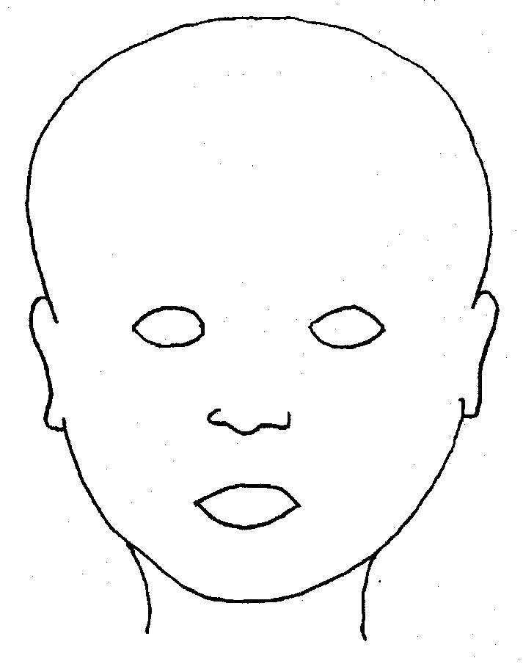 |  | 
FRONT |  | BACK
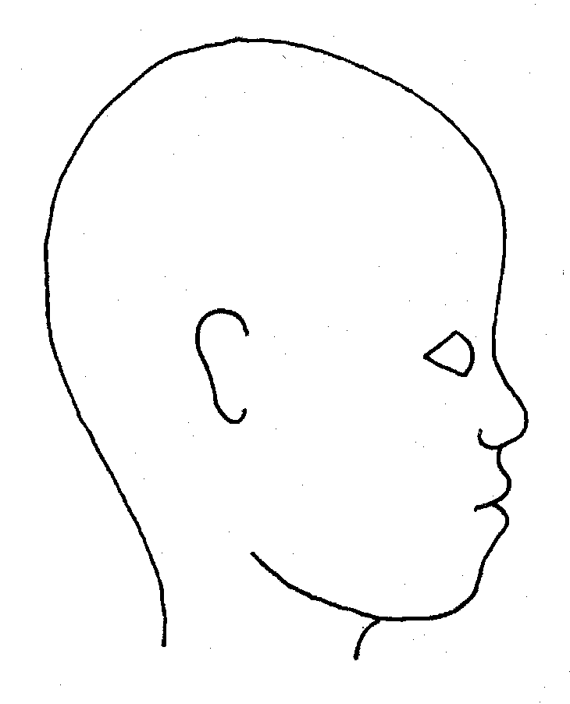 |  | 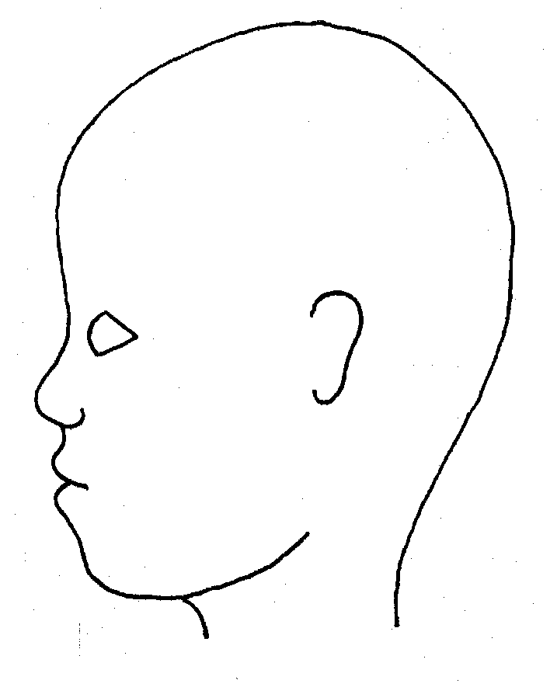
RIGHT |  | LEFT

Name of pupil: |  |  |  |  |  |  | Date and time of observation:
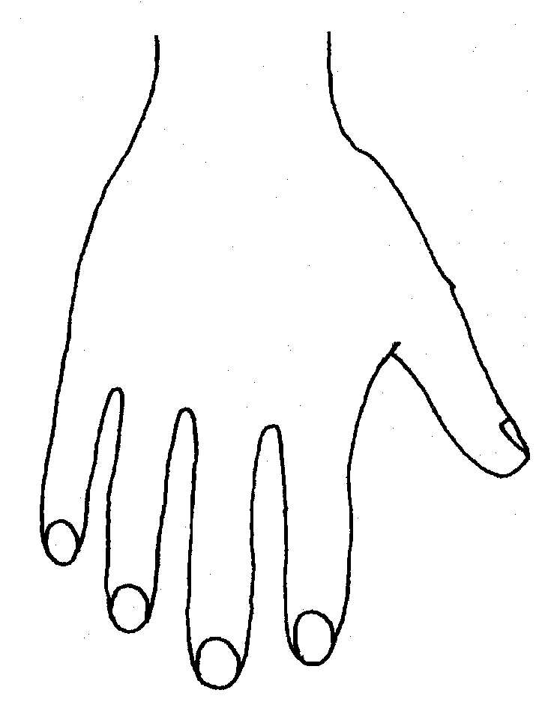 |  |  |  |  |  | 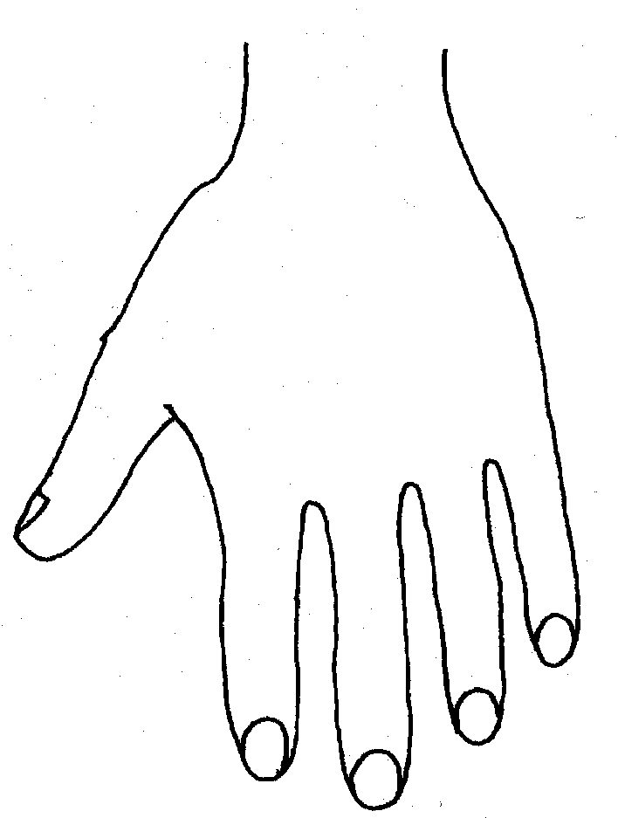
R |  |  |  |  |  | L
BACK
 |  |  |  |  |  | 
Name of Pupil: |  |  |  |  |  |  | Date and time of observation:
 |  |  |  |  | 
R | TOP |  |  | L | R |  |  | BOTTOM |  |  |  | L
 |  |  |  |  | 
R |  |  |  |  | L
INNER
 |  |  |  |  | 
R |  |  |  |  | L
OUTER
Printed Name, Signature and Job title of staff:

In maintained schools the governing body is responsible for ensuring their functions are exercised with a view to safeguarding and promoting the welfare of children in accordance with section 175 of the Education Act 2002, for pupil referral units it is the management committee, in independent schools, including academies and free schools, and 16-19 academies, this duty sits with the proprietor (in the case of academies the proprietor will be the academy trust). References to the governing body throughout this policy framework includes management committees.
Guidance on Low-Level Concerns may be a stand alone policy or included within another policy e.g. Staff Code of Conduct
Annex A of KCSiE is a condensed version of Part One of KCSiE. Whilst it is a matter for schools, based on their assessment, HSCB take the view that it should only be those staff that do not have regular direct contact with children in school, e.g. cleaners who come in out of school hours, who are expected to only read the condensed version of Part One of KCSiE.
The governing body may decide that for some roles should read additional parts of the guidance e.g. colleagues involved in safer recruitment administration including the maintenance of the single central record should also read Part Three of KCSE.
Section 175, Education Act 2002 – for management committees of pupil referral units, this is by virtue of regulation 3 and paragraph 19A of Schedule 1 to the Education (Pupil Referral Units) (Application of Enactments) (England) Regulations 2007
Set out in paragraphs 83-93 of KCSiE
See LA explanatory note on the requirements around children having an appropriate adult Schools-StopSearch-v2.3.pdf (squarespace.com)
Whilst it is a matter for schools, based on their assessment, HSCB take the view that it should only be those staff that do not have regular contact with children in school, e.g. cleaners who come in out of school hours, who are expected to only read the condensed version of Part One of KCSiE.
Dependent on school stance on the condensed version of KCSiE. Whilst it is a matter for schools, based on their assessment, HSCB take the view that it should only be those staff that do not have regular contact with children in school, e.g. cleaners who come in out of school hours, who are expected to only read the condensed version of Part One of KCSiE.
UKCIS guidance: Sharing nudes and semi-nudes advice for education settings.
Under section 5B(11) (a) of the Female Genital Mutilation Act 2003, ‘teacher’ means, in relation to England, a person within section 141A(1) of the Education Act 2002 (persons employed or engaged to carry out teaching work at schools and other institutions in England)
N.B. The exception to this process will be in those cases of known FGM where there is a mandatory requirement for the teacher to report directly to the police, although the DSL should also be made aware.

