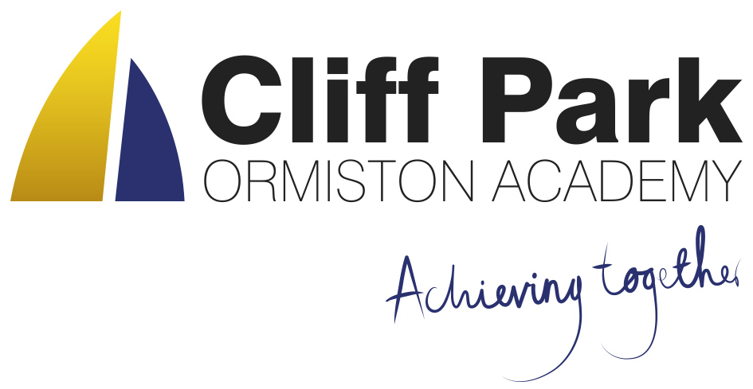

Cliff Park Ormiston Academy

Catering Assistant Job Description

Grade: OAT – Catering 1 25 Hours per week 9.30 am – 2.30 pm Monday to Friday

Responsible to: Head of Kitchen

Disclosure level: Enhanced Disclosure and Barring Services Check (DBS)

Overall role purpose:

The role is crucial in providing the students and staff at the Academy with a high level of food preparation with a courteous and efficient service.

Main duties and responsibilities:
- Ensure that all work is undertaken in a safe manner without risk of injury to self or colleagues.
- Ensure that all equipment is checked on a regular basis and any damage or inoperative equipment is immediately reported to the Catering or Deputy Catering Manager.
- To maintain high standards of food hygiene in the kitchen and serving areas in accordance with the school’s Policies and procedures and those laid down in “Safer Food, Better Business.” To pass and then adhere to the requirements of Level 2 in Food Safety at all times.
- Ensure that the kitchen is kept in a clean and tidy condition by following the cleaning schedule. This includes cleaning worktops and tables, sweeping up and mopping floors.
- To clean communal areas on a rota basis.
- Prepare food, as required and instructed, for service daily.
- Minimise food wastage.
- Serve food, taking note of portion control, in a friendly and welcoming manner.
- Operate the cashless catering tills as required.
- Undertake washing up; both manually and using the industrial washing machine.
- Carry out some administrative tasks that might include recording temperatures, food temperatures (from probes) and checking off deliveries
- Delivering a high quality customer service that includes communicating with students appropriately, giving basic advice and guidance and helping them to manage their accounts.
- Undertake any other duties as may be reasonably requested.
- Undertake any training deemed necessary by Catering Manager including safeguarding

Personal Specification

Essential

- Level 2 in Food Hygiene or a willingness to take and pass the course

- Reliable, flexible team player

- Ability to cope with pressure and prioritise tasks accordingly to meet all deadlines

- Friendly, cheerful person with a good sense of humour

- Accept the need for continuing professional learning

- Be able to follow all safe working practices and procedures

- Communicate effectively and appropriately with both students and adults and must enjoy being around teenagers.

- High standard of personal cleanliness

- Be able to or prepared to learn how to operate cashless touch screen till

Desirable

- Passionate about food and cooking

- A willingness to learn how to cook

- Please be aware that this job involves some lifting and carrying

Notes:

- All staff are part of a wider academy team. Each individual, therefore, is required to support the values/ethos of the academy and the academy priorities as defined in the Academy Improvement Plan. This will mean being responsive to the needs of colleagues, parents and students and being flexible in a demanding environment. On occasions the post holder may be expected to carry out additional tasks, as requested by the Principal and Governors, which are not specifically specified in this job description.
- All staff in the academy work subject to statute and academy policies and procedures. The post holder will be expected to become familiar with these and work in accordance with them.
- Due to the nature of this job, it will be necessary for the appropriate level of Criminal Record Disclosure to be undertaken. It is essential that post holders disclose whether they have any pending charges, convictions, bind-overs or cautions and if so, for which offences. Any failure to disclose such convictions will result in dismissal or disciplinary action by the academy.

