Key Stage 2 Class Teacher
Location: Kilburn, North-West London (NW6)
Salary: M1–M3 (£40,317–£44,238, Inner London)
Contract: Full-time, 1-year fixed term (from September 2026)
Early Career Teachers welcome

Join a school where your impact truly matters
At Kilburn Grange School, we believe in growing hearts and minds so that every child can learn, enjoy and succeed. Serving a richly diverse community in Brent, many of our pupils face significant disadvantage—but the progress they make is remarkable, and being part of that journey is deeply rewarding.

If you are motivated by purpose, challenge, and the chance to change children’s life chances, this could be the role for you.

About us
Kilburn Grange is a modern, well-resourced free school that opened in 2015. We are part of the Bellevue Place Education Trust (BPET), a family of schools across London and Berkshire.
Our curriculum is built around three core principles: Learn, Enjoy, Succeed, brought to life through six key drivers that shape everything we do in and beyond the classroom:

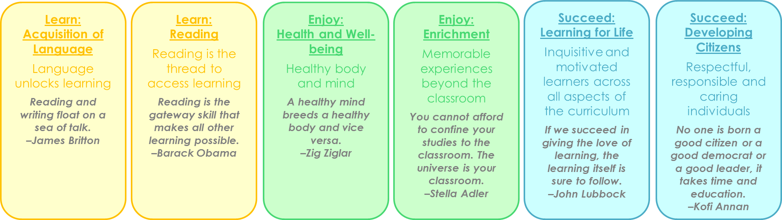

The role
We are looking for a committed and reflective Key Stage 2 teacher who:
- Has a genuine passion for working with children
- Can deliver engaging, creative and inclusive lessons
- Has high expectations and a commitment to pupil progress
- Is resilient, proactive and motivated by challenge
- Is eager to develop their practice and contribute to a team

This role is particularly suited to someone who wants to grow quickly as a teacher and make a meaningful difference.

Why join us?
- Real impact: See the tangible difference your teaching makes every day
- Supportive team: A close-knit staff who collaborate and support one another
- Strong classroom support: Experienced and skilled teaching assistants in every class
- Professional development: High-quality training within school and across the BPET network
- Career progression: Opportunities to grow within a forward-thinking trust
- Excellent benefits: Inner London salary + access to a stakeholder private pension scheme with no employee contribution needed

Come and see us in action
We warmly welcome visits to the school. Please email to arrange a meeting with our Headteacher, Helen Khinich.

To apply, please submit your application form to:
📧 info@kilburngrangeschool.org.uk
🌐 More information: www.kilburngrangeschool.org.uk

Closing date: 29 May 2026
Interviews: Ongoing upon application

We reserve the right to close this vacancy early if we receive sufficient applications. Early applications are encouraged.

The school is committed to safeguarding and promoting the welfare of children and expects all staff and volunteers to share this commitment. All appointments are subject to satisfactory references, pre-employment and DBS checks. Kilburn Grange School will welcome a diverse population of both children and staff and is committed to promoting and developing equality of opportunity in all its functions.

