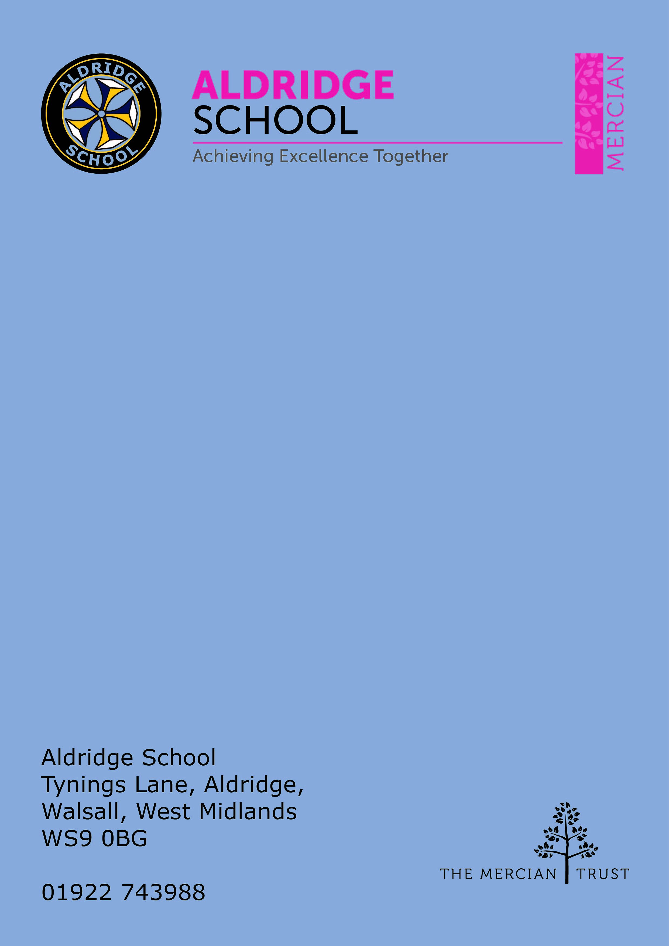

Application Pack

DT Technician


About Aldridge School – a Founder Academy of the Mercian Trust

About The Mercian Trust

Person Specification
How to Apply

Job Description

About Aldridge School

Thank you for taking the time to find out more about Aldridge School. This pack is intended to give you information about this role and our school's broader vision and ethos. Further background information is available in our Prospectus and Sixth Form Prospectus on our website.

We are a comprehensive school of over 1600 students situated near the centre of Aldridge village. We believe that it is our responsibility to work to meet the needs of every individual student, challenging them to achieve their best, supporting them to become responsible young adults and preparing them for their next steps into the world of work or further education.

Aldridge School is a good school (Ofsted 2022). It is a school which is proud of its traditions and successes which have been achieved through hard work and high expectations.

Aldridge School has a dedicated, talented and conscientious team of staff who work together to provide a high standard of teaching, excellent pastoral care and professional support services. Our broad curriculum is designed to meet national expectations, be relevant and interesting, support our students in achieving the best possible standards in external examinations and to equip them with the skills they need to be successful in adult life.

At Aldridge School we have a popular and thriving Sixth Form. We are very proud of our students' success with over 80% securing places at some of the top Universities and on Higher Apprenticeships last year. We offer a very broad range of both academic and vocational courses at level 3, ensuring that Aldridge School Sixth Form is an option for a wide range of students.

We also enjoy strong links with surrounding primary schools, working with students in Years 5 and 6 including work in Science, Maths, English, Performing Arts and Enterprise. We are proud of our community and we work hard to promote this pride in all our partnerships, so that we can make sure that future students from these schools enjoy an easy, enjoyable transition to Aldridge School.

Students at Aldridge School are friendly, polite and respectful. Strong relationships between staff and students contribute significantly to ensuring that students are happy and feel safe.

If you would like to find out more, please contact us to arrange a visit to see our school at work. We look forward to meeting you.


The Mercian Trust

Aldridge School is an academy in The Mercian Trust.

The Mercian Trust brings together twelve very different and individual schools together as a single Multi-Academy Trust or MAT.

The twelve schools are unique in their identity and united by their ambition to offer the best possible future for their students.

The twelve schools are:
- Aldridge School
- Queen Mary’s Grammar School
- Queen Mary’s High School
- Shire Oak Academy
- The Ladder School
- Walsall Studio School
- Q3 Academy Great Barr
- Q3 Academy Langley
- Q3 Academy Tipton
- New Leaf
- Rushall Primary School
- Oakwood School

Each school has its own distinct ethos and approach, but we have this over-arching aim in common: we prepare all our students to enjoy life to the full by inspiring them to:
- Realise their potential as learners
- Thrive in the world of work
- Make a positive contribution to the local, national and international community

The Mercian Trust respects the autonomy of its member schools but, through collaboration, fosters strengths that are greater than the sum of its parts. Working together as a Multi-Academy Trust provides a framework for sharing expertise and enthusiasm, resources and ideas.


Job Description

Post: DT Technician
Responsible to: FL Design & Performance
Salary: Grade 3 SCP 4-6
Working hours: 25hrs

Aldridge School is seeking an experienced and proactive DT Food Technology Technician to join our vibrant and supportive Food Technology department. The successful candidate will play a key role in ensuring that practical lessons are well-prepared, well-resourced and delivered in a safe, organised environment for both staff and students.

Key Responsibilities

Lesson Preparation
- Prepare ingredients, equipment, and materials for all Food Technology lessons.
- Organise and set up workstations ahead of practical sessions.
- Ensure all practical areas, equipment and storage spaces are clean, well‑organised and compliant with health and safety standards.
- Maintain a safe working environment, following all food hygiene and safety regulations.
Classroom Support
- Support teachers during practical lessons when required.
- Support the teacher in lessons by preparing demonstrations, organising resources and assisting students where appropriate.
- Assist students with equipment use, safe working practices, and correct food hygiene procedures.
Health, Safety & Hygiene
- Maintain a clean, safe, and well-organised kitchen/classroom environment.
- Ensure all food hygiene standards and health & safety guidelines are followed at all times.
- Clean and maintain equipment, utensils, and work areas after lessons.
- Maintain accurate written and digital HACCP records, ensuring all documentation is fully completed, up to date and stored in the correct folders.
- Ensure all digital departmental folders are clear, well organised and audit‑ready, including ingredient checks, cleaning logs and equipment maintenance records.
- Support the completion, organisation and upkeep of risk assessments, ensuring these are reviewed and accessible for health and safety audits.
- Follow all food hygiene and safety regulations, maintaining a clean and safe practical environment for students and staff.
Stock & Resource Management
- Maintain accurate inventory records, monitor stock levels and manage rotation to minimise waste.
- Order stock, ingredients and consumables, ensuring best value and timely delivery.
- Ensure correct storage, rotation, and safe handling of all food items.
Wider Department Responsibilities
• Support with displays, departmental events and practical assessments as needed,
including assisting in the preparation of resources for KS3 Textiles rotation lessons and carrying out any other reasonable duties to support the wider department.



Person Specification

Experience
- Experience in a food preparation, catering, or school-based environment (desirable)
- Knowledge of food hygiene and health & safety requirements.
- Strong organisational skills with excellent attention to detail.
- Ability to work independently and as part of a team.
- Good communication skills and a positive, flexible approach.
- Conscientious, reliable and meticulous, with excellent attention to detail.
- Highly organised, able to manage time and resources effectively.
- Adaptable and able to work independently as well as part of a busy department.
- Confident in following food hygiene procedures (training can be provided).
- Enthusiastic about helping young people learn essential life skills.

Desirable qualifications
There are no essential qualifications for this role, however the following would be beneficial:
- GCSE or equivalent in English and maths
- Prior experience of working in schools
- Be self-motivated and enthusiastic and able to remain positive under challenging circumstances
- Have excellent administration and organisational skills



How to Apply

Salary Scale: Grade 3 SCP 4-6

Contract / Hours: Permanent, Term time inclusive of inset days

Hours of Work: 25hrs per week

Closing Date

We reserve the right to close vacancies before the advertised date if a large number of applications have been received.

Start Date
As soon as possible

Visits to School
For further information, please contact the school either by email info@ald.merciantrust.org.uk or by telephoning on 01922 743988 ex 2224

Applying
Apply via The Mercian Trust portal
