


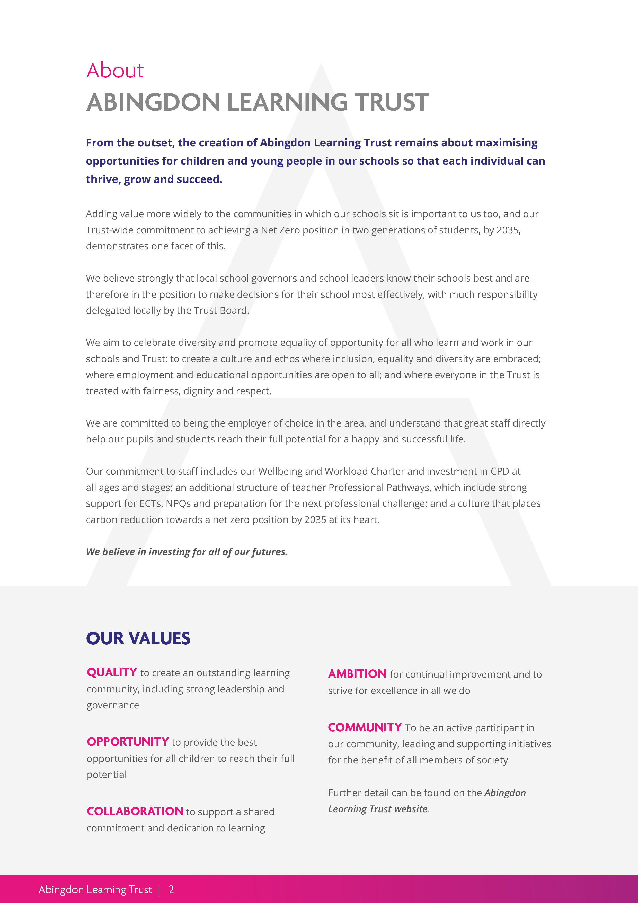
DESIGN TECHNOLOGY TECHNICIAN RECRUITMENT PACK
May 2026
FITZHARRYS SCHOOL
Abingdon Learning Trust
About
ABINGDON LEARNING TRUST

At Abingdon Learning Trust, our vision is to nurture curiosity, ambition, resilience, and courage. We support a deep-rooted compassion for others and our world, enabling choices and opportunities for a happy and successful life. This vision encompasses every child, pupil, student and member of staff.

Why Work for Us? At Abingdon Learning Trust, we believe that our people are our greatest asset. We are dedicated to creating an environment where every member of staff feels valued, supported, and inspired to achieve their best.

A People-Centric Culture. We are passionate about making a positive difference in the lives of children and young people. Our inclusive culture embraces equality and diversity, ensuring that everyone is treated with fairness, dignity and respect. You will be part of a community that values your unique contributions and supports your professional growth.

Empowered Local Leadership. We trust our local school governors and leaders to make the best decisions for their schools. This means you will have the autonomy to innovate and tailor your approach to meet the needs of your students and community. Each school within our Trust has its own unique ethos, yet we all share the same core values.

A Long-Term Vision. We are focused on preparing the next generation for the future. Our long-term view goes beyond immediate test and exam results, emphasising the development of skills and capabilities that will benefit our pupils throughout their lives. Join us in our mission to create a sustainable future with our net zero ambitions for 2035.

Investment in the Future. At Abingdon Learning Trust, we are committed to investing in our staff and our schools. You will be part of a forward-thinking organisation that values innovation and continuous improvement. Together, we can make a lasting impact on education and the wider community.
AMBITION for continual improvement and to strive for excellence in all we do

COMMUNITY to be an active participant in our community, leading and supporting initiatives for the benefit of all members of society

Further detail can be found on the Abingdon Learning Trust website.
OUR VALUES

QUALITY to create an outstanding learning community, including strong leadership and governance

OPPORTUNITY to provide the best opportunities for all children to reach their full potential

COLLABORATION to support a shared commitment and dedication to learning

POST OF: | Design Technology Technician
AT: | Fitzharrys School
Commencement: | As soon as possible
Contract type: | Permanent, Part-time – 16 hours per week
Salary: | Support Staff Grade 4 Point 4  £13.05 per hour, pay award pending  Actual salary £9,349 due to term time only nature of the post


Letter from the
Chair of Local Governors

On behalf of the Local Academy Board, I would like to thank you for applying to work at Fitzharrys.

We are extremely proud of what the school has achieved under its current head, Will Speke.
If you join the school, you will find a strong sense of common purpose among your colleagues; a commitment to widening the opportunities available for young people; a sense of ambition reflected in the great results that our GCSE and A level students achieve; and, of course, a group of youngsters who embody the school’s key values of trust, decency, sincerity and truthfulness.

As governors we are a mixed group, comprising parents, members of the local community, employers and staff: mixed in background, but all united in our support of the school’s professional staff and all ambitious to make the school an excellent place to work and an excellent place to be a student.

We believe that our support, and the challenge we provide, are part of what makes Fitzharrys a good school.

We hope you will be inspired to work here and will want to be part of Fitzharrys’ journey to becoming an outstanding school. You will receive good support, and opportunities provided for professional development outside the school, without the anonymity that you might experience in a larger trust.

We look forward to your application.


Introduction to
FITZHARRYS SCHOOL

Fitzharrys is a fantastic school where students are given an array of opportunities to develop, thrive and achieve high aspirations. Our superb team of staff are committed to helping every student reach their full potential. They work with care and expertise to bring the very best out of our students. This is evident in the enthusiasm, focus, and achievements of our students.

There is real warmth in the welcome you receive when you join Fitzharrys. The sense of pride and belonging is evident in the school, as is the support and challenge. We want our students to be the very best they can be, and we do everything we can to make that happen.

Our Ofsted report, consistently strong results, high attendance, and impressive behaviour for learning all illustrate the ethos of Fitzharrys. We pride ourselves not only on our students' academic and extracurricular achievements, but also on their approach to every challenge and opportunity; integrity is a key characteristic at the school.

We have high aspirations for our students, and our clear approach to teaching and learning, through our Fitzharrys Lesson Standard, ensures consistent high-quality teaching in every subject area. Students study a carefully designed curriculum, balancing skills, knowledge and understanding.

Staff and students see that the biggest opportunity is in their learning, yet the wider opportunities we provide for students are exciting, engaging, and enhance the personal development of our students. This includes school productions, sports tours, ski trips, the Duke of Edinburgh award, and our school camp. Fitzharrys students have the chance to develop and progress both in and out of the classroom.

Our social media pages and events calendar give a sense of what our students achieve and the opportunities they have; we are incredibly proud of what our students accomplish from year 7 through to year 13.

We always welcome people to come and visit us. Meeting our staff and students will give you a real insight into what our great school has to offer.


Job
DESCRIPTION
JOB PURPOSE: To assist in the support of Technology related activities within the Technology Department.
To ensure that staff are supported in the successful preparation of materials and the maintaining of subject related equipment to ensure the successful delivery of lessons.
MAJOR AREAS OF RESPONSIBILITY:
- Teacher Support – To prepare the classroom for lessons, practical activities and demonstrations
- Pupil Support – Develop an understanding of the specific needs of students taught within the department and provide support when appropriate during practical activities in order for all students to learn as effectively as possible
- Department support – Work closely with the Lead Teacher for the specialist area being supported to ensure that all equipment is maintained and in good working order and that materials are stocked as required.
- Health & Safety – To ensure that Health & Safety requirements are observed and high standards upheld across the department
KEY TASKS:
A1. To prepare, distribute and then clear away equipment materials and resources for lessons as required
A2. To undertake and ensure that all administrative duties, checks and documentation are completed to the required level of accuracy including photocopying, filling and collection of payments from students
A3. To assist in putting in place provision for practical school and public examinations

B1. To provide technical advice and support in the classroom, for example, with demonstrations, practical activities and resources
B2. To assist in escorting students on educational visits and participate in extra-curricular activities as required
B3. To establish and maintain good relationships with all students, parents / carers, colleagues and other professionals
B4. To support SEN pupils in lessons as and when required by subject staff

C1. To contribute to the development and organisation of facilities, equipment, tools and resources to support the teaching of the curriculum
C2. To ensure that equipment is in good working order and that the classroom, preparation room and storage areas are in a clean, secure, safe and orderly condition.
C3. To assist in stock control, compiling purchase orders, liaising with suppliers and
maintaining appropriate records
C4. To maintain both manual and computerised record and filing systems in line with departmental requirements
C5. To assist and maintain appropriate classroom and corridor displays within the Technology Department and within the School
C6. To attend school events as required, for example, open evenings
C7. To take part in training for the role

D1. To assist in the promotion and observance of a healthy and safe working environment
D2. To assist in ensuring the safe and effective operation and use of equipment, materials and resources
D3. To carry out both routine and non-routine checking, cleaning, maintenance and testing of equipment to the required standards
D4. To liaise with facilities, suppliers or contractors when necessary and in relation to equipment repairs, servicing and maintenance, new installations and disposals
D5. To assist with the carrying out of risk assessments including those on a variety of equipment and processes
D6. To attend relevant meetings and training sessions as required


D1. To assist in the promotion and observance of a healthy and safe working environment
D2. To assist in ensuring the safe and effective operation and use of equipment, materials and resources
D3. To carry out both routine and non-routine checking, cleaning, maintenance and testing of equipment to the required standards
D4. To liaise with facilities, suppliers or contractors when necessary and in relation to equipment repairs, servicing and maintenance, new installations and disposals
D5. To assist with the carrying out of risk assessments including those on a variety of equipment and processes
D6. To attend relevant meetings and training sessions as required
OUTCOMES
The outcomes that are associated with this role are to work as part of the Technology department team who:
- Are consistent in their practice
- Share good practice with other team members
- Act as role models for all learners

The outcomes associated with the specific role are:
- Effective communication
- An individual and team belief that all students can learn and develop
- An ethos where problems are minimised
- Effective teamwork where everyone is treated with dignity and respect
- Students feel confident and are included

ACCOUNTABILITY:
Technology technicians are accountable to The Head of Faculty and the lead teacher for the specialist area being supported.
Safeguarding
The points below are a requirement for the postholder of this position:
- A knowledge and keen awareness of Safeguarding matters and an ability to demonstrate personal values and beliefs in accordance with the Trust’s Safeguarding Policy
- Display commitment to the protection and safeguarding of children and young people
- A strong appreciation of child protection issues and the capacity of acting in accordance with the Trust’s Safeguarding policy
- Reading, understanding and following all aspects of the Trust’s Safeguarding policies and processes
- Comply with safeguarding training expectations

Your contract of employment is directly with The Abingdon Learning Trust. Your main place of work will be Fitzharrys School, but you may be deployed to work at any school within The Abingdon Learning Trust and carry out those duties that may be reasonably required in relation to such deployment. This will depend upon the role, timetabling and organisational needs of the schools in the Trust and your own individual professional development needs. Any change to your main place of work will be discussed and agreed with you, in advance.

Abingdon Learning Trust is committed to safeguarding children and young people. All post holders in regulated activity are subject to appropriate vetting procedures and a satisfactory Disclosure and Barring Service Enhanced check. The Trust is fully committed to the principles of equal opportunity, diversity and inclusion and welcomes applications from less well represented groups in the school and Trust. Posts in regulated activity are exempt from the Rehabilitation of Offenders Act (ROA) 1974 and all shortlisted candidates will be required to disclose information about their previous criminal convictions. All staff are expected to promote fundamental British values.


Person
Specification
SPECIFICATION | ESSENTIAL | DESIRABLE
Education/Training | - Good levels of proficiency in English and Mathematics  - Functional ICT skills
Experience | - Experience of working with young people  - Knowledge / experience of workshop machines and hand tools / equipment and safe working practices within the workshop environment (full training will be given) | - Knowledge / experience of working  with and maintaining workshop-based equipment, tools and resources
Skills/Attributes | - Effective interpersonal skills  - Remains calm under pressure  - Works effectively in a team  - Able to be flexible over hours during the working day  - Trustworthy  - Communicates clearly and concisely  - Excellent time management skills  - Demonstrates initiative, flexibility, and commitment to get things done  - Knows when to seek help from others  - Able to prepare demonstration and support materials in response to staff requests  - Supports others by listening  - Ability to manipulate and handle the materials used in the department  - Ability to Manage Health and Safety records and documentation | - Ability to lead small group activities
Personal Qualities | - Commitment, enthusiasm and energy  - Ability and willingness to work to get the best from all children  - Commitment to own personal and professional development  - Willingness to be involved in the wider life of the school community  - Emotional intelligence and empathy  - Willingness to undertake training  - Willingness to try new approaches  - Understand need for confidentiality  - Respect and support ethos of school



Terms of
APPOINTMENT

The appointment will be made based on National Joint Council’s Support Staff pay and conditions.

The appointment is for as soon as possible and is part-time, and permanent.

Fitzharrys School and Abingdon Learning Trust are committed to safeguarding and promoting the welfare of children and young people and require all staff to share this commitment.
This post is exempt from the Rehabilitation of Offenders Act.

A copy of the school’s Safeguarding and Child Protection Policy is here: Policies - Fitzharrys School

Applicants must be willing to undergo all the relevant pre-employment checks as laid out in Keeping Children Safe in Education.
Person
SPECIFICATION

Closing date for completed applications is 12 noon on 1 June 2026, however applications will be processed on arrival.

Applications should be completed online through our recruitment portal, My New Term, at Vacancies - Fitzharrys School

Shortlisted applicants will be notified following assessment of applications against the person specification and job role requirements.

Interview date to be confirmed.

Please do contact Carole McKivitt, Head of HR, by email to cmckivitt@fitzharrys.school
or by phone on 01235 462424 for an informal discussion about the role

We look forward to receiving your application.

Polite notice to Recruitment Agencies:
Please be aware that we do not accept unsolicited applications or CVs from recruitment agencies. Any unsolicited information sent to us will not be considered, and we will not be liable for any fees related to such submissions.

