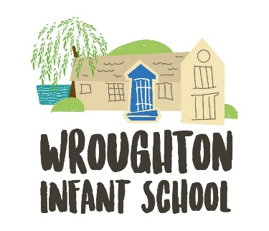

ADVERT
Wroughton Infant School is a two-form entry Infant School in the village of Wroughton, just outside Swindon Wiltshire. At Wroughton Infants, we are ‘Proud to Belong’ and this is shown through all aspects of the school. We work hard to ensure that no child is left behind and that the unique identity of the school is protected, celebrated and valued for the contribution they make to ensuring children have the best educational experiences. We passionately believe, that by working together, the children will receive a higher quality of education.
We encourage our pupils to be responsible and determined citizens who care about their community. We value honesty and respect.

We are looking for a Catering Assistant to join our small team of dedicated support staff, providing nutritious and delicious hot school meals each day. This is a part-time, permanent position which is term time only.

In return for your warmth, dedication and unwavering desire to support children to thrive, we can offer
- Free breakfast club for any of your children who attend Wroughton Infants
- Access to free, high-quality professional development and training
- Free sight test plus a contribution towards the cost of glasses
- Free, confidential access to our employee assistance programme which includes legal and financial advice as well as wellbeing support
- Generous pension scheme
- Enhanced family-friendly policies, including maternity, paternity, adoption, and shared parental leave, and flexible working to allow staff to attend significant family/life events (weddings, children’s assemblies, hospital appointments etc.)
- Blue Light Discount & Discounts for Teachers
- Cycle to work scheme

