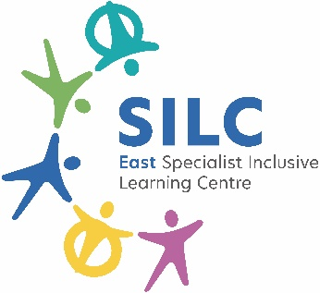
Employee Specification – Educarer
Detailed below are the types of skills, experience and knowledge that are required of applicants applying for the post. The ‘Essential’ requirements indicate the minimum requirements, and applicants lacking these attributes will not be considered for the post. The points detailed under ‘Desirable’ requirements are additional attributes to enable the applicant to perform the position more effectively or with little or no training. They are not essential but may be used to distinguish between
 | KEY
 | A | = Application
 | SP | = Selection Process
Person Specification | Essential | Desirable | Method of Assessment
Qualifications and Training
GCSE level or above in English & Maths | ✓ |  | A & SP
Healthcare/ medical qualifications |  | ✓ | A & SP
Basic First Aid Qualification |  | ✓ | A & SP
Experience
Experience appropriate to working with learners in an educational setting |  | ✓ | A & SP
Experience of assisting with health and medical routines of learners |  | ✓ | A & SP
Preparation of meals and gastrostomy tube feeding |  | ✓ | A & SP
Experience of working in a class based environment with SEN learners |  | ✓ | A & SP
Experience of working effectively with learners with difficult behaviour |  | ✓ | A & SP
Skills & Knowledge
Good written and verbal communication skills with a range of staff, learners and their families | ✓ |  | A & SP
Good understanding of child development and learning processes | ✓ |  | A & SP
Administering of medication orally/inhaled/via gastrostomy and supplies management between home and school |  | ✓ | A & SP
Sound literacy and numeracy skills | ✓ |  | A & SP
Basic IT skills | ✓ |  | A & SP
Behaviour Management |  | ✓ | A & SP
Personal Qualities
Being sympathetic, patient and sensitive to the needs of individual learners | ✓ |  | A & SP
Being discrete, professional, respectful and friendly | ✓ |  | A & SP
Being efficient and dependable, while maintaining flexibility to adapt to rapid change, while remaining calm in unexpected to changing circumstances | ✓ |  | A & SP
Other Requirements
To be committed to the school’s policies and ethos | ✓ |  | A & SP
To be committed to continuing professional development | ✓ |  | A & SP
Motivation to work with learners | ✓ |  | A & SP
Ability to form and maintain appropriate relationships and personal boundaries with learners | ✓ |  | A & SP
Emotional resilience in working with challenging behaviors and attitudes to use authority and maintain discipline | ✓ |  | A & SP

The East SILC is committed to safeguarding and promoting the welfare of children and young people (learners) and expects all staff and volunteers to share this commitment. Appointments are made subject to a satisfactory enhanced Disclosure and Barring Service check (DBS formally CRB) and medical clearance from Leeds City Council’s Occupational Health Service.
All shortlisted candidates must complete a self-disclosure form before interview.
It is illegal to apply if you are on the children’s barred list.

The East SILC promotes diversity and wants a workforce which reflects the population of Leeds.

