Fir Tree Primary School Headteacher Information Pack

Table of Contents
1 Welcome letter from The Local Governing Body and ODST 4
2 About our school 6
3 OFSTED 8
4 What our children would like in our next Headteacher 9
5 Job Description and Person Specification 10
6 Copy of the Job Advertisement 13
7 About ODST 14
8 How to apply 16


- Welcome letter from The Local Governing Body and ODST
We are delighted that you are taking an interest in the role of Headteacher at Fir Tree Primary School, a highly regarded, community school at the heart of the local community in Wallingford, South Oxfordshire.
This is an exciting time to join Fir Tree, and we are looking for an experienced leader to drive the next phase of our development.
Historically we have been a vibrant, successful two-form entry setting, but the culmination of an exciting and eagerly awaited project will be reached in September 2026 when Fir Tree officially converts from a Junior to Primary setting.
The school has developed an ambitious and creative curriculum and takes pride in the breadth of wider learning opportunities offered to enrich pupils’ education including forest school, trips, music tuition and more. Staff place the school values of respect, kindness, resilience, curiosity, aspiration and fairness at the heart of school life, modelling these every day. Our experienced and hard-working team provides quality-first teaching to inspire and enthuse children with high ambitions, and they go the extra mile to value every child’s contribution to nurture their progress and achievement.
Our children are proud of their wonderful school; they are well-behaved, considerate and keen to learn. We are proud of our child-centred approach, giving prominence to the pupil voice through an active School Council, Values and Arts Reps plus a variety of other student leadership roles.
We are fortunate to have a fantastic school site, with a forest school and pond, a large playing field, play equipment and an outdoor classroom which we call ‘The Castle’.
In April 2018, Fir Tree became an academy as part of the Oxford Diocesan School Trust (ODST). Being a part of a trust has enabled us to develop and work collaboratively with other member schools, whilst also preserving our community school status.
For you, working in an ODST school will mean access to the Trust’s central team who will support you and share your ambitions to develop yourself and those around you. That will include a wide range of professional development opportunities, both formal and informal, and you will be provided with induction and support. In addition, we will look to draw on your strengths to support the development of others in due course with those principles encapsulated in ODST’s ‘Common Vision for the Common Good’.

Above all, the person we are looking for to be Fir Tree’s next Headteacher is someone who cherishes each child as a unique individual. You will need to build good relationships with colleagues, partners and stakeholders including external service providers, parents and governors. As an experienced teacher and senior leader, at the heart of your practice is a passion for education and a strong belief in the difference it makes to children’s lives.
We are looking for a Head who will take pride in leading our new primary school and be ready to embrace the changes and enable children to flourish and grow.
We hope you will come and visit the school to see for yourself what a wonderful place it is to work and please do contact us if you would like to ask any questions.
We look forward to hearing from you.
The Local Governing Body at Fir Tree Junior School
and
Sharon Mullins, Chief Executive, Oxford Diocesan Schools Trust
- About our school
Respect
Resilience
Kindness

Curiosity
Fairness
Aspiration

We are very proud of our school and all that the children achieve during their time with us. We have a dedicated team of staff and governors who give their time, expertise and support in making each day a special day for the children along with a committed PTA, who work tirelessly to raise funds for our extra-curricular activities.
We take pride in our ethos, which is underpinned by the values of: respect, kindness, resilience, curiosity, aspiration and fairness. The children learn about the importance of values and how values make the person you are. In becoming citizens of the world, we learn about different cultures, religions and beliefs; we learn to understand and celebrate similarities and differences. Each child in our care is unique. We are committed to providing opportunities for them to excel and achieve and to raise their self-esteem and confidence. We recognise that they have much to offer in their skills and strengths and they understand that with perseverance and challenge they can achieve more.
The behaviour of all our children is important to us. Together we agree the rules for appropriate behaviour, which in turn fosters positive relationships and nurtures an environment for learning. We have adopted the Family Links programme, which is rooted in the principles of choices and consequences.
We believe that learning and teaching is far more exciting when children are given the opportunities to question, explore and investigate. English and mathematics are the bedrock of our curriculum, which is enriched with the arts and sports, whilst providing a thirst for exploring the sciences and humanities. We are living in a world that is moving very fast in the field of technology, and our curriculum aims to provide the children with the skills to meet the demands of the 21st century. We pride ourselves on being a learning community where everyone is a learner.
We work closely with St Nicholas C of E Primary School, who have historically been our feeder school (and are a fellow member of ODST), and Wallingford School where most of our children transfer to in Year 7. We have a robust transition process, which involves visits from the children and meetings between the teachers to pass on relevant information.
All that we do and achieve is because of the strong team of professionals who, without exception, work hard to ensure that each child achieves and enjoys their time at Fir Tree.

In September 2026 we will have our first Reception, and Year 2 classes, along with a single Year 3 entry.
As such, the appointed candidate will need to be able to demonstrate strong planning skills and an ability to work collaboratively with colleagues at St Nicholas C of E Primary School, within ODST and with those at Oxfordshire County Council. The appointed candidate will also need to inspire staff through the changes and encourage growth and development as needs change over the next few years.
This is a rare opportunity to facilitate the transition of a junior school into the full primary phase.
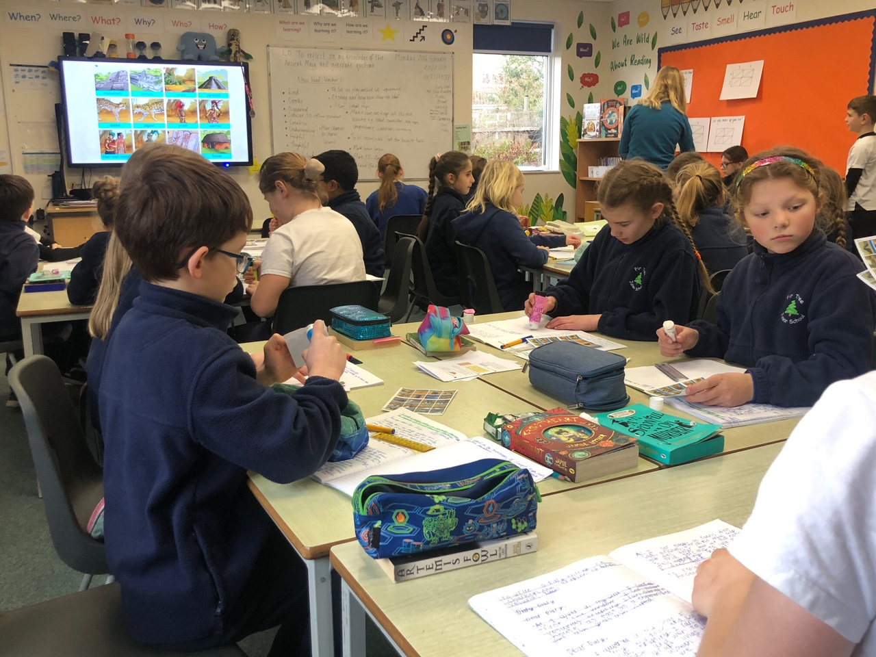

- OFSTED
In our last Ofsted (Section 8) inspection in July 2022, we were deemed to remain a good school with many strengths being highlighted.
Here are just some excerpts:
- Pupils thrive at this friendly, welcoming school.
- Leaders aspire for all pupils, including those with special educational needs and/or disabilities (SEND), to achieve well.
- Pupils are taught to show high levels of consideration towards their peers and towards other people.
- Pupils enjoy making a difference to their school, the local community and the wider world. They are rightly proud that they grow fruit and vegetables in the school allotment for use in school dinners.
- Leaders have designed a broad and ambitious curriculum.
- Leaders prioritise reading….Books are everywhere in the school…As one pupil stated, ‘In our library there is a book for everything and for everyone. We have so much to choose from’.
- The school’s work to support pupils’ wider development is a strength.
- All pupils learn to play a variety of musical instruments.
- Leaders and governors work well together to continually improve the school.
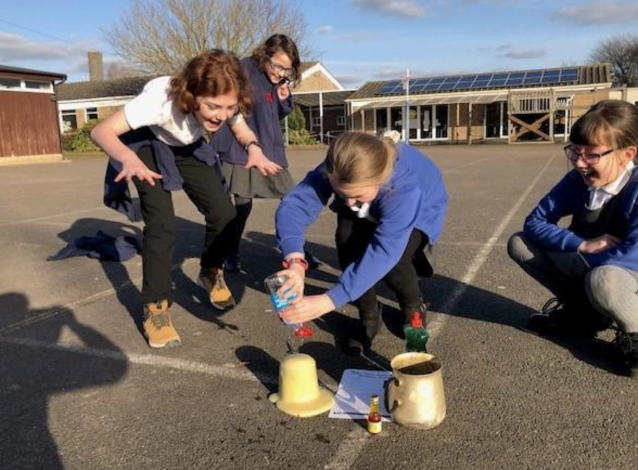
- What our children would like in our next Headteacher
Someone who does what they say they are going to
Someone who listens to us and shows that they respect what we say

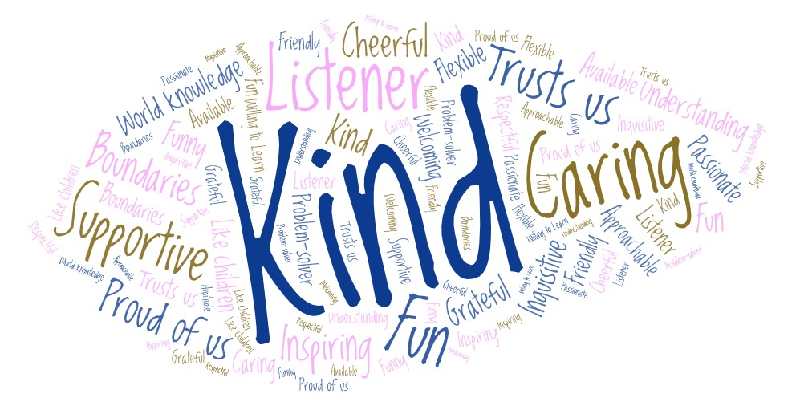
Someone who helps us to make good behaviour choices
It would be good if it was someone sporty because we love PE

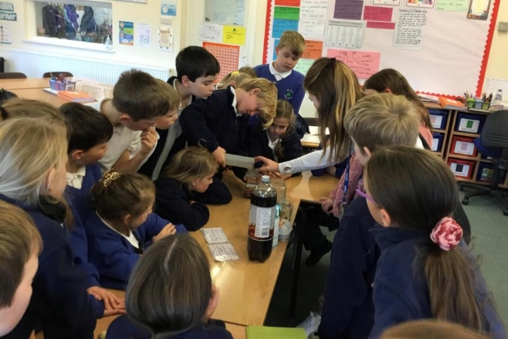

- Job Description and Person Specification
The DfE’s ‘National Standards of Excellence for Headteachers’ gives details of the generic role and professional responsibilities of the Headteacher. You will be familiar with these.

Within that framework, the school’s Local Governing Body and ODST are seeking to emphasise the following.

Job Purpose
To lead, shape, and develop our happy school for the next phase of its growth and development by:

- Continuing to embed the ethos, vision and values of the school in every aspect of school life, from day-to-day school management to strategic decision-making,

- Maintaining and developing our inclusive and creative curriculum, so that all children can flourish, working with senior leaders to continue to raise the quality of teaching and learning,

- Leading the school through the transformation and challenges of becoming a through primary whilst working collaboratively with external partners, governors, staff, children and parents and maintaining our school identity,

- Building supportive and respectful relationships with our highly valued and dedicated staff team, fostering a good work-life balance for all and focusing on career development and well-being,

- Providing strong leadership on provision for SEND and disadvantaged children, ensuring the school remains inclusive and aims to achieve ambitious outcomes,

- Developing clear and strategic communications with parents, as well as with the wider community, keeping the school at the heart of the local community.

Person Specification
 | Essential | Desirable
Qualifications
DfE Qualified Teacher status. | 
Evidence of relevant, recent professional development that prepares for this post. | 
National professional qualification for headteachers or senior leaders or working towards this. |  | 
Knowledge and Experience
Substantial and proven successful teaching experience within the primary phase. | 
Significant knowledge and experience of education within the primary phase and the issues and challenges facing the sector. | 
A broad understanding of the Ofsted framework and requirements | 
Up-to-date knowledge of safeguarding procedures and an understanding of the role’s responsibilities with regard to safeguarding. | 
Knowledge of the statutory frameworks and good practice for curriculum delivery and assessment. | 
Experience of educating children with special educational needs within an inclusive classroom. | 
Experience in more than one appropriate key stage. | 
Experience of monitoring and evaluating performance and practice. | 
High expectations of pupil behaviour and the effective use of behaviour management strategies. | 
A secure understanding of school finances and the principles of budget setting. | 
Knowledge of GDPR and the requirements relating to a school | 
Experience of leadership and management of change. | 
Experience in mentoring and enabling both professional and leadership development |  | 

 | Essential | Desirable
Skills
Excellent ability to lead, manage, support, and inspire colleagues. | 
The ability to communicate thoughtfully, fairly, and confidently to children, staff, parents, governors, and the wider community. | 
The ability to build effective relationships with a wide variety of people- staff, learners, senior leaders, governors, parents, parish church, and the wider community. | 
The ability to set clear and fair expectations and standards, and to bring about improvements where under-performance occurs | 
The ability to provide objective support and advice to the governing body, to enable it to meet its responsibilities. | 
Excellent analytical, problem solving, negotiating and decision-making skills. | 
The ability to analyse and use data confidently to improve the quality of teaching and learning. |  | 
The ability to create and implement a strategic school improvement plan, based on effective self-review which identifies priorities and targets ensuring that every child can flourish in their learning | 
Personal Qualities
Is resilient and patient, whilst consistently showing kindness, compassion, fairness, and gentleness to others | 
Embodies and models the values of the school | 
Exercises authority in a manner that encourages others and enables them to grow in their own learning and personal development | 
Is an empathetic listener, whose door will be open to staff, children, parents, governors and the wider community. | 

- Copy of the Job Advertisement
Fir Tree Primary School
Learning and Growing Together
Are you an enthusiastic, child-centred and confident leader, committed to inspiring and supporting pupils, staff and the wider school community to build on the successes of our school? Our children and staff are looking for a Headteacher who is inspirational and passionate, who is warm and considerate, but is also strong and willing to stand up for the best interests of both pupils and staff.
We are looking for a Headteacher who will:
- Build on the solid foundations already in place,
- Be approachable and a good listener, with an ability to work collaboratively with others,
- Place the children front and centre of all that you do, valuing each child as an individual and continuing the school’s inclusive approach,
- Develop the excellent teaching and learning provision for our children, ensuring that each child achieves their true potential,
- Encourage, motivate and support the staff team, providing opportunities to share skills and develop,
- Inspire the whole school community by setting clear standards and fair expectations.
In return we can offer you:
- Children who are keen to learn, behave well and care for one another,
- An excellent staff team with considerable expertise, who work well together and care deeply for our pupils,
- A broad and ambitious curriculum which offers exciting and inspirational teaching and learning opportunities,
- A fantastic school environment, with excellent outdoor space and established programmes for wider learning,
- A committed local governing body who supports the Headteacher and cares for staff and pupil wellbeing,
- An engaged and supportive parental community with a hard-working PTA.

We believe this is a fantastic opportunity to lead a committed and hard-working team in a friendly, welcoming school. If our vision and values resonate with you, we would love to hear from you whether you are a current Headteacher or an experienced leader seeking your first headship.

Salary Range: L13 – L19 (£63,430- £73,509) (pending pay award in September 2026)

Closing date for applications is 12.00 midday on Tuesday 22 September 2026.
A selection process for shortlisted candidates will be held on Tuesday 29 September 2026.
This position has a start date from 1st January 2027.

Visits to the school are actively encouraged. Please contact Bob Pattenden, ODST School Improvement Partner on 07423 109263 or bob.pattenden@oxford.anglican.org to arrange or if you would like to discuss the role further.

Fir Tree Primary School, as a member of the Oxford Diocesan Schools Trust, is committed to safeguarding children and young people. All post holders in regulated activity are subject to appropriate vetting procedures and a satisfactory Disclosure and Barring Service (DBS) Enhanced check.
- About ODST
The Oxford Diocesan Schools Trust (ODST) is one of the largest Multi-Academy Trusts (MATs) in southern England based on the number of schools within the Trust. It was founded in 2012, originally with 3 sponsored and 2 convertor schools. ODST currently consists of 46 schools across Oxfordshire and Berkshire and has significant primary expertise and capability, with all our schools covering at least some part of the Primary phase.
The ODST Vision
ODST is committed to delivering an excellent education which meets the needs of all learners. We are proud of our track record of delivering improvements in schools experiencing challenges, and in supporting our strong schools to continue to develop and be in a position to share their expertise with others. ODST’s vision for education centres on our sense of a community which works for the common good. The Trust’s key values are identified as:

• Inclusivity: Our schools embrace equality of opportunity and a wholly inclusive approach to
education. We believe every person matters.
• Empowerment: A fully functioning community is one where each person knows their own value and potential. Our job as educators is to enable that potential to flourish; to create a culture where children can be nurtured to be the best they can be. We believe this is best done by empowering each other to contribute the best we have to give.
• Community: Communities are important and flourish best when relationships are strong. We believe our schools and the people in them are a vital part of many different communities, all of which can be enriched as we work together.
• Abundant Living: We want our schools to be places where children are loved, nurtured and learn to live well. We believe all people should be enabled to fulfil their whole potential, not just
professionally and academically, but also creatively, morally and spiritually.
• Service: Our schools are outward-facing communities where we all learn to serve others and
contribute to the common good.

Each ODST school maintains delegated authority to make local decisions as we recognise that each is unique and can only meet the needs of its local community if that remains the case.

School Improvement Support
ODST has a very strong package of support, development and challenge for its school leaders and governors. As part of our planned school improvement support across the Trust, our SI team and school leaders engage in discussions regarding where the school’s performance is currently in terms of pupil outcomes, quality of teaching and learning, and leadership. Our Local Governing Bodies (LGBs) are also part of this process and the subsequent monitoring. The agreed work pattern for schools in the Trust consists of not fewer than six regular visits to each of our schools.

Continuing professional development (CPD)
ODST is very proud of the level of professional development offered to our staff and believes we offer an
excellent support package for staff at all levels in our organisation, to enable them to fulfil their potential,
and thereby support children’s learning in the best way. This includes:

• Headteacher &  Senior Leaders: | Access to termly Headteacher conferences; termly leadership briefings that include school improvement; the opportunity to work and share with a local hub of ODST schools that contains a significant number of existing partnership schools;
• Governors: | Termly leadership briefings and specific governor training arranged through either ODST or a sister organisation;
• Teachers: | We have a well-developed series of network meetings held regularly in the Trust (e.g. for early years leads, for maths leads, for RE leads etc) led by a range of subject experts. This is provided as part of our SLA with the schools and also includes a cycle of moderation for mathematics and English;
• Administrative staff: | Termly business manager meetings provide the opportunity for training and development and the sharing of knowledge and new procedures across the Trust.

Central team support
The central ODST staff team comprises a finance team, an HR team, school improvement team and
operational management team, as well as administrators and the CEO. We work closely together and with ODBE staff who provide all our capital bid and project management services on a contractual basis. School support, for each professional area, is not limited in any way so that we can ensure each school can access the support it needs when it needs it.

- How to apply
What to do next?
For more information, or to arrange an informal visit to the school, please contact Bob Pattenden, ODST School Improvement Partner, on 07423 109263 or bob.pattenden@oxford.anglican.org.
Applications should be made online through My New Term. Please try and outline within your personal statement how you meet the person specification for the role.
Closing date for applications is 12.00 midday on Tuesday 22 September 2026.
Interviews for shortlisted candidates will be held on Tuesday 29 September 2026.
This position has a start date from 1st January 2027.
Fir Tree Primary School, as a member of the Oxford Diocesan Schools Trust, is committed to safeguarding children and young people. All post holders in regulated activity are subject to appropriate vetting procedures and a satisfactory Disclosure and Barring Service (DBS) Enhanced check. All schools in the Oxford Diocesan Schools Trust (ODST) are committed to equality and diversity and the safeguarding and wellbeing of all children and young people across the Trust. The Trust expects all staff and volunteers to share this commitment.
The Headteacher will be required to demonstrate a commitment to promoting and safeguarding the welfare of children and young people in the school and to become the Designated Safeguarding Lead (DSL) for the school.
From a GDPR perspective, the information you have provided will be stored on our secure database and will only be used to process your application. It will not be passed to any other organisation.



