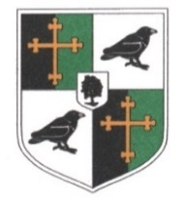
Ravens Wood School
Person Specification – Behaviour Coach and Cover Supervisor

__________________________________________________________________________________
Experience
- Experience working with young people, ideally in a secondary school
Education & Training
- GCSE (or equivalent) in English and Maths
- Evidence of ongoing professional development
Knowledge & Skills
- Understanding of adolescent behaviour and wellbeing
- Strong communication and literacy skills
- Effective classroom and behaviour management strategies
- Ability to work under pressure and meet deadlines
- Adaptability, initiative, and commitment to inclusion
Generic Responsibilities
All staff at Ravens Wood School are expected to:
- Promote and safeguard the welfare of children and young people
- Uphold the school’s ethos and values
- Model professional conduct and high standards at all times
- Contribute to the wider life of the school through teamwork, CPD and extra-curricular involvement
- Act as a Fire Marshall if required

