

Teacher of Music
(1.0FTE)
Candidate Information

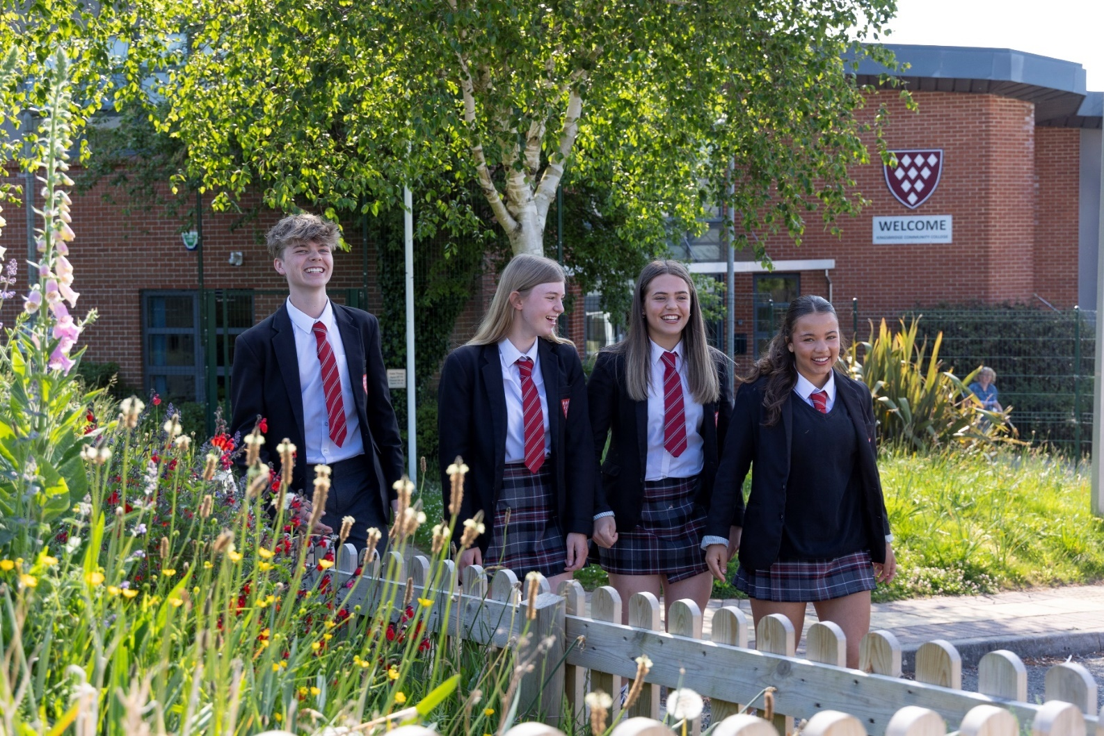



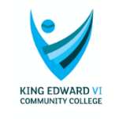







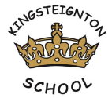




Welcome from Education South West

Dear Candidate,

Thank you for your interest in Education South West - we are always on the lookout for exceptional talent to join us and contribute to our team of creative education professionals.

At Education South West we believe that education makes children’s lives better, it is as simple as that; it enables them to lead great lives in every sense of the word. We believe that every child has the right to achieve all that they are capable of and more, regardless of their background or raw ability.

Across all of our schools our staff aim to provide an educational experience which is outstanding; our schools all believe strongly in the power of and broad and balanced curriculum. Sport, art, technology drama and music play an important role in all of our schools.

We encourage innovation, creativity and individuality. By sharing this individuality and creativity we firmly believe that schools and communities become stronger through unity and collaboration.

We are caring and compassionate. Every individual in our schools matters and we believe strongly that children and staff should enjoy their time at school, and work. A positive can-do attitude to their work and study is a must. The happier and more stimulated a person is the more motivated they are to improve.

We believe in developing a positive attitude to learning and to life, in having clear goals and in providing a supportive environment to help the realisation of these.

We support and challenge our school leaders and the staff in our schools to be the very best they can, leading effective teams at every level, growing future leaders and working together to provide an exciting education for all.

We welcome and support aspirational and ambitious teachers and classroom support staff, dedicated to supporting children through their time at school.

We offer excellent opportunities and professional development through in-school CPD, our Research School status, through our teaching schools and through our links with the wider education community. We are ambitious for our children and our employees and always looking to support, challenge and develop talent, whatever stage you are in your career.

When recruiting staff to work with children we place great importance on:

- people who go the extra mile
- a commitment to professional development and a desire to continue learning, via research, private study and in learning from others
- a desire to ensure that everything that is done within schools is the very best it can be
- a firm commitment to the philosophy that we work in education to improve young people’s lives and improve society; we serve our communities and the wider populace
- the ability to develop positive relationships with pupils, students and parents
- good interpersonal and communication skills when liaising with stakeholders
- a good sense of humour
- a commitment to working in partnership with others and sharing selflessly best practice within and outside of ESW

Your journey with ESW starts here and I look forward to meeting you in the future.

Yours faithfully,


Matthew Shanks
CEO

Welcome from KCC Governors

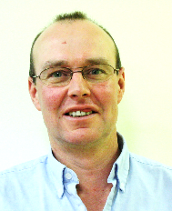
Dear Candidate,

This is an exciting time for Kingsbridge Community College. The Governing Body look back over the last few years with a sense of real pride in what continues to be achieved by the leadership, staff and students of Kingsbridge Community College

I never cease to be amazed at the commitment, talent and hard work from the staff that I see when I visit. The students are a real credit to the community and make giving up my time a privilege.

The Principal and senior leadership team have a common sense of purpose and vision; you will enjoy the backing of a dedicated and supportive team of governors who will value your contribution to the creativity and innovation of an existing first-class team of staff.

Most importantly you will be someone whose focus is on helping every single student within our College to maximise their potential and be the very best that they can be during their time with us.

Thank you in advance for the time that I know you will commit to this process.

Yours faithfully


Steve Tucker
Chair of Governors

Letter from the Principal


Dear Colleague

Teacher of Music - MPS/UPS
Full time – September 2026 or January 2027 for the right candidate

Thank you for your interest in Kingsbridge Community College and the position we have available. I am delighted that you are considering joining our accomplished team and I hope that this information pack along with the school website gives you all of the information that you need to apply for the post. Kingsbridge Community College is an inspirational place to work and visitors to the school all comment on the commitment, behaviour and academic qualities of our young people, the fantastic resources and school buildings, and the strong supportive relationships evident between staff and students.

This is an opportunity to join the college at an exciting point in our journey. In January 2017, we merged our Multi Academy Trust to form Education South West, with 14 schools spanning primary, all-through and secondary: nearly 5,000 students and 600 staff in total. The aim of the Trust is simple: to work together so that children can lead great lives.

We are fortunate to be able to attract a high calibre of staff to KCC. Our staff are friendly and supportive and we offer a whole range of professional development opportunities no matter what stage you are at in your career. We want all of our teachers to be exceptional and so offer unrivalled professional development and support. Many of our senior and middle leaders started as teachers with us and have developed into highly talented practitioners. We offer internal and external training through our National Professional suite of qualifications including NPQML and NPQSL - your professional development is important to us. We are currently graded Good by Ofsted.

If you have a genuine desire to do the best for young people, then we would welcome your application. The college is committed to safeguarding students and personnel, and will conduct checks based on the information in your application. If you are selected for interview, safeguarding will feature in the interview programme.

If you wish to visit the college or have any questions about this role, please feel free to contact the school and ask to speak to my PA, Emma McQuitty. Applications must be made by completion of an application form, and candidates invited to interview must supply a signed copy of their application form before their interview takes place. We would also request that interviewees bring to the interview original copies of relevant exam certificates, and where available original copies of their DfE registration and DBS disclosure.

The closing date for applications is 9.00am Tuesday 23rd June 2026.

Yours faithfully

Tina Graham
Principal

THE DEPARTMENT
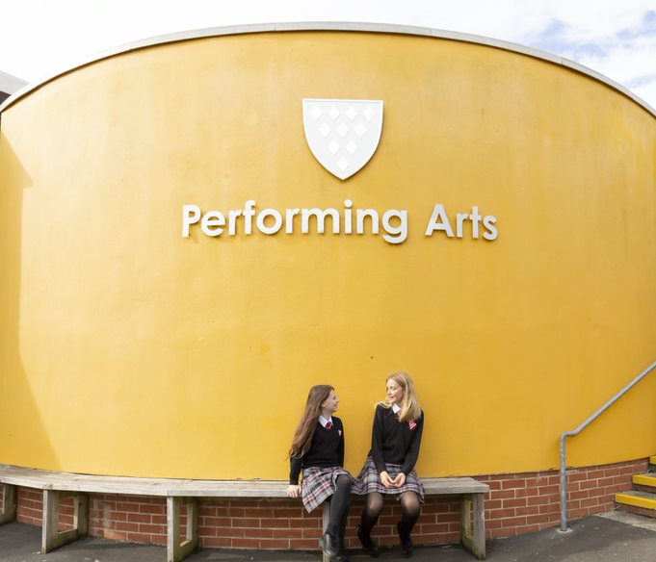
This is a great opportunity to teach Music throughout the College from Key Stages 3-5 as part of the Music team who are dedicated specialist teachers with excellent facilities. Both the drama and music departments work together successfully.

The Music Department is equipped with two large teaching rooms with a variety of instruments including a number of acoustic pianos, electric pianos, keyboards, guitars and full band set ups. Also situated within the department are 13 practice rooms and a brand new Mac Suite including LogicPro software. Students have weekly hour-long lessons in Music throughout Key Stage 3 and are taught in mixed ability sets. At KS4, we offer the Eduqas GCSE and at KS5, the Eduqas A Level. In addition to the Music provision within the curriculum we also run a varied programme of extra-curricular Music groups including Choir, Jazz Ensemble, Junior and Senior Collective and Busking Group. We also organise annual theatre trips to watch musicals and operas and are actively involved with the Devon Music HUB. Around 100 students across all years regularly take part in the annual college show in which we strive for the highest possible standards.

If you would like more information about the Music Department, please contact the Head of Department, Ben Smith (Ben.Smith@kingsbridgecollege.org.uk)

THE POST
We are seeking to appoint a dedicated, creative and inspiring Teacher of Music to deliver Music across the full age and ability range. As a Music teacher at Kingsbridge Community College, you will join supportive and friendly departments focused on continuing to secure fantastic results and outcomes for all our students.

We are looking for a talented teacher with the enthusiasm and drive to embed and improve our high expectations, continuing to develop a love of music and drama and performing in our students. You can expect to work in a supportive yet highly creative atmosphere.

What you will need to succeed:

- Be an excellent classroom practitioner with a focus upon achievement and success
- Be an enthusiastic classroom teacher who can inspire and excite students about their learning in all aspects of Music and Drama.
- Be able to use a variety of innovative and creative ways to engage students within their lessons.
- Be able to work as part of a team.
- Have high expectations for themselves and students.

- Be keen to make a difference to the education of all students, as part of the wider role of creative subjects across the curriculum.
- Be able to teach KS5.

If you have imagination, drive and the desire to be successful, can demonstrate a passion for music and drama and share this enthusiasm with students, we want to hear from you. ECTs are welcome to apply.

A COLLEGE WITH A NATIONAL REPUTATION

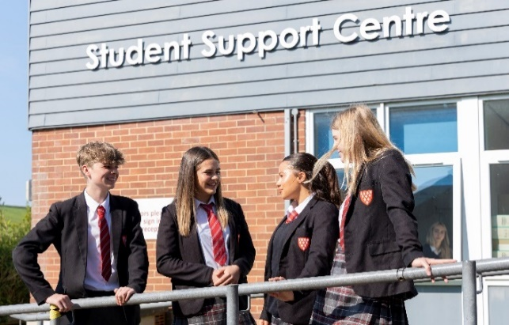
We all came into teaching in order to make a difference and to help students to develop the attributes they need to go on and lead great lives. We have the resources, support and wider networks that will enable you to do this, and offer you the wider opportunities to develop your leadership not just at the College but across the system. Our ambition is simply to be one of the best schools in the country, and we are at the forefront of shaping the school-led system.

KCC is an 11-18 comprehensive school and a member of Education South West which comprises 6 secondary schools and 8 primary schools within Devon. The schools within the ESW family share a common desire to give our children the education, opportunities and confidence that will enable them to lead great lives.

We converted to an academy in January 2011 and in September of that year we were honoured to be in the first 100 schools in the country to be designated a Teaching School and we are also the lead school in a Teaching School Hub: Teaching Schools South West. This is a partnership between Teaching Schools, MATs, Research School and Curriculum Hubs, which means that our staff can access the best, most up to date training and support in the South West and Nationally. We are appointed as one of only 32 licence holders to run National Professional Qualification programmes including NPQH, NPQSL and NPQML. Our charitable company, Leading Schools South West, has now trained over 600 teachers on these programmes.

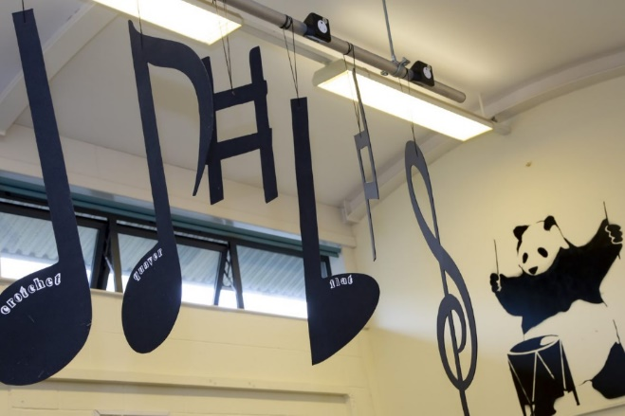
Since we became one of the first designated National Research Schools in 2016, Kingsbridge Community College has been working closely with our other partners to develop evidence informed approaches to teaching and learning across the Southwest of England, helping schools and teachers to make better use of evidence to inform their teaching and learning.

Our ambition and dynamism are far-reaching. It means that you have unprecedented opportunity to work with colleagues in other schools, lead professional development programmes and develop the skills and profile you need for your next promotion.

THE COLLEGE’S FACILITIES

The College is situated on the edge of the town with wonderful views over the surrounding countryside. Extensive building programmes have resulted in enviable facilities.

We have built over £14 million of buildings in more than 6 different projects. This has resulted in all departments teaching in modern, specialist facilities. It also tells you about our drive and ability to get results: all these developments were as the result of successful bids, and all the building processes were managed by ourselves – on budget and on time.

STAFF AND STUDENTS OF THE COLLEGE

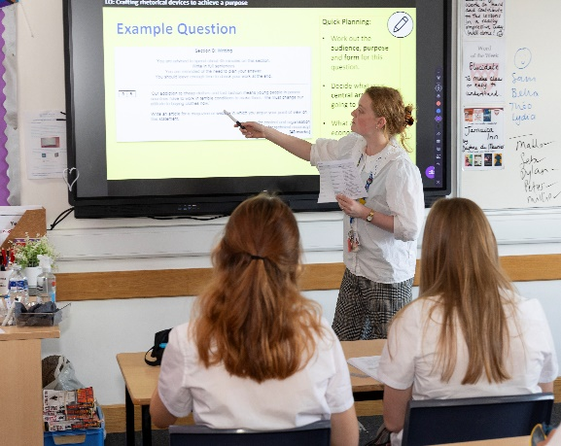
All staff are considered leaders within the school and given the opportunity to participate in the decision-making process through regular departmental, pastoral and staff meetings – and whole school events. Staff commitment is high and new teachers are expected to demonstrate similar commitment as well as high quality teaching and a willingness to contribute to the ethos and broader life of the school.

Relationships between staff and students here are excellent. We see evidence of this in the time which staff devote to giving students individual help out of classes and the time and energy they commit to trips. Our students are generally well motivated and responsible, and we receive many plaudits when they are out and about on visits. We are a fully comprehensive college, with plenty of able students who go on successfully to universities including Oxford and Cambridge.

CONTINUING PROFESSIONAL DEVELOPMENT
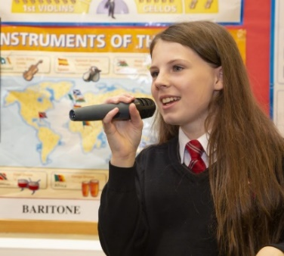
We are very clear in our belief that the staff are our best resource, and invest a lot of time and resources in continuous professional development. We place a great deal of importance in supporting trainee teachers and ECTs. All of our ECTs have an individual department-based mentor as well as mentoring from a senior member of staff in the College and a regular seminar programme. We do our very best to offer all our staff a continuous training programme as their career enters different stages from ECT through to preparation for middle and senior leadership, and then on eventually to headship. Our policy is to train our own staff who can then lead others.

We also use Instructional Coaching as the basis of regular developmental discussions for staff.

THE CURRICULUM
We have an admission number of 203 students in each year group which we organise into seven mixed ability tutor groups. They are taught in mixed ability groups at Key Stage 3 except in Maths, MFL and Science. Students are taught either French or Spanish in Year 7.

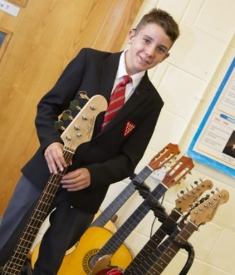
We have a very clear vision of what makes teaching and learning at Kingsbridge distinctive. Learning here is exciting, inspiring, engaging and effective. We train all our staff in using effective teaching and learning strategies based on the work of the EEF and Research School. We support staff by having a programme of Instructional Coaching that ensures that all staff have access to a coach who focusses on in-lesson improvements in teaching strategies.

Our Sixth Form offers a wide programme of A levels and vocational qualifications. We are very proud of the breadth of our curriculum with many opportunities for enrichment as part of the Sixth Form which prides itself on being a thriving community of its own.

EXTRA CURRICULAR

We have a thriving extra-curricular programme which is always changing and always developing. We will discuss with you at interview how you would like to contribute to this programme. We run many sports teams who achieve County and national success, and stage many different concerts and drama productions throughout the year. Other clubs and activities range from chess to rocket building! We hold a Challenge Week at the end of the Summer Term where all students opt for residentials or daily activities, with options ranging from residentials in France, Holland and Spain to cycling across Devon and Dorset staying in YHA’s along the way.

There are many other trips and visits which enhance the curriculum including a Technology residential in London to look at all aspects of design, English and Drama residentials in London and Stratford, a Media Studies residential in Manchester and Hollywood, Geography and Biology field trips and so on. In recent years we have had expeditions to South America, Africa, China, Borneo and India. Staff would not give up this time if they did not enjoy working at Kingsbridge with our students, and we are enormously appreciative of their time and goodwill.



KINGSBRIDGE COMMUNITY COLLEGE
Job Description

Post Title: Teacher of Music
Responsible to: Head of Music
Scale: MPS/UPS

This job description is not a comprehensive definition of the post. Discussions will take place on a regular basis to clarify individual responsibilities within the general framework and character of the post as identified below. The conditions of employment of teachers in the School Teachers’ Pay and Conditions of Service Document apply to this post, whose holder is expected to carry out the professional duties of a teacher as circumstances may require, under the reasonable direction of the Principal. Appropriate level of performance is defined in the Framework of Performance Standards for Teachers in England.

Job Purpose
To be an effective teacher and tutor who supports and challenges all students to achieve their full potential.

Accountabilities:
- To maintain a thorough and up-to-date knowledge of the teaching of your subject(s) and take account of wider curriculum and pastoral developments which are relevant to your work.
- To plan tutorials, activities, lessons and sequences of lessons to meet students’ individual learning needs.
- To use a range of appropriate strategies and follow College policies for tutoring, teaching, behaviour management and classroom management
- To do all you can, involving parents and other agencies, to ensure that as a result of your tutoring and teaching you promote the health, safety, economic wellbeing and achievement of your students.
- To assess, monitor and record the progress of students in your teaching and tutorial groups and give them clear and constructive feedback.
- To set well-grounded expectations for students in your teaching and tutorial groups using information about prior knowledge and previous attainment, making progress as good or better than similar students nationally.
- To take responsibility for your own professional development and use the outcomes to improve your tutoring and teaching and your students’ learning.
- To make an active contribution to the policies, aspirations and plans of your year group, of your curriculum team and of the College.

UPS2: UPS2 teachers are expected to make a sustained and substantial contribution to the College based on threshold criteria.

UPS3: UPS3 teachers play a critical role in the life of the College. They provide a role model for teaching and learning, make a distinctive contribution to the raising of students’ standards and contribute effectively to the work of the wider team. They take advantage of the appropriate opportunities for professional development and use outcomes effectively to improve students’ learning.

Name: |  | Date:

Signed: | (Principal) | Signed: | (Member of Staff)

KINGSBRIDGE COMMUNITY COLLEGE
Teacher of Music
Person Specification

The successful candidate will meet the following person specification. Please note that the listed criteria will form the basis of the selection process.

Essential | Desirable | Evidence Base
Qualifications
Degree and Qualified Teacher Status | Essential | Application Form / Certificates
Successful experience of teaching subject in placement or a previous school. | Essential | Application Form / Certificates
Professional Experience and Knowledge
Successful teaching and curriculum experience | Essential | Application Form
Ability to teach subject to GCSE. | Essential | Application Form
Experience of teaching at A Level. | Desirable | Application Form / Certificates
Strong keyboard skills | Desirable | Application Form
Ability to communicate effectively with students, parents and colleagues. | Essential | Application Form / Interview
Ability to use assessment for learning and data to improve student performance. | Essential | Application Form / Interview
High level ICT skills. | Essential | Application Form / Interview
Inspirational practitioner with a passion to enthuse and engage students so they achieve their full potential. | Essential | Application Form / Interview
Excellent understanding of the curriculum and current developments in teaching and learning. | Essential | Application Form / Interview
Positive attitude towards your own and others professional development. | Essential | Application Form
Able and willing to make a full contribution to the life of the department and the wider school community. | Essential | Application Form
Personal Qualities
Adaptable, flexible. | Essential | Application Form / Interview
Able to take responsibility and show initiative. | Essential | Application Form / Interview
Enthusiastic and inspiring. | Essential | Application Form / Interview
Able to command respect. | Essential | Application Form / Interview
Excellent team member, able to work both independently and cooperatively with others. | Essential | Application Form / Interview
Excellent sense of humour | Essential | Interview



How to apply

Application deadline
Completed applications must be received by 9.00am Tuesday 23rd June 2026.

Please submit your application via the mynewterm website.

Completing your application
Candidates are asked to complete all the standard information required on the application form, and to submit a supporting statement outlining your suitability for the role.

The Governors are committed to safeguarding and promoting the welfare of children and applicants must be willing to undergo child protection screening appropriate to the post, including checks with past employers and an enhanced disclosure via the Disclosure and Barring Service.

It is the Governors’ Policy to ask to see original certificates for all qualifications of A Level or equivalent, and above, at interview.

Discussion and visits
Informal discussions with the Head of Department are welcomed, as well as visits to the College. Please arrange a suitable time with Emma McQuitty emma.mcquitty@educationsouthwest.org.uk. Telephone: 01548 852641 ext. 2502

References & Social Media Checks
Candidates are advised that references will be taken up immediately after shortlisting. Candidates are asked to ensure that their referees are informed of the need to respond within the timescale set. In all cases, at least one professional reference is required.

Shortlisted candidates should be aware that social media and online searches will be carried out as part of the recruitment process.

The post will be offered subject to satisfactory completion of pre-employment checks.

ESW is committed to safeguarding and protecting the welfare of children, and applicants must be willing to undergo child protection screening appropriate to the post, including checks with past employers and an enhanced disclosure via the Disclosure and Barring Service.

