JOB DESCRIPTION

Job Title: | Exam Invigilator
Salary: | Grade 4
Hours of work | Fulltime

Job Purpose:
To conduct examinations in accordance with the Joint Council for Qualifications (JCQ), awarding body and
Crestwood’s regulations and instructions
Overall Responsibilities and Tasks
Before exams
- Report to and be briefed by the exams officer prior to each exam session
- Keep confidential exam question papers and materials secure before, during and after exams
- Ensure exam rooms are set up according to the requirements
- Admit candidates into exam rooms under formal exam conditions
- Where required, understand the access arrangements for individual students and offer the support as directed by SENCO
- Distribute the correct question papers and exam materials to candidates
- Instruct candidates in the conduct of their exams
- Deal with candidate questions
During exams
- Supervise and observe candidates at all times and be vigilant throughout exams
- Keep disruption in exam rooms to a minimum
- Record/report any incidents, disruption or irregularities
- Complete attendance registers
- Deal with candidate questions according to the regulations
After exams
- Instruct candidates in finishing their exams and collect exam scripts and exam materials
- Dismiss candidates from the exam room
- Check candidates’ names on scripts, match the details on the attendance register
- Securely return all exam scripts and exam materials to the exams officer
Staffing and resources
- Be reliable, flexible and readily available during main exam periods
- Work well as part of a team
- Be confident and a reassuring presence to candidates in exam rooms
- Be able to give instructions and manage situations involving different groups of people

- Be confident in being able to work with a student in a 1:1 setting to provide access support to students that may need questions reading to them or to scribe for students
Other Professional requirements
Undertake training, update and review sessions as required
Undertake, where required and where able, other duties requested by the exams officer, for example:
- facilitating access arrangements for candidates, for example as a reader, scribe etc. (full training will be provided)
- other exams-related administrative tasks including maintaining question paper security by supporting
the ‘second pair of eyes check’
Other Specific Duties
- Play a full part in the life of the Trust community, to support its vision, mission and values
- Be an ambassador of the Invictus ethos and to encourage and ensure staff and students follow this example
- Be courteous to colleagues and be welcoming to visitors
- Comply with the Trust’s Health and Safety Policy and undertake risk assessments as appropriate

Whilst every effort has been made to outline the main duties and responsibilities of the post, each individual task may not be identified. Employees will be expected to carry out any reasonable request to undertake work of a similar level that is not specified in this job description. This job description is current at the date shown but following consultation may be changed to reflect or anticipate changes in
the job which are commensurate with the job title and salary
Support for the Trust
- To take a full part in promoting the good name of the Trust and contributing positively to the overall ethos/work/aims of the Trust
- Be aware of and comply with policies and procedures relating to child protection, health and safety, security confidentiality and data protection
- Comply with the Trust’s dress code
- Attend and participate in meetings as required
- Participate in training, other learning activities and appraisal as required
- Recognise own strengths and areas of expertise and use those to advise and support others
- It is the responsibility of all adults employed by Invictus Education Trust to safeguard and promote the welfare of children and young people. This responsibility extends to a duty of care for those adults employed, commissioned or contracted to work with children or young people.

PERSON SPECIFICATION
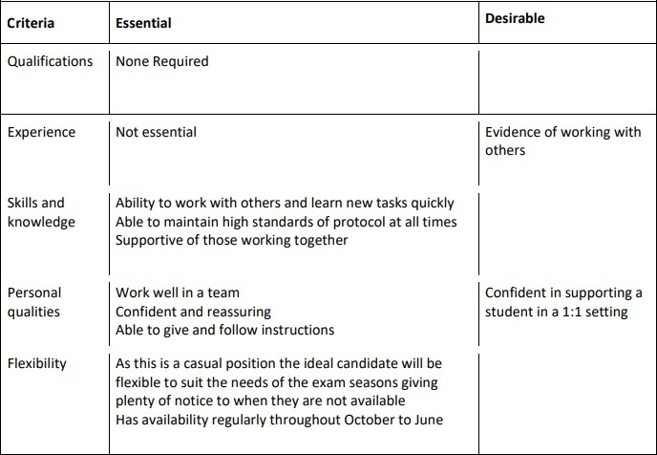

Special Conditions
SJBCA is committed to safeguarding and promoting the welfare of children and expects all staff and volunteers to share this commitment. All offers of employment are subject to an Enhanced DBS check, and where applicable, a prohibition from teaching check will be completed for all applicants.
This post is exempt from the Rehabilitation of Offenders Act 1974 (Exceptions) Order 1975 (2013 and 2020). This means that certain convictions and cautions are considered ‘protected’ and do not need to be disclosed to employers, and if they are disclosed, employers cannot take them into account. Guidance about whether a conviction or caution should be disclosed can be found on the Ministry of Justice website.
Guidance on the Rehabilitation of Offenders Act 1974 and the Exceptions Order 1975- GOV.UK (www.gov.uk)

