
Woods Avenue, Hatfield, Hertfordshire, AL10 8NN
Telephone: 01707 276 504

Woods Avenue, Hatfield, Hertfordshire, AL10 8NN
Telephone: 01707 276 504

Candidate Information Pack
Finance Administrator

Introduction
We are seeking a Finance Administrator to join our school office team, providing specialist administrative support across finance, pupil data and admissions. This is a key operational role, ensuring that systems are accurate, compliant and reliable, and that the day-to-day running of the school is underpinned by strong administrative practice.
This is a full-time role (Monday to Friday), starting as soon as possible.

The successful candidate will work independently within established procedures, using initiative and sound judgement to manage specialist administrative processes. While the role does not include decision-making or budget ownership, it carries significant responsibility for accuracy, confidentiality and compliance, and plays an important part in safeguarding and supporting children and families.

Please note: Recruitment will be in line with our Safer Recruitment Policy and online searches, and checks may be conducted.

Contract Type
This is a permanent role, 37 hours a week, working term time only, plus 20 days.

Start Date
We are looking to appoint as soon as possible.

Please note: If we receive a high volume of applications, we may close this advert early. Southfield School reserves the right to interview and appoint candidates on receipt of applications before the closing date. We encourage you to submit your application as soon as possible.

Salary
£ 25,989 FTE (Grade H4-6)

About the School

Southfield is a primary school for over 100 pupils with Learning Difficulties, which include, Autism, Speech Language and Communication Needs, Global Developmental Delay, and other conditions.

Admissions are via the Local Authority, and the present criteria is that children are accessing learning approximately 50% below their chronological age. We follow the EYFS and Key Stage 1 National Curriculum and adapt these to meet the individual interests and needs of our pupils. We do this through a 3 Phase curriculum that is presently being developed. Priority is given to communication, self-regulation, independence and functional Literacy and Maths. We use a wide range of approaches and strategies to support learning, including multi-sensory communication, social stories, TEACCH and Hertfordshire Steps. We also work with a range of professionals, from advisers in the Local Authority to Therapists and social care colleagues. Access to sporting and creative arts organisations, provide a range of enhanced learning opportunities, both in school and the local area.

Southfield is going through a period of rapid and exciting change, that you could be part of. It is a journey of challenge, in the pursuit of excellence, but one that provides huge rewards both personally, in your professional development and when you see the difference you make to the lives of our young people and their families.

About the Role

To provide efficient, accurate and confidential financial and administrative support within the school office, ensuring that all accounting procedures comply with school and regulatory requirements. The postholder will assist in maintaining accurate financial records, processing payments, and supporting the smooth running of the school’s financial operations.
Key Responsibilities:
Financial Administration
- Process purchase orders, invoices, and payments in line with school financial procedures.
- Reconcile supplier statements and resolve any discrepancies.
- Record income and bank receipts.
- Assist with the preparation and reconciliation of monthly accounts.
- Assist with payroll preparation.
- Maintain and update financial records using Arbor and the One Drive
Administrative Support
- Provide general administration within the school office when required.
- Maintain accurate and secure filing systems both electronically and paper based.
- Support period and year-end financial procedures and audit preparation.
- Liaise with suppliers, contactors, and parents regarding financial matters.
- Assist in the administration of school trips, clubs, and events.
Essential Skills and Experience
- Experience in financial administration or accounts work
- Strong numeracy and IT skills (particularly Excel and finance software)
- Excellent attention to detail and accuracy in data entry and record keeping.
- Good organisational and time management skills
- Ability to maintain confidentiality and manage sensitive information.
- Effective communication and interpersonal skills with all colleagues, parents and external partners.
Desirable Skills and Experience
- Experience in a school or educational setting
- Familiarity with school finance system – Arbor Finance

This job description is not a comprehensive definition of the post. Discussions will take place on a regular basis to clarify individual responsibilities within the general framework and character of the post as identified below.
The duties may be varied to meet changed circumstances in a manner compatible with the post held, at the reasonable direction of the Headteacher. This job description does not form part of the contract of employment. It describes the way in which the member of staff is expected and required to perform and complete the duties as set out above.
A word from our Headteacher


Are you bored with life? Looking for a new challenge? Have a desire to work in an environment where you can make a ‘real’ difference to the lives of young people? If so, Southfield School is the right environment for you.
We are a family with over 100 pupils. No two students are alike, and no two members of staff are alike. Our pupils all have challenging ASD and associated conditions.
Our school vision is to support all children, so they thrive during their time at Southfield School and are prepared socially, emotionally, and academically for their next steps in education. Collaboration with parents and carers and the entire multi-disciplinary team who support our students is vital and key to our success.
Everyone plays a part in the future of our students with staff skills being used in order that we have a huge range of skill set and expertise. Everyone makes a difference to the lives of our students and families.
We are looking for like-minded, resilient staff who are passionate and who can work in a team.
If you have yet to find what it is that you were meant to do with your life – Southfield School may be what you have been searching for.

Come and join us and make a difference to the lives of children every day.

Angela O’Rourke
Headteacher

Our vision and values

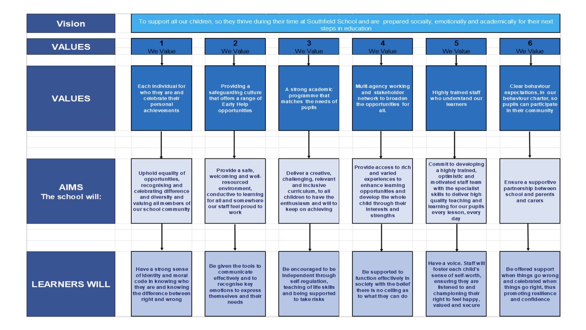
A Bright Future for ALL

Post

Application Information

Equal Opportunities Monitoring Form
At Southfield School, we want our workforce to reflect the diversity of the community we
serve. It is our policy to ensure that job applicants and employees are treated justly, and are
recruited, selected, trained, and promoted on the basis of the job requirements, skills and
abilities. We will ensure that people are not disadvantaged by conditions or requirements, which cannot be shown to be justified as being necessary for the effective performance of
the job. You are under no obligation to complete this form, however if you do you are agreeing, under the Data Protection Act 2018 that Southfield School may hold and use personal information about you for monitoring purposes.

Safeguarding
Southfield School has a responsibility for and is committed to safeguarding and promoting
the welfare of children, young people, and vulnerable adults to ensure that they are
protected from harm. All conditional offers of employment are subject to the following pre-employment clearances:

Satisfactory Medical Clearance
All successful candidates complete a medical questionnaire and may be required to pass a
medical examination by the Southfield School.

Satisfactory References
It is the school’s practice to take up 2 references from your last two job references. Referees must not be a member of your family, or spouse/partner and the reference must be provided on letter headed paper or come from a work email address. If you are a recent school or further education leaver, one of your references must be from your school or college. Occasionally more than two references may be required, if this is the case, we will inform you before we contact former employers.
In line with our safer recruitment policy, we will take up references ahead of interview. Once we have received your references, we will call your referees to verify that the reference
is from them as part of the keeping children safe in education requirement. No employment
will be offered until 2 satisfactory references are received.

Rehabilitation of Offenders Act 1974
The Rehabilitation of Offenders Act 1974 makes it unlawful for prospective employers to
consider offences in relation to which the person concerned is deemed to be rehabilitated. This means that after a certain period (dependent on the seriousness of the offence
and length and severity of the punishment), the person concerned is to be assessed as if the conviction has been ‘spent’ (i.e. treated as if it had never occurred). Rehabilitation periods vary according to the type and length of conviction originally incurred. All posts within the school are covered by the Rehabilitation of Offenders Act (Exemptions)
Order 1975 and DBS clearance is required and therefore detail must be given about all
convictions, whether spent or not.

Disclosure and Barring Service (DBS) (Previously CRB) Clearance
As all posts require a DBS check, the successful candidate will be required to complete the
appropriate DBS documentation. The successful candidate will be unable to take up the
appointment until the clearance is received from the DBS. The timescale for these checks is
outside the Southfield School’s control.

Prohibition from Teaching
All teaching appointments are subject to a check with the Department for Education to
ensure that you are not subject to a prohibition order or an interim prohibition order.

Evidence of Qualifications
We will need evidence of the qualifications (original certificates) you specify in your
application form. Originals must be brought to the interview for candidates who have been
short-listed. Copies will not be accepted.

Eligibility to work in the UK
To comply with the Asylum and Immigration Act 1996 (As AMENDED) (Immigration, Asylum
and Nationality Act 2006), all employers in the United Kingdom are required to make basic
documentation checks on every person they intend to employ. We ask all short-listed applicants to provide proof that they can be legally employed. We must see satisfactory proof in the form of original documentation before we can confirm any
offer of employment. If we do not see satisfactory proof, an offer of employment can be
withdrawn.
The complete list of documents that may be accepted as proof of your identity, along with
information on the number and types required can be found below. There are three routes as outlined, however where possible, we encourage short listed applicants to produce
documents which adhere to Route 1 of the ID Checking process to avoid delays in the ID
checking process.

