New INFORMATION PACK
MELLAND HIGH SCHOOL
Teaching Assistant Level 1
Overview of the Role

The successful candidates will join our highly effective team of Teaching Assistants who work alongside teachers to provide curriculum and pastoral support for students across key stages 3, 4 and 5. They will share our determination to transform the life chances of young people who attend Melland High School.

Bright Futures Educational Trust

Bright Futures Educational Trust (The Trust) is a multi-academy trust (MAT) set up in 2011. The Trust is made up of a richly diverse group of schools in Greater Manchester and Blackpool. We are passionate about working together within and beyond the Trust to achieve our aspirational vision: the best for everyone, the best from everyone. We are an organisation that is underpinned by values of: community, integrity, and passion. In everything we do, we remember that we are accountable to the children, families and the communities that we serve.

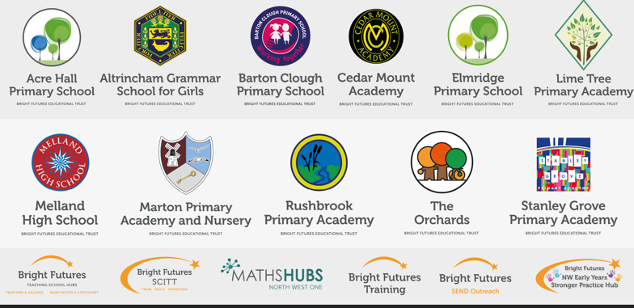

Our schools have their own identities and form one organisation and one employer, Bright Futures Educational Trust. Bright Futures’ Board of Trustees maintains strategic oversight of the Trust and delegates some of its responsibilities to the Executive Team, Principals, and local governing bodies. We place high value on integrity and probity and take seriously our accountabilities for making the best use of public money. How decisions are made is described in our delegation framework. You can find out more about the Trustees and the Executive Team on our website: About Us - Bright Futures Educational Trust (bright-futures.co.uk)

The central team includes the Executive Team: Lisa Fathers (Interim CEO), Sarah Schollar (Interim Director of Education), Anna Sharpley (Chief Finance and Operations Manager) and Jayne Carmichael (Director of Professional Development).

Bright Futures Development Network is another important outward facing component of our organisation made up of a number of hubs and networks at the heart of the Trust. In January 2021, after significant national reforms to the teaching school policy Bright Futures was designated with two new large-scale Teaching School Hubs, which replace the Alliance for Learning Teaching School. This growth and expansion in our outward facing work brings about a significant increase in accountability and reach. The two Bright Futures Teaching School Hubs are designed to provide strong strategic regional leadership to build robust partnerships to support teachers and leaders in every phase and type of school, at each stage of their development. A crucial part of the hub remit is carefully ensuring structured collaboration. The Teaching School Hubs are at the forefront of providing high quality professional development, playing a significant role in the implementation and delivery of: The Early Career Framework, National Professional Qualifications (NPQ), Initial Teacher Training and Continuous Professional Development (CPD). The Hubs work directly with the Department for Education and national NPQ/ECT providers. In addition to this, the Hubs enhance the professional development needs of Bright Futures schools and academies. Within this outward facing area of Bright Futures Educational Trust, we have a commercial offer run through the Alliance for Learning which provides first-class school improvement services and CPD to over 700 schools, further complementing the work of our Teaching School Hubs. Our School-Centred Initial Teacher Training (SCITT) Bright Futures SCITT is also an integral part of the Teaching School Hubs, with over 10 years’ experience and judged Good by Ofsted, we offer Early Years, Primary and Secondary teacher training programmes. Within the Bright Futures Development Network, we are also proud to have a Maths Hub: NW1 Maths Hub offering a wide range of maths specific high-quality professional development opportunities and training/coaching to 500 schools.

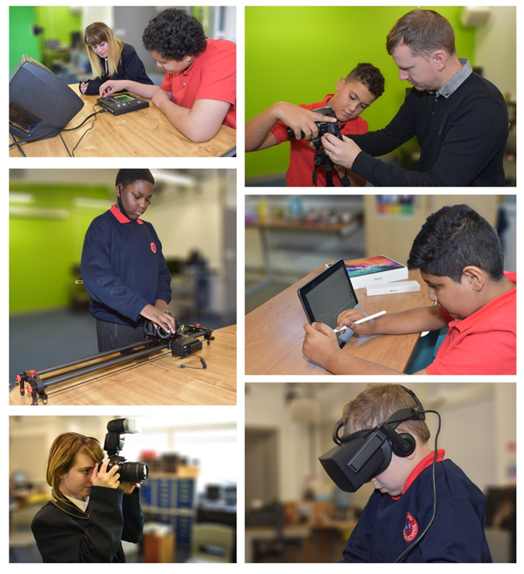
Melland High School is an outstanding school which meets the diverse special educational needs of students aged between 11 and 19 years of age. It is co-located with Cedar Mount Academy in Gorton Education Village and is a member of the Bright Futures Educational Trust.
Melland is a specialist support school for central and east Manchester high schools, a National Support School and leads on SEND provision across the twelve academies within Bright Futures.
As a high achieving inclusive learning environment, the school is proud to uphold the values of passion, community and integrity.
Melland’s bespoke curriculum is appropriately broad and balanced, has spiritual, moral, social and cultural development at its heart and actively supports all students as they prepare for adulthood.

WHY WORK FOR US?


We offer a great opportunity to join an organisation which really lives its values. Our working environment is very inclusive and whilst you can expect to be challenged in your role, you will be supported through professional learning, treated fairly and with dignity and respect. Please see the Equality,
Diversity, an Inclusion statement on our website.

Terms and Conditions
Salary: £17,467 - £18,025
The full time equivalent pay is £25,185 rising to £25,989: Bright Futures NJC scale points 4 to 6 (Bright Futures Grade 3). Pay progression is linked to performance.

Working weeks: 38 weeks during school term time.

Hours: 5 days per week - 30 hours per week.

Holidays: You will be paid for the prorate equivalent of 25 days, plus 8 public holidays. This increases to 30 days plus 8 public holidays after 5 years’ service.
Pension: Local government pension scheme. Please take a look at the website: https://www.gmpf.org.uk/.

Other: We offer salary sacrifice schemes for purchasing bikes used for travel to work and technology for personal use, through monthly interest free salary deductions.
We also offer opportunities for professional development.

How to Apply
We can only accept completed application forms, rather than CVs. This is because the regulatory guidelines of
Keeping Children Safe in Education (2025), require us to check various details of job applicants and an identical
application format for each candidate enables us to do this. We use a process that does not identify personal
characteristics to the shortlisting panel. This is part of our commitment to equalities and diversity.

For a full explanation of our employment offer please see the booklet on our website:
Our-Employment-Terms-November-2023.pdf (bright-futures.co.uk)

NO AGENCIES PLEASE.

Our application form is available online, along with the disclosure of criminal background form. The portal link is: Melland High School, 50 Wembley Rd, Manchester | Teaching Jobs & Education Jobs | MyNewTerm

Please complete the application by 12 Noon on Thursday 5th March 2026. Shortlisting will take place during w/b 9th March 2026. Interviews will be held during w/b 16th March 2026.

Keeping Children Safe in Education
Bright Futures Educational Trust is committed to safeguarding and promoting the welfare of children and young people and we expect all staff and volunteers to share this commitment. This post is exempt from the Rehabilitation of Offenders Act 1974; pre-employment checks will be carried out and references will be sought for shortlisted candidates and successful candidates will be subject to an enhanced DBS check and other relevant checks with statutory bodies.

Data Privacy
You can read the details of how we use the personal data that you provide us with in our Job Applicants’ privacy notice on our website: http://bfet.co.uk/wp-content/uploads/2018/07/BFET-Applicant-privacy-notice-002.pdf

JOB DESCRIPTION
Teaching Assistant – Level 1
Grade 3
Special/Additional Needs

SUMMARY

The main purpose of the job will be to support access to learning and provide general support for the school in the management of pupils and resources, as directed by senior staff.

Support for pupils

- To work with small groups of children under the supervision of the teacher including the implementation of ILPs

- Give regular feedback on children’s progress to the class teacher and file records

- Attend to children’s personal needs, including pastoral, social, health, physical hygiene, minor first aid and welfare matters

- Establish good relationships with pupils, taking on role model by presenting a positive personal image and responding appropriately to individual needs

- Promote the inclusion and acceptance of all pupils

- To assist with the dispensing of medication in exceptional circumstances with appropriate training and under the supervision of medical staff where necessary.

- To carry out escort duties as appropriate whenever required.

- To assist pupils in the hydrotherapy pool (where applicable), lift, dress, and provide support to the pupils with the activities in the pool.

- To support pupils on integration placement in mainstream schools or colleges and on work experience placements.

Support for Teachers

- To assist the teacher to ensure a safe classroom and outdoor environment, checking materials and personal equipment for defects and implement risk assessments carried out by the teacher according to school guidelines. This will include cleaning equipment used by pupils and ensuring its accessibility.

- To work closely under the guidance of the teacher as required, with therapists, medical staff, and other personnel working with pupils, so that their advice and practice are integrated in to ILPs.

- Provide curricular clerical/admin support, eg. photocopying, making lists, and collection of monies.

- Prepare the classroom for lessons, including display work under the direction of the teacher

- Undertake pupil record keeping as requested (e.g. provide a written statement on pupil progress to the teacher)

- Support the teacher in managing pupil behavior, reporting difficulties as appropriate

- Gather and report information between parents and carers as directed

Support for the Curriculum

- To provide support in all areas of the curriculum and on social occasions for pupils who have been identified as having medical conditions which disable their full independent access to mainstream school life.

- Provide Curriculum / resource support and undertake programmes linked to local and national learning strategies

- Support the use of ICT in learning activities and develop pupils’ competence and independence in its use

- Prepare and maintain equipment/resources as directed by the teacher and assist pupils in their use

Support for the School

- Be aware of and comply with child protection procedures, health and safety and security, confidentiality and data protection, reporting any concerns to the relevant member of staff.

- Maintain high standards of health and safety at all times.

- Maintain good relationships with colleagues and work together as a team.

- Assist in the supervision of classroom and outdoor activities.

- Assist with the supervision of discreet groups of pupils for short periods when the teacher is not present.

- Contribute to the overall ethos/work/aims of the school.

- Be aware of and support difference and ensure all pupils have equal access to opportunities to learn and develop.

- Attend relevant meetings.

- Participate in training, including relevant learning strategies and other learning activities and performance management where required.

Person Specification

Experience of working with children/young people with behavioural difficulties and those with communication, severe, profound or complex learning difficulties where appropriate.

Numeracy/literacy skills (at a level equivalent to Level 2)

Completion of the Teaching Assistant Induction Programme

Ability to relate well to children and adults

Ability to work as part of a team

An understanding of the role of the Teaching Assistant and other professionals working in the classroom

Ability to use relevant technology eg photocopier

Understanding of national/foundation stage curriculum and other basic learning programmes/strategies

Basic understanding of child development and learning

Willingness to undertake first aid training as appropriate

Personal Style and Behaviour

Tact and diplomacy in all interpersonal relationships with the public, pupils and colleagues at work.

Self-motivation and personal drive to complete tasks to the required timescales and quality standards.

The flexibility to adapt to changing workload demands and new school challenges.

Personal commitment to ensuring support is equally accessible and appropriate to the diverse needs of the pupils.

Personal commitment to continuous self-development.

Personal Commitment to continuous school improvement.

Be willing to consent to and apply for a DBS (Disclosure and Barring Service) check.

