
Senior IT Technician

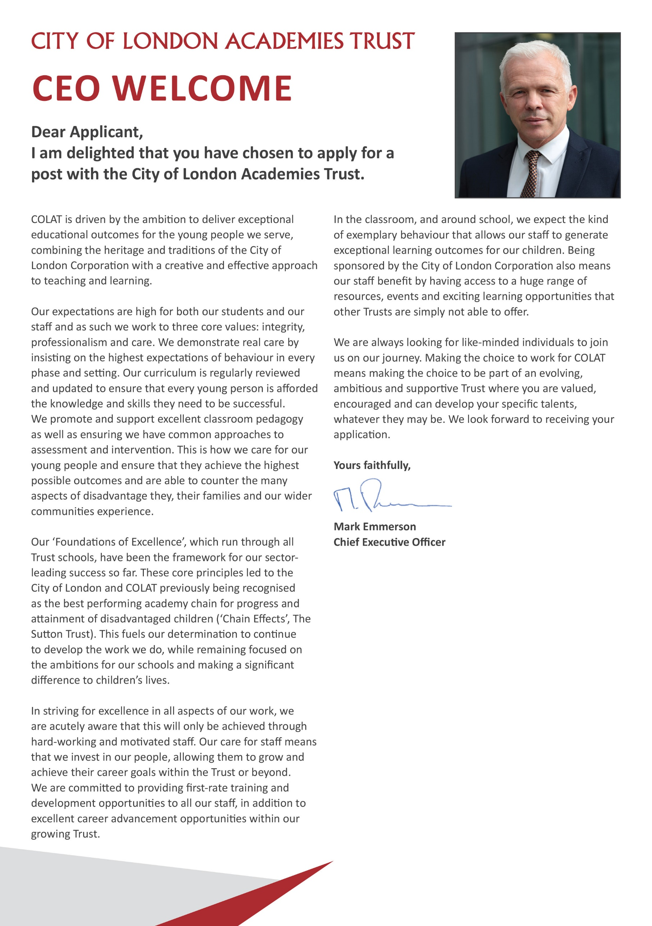

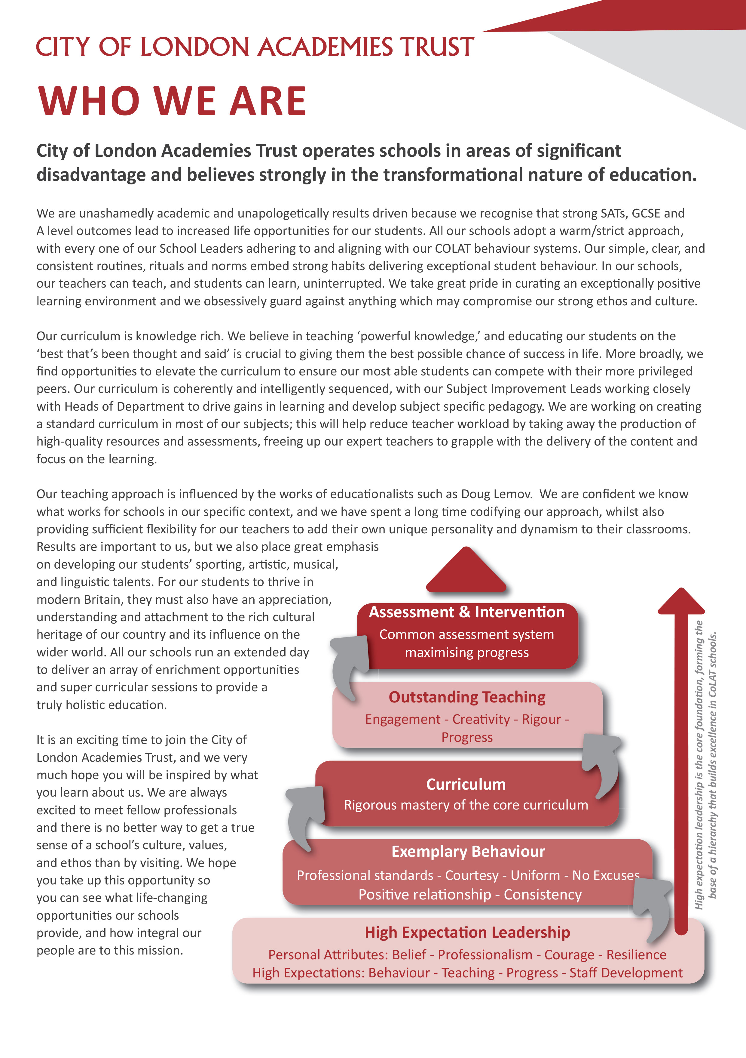

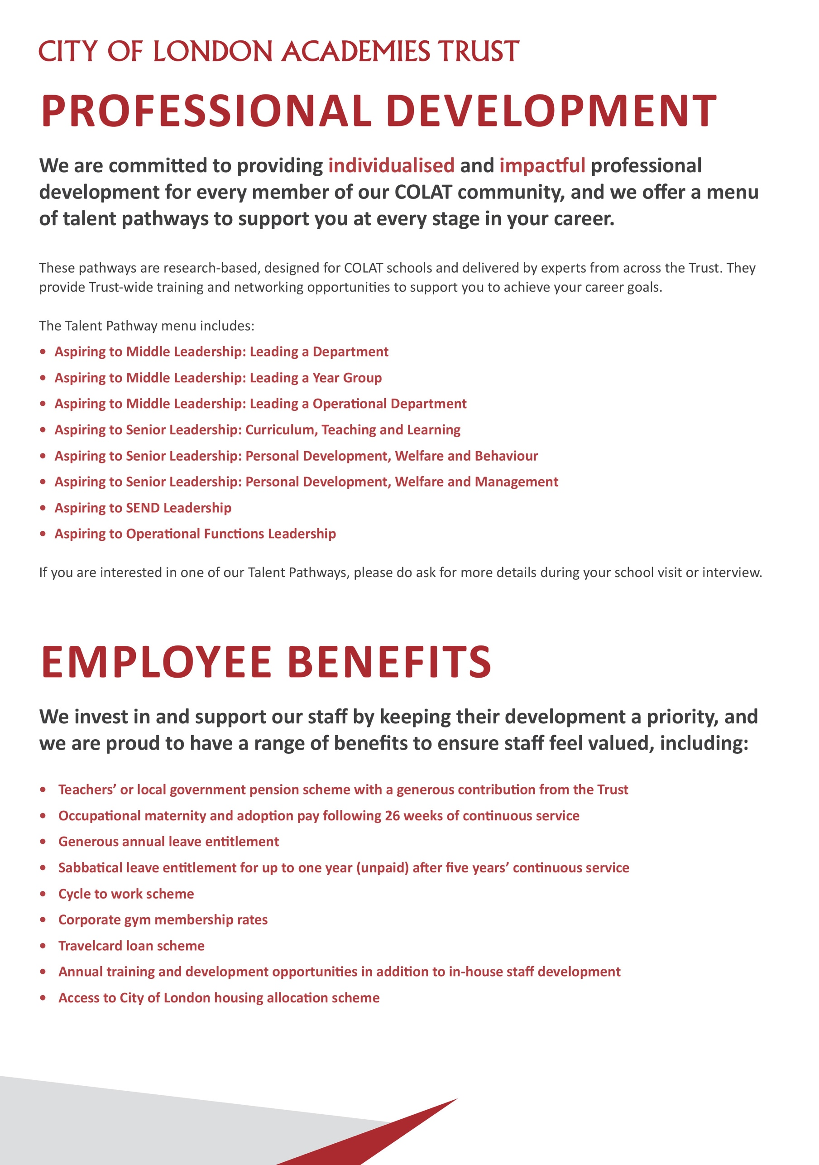

Senior IT Technician - Job Description

Post: Senior IT Technician

Reporting to: Trust IT Service and Operations Manager (ITSOM)

Grade: S01 Grade NJC Scale Points 21 - 25

Salary: £39,214 - £41,635 FTE

Working Pattern: 35 hours per week, 52 weeks per year

Location: TBC

Disclosure level: Enhanced

Main Purpose

- To provide first contact and second level support for users via the service desk including remote assistance, assessing and diagnosing reported incidents.
- Act as the point of escalation for Technicians, provide higher level first time fix by investigating escalated incidents and supporting these through to resolution within the service level targets; responding to site as required.
- To provide day to day management of the IT service desk by assigning tickets to deployed Technicians in coordination with the service schedule and ensuring efficient and effective ticket closure.
- To ensure the smooth running of Trust ICT systems and infrastructure to facilitate outstanding Teaching, Learning, Administration and Leadership.

Key Accountabilities

Service Desk & Support
- Responsible for management of the service desk tickets ensuring that all tickets are logged, assigned to Technicians, prioritised and completed in a timely manner in accordance with defined service indicators.
- Oversee the effective and customer focused IT support to students, staff and stakeholders, ensuring the diagnosing, troubleshooting and resolution of incidents/request through use of the service desk, telephone, face to face or remote support assistance.
- Supervise deployed Technicians to ensure an accurate record of incidents/requests are maintained and resolved through the service desk, ensuring users are regularly informed of the status.
- Develop and maintain documentation such as knowledge base articles or FAQs to support Technician tasks, inspect the ticketing system for trends to help drive improvements whilst reporting these regularly to the Trust ITSOM.

Service Operation & Supervision
- Provide a point of escalation for Technicians, managing incidents/requests remotely whilst using initiative to problem-solve complex technical issues to achieve resolution in a timely manner.

- In collaboration with the Trust ITSOM/ IT Systems Infrastructure Manager (ITSIM) and deployed site technicians, liaise with 3rd parties, partners and suppliers, including the supervision of contractors.
- Perform and supervise routine system checks and maintenance to ensure all systems and devices operate reliably in support of effective service delivery.
- Co-ordinate the maintenance of an accurate ICT inventory, ensuring the correct disposal of ICT equipment.
- Provide appropriate support and guidance to Technicians, assisting in the training and development as required.
- Organise and coordinate support for events, exams and other key activities, ensuring that adequate technical resource is available, and support is provided.
- Assist with deployment of IT solutions, projects and developments as required by the IT Leadership Team (Trust ITSOM/ITSIM and Director of IT).

Equipment & Applications
As a senior level Technician, carry out, provide support and supervise Technicians to:
- Install, support and maintain all ICT hardware and software and peripherals, without exception, including Windows, Apple and Chrome end-user devices
- Support and maintain school audio visual, print solution and VOIP/Telecom equipment, liaising with 3rd parties as required
- Perform routine maintenance on system software applications, upgrading and supporting as required
- Monitor the performance and effectiveness of ICT equipment, resolving hardware and software faults, escalating within the IT Service as appropriate
- Install, maintain and support device manage systems to ensure efficient control of mobile IT equipment

Server and Network
As a senior-level Technician, carry out, provide support for, and supervise Technicians, in collaboration with the ITSIM, to:
- Perform maintenance, diagnostic and recovery routines on active, physical and Wifi network infrastructure, complete switch maintenance and VLAN updates; escalating where necessary to the Trust ITSOM/ITSIM.
- Perform complex diagnostic testing of network connectivity to and from end user devices, maintaining structured cabling.
- Maintain and support incoming communication services such as internet/WAN and CPE equipment, liaising with the provider as necessary.
- Undertake remote monitoring, routine and scheduled maintenance on servers and/or network infrastructure.
- Actively support, maintain and monitor health and security of the systems to ensure the integrity of data, systems and resources, managing virus protection and security.
- Support the effective delivery of IT disaster and business continuity plans such as the co-ordination of effective backup and recovery routines, ensuring provision is regularly monitored, tested and reviewed
- Provide assistance with use of site technical systems and integrations e.g. Door Access, CCTV.
- Ensure the highest level of protection against loss, misuse and cybercrime.

System Administration
- Administer user login accounts, manage security and distribution groups to ensure that users have appropriate access to digital learning platforms, communication tools, data and resources.
- Identify, review and implement change request, providing authorisation to release.
- Ensure that all equipment is periodically audited for condition and status.
- Maintain, configure, and conduct termly tests of internet filtering systems and user policies.
- Ensure documentation produced is to a high standard and is consistent.

General
- Proactively develop your subject expertise and engage fully in staff training and professional development to enhance skills and knowledge.
- Demonstrate a willingness to work flexibly, including occasionally outside normal core hours, to meet service demands as agreed with your line manager.
- Undertake such other duties as reasonable to the general character of the post and commensurate with roles of this level, such supporting other Trust schools as required by the IT Service.

Compliance

- Ensure that statutory responsibilities are maintained, acting legally and responsibly.
- Uphold, follow and actively support the Trust’s policies and procedures such as areas of GDPR, data retention, e-safety, cyber security, business continuity, asset management, procurement and acceptable use.
- Ensure that confidentiality is maintained and in line with agreed Trust policies and protocols.

Statutory
- To work within a framework of best practise governed by the relevant occupational standards to support excellence in teaching and learning.
- To promote the safety and wellbeing of students, ensuring that the school’s Child Protection and Safeguarding policies and procedures are promoted within the school.
- To be responsible for your own health and safety and that of students and your colleagues, in accordance with the Health and Safety at Work Act 1974 and relevant EC directives.
- Adhere to the Trust’s Equality Policy in all activities and actively promote equality of opportunity.

Safeguarding Children
COLAT is committed to safeguarding and promoting the welfare of children and young people. We expect all staff to share this commitment and to undergo appropriate checks, including enhanced DBS checks.

The above responsibilities are subject to the general duties and responsibilities contained in the Statement of Conditions of Employment. The duties of this post may vary from time to time without changing the general character of the post or level of responsibility entailed.

The person undertaking this role is expected to work within the policies, ethos and aims of the Trust and to carry out such other duties as may reasonably be assigned. The post holder will be expected to have an agreed flexible working pattern to ensure that all relevant functions are fulfilled through direct dialogue with employees, contractors and community members.

English Duty
This role is covered under part 7 of the Immigration Act 2016 and therefore the ability to speak fluent spoken English is an essential requirement for this role.

Person Specification

Our Values and Vision
The City of London Academies Trust, sponsored by the City of London Corporation, aims to provide high-quality education for students and pioneer educational innovation. We are driven by the ambition to provide world-class experiences and deliver exceptional educational outcomes for the young people we serve.

All City of London schools and academies draw upon the traditions, institutions, heritage and historical successes of London to furnish each of their diverse communities with life-transforming learning experiences. In doing so, we believe that the young people we serve develop into successful, compassionate young adults, who make a positive contribution to their local, national and global communities.

Our schools are characterised by a common understanding of what makes outstanding schools, based on five key principles which are known as our 'Foundations of Excellence’.

Our Staff
Our staff have high expectations, are consistent and driven to provide the best teaching and opportunities for our students. Teachers work in a well-disciplined environment where they are able to teach creative and engaging lessons, and all staff are given exciting opportunities to develop and learn from exceptional practitioners.

Equal Opportunities
The post holder will be expected to carry out all duties in the context of and in compliance with the Trust’s Equalities policies.

 | Essential | Desirable
Qualifications and Training
Hold a recognised technical qualification (Cisco CCNA, CompTIA A+, Cisco IT Essentials, MCSA/MCP or MCITP etc) at NVQ level 3 or equivalent experience | ✓
ITIL foundation or higher - training |  | ✓
Experience, Skills and Knowledge
3 years’ experience in a similar role | ✓
Experience of working in an education setting | ✓
Experience of using Capita SIMS or similar MIS databases | ✓
Experience of supporting a Google Apps for Education, Chrome OS and Chromebook Devices | ✓
Experience in support and maintenance of Windows 7, 8 and 10 OS | ✓
Experience in support and maintenance of Windows Server, including AD, GPO, DNS, DHCP; | ✓
Experience of supporting and configuring VMWare or Hyper V | ✓
Experience in supporting Cisco/Meraki Network and Wifi Infrastructure |  | ✓
Excellent understanding of networks, TCP/IP and subnetting | ✓
Experience with a range of backup products including VEAM | ✓
Experience with Web filtering products LGFL, Smoothwall, Sonicwall, Websense |  | ✓
Experience with Sophos Intercept X and other managed antivirus systems |  | ✓
Experience of working with Audio Visual Equipment. | ✓
Experience and understanding of incident, request and change management processes through an IT Service desk. | ✓
Appropriate problem-solving skills | ✓
Personal Qualities
Strong relationship-building skills with the ability to inspire trust and commitment across the organisation | ✓
Good organisational and project management skills, and the ability to balance competing pressures, deadlines and demands | ✓
Excellent communication skills, verbal and written – able to deal with a variety of people sensitively and empathetically including staff and students | ✓
Ability to work under pressure while maintain a positive professional attitude, and work on own initiative | ✓
Flexible and willing to contribute to the success of the team | ✓
Other
Commitment to safeguarding and promoting the welfare of children and young people | ✓
Willingness to undergo appropriate checks, including enhanced DBS Checks | ✓
Motivation to work with children and young people | ✓
Ability to form and maintain appropriate relationships and personal boundaries with children and young people | ✓

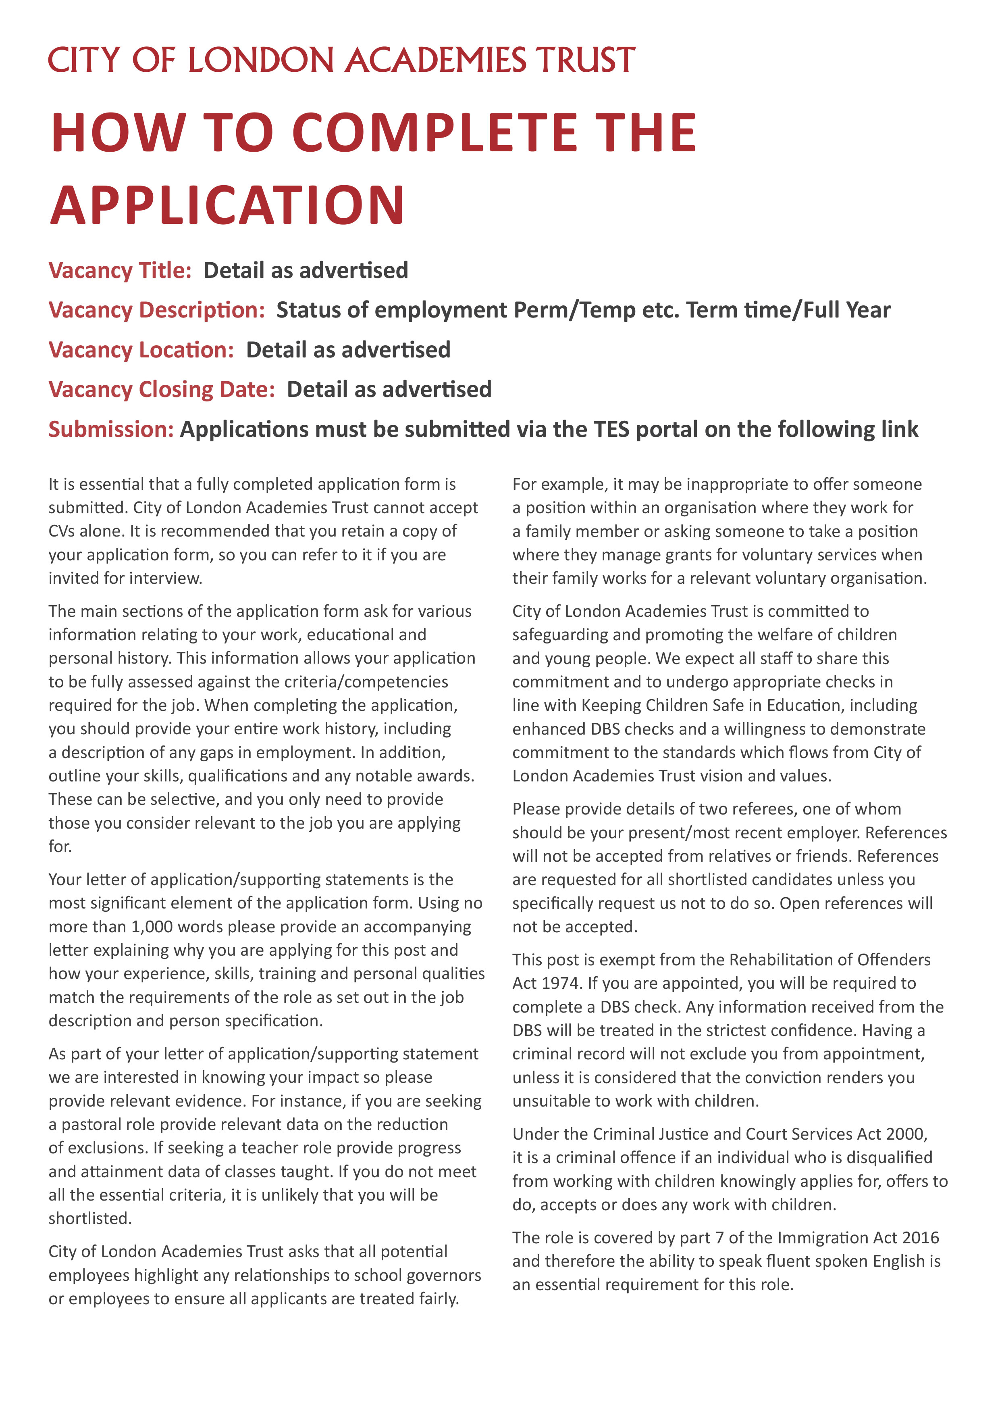
Monday 11 May at 09.00
Guildhall, London
Applications are to be submitted through the My New Term portal
09.00, Monday 02 March 2026
Full time, 35 hours per week, all year round
Senior IT Technician
erer



