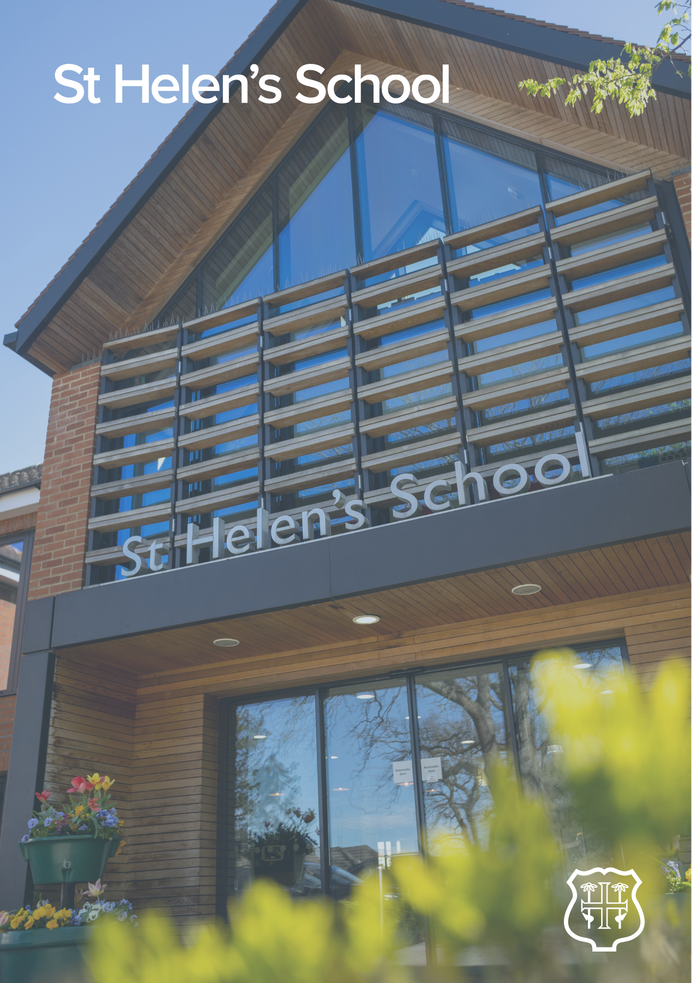

Sports Centre Weekend Cleaner – Job Description

JOB DESCRIPTION
Sports Centre Weekend Cleaner
Main Responsibilities
- Maintain the highest standard of cleanliness within your areas of responsibility in accordance with the current specifications of work. These schedules are completed as instructed by your manager.
- Ensure Daily checks of the equipment and machines used during your hours of duty and report any defects to the Manager. Return all equipment to allocated area at shift end.
- Follow all health and safety policies and procedures and report any dangers or hazards that you encounter to your manager.
- Ensure that you wear any personal protective equipment you are provided with, adequate footwear and your full uniform at all times whilst on site.
- As and when necessary, assist with other tasks within your capabilities to maintain and improve the cleaning services within the premises.
- Attend the training sessions that pertain to the role.
- Represent and promote the school wherever possible.
- Make yourself familiar with and follow all School and cleaning procedures and working methods.
- Comply with the School’s Safeguarding and Child Protection Policy and Procedures.

Hours
Saturday and Sunday 17:00pm-20:00pm
This position is all year round, 52 weeks of the year

The Person
No previous experience is necessary, training will be provided.
Hourly rate - £14.43

APPLICATION PROCESS
Closing date: 18:00pm Sunday 31st May 2026
Please apply as soon as possible as shortlisting/interviews will progress up until the closing date. Should a suitable candidate be appointed, we reserve the right to close the advert early.
Due to the volume of applicants, we receive, if you do not hear from us within 4 weeks of the closing date, please assume we will not be progressing your application further on this occasion.

