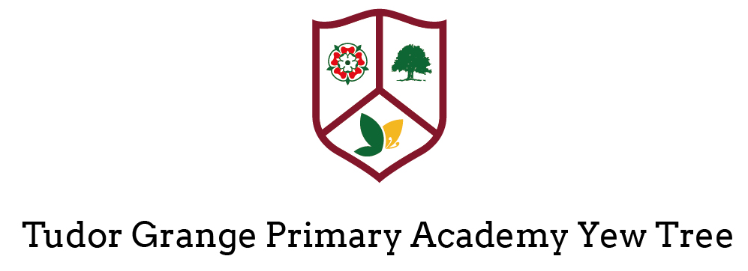

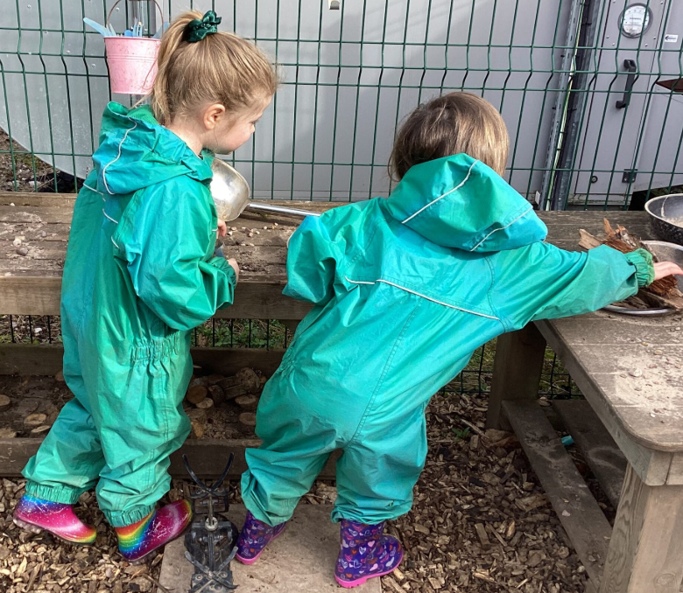

Applicant Information Pack


Welcome

Thank you for your interest in the Nursery Class Teacher position at Tudor Grange Primary Academy Yew Tree. We are delighted that you are considering joining our vibrant and dedicated team. Our school is committed to fostering a nurturing and inclusive environment where every student can thrive academically, socially, and emotionally.

As a prospective Nursery Class Teacher, you will play a pivotal role in shaping the future of our school. We are looking for a visionary practitioner who is passionate about education and dedicated to inspiring both students and staff. Your teaching will be crucial in driving our mission to provide high-quality education and to cultivate a love of learning in every child.

In this application pack, you will find detailed information about our school, the role, and the qualities we are seeking in our next Nursery Class Teacher. We hope this pack provides you with a comprehensive understanding of our values, goals, and the exciting opportunities that await you here.

We look forward to learning more about you and how your experience and vision align with our aspirations. Thank you for considering this opportunity to make a significant impact on our school community.

The academy is part of the Tudor Grange Academies Trust which includes: Tudor Grange Academy Solihull; Tudor Grange Academy Worcester; Tudor Grange Primary Academy St James; Tudor Grange Primary Academy Haselor; Tudor Grange Academy Redditch; Tudor Grange Samworth Academy, Tudor Grange Robert Smyth Academy; Tudor Grange Academy Kingshurst; Tudor Grange Primary Academy Meon Vale, Tudor Grange Primary Academy Perdiswell, Tudor Grange Primary Academy Hockley Heath and Tudor Grange Primary Academy Langley.

Opportunities within the Trust are readily available to outstanding practitioners who are keen to explore career progression. As part of our commitment to CPD, we have planned seven INSET days for 2025-6, three of these being joint with the other Academies within the Trust to allow for meaningful collaboration.

At the heart of what we do is the belief that all children should be given the opportunity to flourish and make a valuable contribution to the academy and the wider community. We celebrate the individuality of our children and are committed to giving all our pupils opportunities to achieve through the experience of a rich and engaging curriculum. We believe that the achievements, values and well-being of all our children matter and that it is important that pupils are supported to develop the skills to be resilient in the face of challenge.

We welcome individuals to site to tour the school prior to making an application. To book a tour please contact Miss C Johnson Office Manager on 0121 704 2067.

We look forward to meeting with you.

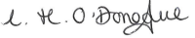
Mrs C O’Donoghue
Principal

Advertisement

Nursery Class Teacher: MPS
Closing Date: Monday 11th May 2026
Planned interview date Tuesday 19th May 2026

Start date: September 2026

Contract time: Full Time - Permanent
Salary: MPS
Suitable for ECTs: No

Job Description

The following Job Description outlines the skills and the experience required for the post at TGPA Yew Tree.

School culture and behaviour
Under the direction of the Early Years Lead, the Nursery Class Teacher will:
- Create a culture where pupils experience a positive and enriching school life
- Uphold educational standards in order to prepare pupils from all backgrounds for their next phase of education and life
- Ensure a culture of staff professionalism
- Encourage high standards of behaviour from pupils, built on rules and routines that are understood by staff and pupils and clearly demonstrated by all adults in school
- Use consistent and fair approaches to managing behaviour, in line with the school’s behaviour policy

Teaching, curriculum and assessment
Under the direction of the Early Years Lead, the Nursery Class Teacher will:
- Establish and sustain high-quality teaching across all subjects within the Early Years Foundation Stage Curriculum, based on evidence
- Ensure teaching is underpinned by subject expertise
- Effectively use assessment and robust tracking of engagement in continuous provision to inform strategy and decisions
- Ensure the teaching of a broad, structured and coherent curriculum
- Use valid, reliable and proportionate approaches to assessing pupils’ knowledge and understanding of the EYFS curriculum
- Ensure the use of evidence-informed approaches to ensure all pupils make a strong start with their reading progress
- Interpret and analyse data, including pupil records and assessment data: monitoring progress and taking appropriate action

Additional and special educational needs (SEN) and disabilities
Under the direction of the Senco, the Nursery Class Teacher will:
- Promote a culture and practices that enables all pupils to access the curriculum
- Have ambitious expectations for all pupils with SEN and disabilities
- Make sure the school works effectively with parents, carers and professionals to identify additional needs and provide support and adaptation where appropriate
- Make sure the school fulfils statutory duties regarding the SEND Code of Practice.

Professional development
Under the direction of the Early Years Lead, the Nursery Class Teacher will:
- Keep up to date with developments in education
- Seek training and continuing professional development to meet needs
- Through peer coaching and the demonstration of excellent classroom practice, work with colleagues to develop their teaching skills ensuring quality of provision throughout the whole school

Teaching & Learning

- Deliver an engaging, creative and connected EYFS curriculum consistent with the academy’s values and policies.
- Plan, prepare and deliver high quality learning experiences that promote curiosity, independence and early learning skills.
- Use a range of teaching strategies and resources to meet varying developmental needs.
- Observe, assess and document children’s progress in line with EYFS requirements.
- Create a nurturing, joyful and respectful environment where children feel confident and excited to learn.

Safeguarding

- Ensure the safety and wellbeing of all pupils, following the school’s safeguarding procedures.
- Build caring, positive relationships with children to support their social and emotional development.
- Promote the school’s values of kindness, respect and doing one’s best in all interactions.
Classroom Environment
- Maintain a well organised, stimulating and child centred learning environment both indoors and outdoors.
- Ensure high standards of behaviour through positive, supportive and consistent approaches aligned with the school’s behaviour policy.
Collaboration & Professional Engagement
- Work closely with Nursery staff and wider school colleagues, contributing to a cohesive and supportive team.
- Liaise with parents and carers to build strong home–school partnerships that support each child's learning journey.
- Participate in staff meetings, training and CPD offered by the school and the Tudor Grange Academies Trust.
Inclusion & Support
- Ensure teaching is inclusive and accessible for all children, including those with additional needs.
- Work collaboratively with the SENCo and external professionals where appropriate.

Leadership Team at Tudor Grange Primary Academy Yew Tree

Principal: | Mrs Catherine O’Donoghue
Deputy Head of School  Leadership Team | Miss Christina Allen  Miss Kate Williams - Mrs Sarah Collett
SENCO | Mrs Natasha Griffiths
Director of Primary Standards: | Miss Sarah Deakin

Why Work for Us?

Competitive salaries
We offer competitive salaries for both teaching and non-teaching staff based on the type and level of role you do. We ensure we are treating people fairly across the Trust as well as remaining competitive. Your starting salary will be determined by the pay range for your role, your experience as well as external market conditions.

Pension Scheme
All contracted members of staff will be automatically enrolled into a pension scheme with either the Teachers Pension Scheme or the Local Government Pension Scheme (whichever is appropriate). You do not pay tax or National Insurance on your contributions and TGAT adds a generous employer contribution, which varies depending on your salary. All staff are entitled to opt-out of the pension scheme should they wish to do so.

Flexible and Family Friendly Policies
We understand that our employment policies need to be flexible and responsive in order to promote diversity and equality, and to attract and retain the highest quality workforce. We offer flexible working opportunities and policies that are often in excess of statutory minimums.

Employee Assist Program (EAP)
Our EAP is a confidential employee benefit designed to help you deal with personal and professional problems that could be affecting your home life or work life, health and general wellbeing. Our EAP service provides a complete support network that offers expert advice and compassionate guidance for you and your close family 24/7. It covers a wide range of issues including legal, finance, property and childcare as well as offering counselling and support if required

Continuous Professional Development
TGPAYT and Tudor Grange Academies Trust is committed to CPD for all staff. Staff have access to a range of internal CPD, as well as opportunities to engage in CPD led by external providers.

Recognition
We are proud to have a range of schemes, which recognise the achievements of our staff and show our appreciation of their contributions.


About our School

At Yew Tree, our guiding ethos is rooted in joy, love, and respect—principles that shape every aspect of school life. We believe in doing our best and being kind, and we expect everyone in our community to embody these values. Together,
we thrive.

We are a one-form entry, inclusive primary school committed to providing a caring, stimulating, and well-rounded education. Our goal is to create a safe and welcoming environment where every child can flourish and enjoy their learning journey.
Our broad and balanced curriculum is enriched with educational visits and extracurricular opportunities, all designed to reflect our core values and inspire curiosity and growth.

We take pride in the positive behaviour and mutual respect that define our school culture. Our approach to behaviour is proactive and supportive, and further details can be found in our Behaviour Policy on the school website.

In February 2024, Ofsted rated us ‘Good’ in all areas, a reflection of our dedication to continuous improvement and excellence.

What truly sets Yew Tree apart is our strong sense of community. It’s the people—our staff, pupils, and families—who make our school a special place. We look forward to welcoming you.

Our Vision for Every Child

- Every child should have at least one trusted adult in school who genuinely cares for them and advocates on their behalf.
- We are committed to building strong, supportive relationships between adults and children.
- All children should experience the joy of success and leave Key Stage 2 confident in reading, writing, and numeracy.
- We hold high aspirations for every child, regardless of background or starting point.
- Children deserve to be taught by adults who are proud to be part of our school community.

Early Years Foundation Stage

All children in the Early Years Foundation Stage are offered the maximum opportunity to develop intellectually, emotionally and socially within a safe environment that is both stimulating and caring. A wide range of high quality indoor and outdoor experiences which challenge, stimulate and extend their learning support children in developing their natural desire, interest, excitement and motivation to learn. Children learn to become confident and independent decision makers, ready for the next stage of their primary education. All children are encouraged to develop care, respect and appreciation for others, including those with beliefs, cultures and opinions different from their own.

Key Stage One

Pupils’ independence and confidence will grow and develop throughout Key Stage One. Pupils will be able to share ideas, work co-operatively and imaginatively. Our pupils are enthusiastic learners who thrive on practical experiences. We encourage children to adopt a positive attitude to learning. When we have fun and work together, we are successful learners.

Key Stage Two

Pupils will work with increasing independence and confidence throughout Key Stage Two.
We expect pupils to be able to work as a team. We encourage children to adopt a positive attitude to learning. When we have fun and work together, we are successful learners

We encourage children to be self-starters and adopt a positive attitude to their learning. Children should have an independent approach to their learning.
Pupils will need to be able to work co-operatively, share ideas and apply their knowledge.

The Recruitment Process

The recruitment process is robust in seeking to establish the commitment of candidates to support the Tudor Grange Primary Academy Yew Tree’s measures to safeguard children and to identify, deter or reject people who might pose a risk of harm to children or are otherwise unsuited to work with them. The successful applicant will be required to undertake an Enhanced DBS check. All applications will be considered on their merit and the post will be offered subject to the usual health and criminal record clearance. We are committed to safeguarding and promoting the welfare of children and young people and expect all staff and volunteers to share this commitment.

