Nova Primary School
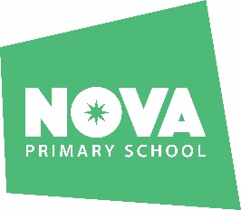

Job Description
Post: School Meals Supervisory Assistant
Responsible to: Lead Learning Mentor
Post Grade: BG4
Hours: 4 hours per week (Tuesday – Friday, 11.45am – 1.00pm) – Fixed Term Contract until 31/8/27. Term time only

Purpose of the Job
To supervise, guide and assist children during the midday break, so as to ensure the safety, general welfare and proper conduct of pupils during this period.

Main Duties and Responsibilities
- To assist in the lunchtime supervision of pupils to ensure that they are eating their lunch on time and in a safe and hygienic setting.
- To set up, engage and lead play activities to promote safe and effective play.
- To ensure full supervision of all play spaces and equipment.
- To follow the school’s behaviour policy and report observations to a teacher.
- To encourage positive behaviour and social interactions.
- Implement emergency procedures in the event of a fire or accident.
- Be a positive role model demonstrating enthusiasm, patience and a caring attitude towards all children.
- To undertake any other duties as reasonably directed.
- To follow TiLA all policies and procedures, especially those relating to child protection and health & safety

