Further details and application forms can be accessed via My New Term https://mynewterm.com/ or on the School website. This school is committed to safeguarding and promoting the welfare of children and young people/vulnerable adults and expects all staff and volunteers to share this commitment. This position is subject to appropriate vetting procedures including a criminal record check from the Disclosure and Barring Service (formerly CRB), which will require you to disclose details of all unspent and unfiltered spent reprimands, formal warnings, cautions and convictions as part of the recruitment process.
About the role:

We are seeking to appoint a highly motivated and enthusiastic Food and Nutrition
teacher to join our supportive and successful school. Applications are invited from
inspiring practitioners who can teach across key stages 3 & 4. Experience of teaching
across art and design subjects is desirable, as would expertise in areas such as
nutrition, hospitality and catering processes.
This post will commence Easter 2026.
The successful candidate will;
- be inspirational – able to engage with our students and create an
atmosphere of enthusiasm for creative subjects.
- be committed to ensuring that all students reach their potential
- be effective in setting and attaining high standards of student progress

Find out more on our jobs page – www.bwh.staffs.sch.uk

APPLICATION DEADLINE – Thursday 22 January 2026 at 8am
Are you looking for a new opportunity in an innovative and supportive 11-18 Catholic school? Now part of the St Gabriel the Archangel Catholic Multi – Academy Trust, the largest multi-academy in the Archdiocese of Birmingham. Blessed William Howard is looking to recruit dynamic, forward-thinking and inspirational staff to join us on our journey to success. With a strong Catholic ethos that puts ‘love’ at the heart of its community, the school provides a haven where all can flourish. Situated just outside the town centre and easily accessed by train, bus or the M6, Blessed William Howard is proud of its strong community links and its beautiful grounds.

Teacher of Food & Nutrition
MS / UPS - Permanent, full-time position

Why Blessed William Howard?

- A Christian community with a caring, secure and
disciplined environment.
- A wide range of extra-curricular activities.
- High academic standards.
- A commitment to success for all.
- Ongoing CPD for all staff.

“There is a warm atmosphere and the quality of relationships between all members of the school community are a particular strength. Pupils and staff are friendly, helpful, polite and welcoming to visitors.” Diocesan Section 48 Report

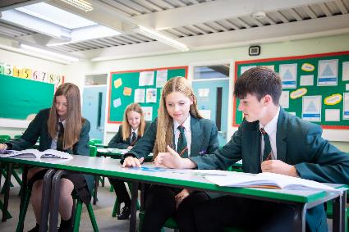
Blessed William Howard is proud to part of St Gabriel the Archangel Catholic Multi – Academy Trust. A company limited by guarantee registered in England & Wales with company number 08146661. Registered Office Address: Station Road, Cheadle, Staffordshire ST10 1LH. Telephone: 01538 493777
Web: www.bwh.staffs.sch.uk

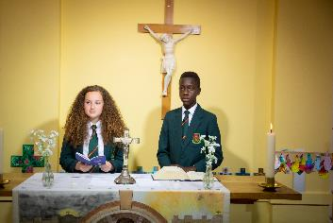

Blessed William Howard
Catholic High School, Stafford ST17 9AB
Part of the St Gabriel the Archangel Catholic
Multi – Academy Trust

