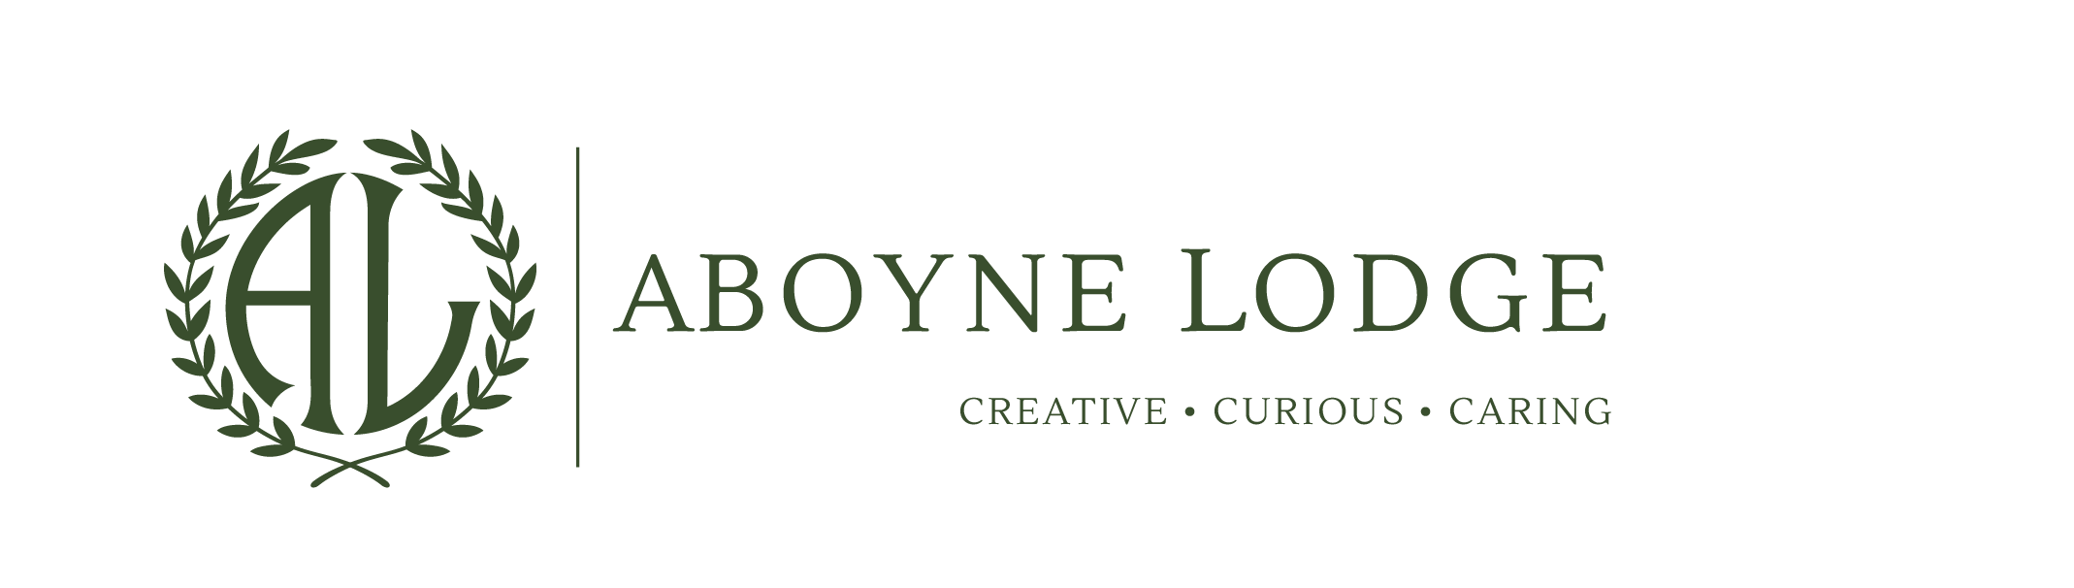


Part-time Caretaker/Handy Person
Purpose of the Role: To be responsible for the maintenance and security of the school premises and site, ensuring a safe environment
Responsibilities:
- Undertake minor repairs (i.e. not requiring qualified craftsperson) and maintenance of the buildings and site and cleaning duties
- Liaising with the Office Manager to arrange emergency repairs
- Arrange regular maintenance and safety checks
- Oversee onsite maintenance contractors, checking that work is completed to required standards and within required timescales
- Monitor stock and order supplies
- Undertake general portage duties, including moving furniture and equipment within the school
- Perform duties in line with health and safety and COSHH regulations and take action where hazards are identified, report serious hazards to line manager immediately
- Undertake regular health and safety checks of buildings, grounds, fixtures and fittings, (including compliance with fire safety regulations and legionnella) and equipment, in line with other schedules.
- Monitor the work of and manage cleaning and other site staff.
- Work with Senior Leaders to complete risk assessments and ensure compliance within the school with all health and safety responsibilities for example COSHH, ladder, asbestos, legionella and asset register
Individuals in this role may also undertake some or all of the following:
- Ensure the operation and maintenance of specialised equipment following training, for example sports/theatrical equipment
- Facilitate lettings and carry out associated tasks, in line with local agreements
- Handle small amounts of cash for the purchase of materials to carry out repairs.

Knowledge | Competencies
NVQ level 2 (or equivalent)  Minor DIY repairs and maintenance  Level 1 Safeguarding / Awareness of keeping children safe  Awareness of Control of Substances Hazardous to Health (COSHH)  Working knowledge of Health and Safety at Work  Working knowledge of policies and procedures  Knowledge of legionella and asbestos testing  Understanding of the Schools Ethos, Vision and Values  Manual Handling | Communication (written and verbal)  Listening  Team working  Monitoring  Planning and organising  Flexibility  Customer Service

Safeguarding:
This post is classed as having a high degree of contact with children or vulnerable adults and is exempt from the Rehabilitation of Offenders Act 1974. An enhanced disclosure will be sought through the DBS as part of Hertfordshire County Council’s pre-employment checks. Please note that additional information referring to the Disclosure and barring Service is in the guidance notes to the application form. If you are invited to an interview you will receive more information.
This role will be reviewed annually as part of the PMD process
The duties and responsibilities listed above describe the post as it is at present. The post holder is expected to accept any reasonable alterations that may from time to time be necessary

