


Candidate Information Pack – Head of Creative Arts

Details of the Post
Start date: | September 2026
Status of post: | Permanent
Closing date for application: | 20 April 2026
Interview Date: | Fortnight Commencing: 20 April 2026

WELCOME – Headteacher
Dear Prospective Candidate,

Thank you for your interest in our post. I hope that after finding out more about Wood Green School, you will want to apply to be part of our dedicated staff team.

Wood Green School is an oversubscribed 11-18 comprehensive in Witney, close to the Cotswolds with excellent links to Oxford and London. We are an extremely supportive school, with staff wellbeing a priority. Our school stands out for its commitment to academic excellence and personal development. Our curriculum approach and teaching principles values subject specialism, giving strong department teams the freedom to share their love of their subject and to light fires. The extensive range of extracurricular activities encourages students to explore their wider talents and build leadership skills. Our dedicated, caring staff are passionate about nurturing each student’s academic and personal potential.

This is a very exciting time for Wood Green. We have created our Wood Green Baccalaureate, that encourages and celebrates everything that a school should develop in young people: engagement in all subjects, learning skills such as research and communication, and personal skills such as thoughtfulness for others. We believe strongly in a culture of mutual respect and strong relationships, demonstrated in our Behaviour Policy built on restorative principles and our Diversity, Equality and Inclusion Policy. Everything is underpinned by our LEARNWell values. Our strong reputation and results improving year-on-year have led to a rapid rise in student applications. This holistic approach ensures that we live out our mission to develop exceptional, well-qualified and well-rounded young people who make a positive contribution to our school, our community and the world.

I believe that investing in staff is crucial to achieving our mission. At Wood Green, we provide a comprehensive programme of staff development, sharing best practice in-school and giving staff the opportunity to work with other schools through our local and national partnerships. All teaching staff work with peer coaches in school and have opportunities for professional development through Trust Peer Reviews, Oxford University Department of Education and National Professional Qualifications.
Wood Green School is part of the Acer Multi-Academy Trust, consisting of nine schools: Wood Green School, Chalgrove Primary School, Stadhampton Primary School, Botley Primary School, Icknield Community College, Watlington Primary School, Glory Farm Primary School, Cooper School and Matthew Arnold School. All nine schools have strong track records of high performance or rapid improvement and share similar values. This partnership adds real benefit to Wood Green School, especially opportunities for staff development. The key values of the Acer Trust are Trust, Big-Heartedness and Ambition.

If this feels like a school where you can flourish, I look forward to hearing from you.

Yours sincerely
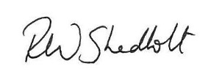
Rob Shadbolt, Headteacher

Mission, Values and Vision

Mission Statement

“Our mission is to develop exceptional, well-qualified and well-rounded young people who make a positive contribution to our school, our community and the world.”

Our Values

LEARNING EFFORT ASPIRATION RESPECT NURTURE WELLBEING
Our LEARNWell values reflect our commitment to developing the whole person and underpin everything we do:
- Learning – Wood Green students show curiosity, are creative thinkers, communicate powerfully, respond well to feedback, and find ways to learn that work for them
- Effort – Wood Green students are proud to try hard and to be successful, are not scared to fail, work well with others and by themselves
- Aspiration – Wood Green students achieve highly, believe they can improve, and leave prepared for their next exciting adventure​
- Respect - Wood Green students respect all others, take responsibility for their own actions, develop good relationships with all students and staff, and take care of their environment​
- Nurture - Wood Green students are kind to others and contribute to their community
- Wellbeing - Wood Green students manage themselves well emotionally, and know how to keep themselves healthy and safe
Department Information
Creative Arts department information
The Department of Creative Arts comprises Fine Art, Graphic Communication and Textile Design across five classrooms with the assistance of a specialist technician. In September 2026 the department will move to the school’s new purpose-built building.
We are seeking to appoint a new Head of Department for Creative Arts to lead the department into the next chapter of its development. The successful candidate will demonstrate the leadership skills to drive improvement and build a strong team of specialist teachers. The Head of Department will themselves be an excellent practitioner, able to teach Fine Art, Textiles and Graphic Communication at Key Stage 3, and Fine Art to GCSE and A Level.
Staffing
The Department comprises of a team of specialist teachers of Fine Art, Graphic Communication and Textiles. Each teacher has their own classroom with a computer, projector and sound system. There is a specialist ICT room shared with the Design and Technology department. Graphics has a class set of laptops.
Ethos
The Department is committed to developing effective learners who are capable of thinking creatively and independently as well as being able to reflect on their own practice. We place a significant emphasis on assessment for learning across the curriculum, setting personal targets for individuals to enable them to make progress and aspire to the best outcomes possible.
Students are taught skills to enable them to explore concepts creatively and practically and all work is underpinned with critical analysis of the work of other artists, designers and crafts people. Drawing skills are also a fundamental part of the curriculum at all key stages and our wide range of specialist equipment allows students to record ideas using a variety of techniques.

Curriculum Key Stage 3
Students experience the Creative Arts on a carousel basis which provides a term each of Fine Art, Graphic Communication and Textile Design. Years 7 and 8 have three, one-hour lessons per fortnight, which increases to four, one-hour lessons in Year 9. The focus in Years 7-9 is on preparing students for the Key Stage 4 curriculum. Students experience the creative process and are directed in the production of outcomes across the three disciplines.
Key Stage 4
We currently offer Edexcel GCSE Art and Design endorsements in Fine Art, Graphic
Communication and Textile Design. Students are allocated six one-hour lessons per fortnight and are based in specialist classrooms.
Key Stage 5
Art students follow the Edexcel Fine Art Endorsement at A Level and are allocated four hours of lessons each week.
Department development
We have recently focused on extensive curriculum development to create cohesion across our endorsements and embedded cognition and metacognition principles into our schemes of work to promote independent learning and creativity both in lessons and outside the curriculum. We offer external visits at KS4 and offer a one-day workshop to develop a range of experimental techniques. We hope to extend these opportunities to other key stages in the future and explore exhibition opportunities both within school and in the wider community.

Job Description

Job Title | Head of Creative Arts
Review Date of Job Description | March 2026
Establishment | Wood Green School
Location | Woodstock Road, Witney, OX28 1DX
Post responsible to: | Leadership Team Line Manager
Posts responsible for: | Teachers of Creative Arts (Fine Art, Graphics, Textiles)  Art Technician
Other Key Personnel to work with | Other Heads of Department  Other Heads of Creative Arts in the Acer Trust  HR  Administrative staff  Leadership Team
Pay | TLR 2(3b)
Purpose of Post: | To provide professional leadership and management for our Creative Arts department
General Duties | Leading the strategic direction  - Develop and review regularly with the team the vision, aims and purpose for the subject area  - Develop and implement policies and practices for Creative Arts in line with our school’s commitment to high-quality teaching and learning, and Inclusion  - Promote the subject across all Key Stages, its importance, and the value that it brings across the school  - Plan the deployment of staff expertise to achieve departmental improvement objectives  - Have a good understanding of how well the subject is being delivered and the impact it has on pupil achievement  - Use this understanding to feed into the school development plan and produce and monitor a department plan for the subject  - Liaise with the Acer Trust leads within subject groups on subject-related events, projects and activities  - Establish a partnership with parents to involve them in their child’s learning of the subject as well as providing information about the curriculum, attainment, progress and targets.  - Develop effective links with the local community, including feeder primary schools, business and industry in order to extend the subject curriculum, enhance teaching and to develop students’ wider understanding.  Leading the curriculum, teaching and learning  - Oversee the planning of the curriculum content across KS3, KS4 and KS5, ensuring it is well sequenced to promote pupil progress in all four subject endorsements  - Ensure the subject planned curricula are effectively and consistently implemented across the department  - Make sure there is an effective system of assessment that oversees the progress of pupils to ensure the curriculum has a positive impact on pupils’ learning  - Have an overarching responsibility for pupils’ achievement and standards in the subject areas across KS3, KS4 and KS5 in all subject endorsements  - Maintain personal expertise and share this with other teachers  - Act as a role model of good classroom practice for other teachers, modelling effective strategies with them  - Monitor and evaluate standards of teaching, identifying areas for improvement  - Plan and implement strategies to improve teaching where needs are identified  - Monitor teaching and learning by visiting lessons, scrutinizing portfolios, and talking with pupils to assess how well the subject area is being implemented and how well it is delivered across the school  - Promote pupils’ spiritual, moral, social, cultural, physical and mental development alongside British values in the teaching of the subject  - Work with the special educational needs co-ordinator (SENDCO) to ensure the curriculum matches the needs of different pupils, such as disadvantaged pupils and those with special educational needs and/or disabilities (SEND)  - Promote careers education through the subject and ensure that teaching and learning illustrates how the subject might lead to career opportunities  Leading and managing a team of staff  - Ensure all the team has a shared vision for the department  - Develop a high functioning team, including all teaching and support staff within Creative Arts, to deliver the vision  - Lead the creation of the Department Handbook and shared resources  - Take responsibility for performance development for your team, including carrying out annual Performance Development reviews with staff in line with the school’s policy  - Identify staff development needs and co-ordinate these with those responsible for CPD in the school  - Take initial responsibility for the pastoral care, morale and welfare of all department staff. This includes being the initial manager of staff absence.  - Induct, support and monitor new staff  - Ensure all the team support school policies  Managing effectively the department, including deployment of resources  - Create a safe, welcoming environment and take care of the classroom accommodation, ensuring classroom displays are stimulating, of high quality, and inspire curiosity in pupils  - Ensure high levels of organisation within the team  - Audit, check and manage resources to ensure they are up to date and match pupil and curriculum needs  - Manage the subject budget effectively to ensure it is spent on resources that add value and enhance the learning experience  - Work with the Art technician to ensure they are deployed effectively  - Ensure that there is a safe working and learning environment in which risks are properly assessed.
Responsibilities and Accountabilities | The Head of Department is accountable for:  - The quality of teaching and learning in the department  - Overall student outcomes in the department in partnership with the teachers concerned  - Ensuring that the curriculum fully meets the needs of all students and is effectively delivered in all respects  - Implementing school policies across the department
Publications: | - The Department curriculum profile for the school web site  - Subject Curriculum Policy  - Department Improvement Plan
Health & Safety | As a Manager you also need to be fully aware of the relevant activities expected of you in relation to H&S, including the need to ensure:  - All new employees, that you manage, are fully briefed at induction  - Your team are regularly reminded of key issues and responsibilities  - Your staff undertake appropriate health & safety training, including refresher training as necessary  - You carry out risk assessments and implement them, for processes, operations and activities under your control  - Health & Safety is a regular item at team meetings  - Your staff are set appropriate targets as part of performance management  As an individual  - To have due regard for health and safety in the workplace  - To be familiar with, and adhere to, relevant parts of the school’s Health and Safety Policy  - Co-operate with health and safety requirements  - Report all known defects  - Use, but do not misuse anything provided for your health, safety and welfare  - Do not undertake unsafe acts  - Inform Head of Establishment of any ‘Near-Misses’  - Be familiar with the emergency action plans for fire, first aid and security issues  - Undertake specific designated duties regarding emergency evacuation  - Raise health and safety and environmental issues with students
Child Protection | Wood Green School is committed to safeguarding and promoting the  health, safety and welfare of children, young people and vulnerable adults.  Staff and volunteers are expected to share this commitment for whom  they are responsible or with whom they come into contact in the course of  - their duties. All successful candidates will be subject to Disclosure Barring Scheme checks along with other relevant employment checks.
Standards and Quality Assurance | - Support the aims and ethos of the school as identified in the staff handbook  - Promote and model good relationships with pupils, colleagues, parents and visitor  - Set a good example in terms of dress, punctuality and attendance  - Participate in training and take a lead in own professional development  - Participate in the School’s staff appraisal process
Notes | - Whilst every effort has been made to explain the main duties and responsibilities of the post, each individual task undertaken may not be identified.  - Employees will be expected to comply with any reasonable request from a manager to undertake work of a similar level that is not specified in this job description.

Selection Criteria (Person Specification)
Education/qualification and training
- Possess QTS
- Well qualified graduate
- Possess a relevant degree
Knowledge/skills
- Sets high standards and expectations of students
- Can teach all elements Fine Art, Graphics and Textiles at KS3
- Can teach Fine Art to GCSE
- Can teach Fine Art to A Level
- Can motivate students at all levels of ability, thus ensuring that the Creative Arts is a truly inclusive department
Experience
- Proven track record of raising educational standards
- Experience of an 11-18 comprehensive setting either during teacher training or in a former post
- Has experience of developing the teaching of others
Personal characteristics/other requirements
- Is a person who works positively and collaboratively
- Is passionate, energetic, versatile and creative about their subject and teaching in general
- Is a strong team player
- Is committed to ensuring that students of all ages and abilities achieve their potential and are successful and happy

Appointment will be subject to enhanced DBS check, qualifications and experience checks and satisfactory references.

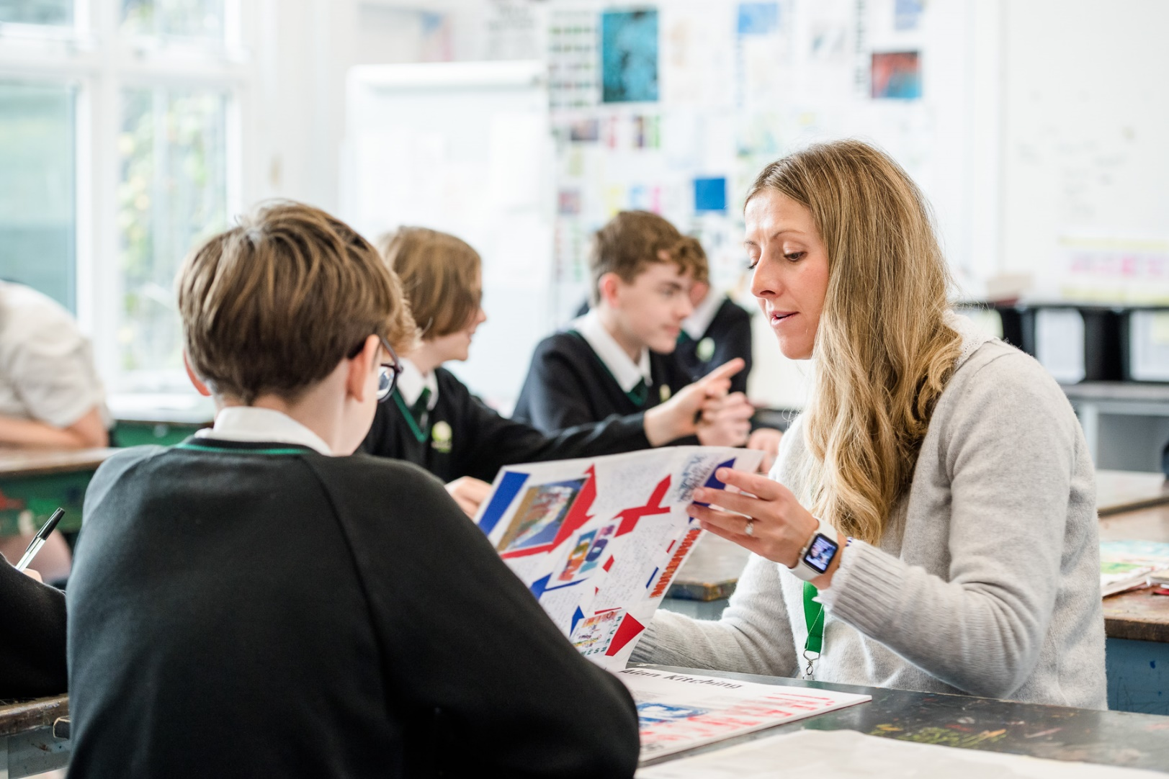

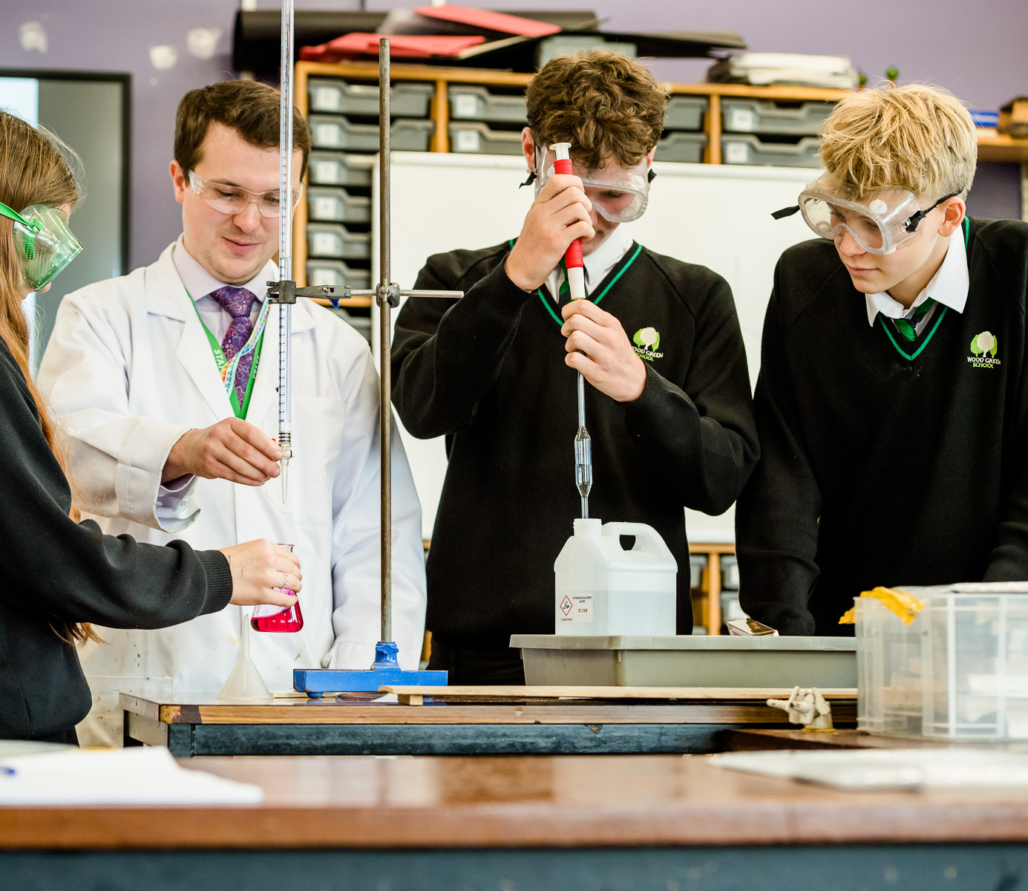

Wood Green School
Woodstock Road
Witney
OX28 1DX

01993 702355
hrwest@acertrust.org.uk
www.wgswitney.org.uk

