
1:1 Inclusion Support Worker 1

Inclusion Support
Practitioner

INTRODUCTION TO THE ROLE

We are seeking to appoint new inclusion support practitioner, committed to providing a transformational quality of education to the pupils in our lovely primary school. This is an exciting opportunity to join a friendly and professional team at a very exciting time for the school.

You will find yourself joining a close-knit team within the school as well as the Multi Academy Trust wider community.
We are interested to hear from you if you want to support pupils to achieve their best in a safe learning environment, and who will approach their role in line with our ambition of offering an exceptional quality of education to pupils of all backgrounds and prior attainment.
Lime Tree Primary Academy has had a £3 Million rebuild and refresh project recently completed, it was then graded GOOD by Ofsted in February 2024.
Joining Lime Tree Primary Academy now is a fantastic opportunity to be part of something really special.

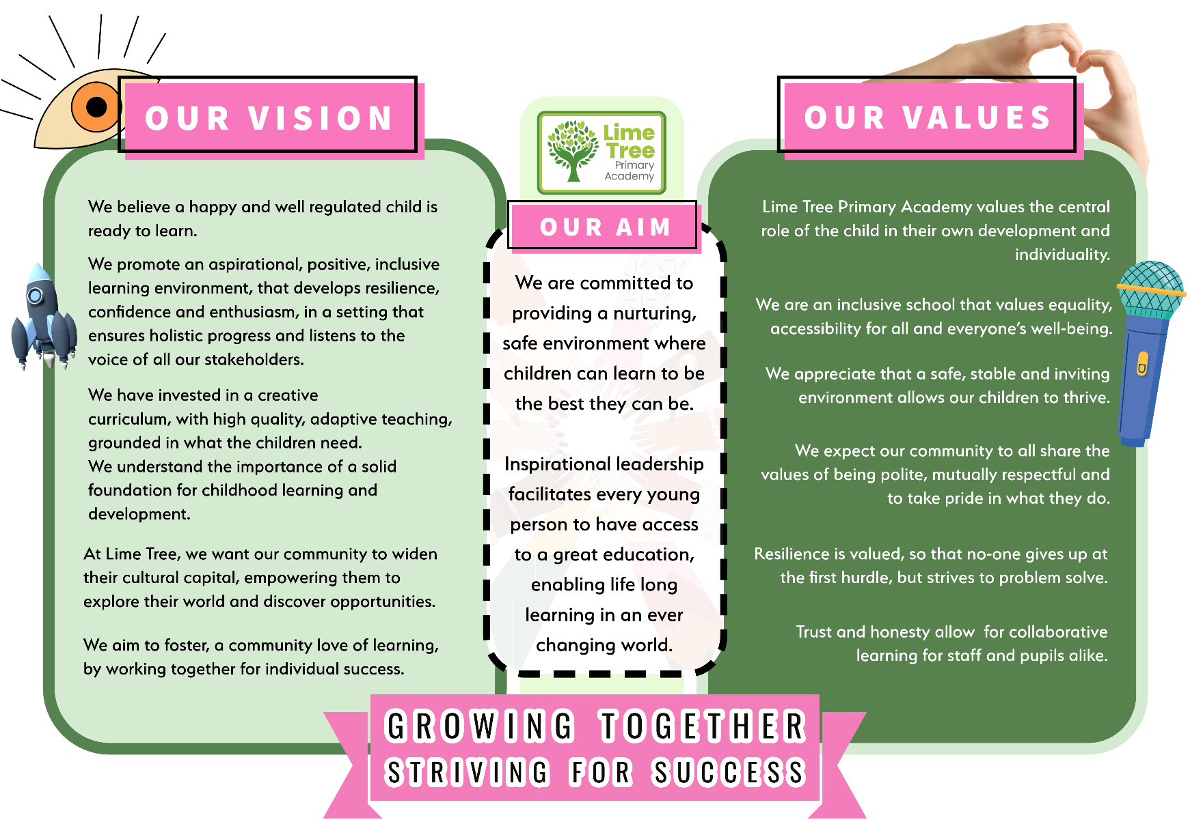
OUR SCHOOL VISION, AIMS AND VALUES

ABOUT THE TENYSON LEARNING COMMUNITY
The Tennyson Learning Community is a small Multi Academy Trust that invests in staff to carry out their roles effectively, in order to attain excellence in its schools.
Dedicated to improving standards, we believe strongly in the benefits of working collaboratively across the Trust to drive outcomes and standards.

We are proud to run one of the highest performing primary schools in the country – Tennyson Road Primary School, Luton – “Together, in strength and partnership” we are able to offer an outstanding school improvement model with a proven track record.

In return of your commitment and hard work we offer:
- A school team who will share your energy and enthusiasm.
- A brilliant community of professionals across the Trust, with great expertise
- A superb professional development programme and career opportunities within the Trust
- Wonderful children who love learning
- Competitive pay rate
- Private health care plan
We are driven by a moral purpose and a vision that ensures every child has the right to outstanding teaching and, every academy, exceptional leadership. It is our vision to work with our children, their parents and carers and our staff to create and to sustain excellent academies.

MESSAGE FROM THE HEADTEACHER
We pride ourselves on being a forward thinking, fully inclusive school. We strongly believe in supporting every child to reach their full potential and provide high quality support and interventions as part of a child’s learning journey here.
Our school motto is ‘Growing together, striving for success” and we firmly believe that working closely with pupils, parents and carers is key to positive outcomes for our pupils, helping them to leave our school equipped and ready for secondary education and the demands of modern life.
Children take part in engaging and exciting lessons and activities. Visitors and events such as drama workshops and artists are regularly welcomed to school to enhance and enrich our pupils’ learning opportunities further.
We fully believe that children who are interested, challenged and engaged will learn more. We aim to provide an excellent education for our pupils together with parental support through a strong home school relationship. Children also learn about today’s society and the importance of diversity and to respect others regardless of ability, gender, ethnicity, sexuality or religion.

Our recent Ofsted Inspection resulted in a grading of good in all areas, we are incredibly proud of the progress made through excellent teamwork and collaborative working, we are excited to drive these improvements further to achieve outstanding outcomes for all.
OFSED - “In lessons, pupils behave well and are attentive. They know their teachers want them to do well. Pupils behave sensibly in lessons and around the school.”
“Children learn the behaviour routines from the early years. For example, they cheerfully share their bikes and toys. They learn to concentrate and persevere.”


Ms Clare Lewis – Head of School

OUR VACANCY

Salary range: L3 Full time
Location: Lime Tree Primary Academy, LU5 5QN
Start date: May 2026 (depending on availability)
We value diversity and are committed to safeguarding. The successful candidate will be subject to an enhanced Disclosure and Barring Service check and any other relevant employment checks.
We are interested to hear from highly motivated individuals whose values are aligned with ours and who possess the knowledge and abilities to work as a successful Inclusion Support Worker as part of a cohesive team.
The successful applicant will have the chance to join a highly ambitious, successful and innovative Multi Academy Trust, and the opportunity to work alongside some of the country’s most experienced, knowledgeable and committed educational leaders.
We invest in and develop staff at all levels of their careers, and we know our track record of performance rests on the impact our staff have.

NEXT STEPS
Please review the Job Description and Person Specification, if you require these documents in any other format, or have any other accessibility requirements, please contact us on hr@tennysonroad.school

Our application process is accessed by applying through My new Term Tennyson Learning Community, Luton | Teaching Jobs & Education Jobs | MyNewTerm
Please do not hesitate to contact the school for an informal conversation about the role. Interviews will be held soon after closing date listed on the posting.
We are committed to safeguarding and promoting the welfare of children and young people. All staff with be subject to appropriate checks, including enhanced DBS checks and referencing.


