

Candidate information pack







Welcome from the Academy Headteacher – Lucy Shaw

Thank you for expressing an interest in the position of an Assistant Headteacher at Shibden Head Primary Academy.

This is an exciting opportunity for a talented or aspiring Assistant Headteacher to join the team at our established and successful primary academy, which is proud to be part of Focus Trust.

The role of an Assistant Headteacher is a key role within the academy in achieving our vision, and is suited to an enthusiastic, innovative and inspirational candidate who is focused on ensuring the best for all children and parents.

To succeed in this role you will need to be have excellent interpersonal skills with the ability to be flexible and adapt and be prepared to roll up your sleeves and lead by example, just like we all do at Shibden Head.

We hope that you will find this information pack helpful in finding out more about this post. We encourage you to make an appointment to visit the school and meet with one of our Senior Leadership Team.

Please contact the school office shibdenhead@focus-trust.co.uk or Tele: 01274 882458 to make an appointment for a visit to the school.
Visit dates & times: 10/11/12 November 9am and 4pm

However, if you would like a further conversation about any aspect of this post or about working as part of Focus-Trust, please do not hesitate me directly by email l.shaw@focus-trust.co.uk or contact me via the school office 01274 882458.

Shibden Head Primary Academy is committed to safeguarding children, and this commitment is reflected in our recruitment processes. References will be taken up on receipt of your application, to avoid undue delay in the process, unless you specify otherwise. They will not be used in the shortlisting process, but may be referred to during an interview.


I look forward to receiving your application.

Mrs L Shaw Headteacher

Welcome from Liz Fiddaman, Chair of Governors

Dear applicant,

Thank you for taking the time to consider applying for the role of Assistant Headteacher at Shibden Primary Academy. As Chair of the Governing Board, I would like to take this opportunity to tell you a little bit about the context of our school.

Shibden Head is one of three schools serving the village of Queensbury, on the outskirts of Bradford. Queensbury is one of the highest parishes in England, with views to the hills of Brontë Country and the Yorkshire Dales to the north and north-west. We have just over 400 primary aged pupils, we converted to an academy on 1st March 2013, joining Focus-Trust. We are delighted by the level of highly skilled professional support and challenge that Focus-Trust provides, as together we strive for higher standards.
When you visit us, you will find children who are happy to be in school. We have a reputation for being friendly and welcoming with an exceptionally hardworking team of staff. Pupil behaviour is a strength and a rich curriculum, good quality teaching and learning combine to make this a rewarding and exciting place to be.

I hope I have given you a flavour of Shibden Primary Academy. We have every confidence that we will successfully recruit an Assistant Headteacher who can continue our tradition of supporting and developing the school. We are a very supportive governing body with high expectations for our young children and staff, and hope that you feel encouraged to apply for the post.

L Fiddaman


Chair of Governors

3

Academy details

Address | Shibden Head Primary Academy Hainsworth Moor Grove Queensbury  Bradford BD13 2ND
Telephone | 01274 882458
Email | shibdenhead@focus-trust.co.uk
Website | www.shibdenheadprimary.co.uk

Job Description

Job title | Assistant Headteacher
Grade | Leadership scale L3-6
Accountable to | The Headteacher
Key Purpose
To assist the Headteacher with the leadership, management and organisation of the Academy in seeking to achieve the highest standards of pupil achievement and Academy efficiency.

To play a major role in assisting the Headteacher to:
- Formulate and model the aims and the objectives of the Academy and the improvement plan
- Establishing the policies and guidance through which objectives are to be achieved
- Managing staff and resources to achieve the objectives of the academy and the improvement plan
- Lead teaching, curriculum and assessment in order to achieve the best outcomes for all pupils
- Monitoring progress towards their achievement

Key relationships
- Children, parents and staff
- Local governing body
- Director of Academies and other members of the Focus-Trust team
- Other academy Headteachers
- The directors and trustees
- Other local Academies and stakeholders

Key responsibilities
The following information is not intended to be exhaustive but included to give an indication of the type of duties associated with the role of Assistant Headteacher in order to realise the Academy’s vision and outcomes of the academy. The key duties are set out under the following headings:

- Shaping the future
- Leading teaching, learning and assessment
- Developing self and working with others
- Managing the organisation
- Securing accountability
- Strengthening community
- Child protection and safeguarding
- Equality
- Deputies
- Specific responsibilities including a teaching responsibility

Shaping the future
  - Ensures the vision for the Academy is clearly articulated, shared, understood and acted upon effectively by all.
  - Motivates and works with others to create a shared culture and positive climate
  - Works with individual staff and teams to translate the Academy's vision into agreed objectives and operational plans which will promote and sustain improvement

Leading teaching and learning
- Be a good role model to all staff within the Academy and reflect a high level of professional teaching standards
Demonstrates and articulates high expectation and can set stretching targets for the whole Academy.
- Monitors, evaluates and reviews class room practice and manages improvement strategies.
- Analyse and interprets data to inform class room practice across the Academy

Developing self and working with others
- Manages positive working relationships with all staff.
- Motivates and challenges all staff to maintain high expectations of professional standards and behaviours.
- Develops and maintains effective strategies and procedures for staff induction, professional development and performance review

Managing the organisation
- Recruits, retains and deploys staff appropriately
- Implements evidence-based Academy improvement plans and policies for the organisation and its facilities
- Ensures that policies and practices take account of Trust, national and local policies and initiatives
- Manages the Academy environment to ensure that the Academy meets all health and safety regulations

Securing accountability
- Managers staff roles and ensures that responsibilities are clearly defined, understood and agreed
- Works with the governing body or governing body sub groups to enable then to meet their statutory responsibilities
- Presents the Academy’s performance and other Academy initiatives to a range of audiences; parents, Governors, Academy improvement officers and other external agencies.

Strengthening the community
- Works with other agencies to ensure learning experiences and opportunities for pupils are integrated into the wider community
- Builds the reputation of the Academy with the outside community
- Creates and maintains partnerships with parents and carers to support and improve pupils’ achievement and personal development

Child protection and safe guarding
- Ensure that the child protection policies and procedures are fully implemented and followed by all staff.
- Ensure that sufficient resources and time are allocated to enable staff to discharge their child protection related responsibilities effectively.

Equality
- Ensure that the academies reflects a vibrant and inclusive ethos which actively values and promotes diversity, community cohesion, and supports pupils to become successful integrated citizens.
- Actively challenge and address discrimination.

Deputies
- Deputies for the Headteacher in their absence

Specific responsibilities (including teaching responsibilities)
- specific responsibilities are to be agreed dependant on experience, but there will be a teaching commitment

Beliefs, attitudes and personal attributes
- Focused on students achievement; puts children ahead of personal or political interests.
- Resilient and persistent in goals, but adaptable to context and people.
- Willing to develop a deep understanding of people and context.
- Willing to take risks and challenge accepted beliefs and behaviours.
- Self-aware and able to learn.
- Optimistic and enthusiastic.

This job description is not exhaustive and may be changed at any time to meet the changing requirements of the academy or the Trust. This job description details responsibilities but does not direct any particular priorities or amount of time to be spent carrying out these duties.

The post holder is expected to:
- Actively support the work and ethos of the Focus-Trust.
- Undertake such additional duties as may reasonably be requested by the Headteacher or the Chief Executive.
- Respect confidentiality of staff, pupils, families and visitors and not breach this trust.
- Participate in arrangements for appraisal and in the identification of areas in which s/he would benefit from training and undergo such training.
- Proactively keep abreast of developments in relation to the post, and whenever possible and appropriate, attend professional development opportunities.
- Comply with and support all policies of the Focus-Trust and academy.
- Ensure that all statutory requirements are met.

This job description is neither exhaustive nor exclusive, and it may, after consultation with the post holder be subject to modification and amendment in accordance with the needs of the academy and/or Trust.

Assistant Headteacher
Person specification

Key:
App – Application Form
Ref – Reference
SP – Selection process. This could include a range of exercises, including an interview.

Knowledge, Experience and Skills

 |  | Essential/  Desirable | How identified
Leadership and management
Ability to build effective relationships with staff, parents, governors and other agencies |  | E | App/SP
Ability to line manage staff |  | D
Ability to use HR policies and procedures |  | D
Ability to make and implement difficult decisions |  | D | App/SP
Shaping the future
Implements an improvement plan across a key stage area or class room, identifying the priorities and evaluating the impact |  | E | App/SP
Works with and motivates teams and individuals to implement changes across the Academy |  | D | App/SP
Leading Teaching and learning
Being an Excellent teacher – by national standards |  | E | App/SP
Knowledge of how to use data to monitor pupil progress |  | E | App/SP
Knowledge of assessment tools to monitor teaching and learning |  | E | App/SP
Ability to identify effective interventions to ensure pupils maintain good progress |  | E | App/SP
Ability to identify excellent classroom practice to enable teachers to improve, through effective feedback |  | E | App/SP
Developing self and working with others
Regularly reviews own practice and continually participates in quality CPD |  | E | App/SP
Uses CPD to motivate, enthuse and develop staff |  | D | App/SP
Ability to plan and allocate work effectively |  | D | App/SP
Ability to coach and mentor staff |  | D | App/SP
Managing the organisation
Implements changes to staffing structures |  | D | App/SP
Recruits, retains and manages a range of Academy staff |  | D | App/SP
Manages the Academy’s environment in line with health and safety regulations |  | D | App/SP
Securing accountability
Holds people to account for what they have agreed to deliver |  | E | App/SP
Works effectively with the governing body to fulfil statutory duties |  | D | App/SP
Provides performance data to parents, governors and Academy improvement officers |  | D | App/SP
Strengthening the community
Builds relationships with community groups, outside agencies and other Academies which create innovative learning experiences for pupils |  | D | App/SP
Promotes the Academy |  | D | App/SP
Works with parents and carers to improve pupil achievement |  | E | App/SP
Child protection
Is aware and able to manage effective CP policies and procedures |  | E | App/SP
Ability to deal with sensitive issues in a supportive and effective manner |  | E | App/SP
Qualifications and training
Qualified Teacher Status or other educational qualification |  | E | App/SP
A degree or management qualification |  | D | App/SP
NCSL – Leading from the middle (or another NCSL leadership programme) |  | D | App/SP
Personal qualities and attributes
Moral purpose (Equality, children and adults treated with respect) |  |  | SP
Excellent communicator (Listening, putting a message across) |  |  | SP
Child centred |  |  | SP
Resilient |  |  | SP
Integrity |  |  | SP
Self motivated and able to motivate others |  |  | SP
Enjoys challenge |  |  | SP
Works to deadlines |  |  | SP
Enthusiastic and optimistic |  |  | SP
Excellent problem solving/analytical skills |  |  | SP
Self awareness, knowledge of strengths and limitations |  |  | SP

About our School

Academy vision, ethos and values
At Shibden Head we aim to create a quality environment where everyone involved with the school has respect for themselves, for others and for their community.

By constantly encouraging and emphasising positive aspects of work and behaviour we seek to promote the high standards we strive to achieve.

We believe that the goals and targets we set should be high but realistic so every child has equal opportunity to achieve their maximum potential.

We actively promote healthy life-styles and give children the knowledge and understanding they need to make informed decisions about their health, safety and well-being as they grow.

Everyone at Shibden Head, be they child or adult, has a role to play and a contribution to make to the life of the school and its place in the community.

We believe that the teaching/learning environment we provide should reflect the fact that
everyone’s contribution will be recognised and their views will be listened to.

We aim to have a school which provides stimulating, enriching and fulfilling experiences - a place which people enjoy coming to.
Our children are our future. At Shibden Head we work together to give children the academic and life skills they will need for a happy and successful future.

Our pupils

The very large majority of pupils are of White British heritage and few have a first language other than English. The proportion of pupils known to be eligible for free school meals is below average. The proportion of disabled pupils or who are supported at school action plus or with a statement of special educational needs is below average. Attainment on entry is broadly in line with age-related expectations.

Our staff

Our leadership team comprises the headteacher, deputy head, business manager, one assistant headteacher and two senior leaders. In addition to teachers and teaching assistants, we have a pastoral lead who works with children and families, staff and outside agencies to offer support for wellbeing and develop parental engagement. The running of the school is also supported by admin, kitchen and lunchtime teams.

Our facilities

Shibden Head Primary Academy is all on one level and so is accessible to anyone with mobility difficulties. In addition to classroom accommodation, there is an ICT suite, a hall and gym, a cooking room and extensive school grounds.

We have our own kitchen and school meals are cooked on site. Our own before-school, after- school -Shine Club is available to all pupils. This opens at 7:30am and closes at 6pm

Our school organisation

Our pupil admission number is 60 and there are two classes for each year group, from Reception to Year 6. In addition to class teachers, learning is supported in classes by teaching assistants – the number of these depends on needs within classes and year groups. PPA time for teachers is covered by a combination of teaching partners/ HLTAs.

Our curriculum

We provide a broad and balanced curriculum with an emphasis on the basic skills all children need to acquire in order to succeed. Our curriculum is designed to capture children’s imagination and natural curiosity and motivate a desire to learn about the world in which they live.

Children are taught to use new technologies as tools for learning in the 21st century. Pupils learn Spanish from Year 3 to Year 6. In Year 5, pupils benefit from whole-class instrumental tuition and swimming lessons.

Our extra-curricular activities

A range of extra-curricular activities usually operates in the autumn and summer terms, during which staff generally run an after-school club once a week. Examples of clubs offered include basketball, choir, gardening and cookery.


School Quick Facts

Type of school | Primary
Age range | 4-11
Location/LA | Bradford
Number of children | 4
Number of teaching staff | 19
Number of support staff | 46
% FSM | 14.14%
% SEN | 10.42%
% EAL | 0.74%

Our geographical area

Shibden Head is one of three schools serving the village of Queensbury on the outskirts of Bradford. Queensbury is one of the highest parishes in England, with views to the hills of Brontë Country and the Yorkshire Dales to the north and north-west.

In addition to our partner academies within Focus-Trust, we work collaboratively with schools in our local partnership and with a range of secondary schools in the Bradford and Calderdale areas to which our pupils transfer at the end of Year 6.
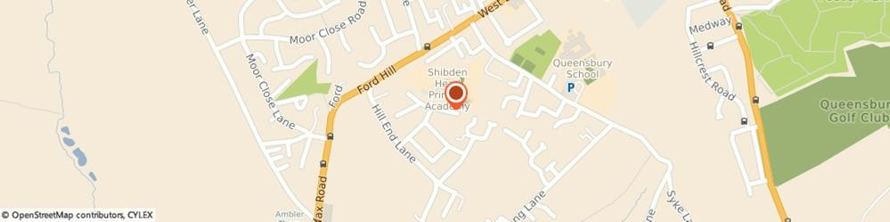

About The Focus-Trust
Background to the Trust
Focus-Trust was incorporated in May 2012 as a primary trust. The Trust has links with the sponsor, Focus Education, but is an entirely separate legal entity. As with all academy trusts, the Trust is a company limited by guarantee and an exempt charity. The Trust’s offices are situated in a newly converted historic mill conversion in Chadderton, Oldham with excellent motorway networks to access our schools.

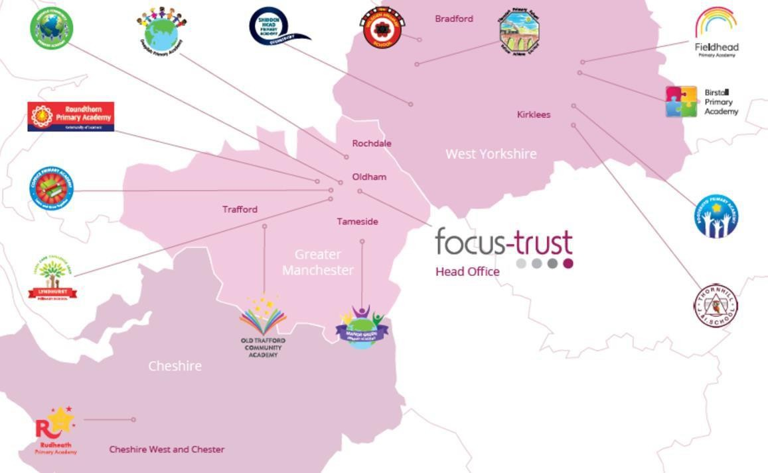
The defining feature of Focus-Trust is that it is a specialist primary phase trust. This means that the work of the Trust is driven by the distinctive needs of primary schools. Whilst the Trust has robust systems for accountability, each school has their own distinctive identity, ethos and culture, and this is a commitment to every school when they convert and join the Trust.

Focus-Trust currently has a small centrally employed team. The members of the team are highly skilled and committed to the vision, culture and values of the Trust.

All the schools within the Trust are willing partners who have actively chosen to join Focus-Trust and there is a very high degree of consensus, cooperation and commitment from within the group.

The Trust has robust policies and systems in place to govern and guide its work. These have been gradually implemented as the Trust has grown. The Trust has well-established productive relationships with trade unions and meets half termly with a group of national trade union representatives to discuss policy development. This has enabled us to introduce and change a range of policies in a streamlined and cooperative way.

Vision
‘Great schools at the heart of our communities’ - with our Community Champions and colleagues, we strive to ensure we are being civic leaders making a difference in the local and national communities and the community is supporting us.

Commitment
‘Learning together, making the difference’

Collective Efficacy
We have a well-developed and securely embedded culture of Collective Efficacy. By this we mean we have, ‘A shared commitment to work together on the things that matter to improve outcomes for all.’

The Focus-Trust Values
Professional honesty is at the heart of everything we do. The Trust knows the schools well because of the strong working partnership between academy leaders and the Trust Central Team. It is only by being honest and transparent with a balance of credible challenge and effective support, that we can move forward and get the best for all children and staff. Our work is underpinned by our values:

Care for children, adults and the learning environment

Dare to do things differently and have a go

Be fair, honest and inclusive – demonstrating integrity

Share expertise and best practice for the benefit of all learners

What you might want to know about Focus Trust

Pensions
Focus-Trust contributes to Teachers’ Pensions and Local Government pensions in the same way
and with the same level of contribution as local authorities.

Employer Relations
Focus-Trust has a Trade Union agreement which recognises the teacher and support staff unions. This is further supported by an ongoing and productive relationship with key trade union officials.

Equality of opportunity
Focus-Trust is an equal opportunity employer, dedicated to a policy of non-discrimination in employment on any basis including age, gender, race, colour, nationality, ethnic origin, disability, gender, religion, age, marital status, sexual orientation and/or medical condition.

Safeguarding
Focus-Trust is committed to safeguarding and promoting the welfare of all children and young people. There is an explicit expectation that all employees share this commitment and adhere to all safeguarding policies and procedures. Applicants should be aware that the recruitment process will include an assessment of your suitability to work with children.

Dress code
We expect all staff to dress professionally and appropriately for the roles undertaken. We pride ourselves on the high standards of dress of both our pupils and staff; these standards are led by our staff who we expect to set an example.

Policies
Focus-Trust and the schools have a range of policies and handbooks that help to make clear our expectations and ways of working. These are always shared openly with staff and are accessible to everyone. There are several policies that prospective employees should be aware of when making an application. These can be found on the Trust website
www.focus-trust.co.uk and school websites. All members of staff will be asked to sign a declaration as part of the induction process to acknowledge that
they have read and understand the Code of Conduct and some of the key policies, e.g. Safeguarding and Child Protection, Health and Safety, Acceptable use of IT.

Right to work in the UK
Under the Asylum and Immigration Act 1996, it is a criminal offence to employ anyone who is not entitled to live or work in the United Kingdom. Applicants can expect us to ask for proof of this at interview stage, where you will be asked to provide some original documentation to confirm that you are eligible to work within the UK. Photographic proof of identity will also be required.

Validation of qualifications and identity
All shortlisted candidates will be asked to bring original certificates or relevant qualifications and identity documents to interview. These will be photocopied and kept on file and, if appropriate, may be confirmed as genuine with the relevant awarding bodies. The copies of the successful candidate will be retained on their personnel file. The copies of unsuccessful candidates will be treated as confidential waste and disposed of appropriately.

References and Social Media Checks
If you are shortlisted, we will take up references before the interview date. One of your referees must be your current or most recent employer. Two satisfactory references must be received before we can confirm any offer of an appointment. The information we request will relate to salary, length of service, skills and abilities, suitability for the job, disciplinary record and suitability to work with children. Copies of references or open references will not be accepted. On receipt of references, your referees may be contacted to verify any discrepancies, anomalies or relevant issues as part of the recruitment verification process.
In line with our safer recruitment policy, social media checks will be undertaken if you are shortlisted. This social media check is designed to complement the range of standard recruitment checks and allows us to identify a candidate’s online presence which potentially could damage the organisation’s reputation.

Knowledge and skills profile
This is an important part of your application and is your opportunity to explain how you meet the person speciation for the post. You should demonstrate your skills, knowledge and experience and give short examples. Describe how you match the requirement of the job; include experience gained from previous jobs, community or voluntary work. Ensure that the information you give is well organised, relevant and brief. You may find it helpful to use sub-headings in order to keep your statement well focused. If you do not submit this profile, you will not be considered for short listing.

Disability
To comply with the Equality Act 2010, we are legally required to consider making reasonable adjustments to ensure that disabled people are not disadvantaged in the recruitment and selection process. We are therefore committed to meeting, wherever possible, any needs you specify on the application form. Please contact Natalie Harris if you need to discuss this in any detail. We will consider any reasonable adjustment under the terms of the Act to enable an applicant with a disability (as defined under the Act) to meet the requirements of the post.

Disclosure of a criminal record
Employment in this role is subject to an enhanced check with the Disclosure and Barring Service (DBS). Checks will also be made against the lists showing people barred from working with children. All checks must be satisfactory before any offer of employment can be confirmed and before commencement of work can take place.

Dress code

We expect all staff to dress professionally and appropriately for the roles undertaken. We pride ourselves on the high standards of dress of both our pupils and staff; these standards are led by our staff who we expect to set an example.

Knowledge and skills profile
This is an important part of your application and is your opportunity to explain how you meet the person specification for the post. You should demonstrate, using no more than 2000 characters, your skills, knowledge and experience and give short examples. Describe how you match the requirements of the role; include experience gained from previous jobs, community, or voluntary work. Ensure that the information you give is well organised, relevant, and brief. You may find it helpful to use sub-headings to keep your statement well focused. If you do not submit this profile, you will not be considered for short listing.

Policies
Focus-Trust and the schools have a range of policies and handbooks that help to make clear our expectations and ways of working. These are always shared openly with staff and are accessible to everyone. There are several policies that prospective employees should be aware of when making an application. These can be found on the Trust website www.focus-trust.co.uk and school websites. All members of staff will be asked to sign a declaration as part of the induction process to acknowledge that they have read and understand the Code of Conduct and some of the key policies, e.g. Safeguarding and Child Protection, Health and Safety, Acceptable use of IT.

Pensions
Focus-Trust contributes to Teachers’ Pensions and Local Government pensions in the same way and with the same level of contribution as local authorities.

Employer Relations
Focus-Trust has a Trade Union agreement which recognises the teacher and support staff unions. This is further supported by an ongoing and productive relationship with key trade union officials.
Thank you for taking the time to read this information pack. We wish you every success in any application you may make.

Focus Academy Trust (UK) Ltd Ram Mill Business Centre Gordon Street Chadderton Oldham OL9 9RH
E: info@focus-trust.co.uk follow us on Twitter @focustrust1
Care for children, adults and the learning environment,
Dare to do things differently and have a go,
Be fair, honest and inclusive – demonstrating integrity,
Share expertise and best practice for the benefit of all learners

School contact details

Shibden Head Primary Academy Hainsworth Moor Grove Queensbury
Bradford BD13 2ND
Tele No: 01274 882458
Email: shibdenhead@focus-trust.co.uk
Website: www.shibdenheadprimary.co.uk

Thank you for taking the time to read this information pack.
We wish you every success in your application

