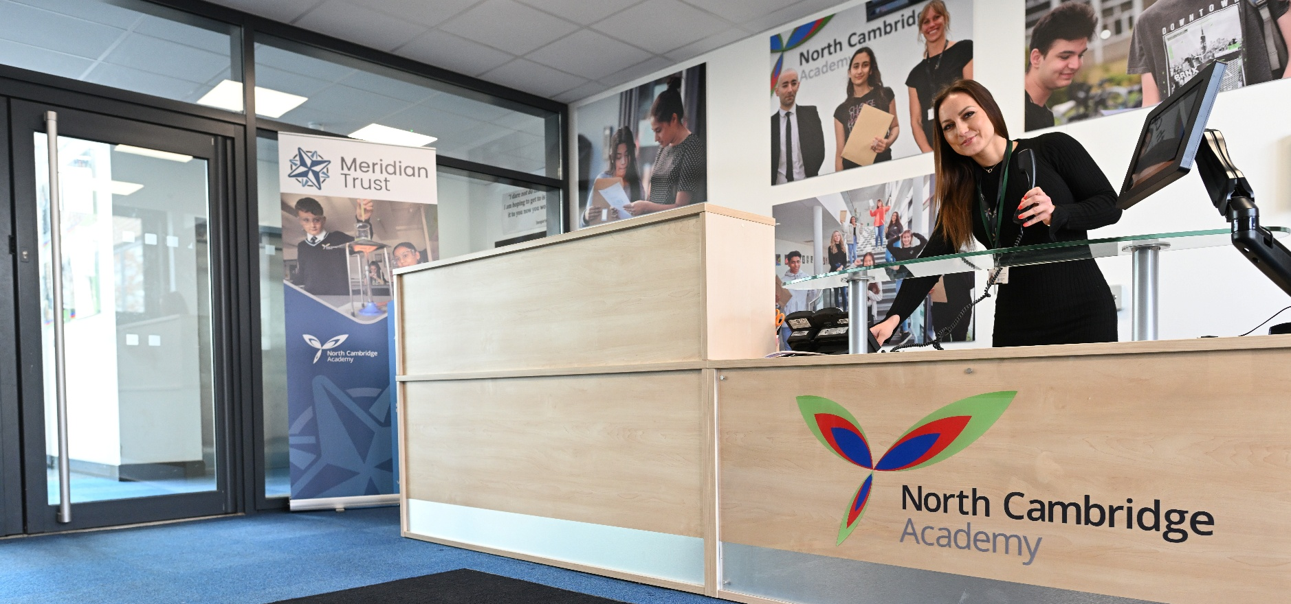

North Cambridge Academy
Teacher of Science
Recruitment Pack





Content

About North Cambridge Academy 3

A brief history of our Trust 4

Our Vison, Mission and Values 5

Why work for us 6

How to apply 6

Job description and Person Specification 7

About North
Cambridge Academy
Principal: Jane Driver
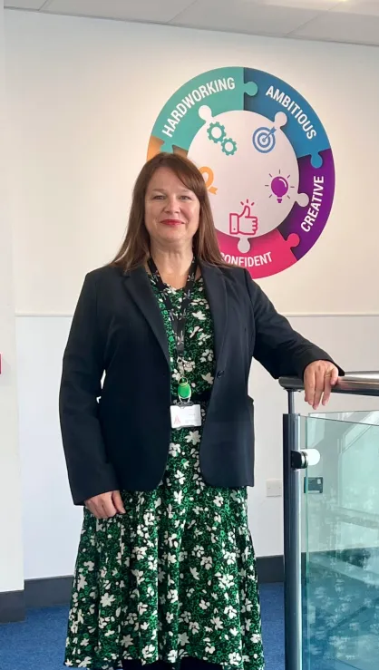
It is my honour and privilege to introduce myself as the Principal of North Cambridge Academy (NCA). I am extremely proud to lead this growing school which has consistently excellent student progress outcomes and is rated Good by Ofsted.
I have been working in education for over 20 years as a Modern Foreign Languages (MFL) and English as a Foreign Language (EFL) teacher abroad as well as in Yorkshire and Cambridgeshire, where I have taken on a range of teaching and leadership roles, most recently Headteacher of a large secondary school in Peterborough. I am a keen linguist, Specialist Leader for Education and Invited Trustee for the Association for Language Learning.
North Cambridge Academy aims to teach all students the values of being Hard-Working, Ambitious, Creative, Confident and Kind. These values can be seen throughout the Academy, whether that is on the wall displays in each classroom and corridor or through the behaviours and language that we use every day. Additionally, our Pledge System supports students to develop these competences through the participation in and leadership of a huge range of curricular and extra-curricular activities and initiatives on offer at the Academy, including our extensive Saturday School provision. The Pledge System allows us to celebrate together and recognise students’ achievements and values development.
NCA has a strong ethos of support and nurture, and our staff work tirelessly every day to support all students to be and achieve their best. As a parent, we know that you want this for your children also and we appreciate your support of and communication with the Academy to get the best out of your child’s/ children’s education – working together we can achieve so much more. We all have huge pride in North Cambridge Academy and thank you for your support in ensuring your child wears our uniform with pride, arrives punctually and shares our values. These things may seem trivial but make a huge difference in us developing a shared identity based on being ‘proud to be NCA’.

A Brief History
Meridian Trust, formerly known as Cambridge Meridian Academies Trust (CMAT), is a values-led Trust and has risen to be one of the highest performing academy groups in the country. Our Trust was first formed as an educational trust to create a federation of schools in 2006 with a desire to provide high quality and dynamic education for everyone, right in the heart of our community. Through various government policies, our commitment to collaboration has remained consistent.
Meridian Trust was formed in 2011 to deliver more widely on that clear vision to provide high quality and dynamic education for all at the heart of the communities we serve. Our steady growth since then reflects our commitment to the communities we serve and our track record of success. The period since 2018 has seen an increase in speed of growth as many long term projects matured and our relationship with Sharnbrook Academy Federation emerged.
We are currently a family of 30 academies (including 14 primary, 3 special and 13 secondary schools). The secondary schools include a University Technology College, an Upper School, four 11-16 schools and six 11-18 schools. We also have 2 new secondary free schools in development. All within 20 miles of Cambridge and Peterborough and the main communication routes between. We merged with Cambridge Primary Education Trust to become the Meridian Trust in April 2022. In addition to operating schools, we are the home of the Cambridgeshire and Peterborough Teaching School Hub, and train more than 150 new teachers each year through Meridian Trust ITT. We retain a strong commitment to growing and supporting staff throughout their training and career development. We have a proven track record of school improvement and transforming the lives of children and young people over the last 10 years.
Students thrive in Meridian Trust academies as a result of the implementation of our values, our successful and proven systems and our commitment to valuing people. We are among the highest performing multi-academy trusts in the country for student progress. Our academies are well-run and our staff benefit from excellent access to professional development.
Our commitment to the education system goes beyond just our own academies. We operate ’The Cambridge Partnership‘, one of the largest initial teacher training providers in the country which has recently merged with the SAF ITT, and ‘Leadership East’ these further strengthen our capacity and commitment to professional development. We also provide support through various SLAs to a number of other trusts and academies.

As a strong, regional multi-academy trust we currently operate schools across Bedfordshire, Cambridgeshire, Lincolnshire, Peterborough, and Northamptonshire. We are proud to have strong partnerships within all these communities.

Trust Vision, Mission and Values
Our values and who we are:
Meridian Trust is a successful multi-academy trust founded on its commitment to people and communities.
Our proven approach over more than a decade has elevated us to a respected and admired academy trust, a national leader in education and a source of great pride to the communities we serve.
Every child is known, equally valued and supported to achieve their potential in all our academies. Every community we serve benefits from the facilities and services we provide.
Our staff benefit from strong networks, excellent career opportunities and a human approach where they are equally valued and supported.
We ensure that well-run schools retain and develop their distinct contextual identity, while sharing and contributing to Meridian Trust values, practices, curriculum approaches and operational systems.
Our Vision:
High-quality educational provision for all at the heart of local communities.
Our Mission:
To deliver, promote and inspire high quality educational provision in schools at the heart of their local communities so that:
- Young people become successful learners and confident, empowered individuals;
- Young people are encouraged to think for themselves and act for others, equipping them with the values, attributes, knowledge and skills to make a rewarding contribution to society;
- Every school is a hub for community activities, a centre for extended services and a source of immense pride for students, their families, and other local stakeholders;
- Our staff benefit from strong networks, excellent career opportunities and a human approach where they are equally valued and supported;
- Well-run schools retain and develop their distinct contextual identity while sharing and contributing to the Meridian Trust values, practices, curriculum approaches and operational systems.
The enactment of our values for staff:
Engaged, developed, supported, and consulted.

Experts who strive for continual development. Collaborative networks, trusted to deliver.

Set ambitious goals and model what success looks like. Eager to improve.
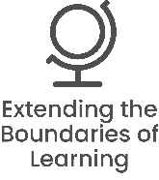


Make connections, provide opportunities. Generous and sharing of knowledge and
expertise.

Are accountable for the outcomes we contribute towards and strive for the very best.

Why work for us
Meridian Trust aims to be the employer of choice for the communities we serve. Since 2010 we have nurtured and developed the careers of many people. You can read about some of those journeys in the 'Meridian Trust People' section of this website. We are committed to making a difference to young people’s lives and the communities we serve. Help us make our mission a reality.
Benefits:
As a multi-academy trust of 30 schools, Meridian Trust can provide a wide network of opportunities for collaboration and career development for both teaching and support staff. With an initial teaching training facility and a teaching hub network within our Trust, there are ample opportunities to both, get into teaching, and develop within the profession.
- As well as the above we also offer:
- Unlimited access to CPD via Meridian Learning
- Free annual eye tests
- Access to a free Employee Assistance Programme, offering mental health and wellbeing support
- Unlimited value cycle to work scheme

To see the full range of benefits available, please visit Employee Benefits - Meridian Trust

How to apply
To apply please complete the online form on Mynewterm Your supporting statement should address and evidence the selection criteria detailed in the Person Specification.
For any questions about the application process please contact:
recruitment@northcambridgeacademy.org

Interviews:
Interviews will be arranged shortly after applications are received.
Early applications are encouraged as we reserve the right to appoint an exceptional candidate at any stage of the application process.

Meridian Trust is committed to safeguarding and promoting the welfare of children. All appointments will be subject to satisfactory pre-employment checks including enhanced DBS disclosure. We are committed to diversity & inclusion and equality of opportunity for all staff and applications from individuals are encouraged regardless of age, disability, sex, gender reassignment, sexual orientation, race, religion or belief and marriage and civil partnerships. Meridian Trust is committed to safer recruitment practice and pre-employment checks will be undertaken before any appointment is confirmed. This post is subject to an enhanced disclosure and barring service check. We expect all adults who work for the Trust to share our commitment to safeguarding and the health and wellbeing of our students.

JOB DESCRIPTION AND PERSON SPECIFICATION
Job Title: | Teacher of SUBJECT
School/Academy: | North Cambridge Academy
Salary: | MPS/UPS
Responsible to: | Principal

Role: | Class teacher with expert subject knowledge.
Purpose of job: | Deliver high quality teaching and pastoral support to all students.

To be an excellent classroom practitioner and committed to becoming an expert in the relevant subject specialism. In line with our model of vertical tutoring all teachers are required to be form tutors with the associated pastoral responsibilities.

In addition to the responsibilities listed below there is an expectation that those paid on Upper Pay Scale:
Will be expected to demonstrate that their level of competence and performance is:
- highly competent in all elements of the relevant professional standards; and
- achievements and contributions to the school are substantial and sustained.

Responsibilities and Accountabilities:
Set high expectations which inspire, motivate and challenge pupils:
- Establish a safe and stimulating environment for pupils, rooted in mutual respect.
- Set goals that stretch and challenge pupils of all backgrounds, abilities and dispositions.
- Demonstrate consistently the positive attitudes, values and behaviour which are expected of pupils.

Promote good progress and outcomes by pupils:
- Be accountable for pupils’ attainment, progress and outcomes.
- Be aware of pupils’ capabilities and their prior knowledge, and plan teaching to build on these.
- Guide pupils to reflect on the progress they have made and their emerging needs.
- Demonstrate knowledge and understanding of how pupils learn and how this impacts on teaching.
- Encourage pupils to take a responsible and conscientious attitude to their own work and study.

Demonstrate good subject and curriculum knowledge:
- Have a secure knowledge of the relevant subject(s) and curriculum areas, foster and maintain pupils’ interest in the subject, and address misunderstandings.
- Demonstrate a critical understanding of developments in the subject and curriculum areas, and promote the value of scholarship.
- Demonstrate an understanding of and take responsibility for promoting high standards of literacy, articulacy and the correct use of standard English, whatever the teacher’s specialist subject.
- If teaching early reading, demonstrate a clear understanding of systematic synthetic phonics.
- If teaching early mathematics, demonstrate a clear understanding of appropriate teaching strategies.

Plan and teach well-structured lessons:
- Impart knowledge and develop understanding through effective use of lesson time.
- Promote a love of learning and children’s intellectual curiosity.
- Set homework and plan other out-of-class activities to consolidate and extend the knowledge and understanding pupils have acquired.
- Reflect systematically on the effectiveness of lessons and approaches to teaching.
- Contribute to the design and provision of an engaging curriculum within the relevant subject area(s).

Adapt teaching to respond to the strengths and needs of all pupils:
- Know when and how to differentiate appropriately, using approaches which enable pupils to be taught effectively.
- Have a secure understanding of how a range of factors can inhibit pupils’ ability to learn, and how best to overcome these.
- Demonstrate an awareness of the physical, social and intellectual development of children, and know how to adapt teaching to support pupils’ education at different stages of development.
- Have a clear understanding of the needs of all pupils, including those with special educational needs; those of high ability; those with English as an additional language; those with disabilities; and be able to use and evaluate distinctive teaching approaches to engage and support them.

Make accurate and productive use of assessment:
- Know and understand how to assess the relevant subject and curriculum areas, including statutory assessment requirements.
- Make use of formative and summative assessment to secure pupils’ progress.
- Use relevant data to monitor progress, set targets, and plan subsequent lessons.
- Give pupils regular feedback, both orally and through accurate marking, and encourage pupils to respond to the feedback.

Manage behaviour effectively to ensure a good and sage learning environment:
- Have clear rules and routines for behaviour in classrooms and take responsibility for promoting good and courteous behaviour both in classrooms and around the school, in accordance with the school’s behaviour policy.
- Have high expectations of behaviour and establish a framework for discipline with a range of strategies, using praise, sanctions and rewards consistently and fairly.
- Manage classes effectively, using approaches which are appropriate to pupils’ needs in order to involve and motivate them.
- Maintain good relationships with pupils, exercise appropriate authority, and act decisively when necessary.

Fulfil wider professional responsibilities:
- Make a positive contribution to the wider life and ethos of the school.
- Develop effective professional relationships with colleagues, knowing how and when to draw on advice and specialist support.
- Deploy support staff effectively.
- Take responsibility for improving teaching through appropriate professional development, responding to advice and feedback from colleagues.
- Communicate effectively with parents with regard to pupils’ achievements and well-being.

Support for School/Academy/Place of work:
- Participation in staff events by arrangement.
- Attend Staff Meetings.
- Contribute and participate in Trust events and activities where possible.
- Develop and maintain effective working relationships with other staff and parents/carers.
- Adhere to the Trust values.
- Follow school policies, practices and procedures.

Data security:
- Act in accordance with legal provisions regulating confidentiality and security of data and information in accordance with GDPR regulations.

Health and Safety:
- Be aware of the responsibility for personal Health, Safety and Welfare and that of others who may be affected by your actions or inactions.
- Co-operate with the Trust on all issues to do with Health, Safety & Welfare.
- To work/operate all equipment within Health and Safety and other legal regulations, including risk assessments.
- Contribute to the maintenance of a safe and healthy environment.

Continuing Professional Development:
- In conjunction with the line manager, take responsibility for personal professional development, keeping up to date with research and developments related to school/academy/place of work efficiency, which may lead to improvements in the day-to-day running of the Trust.
- Undertake any necessary and identified professional development taking full advantage of any relevant training and development available, particularly when related to the use of ICT, for data management and record keeping.
- Maintain a professional portfolio of evidence to support the Performance Management process – evaluating and improving own practice.

Child Protection and Safeguarding
- The post holder will have a shared responsibility for the safeguarding of all children and young people. The post holder also has an implicit duty to promote the welfare of all children and young people.
- To inform the Child Protection Officer of any issues relating to the safety and well-being of students.

The post holder will undertake any other duties commensurate with the grade of the post, in consultation with line manager.

This job description is subject to review and may be changed following consultation with the post holder. It is not a comprehensive statement of procedures and tasks but sets out the main expectations of the Trust in relation to the post holder’s professional responsibilities and duties.

The Trust is committed to safeguarding and promoting the welfare of children and young people and expects all staff and volunteers to share in this commitment.
All staff will be subject to an enhanced check with the Disclosure & Barring Service.
Updated: January 2023

Person Specification – Teacher |  |  | Assessment Key:  A = Application Form  I = Interview  RE = Reference  AS = Assessment
Education and Qualification |  |  | Essential | Desirable | Assessment
1 | Qualified Teacher Status. |  | ✓ |  | A
2 | Good educational background including a good Honours Degree or equivalent. |  | ✓ |  | A
3 | Evidence of continuing professional development. |  |  | ✓ | A/I
Experience |  |  | Essential | Desirable | Assessment
4 | Excellent classroom practitioner. |  | ✓ |  | A/I/RE/AS
5 | Excellent subject knowledge. |  | ✓ |  | A/I/AS
Knowledge and Skills |  |  | Essential | Desirable | Assessment
6 | Evidence of both curricular and pastoral responsibilities. |  | ✓ |  | A/I/RE/AS
7 | Understanding of and commitment to teaching standards. |  | ✓ |  | A/I/RE
8 | Ability to foster and promote good relationships with all stakeholders. |  | ✓ |  | A/I/RE
9 | Ability to contribute to team meetings and contribute ideas. |  | ✓ |  | A/I/RE
Personal Qualities |  |  | Essential | Desirable | Assessment
10 | High personal standards in terms of attendance, punctuality and organising workload. |  | ✓ |  | I/RE/AS
11 | Willingness to undergo further training and development. |  | ✓ |  | I
12 | Excellent interpersonal and communication skills. |  | ✓ |  | I/RE/AS
13 | Think creatively and collegiately to solve problems and identify opportunities. |  | ✓ |  | I/RE/AS
14 | Positive and enthusiastic approach towards work. |  | ✓ |  | I/AS
15 | Professional approach when dealing with all issues, students and staff. |  | ✓ |  | I/AS
16 | Clear, fully inclusive, educational philosophy. |  | ✓ |  | A/I/RE
17 | Commitment to continual improvement and challenging norms. |  | ✓ |  | A/I/AS
Child Protection |  |  | Essential | Desirable | Assessment
18 | Support the Academy policies on safeguarding and child protection. |  | ✓ |  | A/I
Other |  |  | Essential | Desirable | Assessment
19 | Flexibility of working hours | ✓ |  |  | A/I

