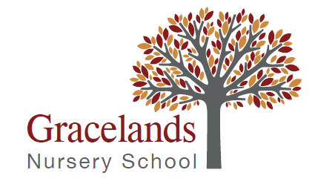
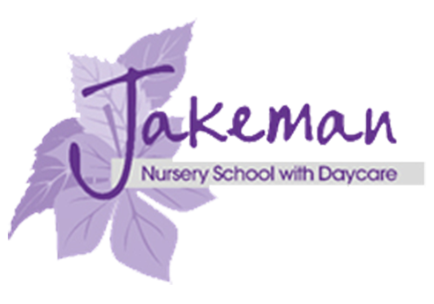

GRACELANDS NURSERY SCHOOL
Grace Road, Sparkbrook, Birmingham, B11 1ED
Tel: 0121 7723124
Email: enquiry@grclands.bham.sch.uk
Executive Head Teacher: Samantha Richards

JAKEMAN NURSERY SCHOOL
Jakeman Road, Balsall Heath, Birmingham, B12 9NX
Tel: 0121 4403066
Email: enquiry@jakeman.bham.sch.uk
Executive Head Teacher: Samantha Richards

SENCO post at Jakeman Nursery School
Working within the Gracelands Nursery School and Jakeman Nursery School cluster:
1 x SENCO – (permanent) Part time 0.5/0.6 MPS/UPS teacher with TLR2b from 1st September 2026

We are looking for an experienced and dedicated SENCO (qualified, holding the PG Certificate in SEN/D Co-Ordination or enrolled on NPQ SENCO, working towards NPQ SENCO accreditation) to lead on inclusion within our cluster of 2 nursery schools, working alongside 1 other part time SENCO. At Gracelands and Jakeman Nursery Schools, we pride ourselves on our creative and holistic approach to pre-nursery and nursery education. Our approach empowers children to make their own choices and helps them to be self-motivated individuals.
The Birmingham Federation of Maintained Nursery schools is made up of 9 Nursery Schools delivering inclusive high-quality early education and care to children aged 0-5 years across Birmingham. We have a vibrant and enthusiastic staff of qualified teachers, teaching assistants, nursery officers, play workers, administrators and other support staff who make up our team.
As well as exceptional and inclusive provision for children and families, we are committed to professional development, and provide opportunities for learning and collaboration across the cluster of 2 schools, the wider Federation, and beyond.
Our settings are culturally diverse with a large number of languages spoken. We have a reputation for supporting children with a range of complex special educational needs and disabilities, as well as support for families who may have additional challenges in their lives.
We are committed to safeguarding and promoting the wellbeing of all children, and expect our staff and volunteers to share this commitment. Suitability checks will be undertaken including online, background, identity, qualification, work history and two professional references.
Early Years education is undergoing ongoing change and challenge so applicants need to not only be an outstanding teacher and SENCO but also flexible, resilient and able to contribute innovative ideas.
If you are interested in this position, with the support of an experienced team, we would like to hear from you. Visits to the school/s are most welcome with prior arrangement. Please contact Samantha Richards (Executive Headteacher) to arrange an appointment.
Jakeman Nursery School – 0121 4403066 – enquiry@jakeman.bham.sch.uk
Gracelands Nursery School – 0121 7734124 – enquiry@grclands.bham.sch.uk
Closing date: Monday 13th April 2026 at 9am Interview date: Tuesday 28th April 2026

