

ROLE PROFILE

*Red Kite Learning Trust is committed to supporting work–life balance and recognise the benefits of flexible working. We welcome requests for flexible working arrangements as part of the recruitment process. While flexibility may be possible for many roles, each request will be considered on an individual basis.
Job Title: | Receptionist | School: | Crawshaw Academy
Salary Grade: | B1 SCP 2-4 | Working Hours: | 37 hours per week
Contract Type: | Permanent, Term Time Only + Training Days | Location: | Leeds
Responsible to: Headteacher
Role summary: To work across our main visitor and student reception team for the Academy and provide a memorable first impression whilst ensuring that all duties as well as the day-to-day office needs of staff, students and visitors are met to the highest standards. In addition, provide first aid when needed (alongside the rest of the reception team).
Special conditions of service:
No smoking policy, including e-cigarettes/vaping.
Role specific responsibilities:
- To meet and greet all staff, students and visitors to the respective reception within our Academy.
- To handle enquiries or requests for support from staff, students and visitors both efficiently and with the utmost confidentiality.
- Responsible for operating the school switchboard and subsequently liaising with any colleagues at any given time.
- Relay all messages generated for staff and students by email, phone and visitors attending reception.
- Manage correspondence to and from the Academy email account.
- To deliver first aid for students and staff recording outcomes on our system in an accurate manner.
- General admin support across the Business Operations team including finance and Human Resources.
- To maintain general tidiness of the public reception area and refresh displays with up-to-date information.
- Process internal and external room bookings using our MIS.
- Attend team and staff meetings as required.
- To ensure ICT is used effectively and intelligently within this role, seeking out efficiencies when appropriate.
- To work together as an admin team to ensure best practice and combine skills/knowledge to support teaching and learning.
- Participate in professional and personal development programmes as required, including regular training and performance review.
- To work flexibly where required to meet the needs of the Academy.
- To adhere to all Academy/Trust policies and procedures.
- Other appropriate admin tasks as requested by line manager.
RK People responsibilities:
- Contribute to the overall aims and values of our Trust, appreciate and support the roles of other members of the wider team and attend and participate in relevant meetings as required
- Comply with all Trust policies and procedures including child protection, health, safety, welfare, security, confidentiality and data protection, reporting any concerns to the appropriate person
- Contribute to ensuring safeguarding procedures are in place and used effectively at all times
The role holder must demonstrate a flexible approach to the delivery of the role. Consequently, the role holder may be required to perform work not specifically identified in the job profile but which is in line with the general scope, grade and responsibilities of the role.
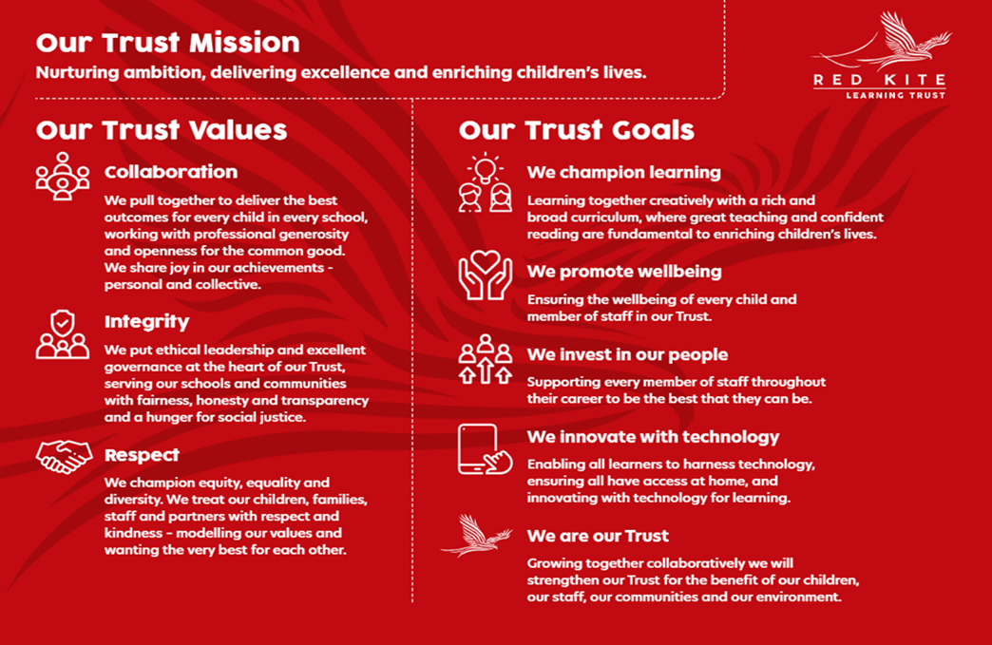
PEOPLE PROFILE
Aptitudes and Characteristics |  |  | Essential | Desirable
Strong interpersonal skills with a welcoming, professional manner |  |  | *
Ability to work flexibly and collaboratively as part of a team as well as on own |  |  | *
Able to use own initiative and motivate others |  |  | *
Ability to communicate to a variety of stakeholders |  |  | *
Willingness to proactively take part in training. Take responsibility for and be keen to improve upon own professional development |  |  | *
Ability to work calmly under pressure to high levels of accuracy |  |  | *
Ability to demonstrate a commitment to equality of opportunity for all pupils |  |  | *
Ability to contribute to wider school life |  |  | *
To demonstrate high levels of confidentiality |  |  | *
Ability to manage workload effectively to meet deadlines |  |  | *
Excellent written and oral communication and organisation |  |  | *
Willingness to be flexible and work to meet the best interests of the Academy |  |  | *
Qualifications, Knowledge and Experience |  |  | Essential | Desirable
GCSEs English and Maths (Level C) or equivalent |  |  | *
Have knowledge of basic first aid |  |  |  | *
Willingness to undertake first aid training |  |  | *
Awareness of key legislation and regulations, including health and safety requirements, data protection and confidentiality. |  |  |  | *
Competent ability in ICT |  |  | *
Experience of dealing with queries from a wide range of people |  |  |  | *
Experience of providing customer facing or administrative role |  |  |  | *
Safeguarding and Promoting the Welfare of Pupils |  |  | Essential | Desirable
An appropriate motivation to work with children and young people |  |  | *
Ability to maintain appropriate relationships and personal boundaries with children and young people |  |  | *
Emotional resilience in working with challenging behaviours and appropriate attitudes to the use of authority and maintaining discipline |  |  | *

